An Invitation to Participate in

4th Fazza Para Archery World Ranking Tournament- Dubai 2018.

Dubai 02-08 March 2018

Dear World Archery members /NPCs/ dear friends: Please forward this invitation to the relevant personnel in regard to Disability Archery within your country.

To whom it may concern:

The Dubai Club for People of Determination is organizing the 4th Fazza Para Archery World Ranking Tournament- Dubai 2018.

Preliminary & Final Registration:-

All entries must be completed using the World Archery WAREOS system.
All entries, accommodation reservations, transport needs, flight arrival/departure information and visa invitation letter requests are to be completed using WAREOS.

The World Archery Online Registration System (WAREOS): http://register.worldarchery.org has been updated to handle the entire registration process for this event. No entry forms, hotel reservations or transport forms will be accepted as all information is to be entered into WAREOS.

In order to use WAREOS, please login on http://register.worldarchery.orgwith your Username and Password assigned by World Archery. After entering WAREOS, please find the event from the list you wish to register your athletes. Select/press the “Entries” button to see the list of categories in the event. Select/press the “category” to enter the athlete and official numbers/details participating for that event. A "WAREOS User Manual" can be downloaded in PDF format (English) using the same website link.

For any questions regarding the WAREOS, please contact the World Archery office, Mr. JK LEE (jklee@archery.org).

A maximum number of 3 athletes per country are allowed to be registered into each category of the event. Preliminary entries should be completed using WAREOS.

DEADLINES:

1st Entry by number Deadline: 2nd December 2018

BY NAME & WITH PAYMENT – DEADLINE 9th February 2018

Classification – “For countries which have athletes needing to be classified for the first time or who have “Review” status which requires a further classification, please complete the classification application form and medical intake form for each person (https://worldarchery.org/Para-Archery) and send to World Archery attention Mr. JK Lee, not later than 1st February 2018.

Preliminary Schedule:

Friday 02 March 2018 | Arrivals, training + Classification
Saturday 03 March 2018 | Classification + official training + Manager´s meeting
Sunday 04 March 2018 | Qualification round recurve, compound and W1 women and men
Monday 05 March 2018 | Elimination Individual recurve, compound, W1, women and men
Tuesday 06 March 2018 | Individual Elimination, and Mixed Team matches
Wednesday 07 March 2018 | Individual and Mixed Team medal matches
Thursday 08 March 2018 | Departures

Introduction

The Local Organizing Committee and in cooperation with Fazza Office would like to invite you to the 4th Fazza Para Archery World Ranking Tournament- Dubai 2018
In the period from 02-08 March 2018 at Dubai Club for People of Determination Dubai, United Arab Emirates.
We are very proud to host this prestigious event that will help develop the legacy within the sport and further develop our athletes with the international competition experiences.
Through the continued support of the government entities, national sports governing bodies, private and public sector partners, we are very pleased that this competition is hosted in the United Arab Emirates; where we are sure your Par- Archers will experience our fantastic Emirati hospitality and face elite competition.

Local Organizing Committee:

Dubai Club for People of Determination

Chairman: Thani Juma Berregad

Date: 02 – 08 March 2018

Venue: Dubai Club for People of Determination

Rules: World Archery Rules will apply

Classes: Male/ Female

Division: Recurve Open, Compound Open, W1 Open

Format: ABC format

Prizes and awards:
Valuable prizes and medals will be attributed to the first three in each class and division contested.
Entry fees:

There is no entry fees for all participants and officials

Accommodation:
The Al Bustan Hotel is the official hotel for all athletes and officials during the FAZZA tournament. This hotel offers accommodation in single, double, and triple rooms.
Hotel name: Al Bustan
Address: Al Nahda Road-Al Towar, P.O.Box 2017, Dubai, UAE
Website: www.al-bustan.com

Type of rooms:
Single room 170 US Dollar per night incl. 3 times a day meals

Double room 280 US Dollar per night incl. 3 times a day meals

Triple room 400 US Dollar per night incl. 3 times a day meals (strongly recommended: apartment including 1 single room and 1 double room, two bathrooms, kitchen, lounge and dining area).

Quadruple room 480 US Dollar.3 times a day meals (strongly recommended: apartment including 2 double room, two bathrooms, kitchen, lounge and dining area with sofa bed).
Teams who arrive on 02 March before 6:00am and want to have access to their rooms before the check in (6:00am) the hotel will charge an extra night. After 6:00am the hotel will have available the room (without extra cost).

*On 08 March 2018 teams who wants to stay in their rooms after the check-out will be charge for an extra night. Teams are allowed to stay in the lobby without extra cost.

* All rooms will be allocated once payment has been received in full.
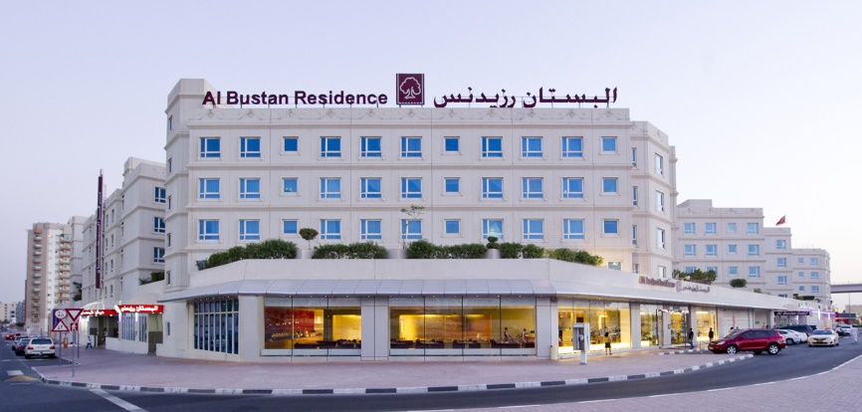

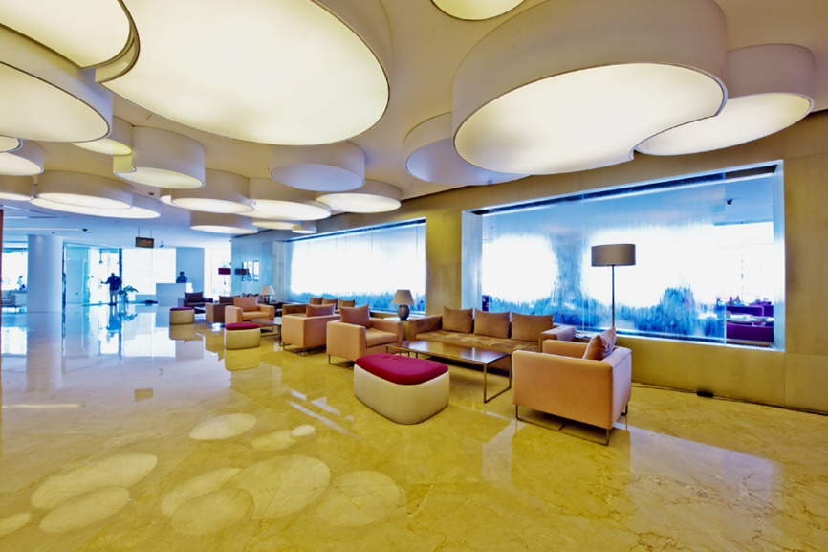

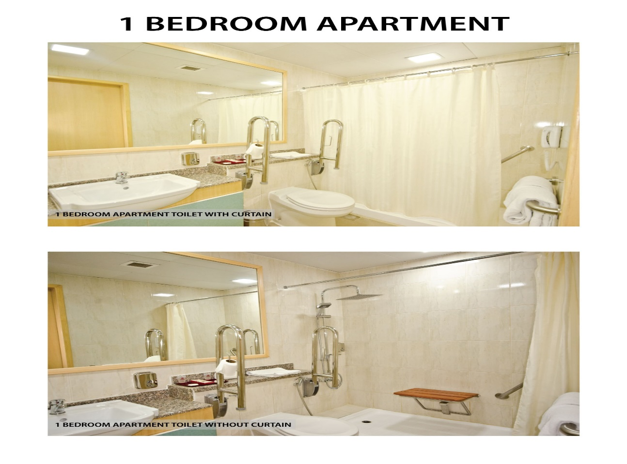

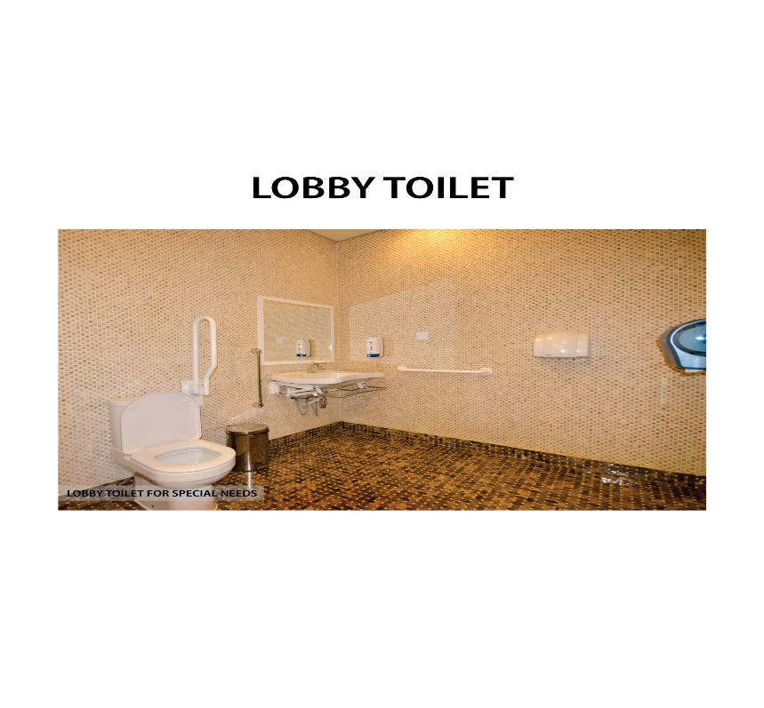

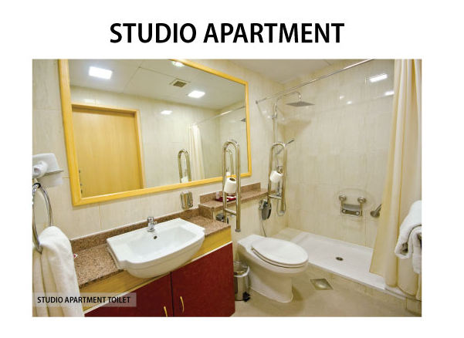

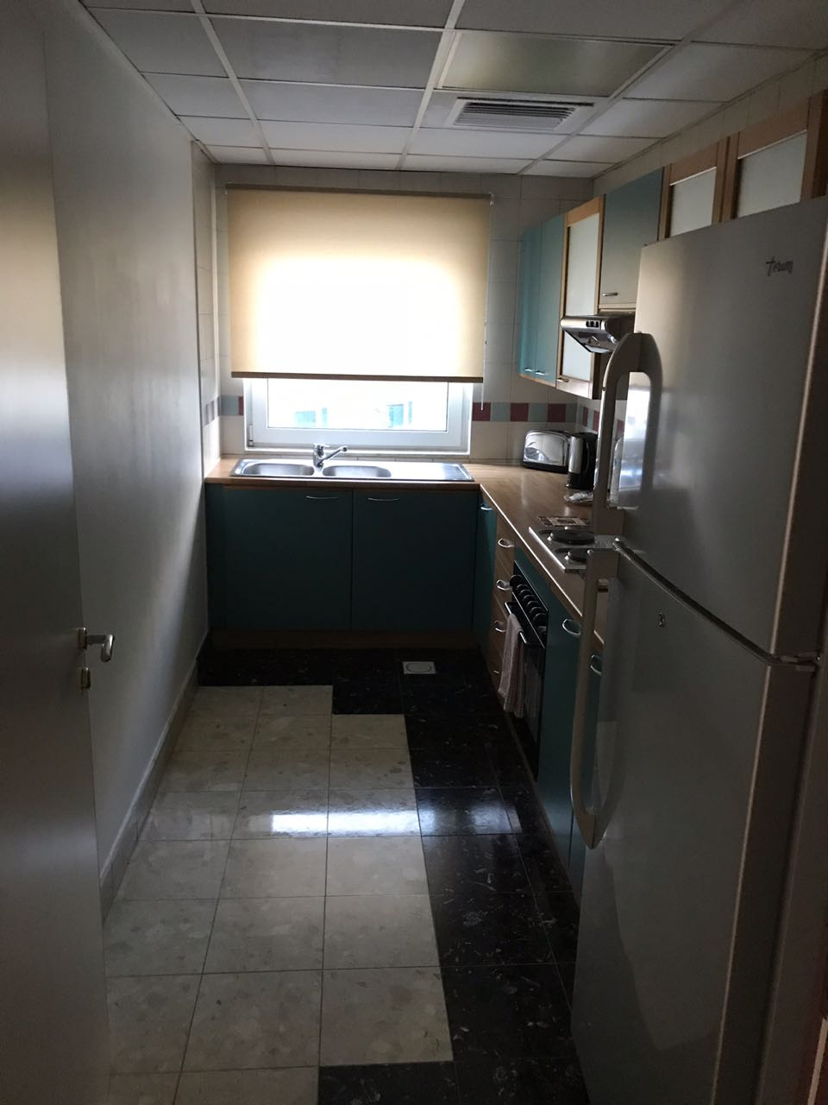
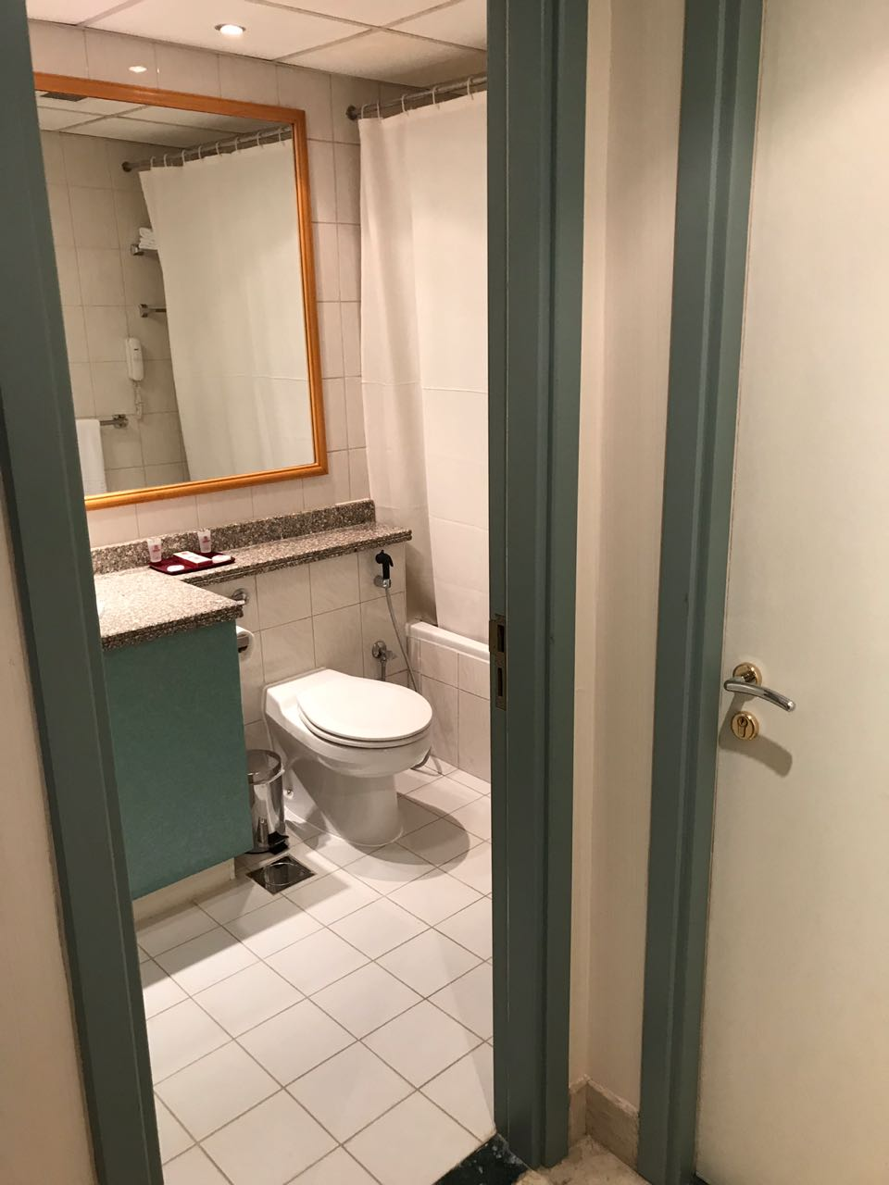
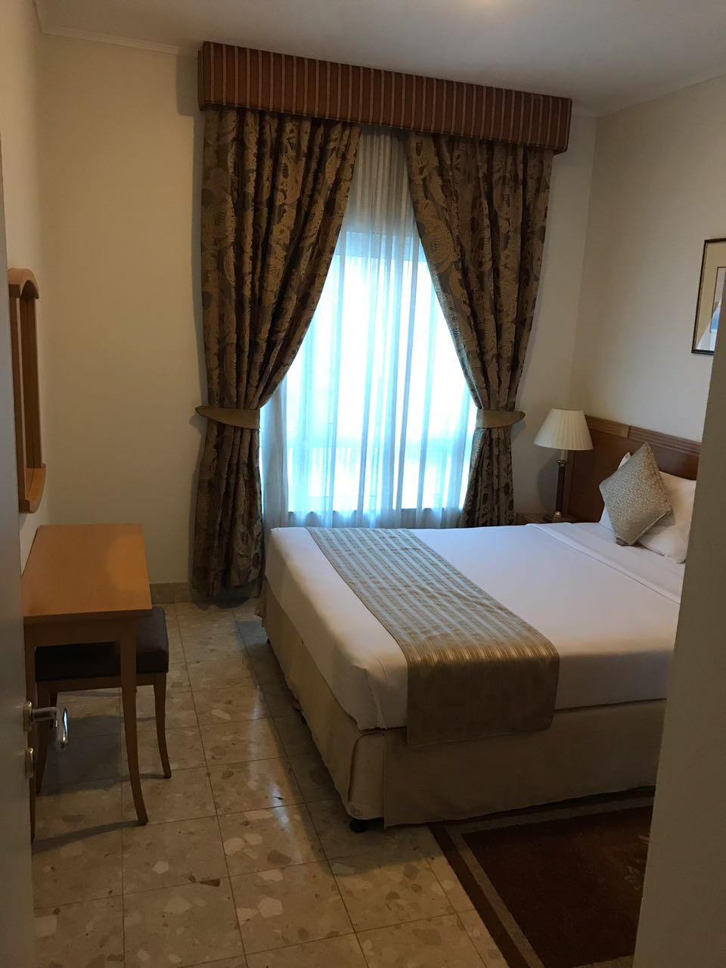
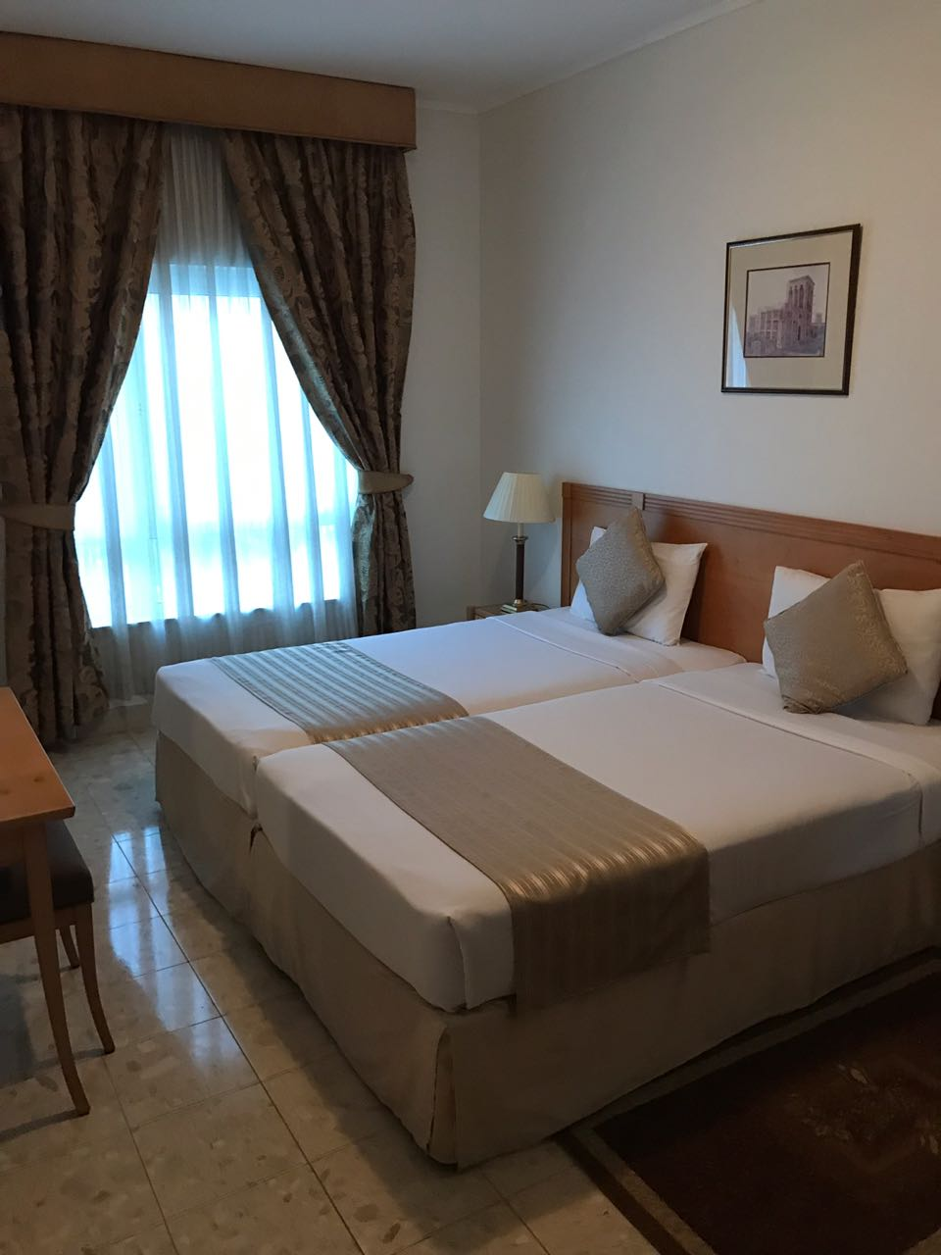

Payment procedure/
Full accommodation fees must be transferred to the following bank account, by no later than
01 February 2018. Please note that rooms will only be booked and allocated to teams when the accommodation payment has been received in full.
Account name | Dubai Club for People of Determination
Bank name | Dubai Islamic Bank
Branch name | Dubai Main Branch
Account number | 001520726988901
Swift-Code | DUIBAEAD
IBAN | AE95 0240 0015 2072 6988 901

Cancellation Policy:
- 50% of payment will be refunded if cancellations are made by 15 February 2018
- No payments will be refunded to cancellations from 16 February 2018

ALL ROOM RATES ARE PER ROOM PER NIGHT

The hotel cost includes 3 meals (breakfast, lunch and dinner), if the competition schedule will not allow teams to get lunch at the hotel, the LOC will provide lunch packets at the venue but only for lunch, this will decided after the Competition schedule has been published officially.

Transportation:
It will be organized from/to Dubai international Airport to the official competition hotel. The distance between the airport and hotel is 6 km; the journey takes only 10 minutes by car or bus. The distance between competition venue and hotel are 500 meters (5 minutes) by bus and 500 meters walking distance (7 minutes) the transport cost is included in the accommodation cost
The athletes /officials will report - directly to the new stadium through the main entrance

Visas:
Visa invitation letters will be provided by LOC. In order to arrange your invitation letters we ask you to complete the appropriate section in WAREOS not later than 1 February 2018.

Contact Details
Dubai Club for People of Determination
Tel: 00971 42988 205
Fax: 00971 42988 459
Email: fazza.dubai2018@gmail.com

Chairman
Thani Juma Berregad

United Arab Emirates

The United Arab Emirates consists of seven emirates: Abu Dhabi, Dubai, Sharjah, Ras Al Khaimah, Ajman, Umm Al Quwain and Fujairah. Four-fifths of the UAE is desert but has contrasting landscapes—from the towering red dunes of the Liwa to the rich palm-filled Oasis of Al Ain, from the precipitous Hajjar Mountains to the more fertile stretches of its coastal plains.
Though small in size (similar to the size of Scotland), the UAE has become an important player in regional and international affairs. In 1971, the late President Sheikh Zayed bin Sultan Al Nahyan unified the small, underdeveloped states into a federation—the only one in the Arab world. With his visionary leadership, oil wealth was used to develop the UAE into one of the world’s most open and successful economies.
In 2004, His Highness Sheikh Khalifa bin Zayed Al Nahyan became the President and has since continued to strive towards an ambitious vision for the UAE.

DUBAI

Dubai is located on the Eastern coast of the Arabian Peninsula, in the south west corner of the Arabian Gulf. It is extremely well known for its warm hospitality and rich cultural heritage, and the Emirati people are welcoming and generous in their approach to visitors. With year round sunshine, intriguing deserts, beautiful beaches, luxurious hotels and shopping malls, fascinating heritage attractions and a thriving business community, Dubai receives millions of leisure and business visitors each year from around the world.
The local currency is the dirham, which is pegged at AED (3.67) to (1.0) US dollar.
Dubai is tolerant and cosmopolitan and all visitors are welcome. However, Islam is a way of life in the city, and therefore tourists should adopt a certain level of cultural and religious sensitivity for the duration of their stay.
Dubai Rulers: Since 1833 the reigning Al Maktoum family have ruled Dubai. Under their wise and progressive leadership Dubai has prospered and it is now the business and tourism hub for a region.
Dubai History: Saruq Al-Hadid site is considered one of the most important archaeological discoveries in Dubai and the region, as it offers much of the UAE› old past, especially during the Iron and Bronze Ages، which confirms that the UAE civilization extends to 5 thousand years.
Dubai Economy: The past few decades have witnessed incredible growth throughout all sectors of the Dubai economy. The emirate’s government is constantly working to improve its commercial transparency and introduce dynamic regulations that aid the formation of small and medium enterprises. Dubai’s economy is no longer reliant on oil, but is more diversified, relying heavily on trade, services and finance sectors. With its central geographic location between Asian and European markets, Dubai has worked hard to establish itself as an integral part of the global trade mechanism. Its central location has also allowed Dubai to become a popular and accessible tourist destination.

