TO ALL World Archery MEMBER ASSOCIATIONS

Dear President,

USA Archery is hosting the 2018 USA Para W.R.E. in Salt Lake City, Utah, United States of America on 07 to 09 September 2018. On behalf of the Organizing Committee, it is a great pleasure to invite you to participate in this competition. This event will be organized following World Archery rules.

Please find enclosed the necessary documents of registration, organization and participation for this event. Please complete all the sections in WAREOS before the deadlines:

Summary of deadlines:

- Preliminary Entries 07 July 2018
- 50% Deposit of Total Cost 07 July 2018
- Visa Support 07 July 2018
- Final Hotel Reservation per each hotel – please check
& Payment
- Transportation 07 July 2018
- Final Entries 17 August 2018

Looking forward to welcoming you in Salt Lake City, United States of America.

Sincerely yours,

Mr. Rod Menzer
CEO
USA Archery

PRELIMINARY PROGRAM:

05 Sept 2018  Wednesday | Arrival of participants  Practice field and local transport available
06 Sept 2018  Thursday | Classification: 9:00 am – 5:00 pm  Practice field and local transport available
07 Sept 2018  Friday | Official Practice  Equipment Inspection  Team Managers Meeting
08 Sept 2018  Saturday | Qualification Round,  (All Categories)
Team Eliminations
(All Categories

09 Sept 2018  Sunday | Individual Eliminations and Finals  (All categories)
10 Sept 2018  Monday | Departure of teams

NOTE:
This preliminary program is subject to change according to participation. All changes will be published and distributed in good time.

CLASSIFICATION:

Classification will be available on 6 September 2018. Athletes needing classification shall submit WA Medical forms in electronic/typed format to classification@archery.org on or before 6 JULY 2018. Medical forms can be found at: https://worldarchery.org/classification

Classification will be held on 6 September 2018 from approximately 9:00am to 5:00pm. This schedule may be adjusted depending on the number of athletes needing classification.

PRELIMINARY & FINAL REGISTRATION

All entries, accommodation reservations, transport needs, flight arrival/departure information and visa invitation letter requests are to be completed using WAREOS.

The World Archery Online Registration System (WAREOS): http://register.worldarchery.org now handles the entire registration process for this event. No entry forms or transportation forms will be accepted; all information must be entered into WAREOS. Hotel reservations will be managed directly with the hotel of your choice.

Member associations can login to WAREOS at http://register.worldarchery.org with the username and password assigned by World Archery. After entering WAREOS, selecting the event from the list will allow a member association to register their athletes. Select/press the “Entries” button to see the list of categories in the event. Select/press the “category” to enter the athlete and official numbers/details participating for that event. A WAREOS User Manual can be downloaded in PDF format (English) upon login.

Contact Mr JK LEE (jklee@archery.org) in World Archery Office with any questions regarding WAREOS.

Preliminary entries should be completed using WAREOS.

Start date for online registration using WAREOS 25 May 2018
End of Preliminary registration using WAREOS: 07 July 2018
End of Final registration using WAREOS: 17 August 2018

Please respect the stated deadlines.

Member Associations can only use WAREOS to make any changes or amendments to entries and will be able to do so at any time. An email will automatically notify the Organizing Committee and Member Association of any changes made in WAREOS.

Any changes that are made after the deadlines specified or if entries differ by more than 4 athletes from the preliminary entries, the following penalty fees will automatically be applied.

Penalty fees to be paid to Organising Committee: | Cost (USD):
Entries made after the entry deadline dates. | 50 per entry
If final entries differ from the preliminary entries by more than 4 athletes/officials. | 150 per entry
When no preliminary entries were made before the deadline date but then submit final entries. | 150 per entry

Penalty Fee to be paid to World Archery: | Cost (CHF):
Lost accreditation. | 30 each
Changes made to the athlete and/or team official names after the final entry deadline date and within 3 days prior to the start of the event. | 50 each change

NOTE: CHF currency exchange rates will be those on the date of the event.

Member Associations that have penalty fees outstanding from 2017 will need to have paid these penalty fees before being eligible to enter and compete.

Any entries received less than 3 days before the team managers meeting will be refused if no preliminary entry and/or final entry are made prior. This decision cannot be appealed by the teams and is fully compliant with the current World Archery rules, article 3.7.1.2. Entries received after the deadlines, are subject to penalties as clearly stated in the rule book and the invitation documents of World Cups and World Championships. A Member Association that has made final entries in WAREOS and does not participate will be invoiced for the number of entries entered in the system, unless they have informed World Archery and the Organising Committee in writing at least one week prior to the event that they are unable to attend.

ACCOMMODATION & GENERAL INFORMATION

Please note: Hotel Reservations shall be made directly with each hotel. The Organizing committee is not responsible to book or manage any accommodation requests.
Hotels are reserved on a first come, first serve basis. All hotels are on or adjacent to the shuttle route and are less than 7 minutes from the venue. The accommodation cost includes breakfast. Catered Lunch and Dinner is not included in registration fee and can be purchased separately per person per day.

Teams must book their own accommodations.
- Reservations are made directly with hotel.
- Hotel rates and cut-off dates are different by hotel.
- To confirm the reservation, a credit card is required

- Courtyard by Marriott Salt Lake Airport (3 Star)
4883 W Douglas Corrigan Way*Salt Lake City* UT. 84116
Make Reservations On-Line (cutoff date for reservations are Sunday, August 5*):

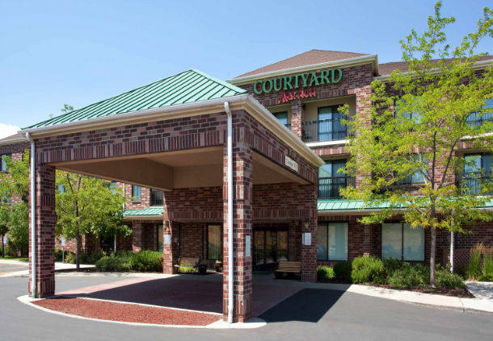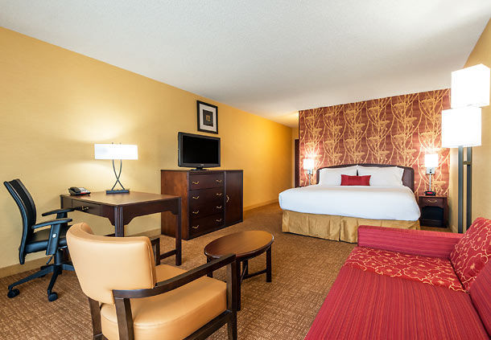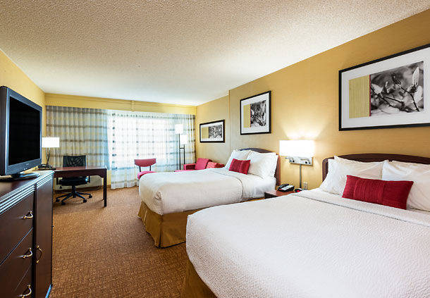
- Single Room with Breakfast $ 99.00 + 12.9% tax USD
- Double/Twin Room with Breakfast $ 99.00 + 12.9% tax USD Per Person
- Book direct with hotel using link here:
Book your group rate for USA Archery 2018 PARA World Ranking Event

Room rate: $99.00 plus 12.92% occupancy tax per person per day Includes buffet breakfast & Wi-Fi
Room Options:
Standard King
Standard Double Queen
ADA SUITE King wheelchair accessible with roll-in-shower
ADA Single King wheelchair accessible with tub and shower chair
ADA Double King wheelchair accessible with transfer shower

- Residence Inn by Marriott Salt Lake City Airport (3 Star)
4883 W. Douglas Corrigan Way, SLC*UT. 84116

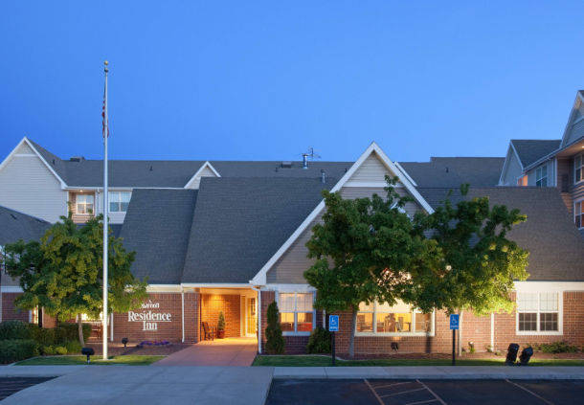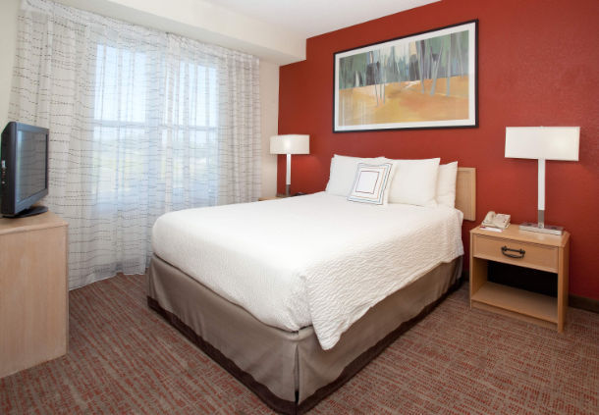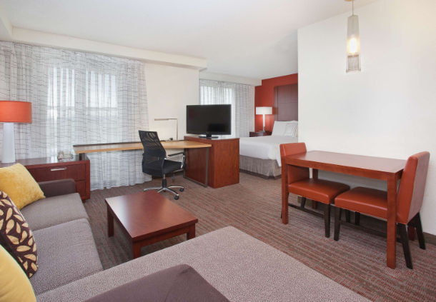
- Single Room with Breakfast $99.00 + 12.9% tax USD
- Double/Twin Room with Breakfast $99.00 + 12.9% tax USD Per Person
- Book direct with hotel using link here:
http://www.marriott.com/hotels/travel/slcra-residence-inn-salt-lake-city-airport/

$99.00 room rate with 12.92% occupancy tax per person per day that includes buffet breakfast & Wi-Fi
Room Options:
One Bedroom Suites – one queen with sofa bed
Studio Suites – one queen with sofa bed
ADA STUDIO SUITE queen bed wheelchair accessible with a tub and shower
chair
ADA Single Queen wheelchair accessible with roll-in-shower
ADA Double Room Suite wheelchair accessible with tub and shower chair

- Holiday Inn & Suites Salt Lake City Airport West
5001 Wiley Post Way*Salt Lake City*UT. 84116
- Single Room with Breakfast $115.00 + 12.9% tax USD
- Double/Twin Room with Breakfast $125.00 + 12.9% tax USD Per Person
- Book direct with hotel at: +1-801-741-1800
- Hotel web site: https://www.ihg.com/holidayinn/hotels/us/en/salt-lake-city/slcff/hoteldetail

Room Options:
Standard King
ADA King SUITE wheelchair accessible with tub
ADA Single King wheelchair accessible with tub
ADA Double Room wheelchair accessible with roll-in shower

- Fairfield Inn & Suites by Marriott Salt lake City Airport (3 Star)
230 N. Admiral Byrd Road*Salt Lake City*UT. 84116

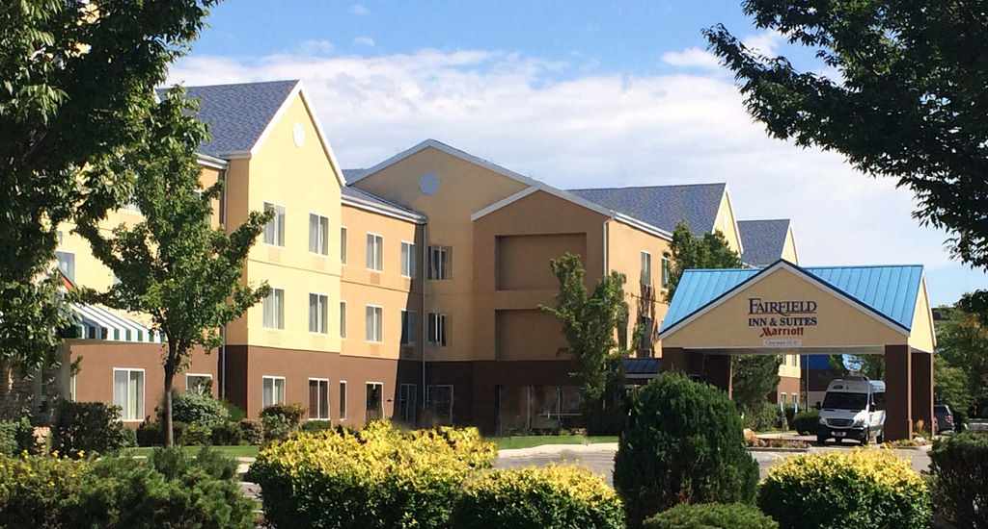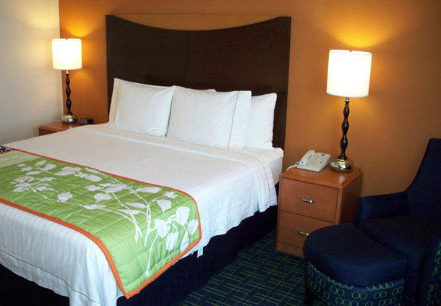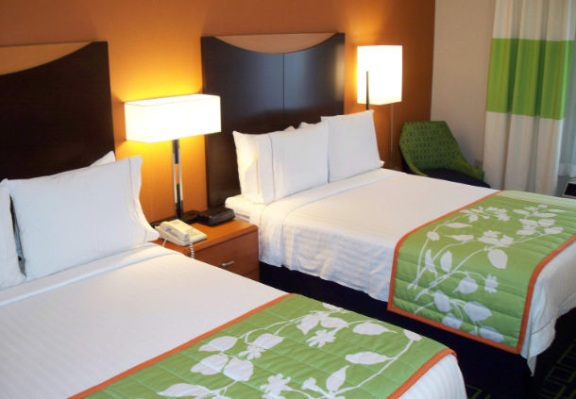
- Single Room with Breakfast $115.00 + 12.9% taxx USD
- Double/Twin Room with Breakfast $115.00 + 12.9% tax USD Per Person
- Book direct with hotel at: +1-801-355-3331
- Hotel web site: https://www.marriott.com/hotels/travel/slcfa-fairfield-inn-and-suites-salt-lake-city-airport/

$115.00 room rate with 12.92% occupancy tax per person per day that includes breakfast
Room Options:
Standard King
Standard Double Queen
ADA Single King wheelchair accessible with roll-in shower
ADA Single King wheelchair accessible with tub

- Doubletree by Hilton Salt Lake City Airport HOST HOTEL (3.5 Star)
5151 W Wiley Post Way*Salt Lake City*UT. 84116

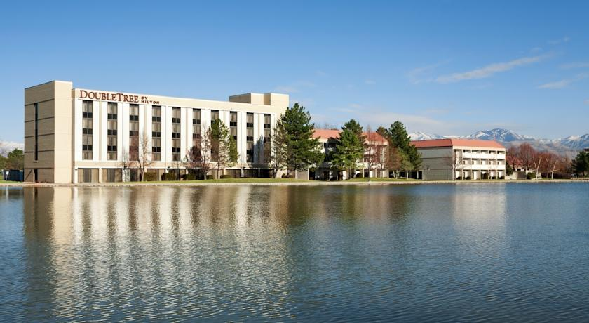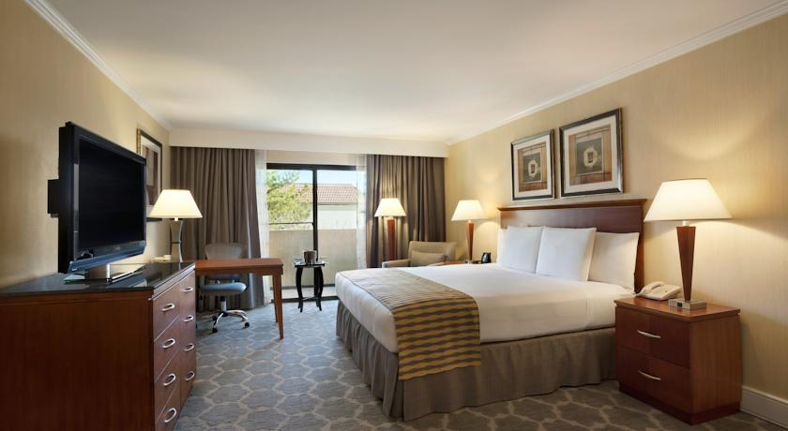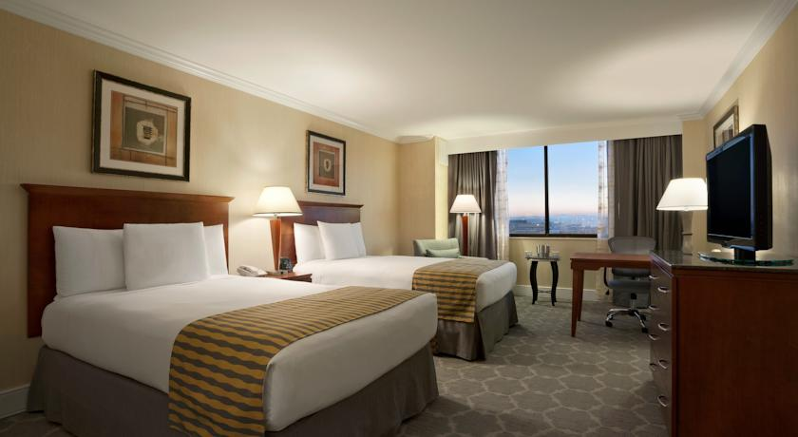
- Single Room with Breakfast $ 119.00 USD + 12.6% tax
- Double/Twin Room with 2 Breakfast $ 119.00 USD Per Person +
tax
- Rate expires on: 16 August 2018
- Book direct with hotel using link below:
http://doubletree.hilton.com/en/dt/groups/personalized/S/SLCARDT-EPW-20180905/index.jhtml?WT.mc_id=POG

$119.00 room rate with 12.92% occupancy tax per person per day that includes breakfast
Room Options:
Standard King
Standard Double Queen
ADA Single King wheelchair accessible with roll-in shower
ADA Single King wheelchair accessible with tub & shower chair
ADA Double wheelchair accessible with tub and shower chair

- Hilton Garden Inn Salt Lake City Airport (3.5 Star)
- W Wiley Post Way*Salt Lake City*UT. 84116

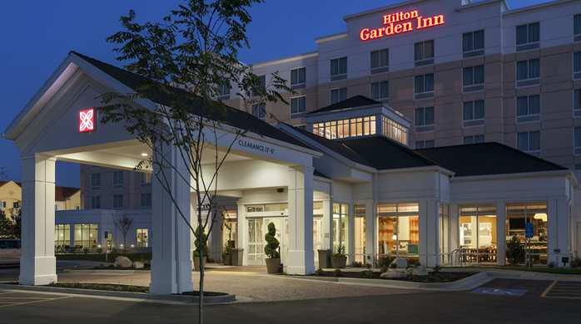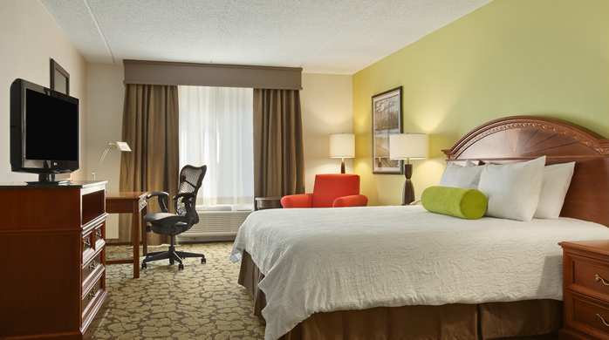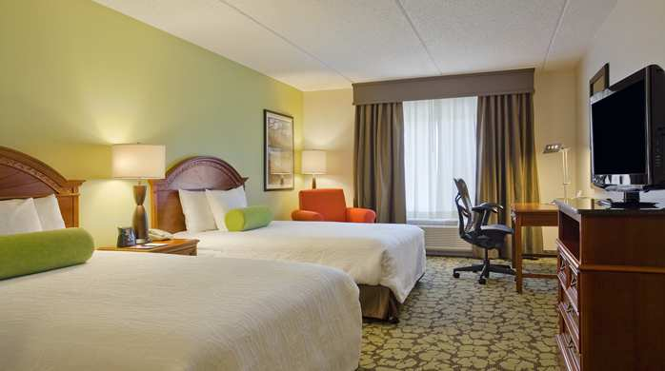
- Single Room with Breakfast $ 119.00 + 12.9% tax USD
- Double/Twin Room with Breakfast $ 119.00 + 12.9% tax USD Per Person
- Rate expires on 4 August 2018
- Book direct with using link here:
http://hiltongardeninn.hilton.com/en/gi/groups/personalized/S/SLCAPGI-PARA18-20180905/index.jhtml?WT.mc_id=POG

$119.00 room rate with 12.92% occupancy tax per person per day that includes breakfast
Room Options:
Standard King
Standard Double Queen
ADA Single King wheelchair accessible with roll-in shower
ADA Double wheelchair accessible with tub and shower chair

All accommodation requests received outside of the OC negotiated hotel deadline dates are subject to current advertised hotel rates.

*Individuals booking rooms under the 2018 PARA World Ranking Event – USA group rate agree that if they cancel less than 48 hours prior to arrival, they will be charged by the Hotel one night’s room rate plus applicable taxes per individual reservation, as a reasonable estimate the cancellation will cause the Hotel. Hotel agrees that after receiving this payment, it will not seek additional damages.

Transportation, Lunch and Dinner Pricing

Airport arrival / departure, catered lunch, catered dinner or local transportation is not included in and can be purchased separately per person per day.

Print out the table below to help calculate total costs.

Cost Calculation Table
Entry Fees | Fee | Quantity |  |  | Total Cost
Entry Fee - Athlete | $175.00 USD
Entry Fed - Official | $100.00 USD
Total Entry Fees
Transportation Fees | Fee | # of people | # of days |  | Total Cost
Airport Arrival and Departure per person | $30.00 USD
Local Transportation per person per day | $10.00 USD
Total Transportation Fees
Lunch and Dinner Fees | Fee | # of people | # of days |  | Total Cost
Lunch per person per day | $20.00 USD
Dinner per person per day | $25.00 USD
Total Lunch and Dinner Fees
Practice Field Fees (Athletes Only) | Fee | Quantity |  |  | Total Cost
Practice field fees September 5 only | 15.00 USD
Total Practice Field Fees
Total Cost
50% Deposit Due - 7 JULY 2018
Final Payment Due - 17 AUGUST 2018

ENTRY FEE

Entry fee:

Individual: 175 USD per athlete
Officials: 100 USD per person
Temporary Upgrade: 30 CHF per accreditation for athletes wishing to
be a coach temporarily.

There is no entry fee for teams.

PAYMENT CONDITIONS:

The entry fees should be paid in full upon arrival.

Payment of accommodation, a minimum deposit of 50% should be made when booking directly with hotel. Accommodation cannot be guaranteed after 1 AUGUST 2018 and at current advertised hotel rate may be applied.

BANK INFORMATION for ENTRY FEES, TRANSPORTATION and MEALS:

BANK: CHASE

BRANCH: UPTOWN
ADDRESS: 402 N. Tejon Street
Colorado Springs, CO 80903
BANK ACCOUNT HOLDER NAME: National Archery Assoc. of the U.S. DBA USA Archery
ABA ROUNTING NUMBER: 102001017
ACCOUNT NO: 80125360
SWIFT CODE: Chasus 33

NOTE:
_ ALL PAYMENTS SHALL BE MADE IN USD
_ By BANK TRANSFER or by CASH upon arrival
_ All bank charges will be paid by the participants
_ CREDIT CARDS or TRAVEL CHECKS will not be accepted

To avoid delays in wire transfers please submit a PRO FORMA invoice to your bank with wire transfer request.

ADDITIONAL INFORMATION

Transportation
Transportation can be purchased to and from the Salt Lake City International airport to the official hotels, two days before the official practice day and one day after the closing day. Daily local transport can be purchased between official hotels and practice and competition venues. Transport timetables will be confirmed. Buses and/or vans will be provided.

Teams may find renting their own cars both cost effective and convenient. Rental car rental companies require international driver’s license and proof of insurance.

Cancellations & Changes

All cancellations and changes must be made through WAREOS:
- Cancellations received before 1 August 2018 a full refund of the deposit payment will be made.
- Cancellations received after 2 August 2018, no refund will be given.
- Refunds will be processed after the event.
- Name changes to team officials or athletes (same category and division) will be accepted up to 72 hours before the event without any additional charge.
- Should flight arrival details change last minute, please contact the Organising Committee using the details indicated in the Team Managers’ Booklet.
- If a participant’s arrival is later than the original scheduled arrival date, the room will be charged from the date of the original booking in WAREOS.
- An email will automatically notify the Organising Committee and Member Association of any changes made in WAREOS.

Training
A training field will be available starting from 5 September 2018. The training field is next to the competition field and is about 2.4 km from the hotels.

Weather
According to weather information, the average temperature in September is expected to be 55.8 to 82.2°F / 13.2 to 27.8 °C.

Internet

Will be available in the official hotels for free (in hotel rooms and in the lobby).

Water

Bottled water will be available at the qualification and practice venues.

IMPORTANT INFORMATION REGARDING U.S. VISAs
Application for and obtaining travel visas to the United States are completely and solely the responsibility of the participating teams. A visa will be required of all visitors to enter the United States with the exception of citizens from 38 countries who are eligible for visa-free entry into the United Sates under the “Visa Waiver Programme”. The process for obtaining a visa requires each individual to submit and pay application fees through a U.S. Embassy or U.S. Consulate. This is a process that MUST be done by the applicant – the organizing committee cannot do it for you!

The information contained in this document was current at the time of distribution. For updated information regarding visa requirements when traveling to the United States of America, please refer to following websites:

ESTA – The Official U.S. Government Website: https://esta.cbp.dhs.gov/

U.S. Dept. of State: http://travel.state.gov/visa/temp/temp_1305.html

VISA WAIVER PROGRAMME COUNTRIES

Andorra | France | Liechtenstein | San Marino
Australia | Germany | Lithuania | Singapore
Austria | Greece | Luxembourg | Slovakia
Belgium | Hungary | Malta | Slovenia
Brunei | Iceland | Monaco | South Korea
Chile | Ireland | The Netherlands | Spain
Czech Republic | Italy | New Zealand | Sweden
Denmark | Japan | Norway | Switzerland
Estonia  Finland | Latvia | Portugal | Taiwan  United Kingdom

NOTE: IF YOUR COUNTRY IS LISTED AS A “VISA WAIVER PROGRAMME” COUNTRY, YOU ARE REQUIRED TO COMPLETE THE ON-LINE ESTA APPLICATION AT https://esta.cbp.dhs.gov/. IT IS IMPORTANT TO REVIEW THE ELIGIBILITY AND PASSPORT REQUIREMENTS TO ENSURE YOU MEET ALL THE CRITERIA BEFORE MAKING YOUR TRAVEL ARRANGEMENTS.

Most categories of visas may be issued to an applicant up to 60 days before its effective date. HOWEVER, it cannot be emphasized enough that the letter of invitation and application process should start as early as possible. Participants from countries subject to additional clearances should be especially conscientious about applying early, since the State Department will not guarantee that ANY cases will be expedited.

Letter of Invitation – For those countries not listed above on the VISA waiver programme, the OC will issue you a Letter of Invitation to use in your application process. AS SOON AS POSSIBLE please complete all the necessary sections fully in WAREOS for the Organising Committee to create the visa letter.

How long should you expect the process to take? There is no standard timeframe for how long it takes to get an appointment for a visa interview and it can vary dramatically from as much as 6 months to just a few days depending on the country. It cannot be emphasized enough to start the application process early.

PLEASE KEEP IN MIND – We cannot guarantee you will receive a VISA and we cannot provide special clearances if you are denied or apply too late. Also note that the application and interview process in your country may very well be in advance of the team selection date required by FITA, so in many cases, you will need to start the application process prior to confirming your final team.

Visa
All participants who need an entry visa to the United States of America, will be required to complete the Visa Support Form in WAREOS by no later than 15 JULY 2018.

It is the applicants’ responsibility for supplying the necessary information, ensuring all details are up to date, correct and submitted by the deadlines specified.

In addition, all participants that require a visa are kindly requested to supply a copy of their latest/valid passport. Copies of each applicate can be uploaded on WAREOS. All passport copies and personal details entered/uploaded to WAREOS will be held securely and in the strictest of confidence and not shared with other parties.

Any questions please email: Sheri Rhodes at srhodes@usarchery.org.

Salt Lake City, the city

Population (Source: US Census Bureau, 2015 Population Estimates)
Salt Lake City: 191,180
Salt Lake County: 1,091,742
Wasatch Front: 2,192,225
State of Utah: 2,995,919

Elevation

City: 4,330 feet 1,320 meters
Nearby mountains:
Snowbird base: 8,100 feet 2,469 meters
Hidden Peak: 11,000 feet 3,353 meters

Geography
Salt Lake lies in a mountain valley with the Wasatch Mountains to the east and north. The Oquirrh (pronounced "oaker") Mountains border the western edge of the valley. Salt Lake's official elevation is 4,330 feet/1,320 meters above sea level. The city is situated on land once covered by the prehistoric Lake Bonneville. This ancient lake existed within portions of Utah, Nevada, and Idaho, with an elevation rising from 4,200 feet to 5,200 feet (1,280 meters to 1,585 meters) at some points. The eastern and northern portions of the city are located on a series of terraces, or former beaches, which are known locally as "the benches."

Public Transportation
Utah Transit Authority (UTA) provides over 100 bus routes throughout an 1,800 square-mile area. UTA also provides light-rail service, airport transportation, service to ski resorts in winter, and door-to-door transportation for disabled passengers. A free fare zone is available downtown.

Local Salt Lake City Tours will be available to purchase:

US BUS Utah:

US Bus Utah provides a hop on, hop off bus touring system. The sightseeing tour of SLC will take you to many famous landmarks such as:. Temple Square, the State Capitol, a state-of-the art library and University of Utah.

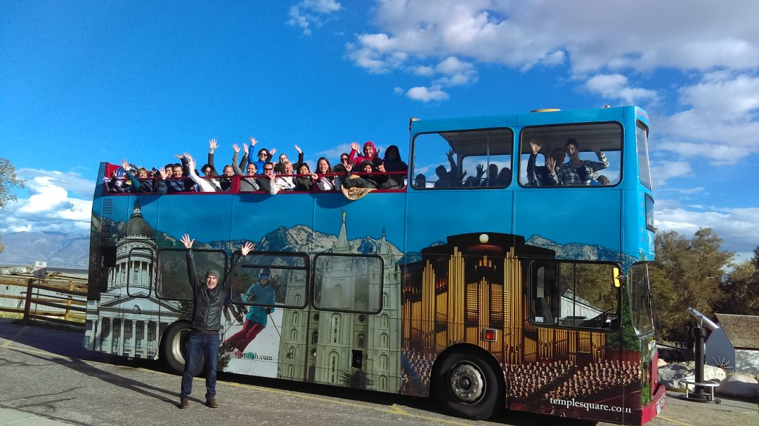 City Creek Center:
City Creek Center is a world-class fashion and dining destination offering 110 retailers and restaurants, including Nordstrom, Macy's, Salomon, APEX by Sunglass Hut, Brooks Brothers, Athleta, Michael Kors, Coach, Brio Tuscan Grille and more. This unique shopping environment also features a retractable glass roof, a creek that runs through the property, a pedestrian sky bridge, three fountains and more. Located just 10 minutes from Salt Lake International Airport, City Creek Center is a must-see during your Utah vacation.

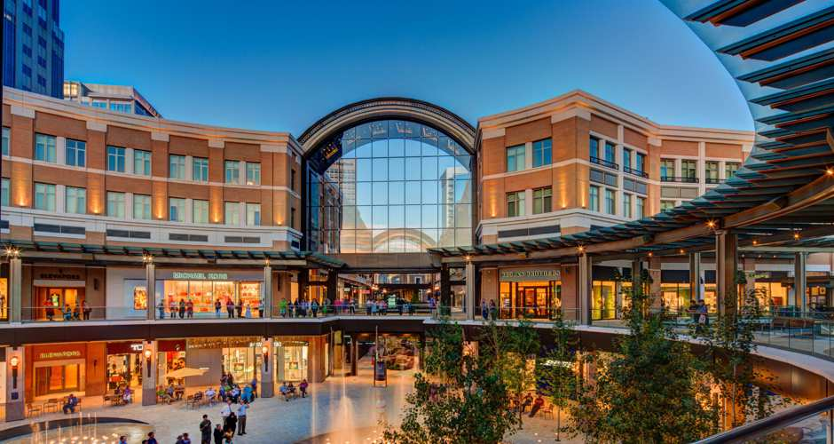

Utah Olympic Legacy Park
The Utah Olympic Park is a winter sports park built for the 2002 Winter Olympics, and is located 28 miles (45 km) east of Salt Lake City near Park City, Utah, United States. During the 2002 games the park hosted the bobsleigh, skeleton, luge, ski jumping, and Nordic combined events.^{[1]} It still serves a training center for Olympic and development level athletes. Other facilities in addition to the ski jumps and bobsled track located on site include a 2002 Winter Olympics and Ski Museum, day lodge, summer aerial training splash pool, ziplines, and a mountain coaster.
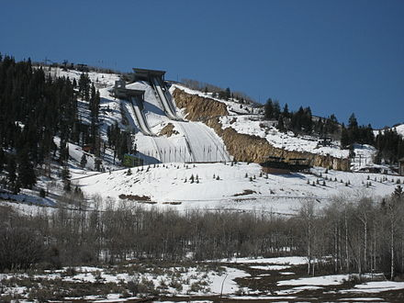.
Tanger Outlets Park City:
Tanger Outlet Center has over 65 brand name outlet stores including Nike, Polo, Tommy Hilfiger, Fossil, Michael Kors, Under Armour, Brooks Brothers, and JCrew

