3rd ISSF International Solidarity World Ranking Archery Championships-2019, Dhaka
22nd to 27th February, 2019
Event Holder: Islamic Solidarity Sports Federation (ISSF)
Organized by: Bangladesh Archery Federation (BAF)

Revised Invitation Package

Date: December 29, 2018

Dear President/Secretary General
All ISSF Member National Olympic Committee (NOC)
All World Archery Members Associations/Federations

Bangladesh Archery Federation (BAF) is honored to be entrusted by the Islamic Solidarity Sports Federation (ISSF) to organize the 3rd ISSF International Solidarity World Ranking Archery Championships-2019 from 22nd to 27th February, 2019 at Dhaka, Bangladesh. It is our pleasure to invite your Archery Teams to participate in the championships. The event will include both Men and Women Division in Recurve and Compound Bow. Competition will be held on Individual, Team and Mix-Team basis. It will be organized following the World Archery (WA) Rules of 2012.

Please find the enclosed documents of registration and accommodation for your team in this event. Grateful if you could return the listed documents within deadlines given below.

- Preliminary Entry (by WAREOS) [Extended time] 10th December, 2018
- Final Entry (by WAREOS) [Extended time] 30th January, 2019
- Visa Support Form with Passport and Photograph 15th January, 2019
- Arrival, Departure (Flight schedule) & Hotel Booking Form 15th January, 2019
- Team Arrival in Dhaka 22nd February, 2019
- Team Departure from Dhaka 27th February, 2019

Yours Sincerely,
Kazi Rajib Uddin Ahmed Chapol
Secretary General, Organizing Committee &
General Secretary, Bangladesh Archery Federation
Executive Board Member, Islamic Solidarity Sports Federation
1st Vice President, World Archery Asia
Consultant, World Archery
Treasurer, NOC Bangladesh
E-mail: isacbangladesh@gmail.com, barchery@gmail.com
Mobile: +8801711409252, +8801977409252

3rd ISSF International Solidarity World Ranking Archery Championships-2019, Dhaka
22nd to 27th February, 2019
Event Holder: Islamic Solidarity Sports Federation (ISSF)
Organized by: Bangladesh Archery Federation (BAF)

Detail Information about Championship

- Venue: Shahid Ahsan Ullah Master Stadium, Tongi, Gazipur, Dhaka, Bangladesh.

- Preliminary Program. This preliminary program could be changed slightly according to number of participants. All changes will be published and distributed to all participants in respectable time.

Date & Day | Description
22nd February, 2019 (Friday) | Arrival of Participants
23rd February, 2019 (Saturday) | Opening Ceremony, Official Practice, Team Managers’ Meeting & Equipment Inspection
24th February, 2019 (Sunday) | Qualification Round
25th February, 2019 (Monday) | Recurve & Compound Individual Mixed Team Eliminations
26th February, 2019 (Tuesday) | Recurve & Compound Individual Mixed Team and Team Finals
27th February, 2019 (Wednesday) | Departure of Teams

- Round. Olympic round over 3 consecutive days.

- Rules. World Archery outdoor target archery rules will apply.

- Transportation. You will be welcomed at the Terminal-2 exit gate of the Hazrat Shahjalal International Airport next to Dhaka Regency Hotel & Resort Ltd, Dhaka. Transportation will be available for moving to respective hotel and hotel to venue (only in the morning and end of the game).

- Accommodation. We expect all participants of the championships to arrive at Dhaka on 22nd February, 2019. Hotel facilities will be ready from Mid-Day of 22nd February, 2019 and will terminate in Mid-Day of 27th February, 2019. All participants are requested to stay in the official hotel for logistic purpose. Ideal time for check in & check out should strictly be maintained [Check in time after 12:00pm & check out time before 12:00pm (sharp)]. Any early check-in or delayed check-out will be charge by hotel and individual/team manager need to settle payment with hotel authority. There is no triple accommodation facility. In case of any third person in same gender, would be shifted in a room with any archer of another country.

Any team/Archer want to stay in any other hotel than official, payment and transportation to game venue to be done under arrangement of respective country.

Dhaka Regency Hotel & Resort Ltd.
Airport Road, Nikunja 2
Dhaka 1229, Bangladesh.

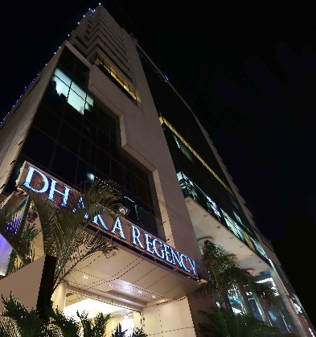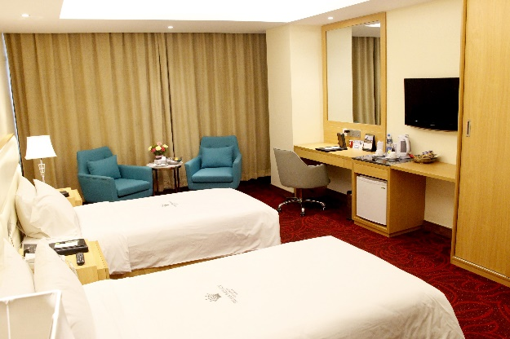
Twin Bed
Dhaka Regency

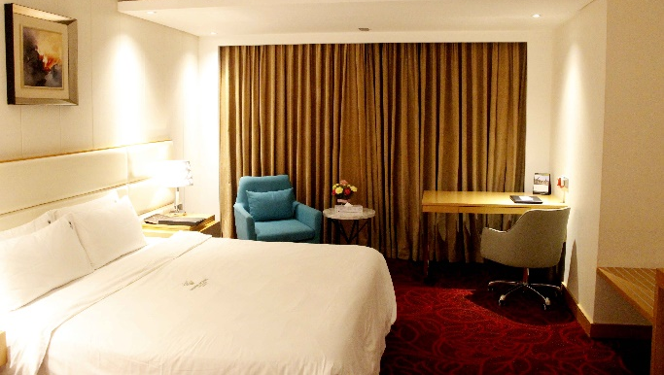
Single Bed
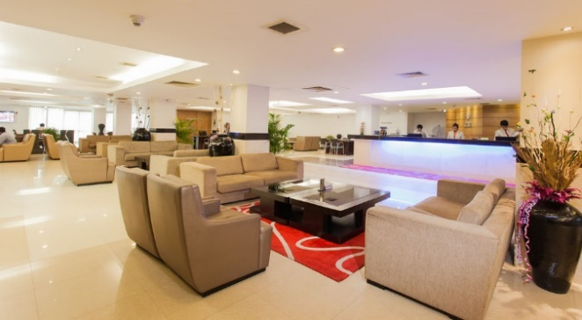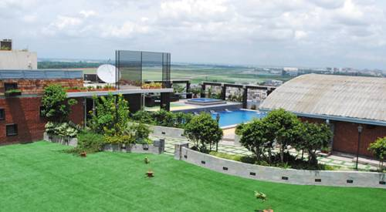
Hotel Lobby
Roof Top Restaurant & Swimming Pool
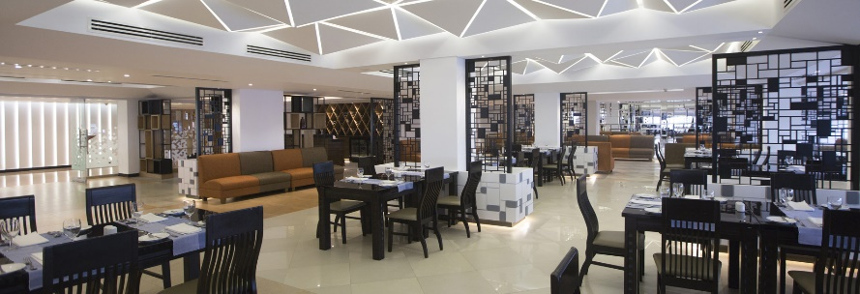
Restaurant

Details of room rents are as follows:
- Single room rate is US$140 per person/day (single occupancy)
- Twin beds room rate is US$120 per person/day (Maximum two occupancy)

All rates are for per person only and including breakfast, lunch, dinner and local transportation. Lunch from 23rd to 26th February, 2019 (4 Lunches) will be served in game field. Any one taking lunch in the hotel restaurant on above dates will be charged separately by the hotel authority from boarder.

- Payment. Remaining dues payment for hotels will be received at the venue on 23rd February, 2019. All transaction to be in cash US Dollar only.

- Preliminary & Final Registration with WAREOS.
Entries must be processed using World Archery Online Registration System (WAREOS): https://extranet.worldarchery.org/.
Member Associations who are not convenient to register online please directly contact to Local Organizing Committee by email: isacbangladesh@gmail.com or over mobile phone at +8801711409252/+8801977409252. Maximum number of 4 athletes per country (host country included) are allowed to be registered into each category of the event.

- In order to use WAREOS, please login on http://extranet.worldarchery.org with your Username and Password assigned by World Archery. After entering the WAREOS, please go to "Online Registration" and register your archers for this event.

- For any questions regarding the WAREOS, please contact Mr. Jae Kyung Lee Email: jklee@archery.org and copy to us at isacbangladesh@gmail.com. We earnestly look forward to the active support of our member associations to participate in this championships and we are awaiting your confirmation soon.

- Visa.
Entry: The countries where have Bangladesh Embassy/Visa Consulate must have to bring their entry visas from the respective authorities.

On-arrival: It is noteworthy that, the countries where there is no Visa Consulate of Bangladesh Government, we will afford them visa on-arrival on condition that they will provide the participants details of passport, photograph and other necessary document at least 30 days before the championships.

All participants are requested to fillup the Visa Suport Form and send it to the Organizating Committee in Microsoft Word (doc) file as soon as possible before deadline to isacbangladesh@gmail.com along with passport copy and photograph.

Please mind the deadlines:

- Preliminary Entry (by WAREOS) [Extended time] 10th December, 2018
- Final Entry (by WAREOS) [Extended time] 30th January, 2019
- Visa Support Form with Passport and Photograph 15th January, 2019
- Arrival, Departure (Flight schedule) & Hotel Booking Form 15th January, 2019

--------∗∗∗ ---------

3rd ISSF International Solidarity World Ranking Archery Championships-2019, Dhaka
22nd to 27th February, 2019
Event Holder: Islamic Solidarity Sports Federation (ISSF)
Organized by: Bangladesh Archery Federation (BAF)

Visa Support Form

Submission Deadline: 30th December 2018

Entry: The countries where have Bangladesh Embassy/Visa Consulate must have to bring their entry visas from the respective authorities.

On-arrival: It is noteworthy that, the countries where there is no Visa Consulate of Bangladesh Government, we will afford them visa on-arrival on condition that they will provide the participants details of passport, photograph and other necessary document at least 30 days before the championships.

All participants are requested to fillup the Visa Suport Form and send it to the Organizating Committee in Microsoft Word (doc) file as soon as possible before deadline to isacbangladesh@gmail.com along with passport copy and photograph.

Hoping your cordial cooperation to submit Visa Support Form in time.

Please Fillup the Format in Your Association Letter Pad

No | Family Name | Given Name | Nationality | Title (Archer/Coach/Official) | Passport No | Date of Expiry | Visa Pick up Place

Date: Signature with Seal: ________

3rd ISSF International Solidarity World Ranking Archery Championships-2019, Dhaka
22nd to 27th February, 2019
Event Holder: Islamic Solidarity Sports Federation (ISSF)
Organized by: Bangladesh Archery Federation (BAF)

Final Arrival and Departure Form
(Final Arrival and Departure Form is unchangeable and non-cancellable)

Submission Deadline: 15th January 2019

- Name of Country/Team: ________
- Name of Association:
- Contact Person: ________
- E-mail: 6. Mobile/Telephone: ________
- Arrival Information
Description | 1st Group | 2nd Group (If any)
Date
Time
Carrier and Flight No
Number of Persons

- Departure Information
Description | 1st Group | 2nd Group (If any)
Date
Time
Carrier and Flight No
Number of Persons

We expect all participants of the championships to arrive at Dhaka either on 22nd February, 2019. Hotel facilities will be ready from Mid-day of 22nd February, 2019 and will terminate in the Mid-Day of 27th February 2019. Ideal time for check in & check out should strictly be maintained [Check in time after 12:00pm & check out time before 12:00pm (sharp)]. Any early check-in or delayed check-out will be charge by hotel and individual/team manager need to settle payment with hotel authority.

Date: Signature with Seal: ________

3rd ISSF International Solidarity World Ranking Archery Championships-2019, Dhaka
22nd to 27th February, 2019
Event Holder: Islamic Solidarity Sports Federation (ISSF)
Organized by: Bangladesh Archery Federation (BAF)

Payment Form

Submission Deadline: 15th January 2019

- Name of Country/Team: ________
- Name of Association:
- Contact Person: ________
- E-mail: 5. Mobile/Telephone: ________
- Accomodation Fee (Fee calculated in US Dollar only)
Cost (Per Person Per Night) | Number |  | Total in US Dollar
 | Night | Person
Single bed Room US$140 |  |  | US$
Double beds Room US$120 |  |  | US$
Grand Total |  |  | US$

- Please sent the payment slip to the following bank account
Account Name | Bangladesh Archery Federation
Bank | Prime Bank Limited
Branch | Islamic Banking Branch
Bank Fax | +88 02 956228
Bank Account No. | 10831020031555
Swift Code | PRBLBDDH005

Please send this payment form with copy of the bank transfer on or before 15th January 2019 by e-mail to isacbangladesh@gmail.com.

Attention:
- Balance payment to be paid in US Dollars upon arrival.
- Bank transfer fees are the responsibility of the sender.
- No Credit Cards, Travellers Cheques and Foreign Currencies will be accepted.

Date: Signature with Seal: _______

