Brazil Cup World Ranking Event Maricá – South American Championship
October 01-06, 2019 - Maricá, Rio de Janeiro (Brasil)

To all World Archery Member Associations

Dear Mr./Mrs President,

In the name of Brazilian Archery Confederation and as Chairman of the Local Organizing Committee of the event, I would like to invite your archers and officials to be part of the Brazil Cup World Ranking Event Maricá – South American Championship.

Maricá is a city in the Rio de Janeiro, commonly associated with beautiful beaches, very welcoming people and it’s a stop point destination for those who enjoy exploring the nature and be surrounded by it. Beside that, the city is 40km away from the city of Rio de Janeiro which is the capital of the state and is able to offer any kind of service, with that, it can also please those who likes a more urban tourism.

The event it’s been done in association with the local prefecture and we are both willing to give you all an excellent competition and an awesome stay.

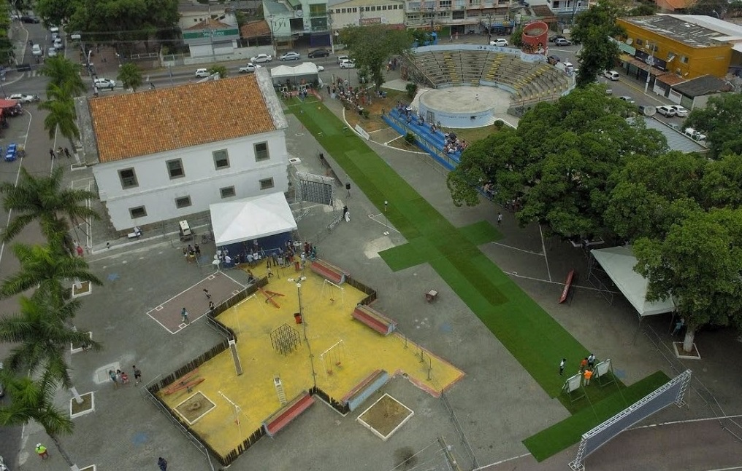
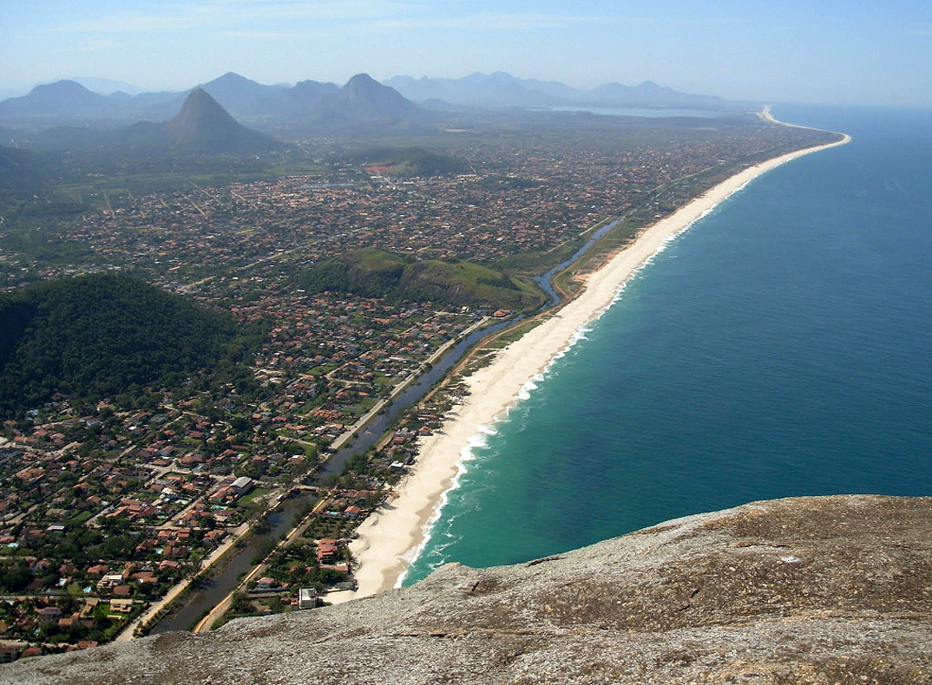

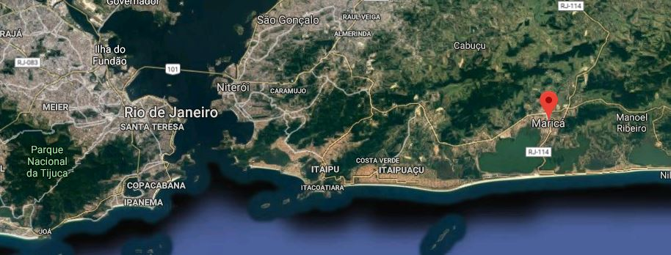

Eros Fauni
National Technical Coordinator
LOC Chairman

IMPORTANT DATES

WAREOS registration opening date (http://register.worldarchery.org/) | ……………………….. February 20
Preliminary registration deadline | ……………………….. July 3
Final registration deadline | ……………………….. September 10
Preliminary Hotel Reservation | ……………………….. August 6
Final Hotel Booking | ……………………….. August 30
Hotel payment deadline | ……………………….. August 30
Entry Fee payment deadline | ……………………….. August 30
Transportation form submission deadline | ……………………….. September 10

Preliminary SCHEDULE

30 Sep 2019, Monday
 |  | Official Practice + Equipment Inspection + Team Captains Meeting
08:30-11:30 | 03:00 | Official Practice + Equipment Inspection: CM and RW
11:30-13:00 | 01:30 | Lunch break
13:00-16:00 | 03:00 | Official Practice + Equipment Inspection: CW e RM
16:15-17:45 | 01:30 | Team Captains Meeting
1 Oct 2019, Tuesday
Qualification Rounds
Qualification Round - Compound Men and Recurve Women
08:30-12:00 | 03:30 | Qualification Round - Compound Men and Recurve Women
12:10-12:15 | 00:05 | Shoot Off, if necessary (Individual and Team)
12:15-13:30 | 01:15 | Lunch break  Qualification Round - Compound Women and Recurve Men
13:30-17:00 | 03:30 | Qualification Round - Compound Women and Recurve Men
17:10-17:15 | 00:05 | Shoot Off, if necessary (Individual and Team)
2 Oct 2019, Wednesday
 |  | Recurve Individual Elimination Round - Brazil Cup WRE
08:30-12:20 | 03:50 | Recurve Individual Elimination Round - Brazil Cup WRE - until semi-finals
12:20-13:30 | 01:10 | Lunch break  Compound Individual Elimination Round - Brazil Cup WRE
13:30-17:20 | 03:50 | Compound Individual Elimination Round - Brazil Cup WRE - until semi-finals
3 Oct 2019, Thursday
 |  | Compound Team Elimination Round - Brazil Cup WRE
08:00-10:00 | 02:00 | Compound Team Elimination Round - Brazil Cup WRE  Recurve Team Elimination Round - Brazil Cup WRE
10:15-12:15 | 02:00 | Recurve Team Elimination Round - Brazil Cup WRE
12:15-13:30 | 01:15 | Lunch break  Team Round - South American Championship
13:30-16:30 | 03:00 | Team Round - South American Championship
4 Oct 2019, Friday

Mixed Team Elimination Round - Brazil Cup WRE
08:00-11:00 | 03:00 Mixed Team Elimination Round - Brazil Cup WRE  Mixed Team Round - South American Championship
11:00-13:00 | 02:00 Mixed Team Round - South American Championship
13:00-14:30 | 01:30 Lunch break  Individual Elimination Round - South American Championship
14:30-17:30 | 03:00 Individual Elimination Round - South American Championship

5 Oct 2019, Saturday
 |  | South American Championship Individual Gold Medals
09:15 |  | Practice Field Opening for South American Individual Gold Medals
10:15-10:49 | 00:34 | CW and CM Gold Medal Matches
10:54-11:14 | 00:20 | Compound Award Ceremonies
11:14-11:48 | 00:34 | RW and RM Gold Medal Matches
11:53-12:13 | 00:20 | Recurve Award Ceremonies  Brazil Cup WRE - Team Bronze and Gold Medals
12:30 |  | Practice Field Opening for Brazil Cup Teams
13:30-15:10 | 01:40 | Compound Team Women and Men Matches
15:15-15:35 | 00:20 | Compound Team Award Ceremonies
15:35-17:15 | 01:40 | Recurve Team Women and Men Medal Matches
17:20-17:40 | 00:20 | Compound Team Award Ceremonies
6 Oct 2019, Sunday
Brazil Cup WRE - Compound Mixed Team and Individual Medal Matches
09:00 | Practice Field Opening for Compound
10:00-10:40 | 00:40 CX Bronze and Gold Medal Matches
10:40-11:48 | 01:08 CW and CM Bronze and Gold Individual Medal Matches
11:50-12:20 | 00:30 Compound Award Ceremonies - CX, CW and CM
12:20-14:00 | 01:40 Lunch break  Brazil Cup WRE - Recurve Mixed Team and Individual Medal Matches
13:00 | Practice Field Opening for Recurve
14:00-14:40 | 00:40 RX Bronze and Gold Medal Matches
14:40-15:48 | 01:08 RW and RM Bronze and Gold Individual Medal Matches
15:50-16:20 | 00:30 Recurve Award Ceremonies - RX, RW and RM

NOTE
This Schedule is subject to change depending on the number of final entries in each category. Changes will be timely announced.

PRELIMINARY & FINAL REGISTRATION

All registrations (both preliminary and final) must be made using the World Archery Registration Online System (WAREOS) http://register.worldarchery.org. There will not be registration forms to send to the Organizers.

There is no limit in the number of archers a country can register in each category.

For the team events, a maximum of 4 archers in each category must be announced prior to the Team Managers’ Meeting, if a country is registering more than 4 for the individual events.

To use WAREOS, each MA Extranet Admin user or a multiple user who has specific privileges assigned within your member association need to log-in into the Extranet http://extranet.worldarchery.org. Click on Online Registration and register your athletes for this event.”

For the Brazil Cup World Ranking Event Maricá – South American Championship, WAREOS will open on:
February 20
- Preliminary registration closes on:
July 3, 2019
- Final registration closes on:
September 10, 2019

Pay close attention to the deadlines above. For changes after the deadlines, you will need to contact the WA Service Coordinator.

A 50.00 USD late preliminary registration penalty will be charged for each registration made after the deadline. A 150.00 USD penalty will be applied for each final registration made after the deadline.

REGISTRATION FEES

Individual: $ 150 USD per athlete
Official: $ 50 USD per person

Teams not using accommodation arranged by the Organizing Committee will not have access to the transportation services arranged by the LOC.

- Arrival dates: September 28 and 29, 2019;
- Departure date: October 06 and 07, 2019;

Payment: The whole amounts (registration fee + accommodation) must be fully paid by September 6, 2019.

GENERAL INFORMATION

LOC Contact: Eros Fauni
Email: ctmarica@gmail.com
Languages: Spanish, English and Portuguese

Competitions, South American Championships and World Ranking Event

The Brazil Cup World Ranking Event is open to all World Archery Member Associations regardless of their geographical location. The South American Championships will have its own separate match play rounds in the individual and team events.

- Categories

Categories | Bow | Gender | Qualification Round
Adult | Recurve | Men and Women | 72 arrows at 70 m
 | Compound |  | 72 arrows at 50 m

- Awards
Both events, in each category, medals will be presented to the top three places in Individuals, Teams* and Mixed Team.
*The team that ends the competition at first place will also get a trophy

Accommodations
- Pousada Vila Flor
Single Room: 100 USD
Double Room: 140 USD
Included: Breakfast
Address: R. João dos Santos Mendes, 217 - Flamengo, Maricá – RJ, Cep.: 24.903-475 (15 minutes from the Competition Field)
Telephone: +55 21 9 9849-9933

- Pousada Luau de Maricá
Single Room: 100 USD
Double Room: 140 USD
Included: Breakfast
Address: Rua Flamboyant , Lote 22A - Condado de Maricá, Maricá – RJ, Cep.: 24905-250 (15 minutes from the Competition Field)
Telephone: +55 21 26377420

- Pousada Colinas de Maricá
Single Room: 100 USD
Double Room: 140 USD
Included: Breakfast
Address: R. Bela Vista, 19 - Flamengo, Maricá - RJ, 24903-690 250 (15 minutes from the Competition Field)
Telephone: +55 21 26374049

Meal Information

Breakfast: Included in the accommodation fee;

Lunch and Dinner: Available at the city center for the maximum price of 15 USD or it can be delivered at the field for the top price of 5 USD (For deliveries, it only can be paid in cash with the local currency).

It will be provided a snack table on the event field.

Cancellations and Changes

Cancellations must be submitted to the LOC in writing. Full reimbursements will be made only for cancellations requested by September 18, 2019. Cancellations made after September 18 will not be reimbursed. The same applies to changes made after September 18 as regards the number of participants once the full payment has been transferred to the LOC.

Change of names (in the same category) will be accepted up to 72 hours prior to the start of the competition with no extra charge. For this type of changes, requests must be emailed to ctmarica@gmail.com . Teams arriving after the date originally scheduled and booked with the hotel will not be reimbursed for the non-used accommodation.

Airport transport
Airport-Hotel and Hotel-Airport transfers will only be available and provided at no extra cost on September 28, September 29 and October 6, October 7 respectively.

Weather
Temperatures range from 22.6° C to 26.5°C.

ACCOMMODATION RESERVATION FORM

- Preliminary booking to be made by (August 6), 2019;
- Reservation is subject to availability at the time the booking is made;
- Reservations will be processed on a first-come first-served basis;
- The first FIVE Federations confirmed (Registration Fee Payed) will have SIX FREE accommodations each during the competition.

LOC Contact: Eros Fauni Email: ctmarica@gmail.com

Country / team: ______________________________ Email: _______________________________

Contact person: _______________________

HOTEL | Room type | Number of rooms by type | Number of people |  | Total |  | Cost per person per night |  | Number of nights |  | Total
 |  |  | Women | Men
 | Single |  |  |  |  | X |  | X |  | =
 | Double |  |  |  |  | X |  | X |  | =
Accommodation total |  |  |  |  |  |  |  |  |  | =
Only breakfast will be included in the accommodation taxes.

National Federation Contact person: _____________________________________________

Email: ___________________________________________________________________________

Date of arrival _________________________ Date of departure: _________________________

REGISTRATION FEE PAYMENT FORM

LOC Contact: Eros Fauni Email: ctmarica@gmail.com

Team: _____________________________ Email: ____________________________

Phone
: ________________________________ Fax: _____________________________

- Participants choosing to stay at accommodation not arranged by the LOC will be charged double registration.

FEE | Number of participants |  | Total |  | Fee (USD) |  | TOTAL USD
 | Women | Men
Athletes in official hotel |  |  |  | X | USD | =
Officials in official hotel |  |  |  | X | USD | =
Total: |  |  |  |  |  | =
GRAND TOTAL  (Accommodation + Registration) |  |  |  |  |  | =

ACCOUNT INFORMATION

Bank transfer

Account holder: Confederação Brasileira de Tiro com Arco.

Holder’s address: Rua Ivone dos Santos Cardoso, n° 340, Itapeba, Maricá, RJ – 24.913-000

Phone: +55 (21) 2634 - 8984 / +55 (21) 2634 - 0310

City and country: Maricá, Rio de Janeiro, Brasil

Bank: Caixa Econômica Federal.

Agency: 1244

Account number: 1650-5

IBAN: BR83 0036 0305 0124 4000 0016 505C 1

TRANSPORT REQUEST FORM

Please send this form to the Organizing Committee by September 6, 2019. The transport is included on the entry fee.

LOC Contact: Eros Fauni Email: ctmarica@gmail.com

ARRIVAL:
Airport: Aeroporto Internacional Antônio Carlos Jobim (Galeão) (GIG)

Date: (DD/MM/YYYY) _______________Airline: ___________________

Flight number: ___________________________

Time of arrival _____________________

DEPARTURE:
Airport: Aeroporto Internacional Antônio Carlos Jobim (Galeão) (GIG)

Date:(DD/MM/YYYY) __________________Airline ________________

Flight number: __________________________

Time of departure flight _____________________

