To All World Archery Member Associations

Dear President, Dear Secretary General,

As the President of organizing committee, I would like to invite you to the INTERNATIONAL ANTALYA CHALLENGE (WRE), which will be held in Antalya – TURKEY on 02 - 04 October 2020.

The competition will be organized following the World Archery rules in both divisions Recurve and Compound.

You will find the Turkish hospitality and we hope you and your team will enjoy your stay in Antalya.

Please find enclosed the necessary documents concerning the registration, organization and participation to this event.

We hope to see you in Antalya.

Sincerely yours.

Husnu KOCAOGLU
President of Organizing Committee

Important Dates:
Please find enclosed information regarding the details of this event and how to complete registration. To register participation, please complete all the necessary sections in WAREOS/OPEN WAREOS within the deadlines listed below:

Summary of deadlines:

- Start date for online registration WAREOS 17 August 2020
- Preliminary Entries 01 September 2020
- Final Entries 21 September 2020
- Late entries fee 29 September 2020
- Hotel Reservation 01 September 2020
- Transportation 21 September 2020
- Visa Support 01 September 2020
- Final Hotel Reservation & Payment 21 September 2020
- Full refund cancellation deadline 21 September 2020

Looking forward to welcoming you in Antalya, TURKEY.

PRELIMINARY PROGRAMME

Day | Date | Description
Day -2 | 30.09.2020 – Wednesday | Arrival of Participants /  Practice Available
Day -1 | 01.10.2020 – Thursday | Arrival of Participants /  Practice Available
Day 0 | 02.10.2020 - Friday | Qualification Round /  Early Round Eliminations
Day 1 | 03.10.2020 – Saturday | Individual Eliminations
Day 2 | 04.10.2020 – Sunday | Individual Finals & Medal Ceremonies
Day 3 | 05.10.2020 – Monday | Departure of Participants

NOTE: This preliminary programme is subject to change according to participation and TV requirements. All changes will be published and distributed in good time.
PRELIMINARY & FINAL REGISTRATION
All entries, accommodation reservations, transport needs, flight arrival/departure information and visa invitation letter requests are to be completed using the World Archery Online Registration System WAREOS and OPEN WAREOS. These systems now handle the entire registration process for this event. No entry forms, hotel reservations or transportation forms will be accepted.

Member associations can login to WAREOS at http://extranet.worldarchery.org with the username and password assigned by World Archery. After entering WAREOS, selecting the event from the list will allow a member association to register their athletes. Select/press the “Entries” button to see the list of categories in the event. Select/press the “category” to enter the athlete and official numbers/details participating for that event. A WAREOS User Manual can be downloaded in PDF format (English) upon login.

Other athletes (not competing as country but only as club) can register on Open WAREOS at http://extranet.worldarchery.org with their username and password if already registered in the past or register to get the log in details if it’s the first time. After the creation of the profile, follow the instructions to register to the event.

Contact Ms CECILE TOSETTI (ctosetti@archery.sport) in the World Archery Office with any questions regarding technical problems on WAREOS. For any question regarding the organisation of the event (transport, accommodation, meals etc.) please contact directly the LOC.

Athletes from a minimum of 4 different Member Associations shall be registered and participate in the event. Entries should be completed using WAREOS / Open WAREOS.

Start date for online registration using WAREOS/Open WAREOS 17 August 2020
End of Final registration using WAREOS/Open WAREOS 21 September 2020

Please respect the stated deadlines.

Member Associations can only use WAREOS to make any changes or amendments to entries and will be able to do so at any time. An email will automatically notify the Organising Committee and Member Association of any changes made in WAREOS.

ACCOMMODATION & GENERAL INFORMATION
Rixos Downtown Hotel – Five Star Hotel
- Single Room price: EUR 180.00 per room
- Number of rooms: 50
- Double/Twin Room price: EUR 270.00 per room
- Number of rooms: 100
- Board plan: Full Board
- Check-in from 30.09.2020 – 14:00
- Hotel website: https://www.rixos.com/tr/hotel-resort/rixos-downtown-antalya
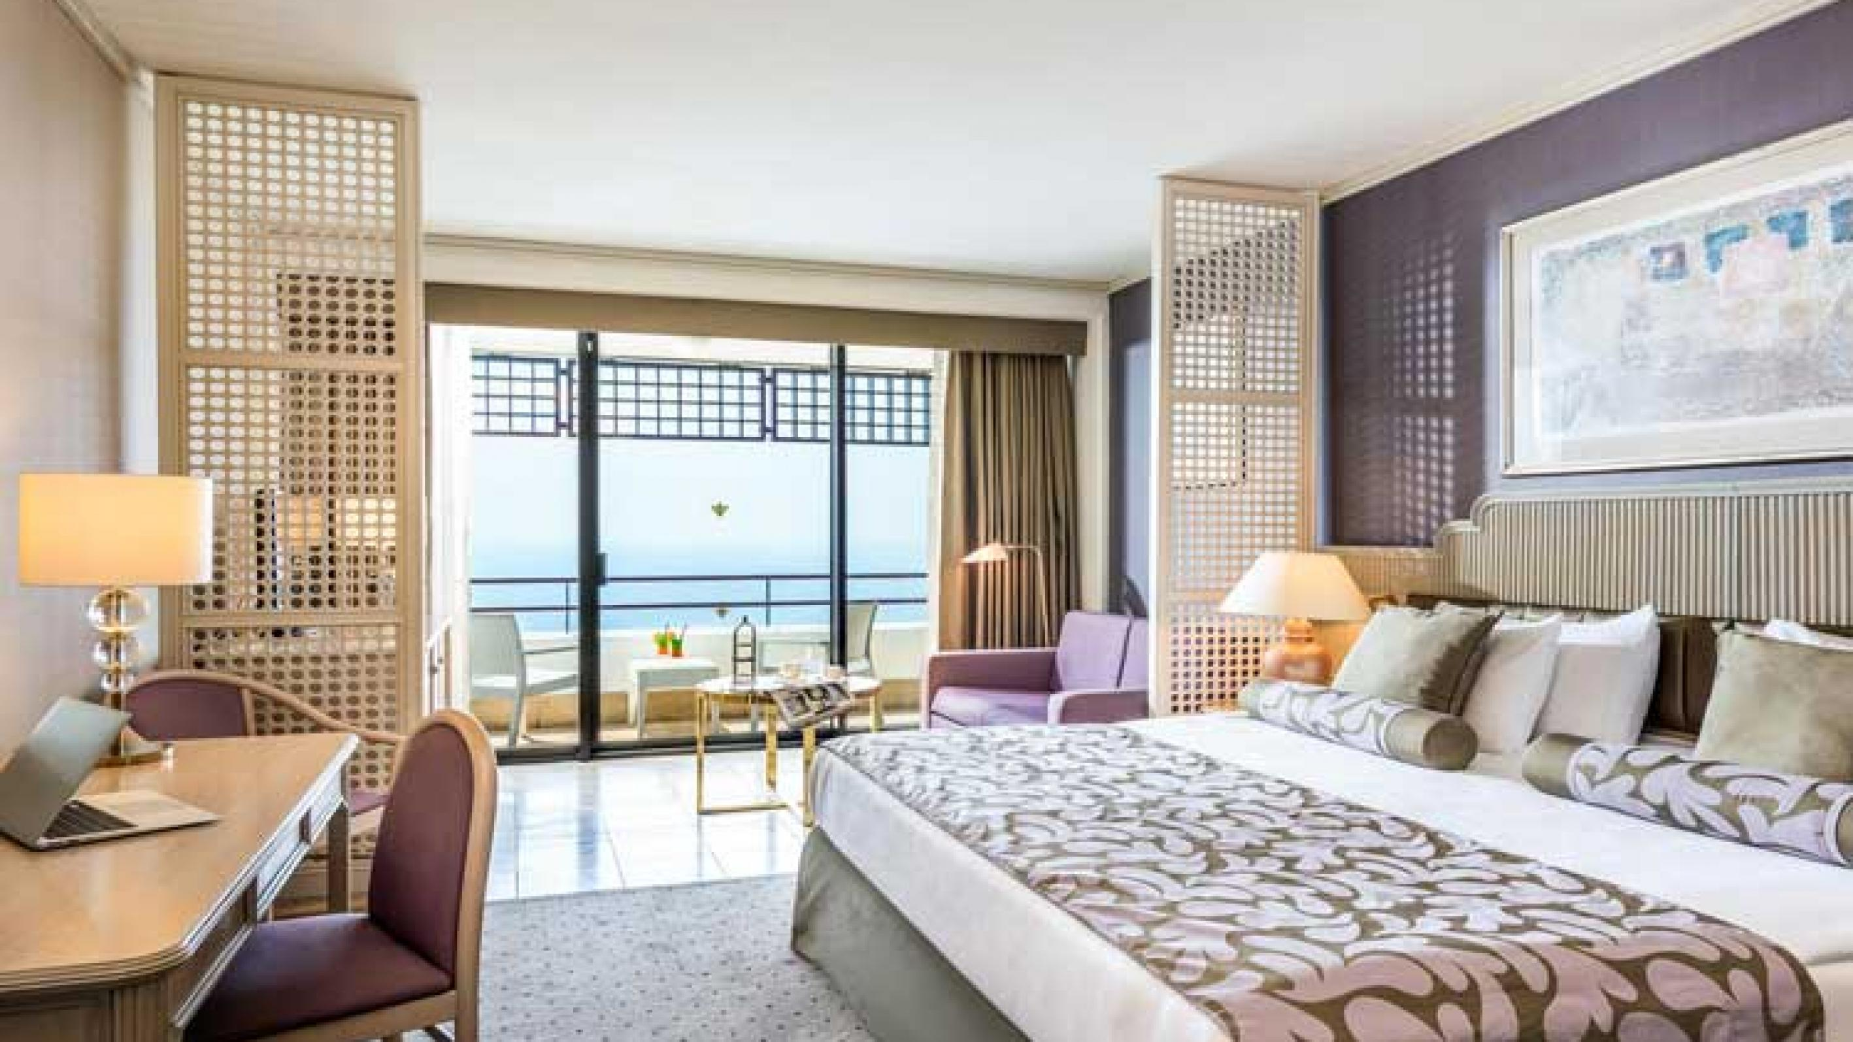
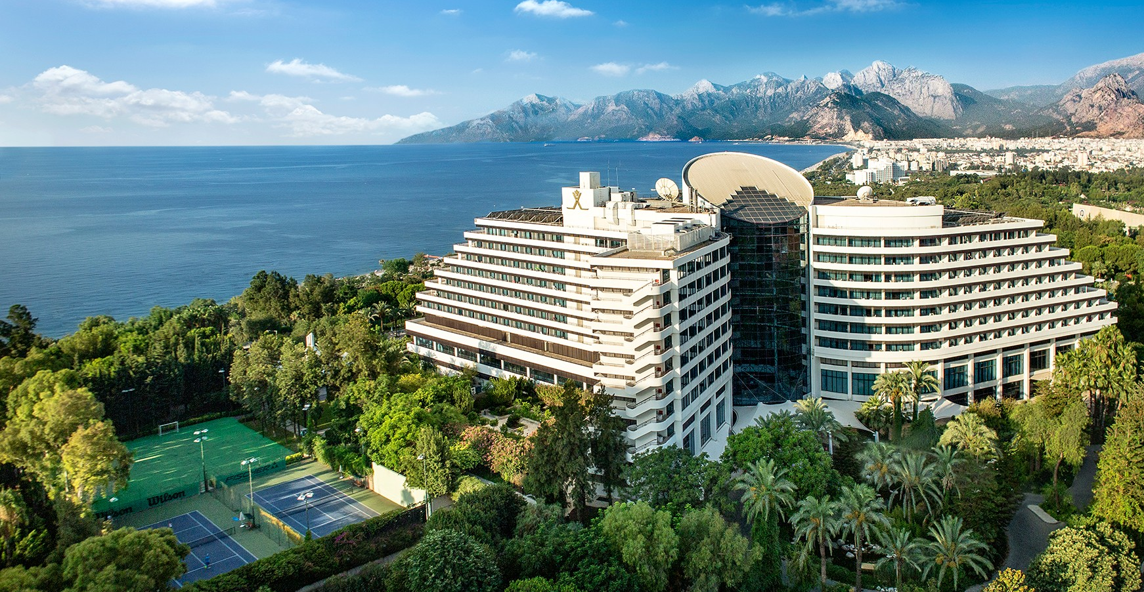
All athletes, officials and staff shall stay in the same hotel. Accommodation includes full board. All meals have to be taken in the hotel, not at any other restaurant/fast-food/bar.
- Reservations should be made before 01 September 2020
- Final Hotel Reservation & Transportation before 21 September 2020

Important Note: Please refer to the accommodation pages below for detailed hotel information. Complete all necessary sections in WAREOS and make full payment for entries and accommodation by the specified deadlines. Bank transfers only, no credit cards will be accepted.

In addition, the LOC will be responsible to provide any event information at this hotel and provide transportation to the venues. Private vehicles can be used too.

ENTRY AND TRANSPORTATION FEE
Entry Fees:
Individual: | 150 EUR per athlete
Officials: | 75 EUR per person

Transportation Fees:
Transport from/to Antalya International Airport is 40,00€ per person (round trip). There will be shuttle services between Hotel and Venue free of charge. The Venue is just 1km distance from Official Hotel.

PAYMENT CONDITIONS:
The entry fees should be paid in full before arrival.

To confirm hotels reservations, a minimum 50% deposit of the total amount is required to be bank transferred to the OC before 21 September 2020. Reservations after this date will be considered only according to availability. The final outstanding balance shall be made via bank transfer before arrival. Accommodation cannot be guaranteed after this deadline. A balanced invoice will be provided via WAREOS.

BANK INFORMATION for ACCOMMODATION, TRANSPORTATION and
ENTRY FEES:
A/C Name: ANTALYA OKCULUK IHTISAS SPOR KULUBU
City and Country: Antalya, TURKEY
Bank: YAPI KREDI BANKASI
Account Number: 25086669
Swift Code: YAPITRIS
IBAN: TR 03 0006 7010 0000 0025 0866 69
Bank’s address: Kültür, Cumhuriyet Blv No:174, 35220 Konak/İzmir
Bank’s Phone: 00 90 (0232) 465 32 12

NOTE: ALL PAYMENTS SHALL BE MADE IN EUR BY BANK TRANSFER.

All bank charges will be paid by the participants. CREDIT CARDS are not accepted.

Cancellations & Changes
All cancellations and changes must be made through WAREOS / Open WAREOS:
- Cancellations received before 21 September 2020 a full refund of the deposit payment will be made.
- Cancellations received after 21 September 2020, no refund will be given.
- Refunds will be processed after the event.
- Name changes to team officials or athletes (same category and division) will be accepted up to two (2) days before qualification day without any additional charge or penalty fees.
- Should flight arrival details change last minute, please contact the Organising Committee using the details indicated in the team managers’ booklet.
- If a participant’s arrival is later than the original scheduled arrival date, the room will be charged from the date of the original booking in WAREOS.
- An email will automatically notify the Organising Committee and Member Association of any changes made in WAREOS.

HEALTH REGULATIONS (COVID-19)
INFORMATION
- Everybody should follow the Government/public health authorities measures (national and sport-specific regulations) and be aware of the travel restrictions
- For your information, Medical infrastructure/Hospital with proper care will be reachable within 15 minutes from the venue, where COVID-19 test can be done

PERSONAL HYGIENE AND HEALTH ADVICES
- Anyone due to participate in the event who is feeling ill should not attend
- Participants (athlete, volunteer, official etc.) should proactively and regularly check their health status (including taking their temperature and monitoring for any symptoms)
- Stay home and self-isolate even with minor symptoms for 10 days or more depending on national protocols, when showing any symptoms (fever, tiredness, dry cough, headache, nasal congestion, runny nose, sore throat, difficulty breathing).
- Contact a healthcare provider immediately if any respiratory illness is noted
- Masks to be worn at all times everywhere (transport, common area in the hotel, venue, training etc.) except on shooting line
- Regularly and thoroughly clean your hands with an alcohol-based hand rub or wash them with soap and water
- Avoid touching eyes, nose and mouth
- Cover your mouth and nose with your bent elbow or tissue when you cough or sneeze. Then dispose of the used tissue immediately and wash your hands
- Avoid touching high-contact surfaces such as door handles, walls or windows, etc.
- Avoid going to crowded places
- Avoid steam rooms or saunas
- No spitting, as the main mode of transmission of the virus is in respiratory secretions
- No handshakes, high fives and any other personal contact
- Athletes should not share clothing, bar soap, sports equipment, water bottles or other personal items
TRANSPORT & ACCOMMODATION
- Avoid using public transport to go to the hotel and between the hotel and the venue
- All meals have to be taken in the hotel, not at any other restaurant/bar
VENUE
- Access to the venue might be denied at any time in case of disease suspicion
- Limit contact/interactions
- Handwashing/alcohol- based hand gel will be available at multiple locations in the event facility and accommodation
- Regular toilet cleaning will be done (at least once per session)
- Tissues and containers will be at disposal to dispose of used tissues on transport to the venue, at the venue and any other facility
- No shows allowed. Winners will receive their medals in a simple ceremony only with the winners and their team, all wearing masks
- Medical post and designated personnel on site able to help assess cases and potential other illness will be present
- An isolation room/space to hold any symptomatic person found at the venue will be available
- Space on shooting line shall be 1.00 metre minimum per athlete
- No spectators are allowed during the event
PARTICIPANTS
- Maintain the staff/team to a minimum to minimise transmission
- Maintain social distancing, at least 1,5 metre distance between yourself and others at all time

ADDITIONAL INFORMATION
Medical emergency contact and location
OZEL AKDENIZ SIFA HOSPITAL – Address: Kuşkavağı Mah., Atatürk Blv. No:81,
07070 Konyaaltı/Antalya, 00 90 444 7 606

Transportation
Transportation will be provided from Antalya International Airport to the official hotel, from two days before the qualification day and until two days after the closing day. Local transport will be available between the official hotel, practice and competition venues. Transport timetables will be confirmed.

Training
A training field will be available starting on 30 September 2020 at the Antalya Archery Center. Transportation timetable will be confirmed.

Weather
Temperatures in October are expected to range between 20 and 26 degrees Celsius. The average in the last few years has been 25 degrees Celsius. There are chances of rain, mainly in the evenings.

Media Registration
Media representatives can apply for registration by emailing info@archery.sport

Internet
Will be available in the official hotel for free (in hotel rooms and in the lobby). There will also be Wi-Fi available for access to results and internet on venue.

Water
Each participant with receive clean bottles of water.
Bottled water will be available at the qualification and practice venues.

Visa
All participants who need an entry visa to Turkey, will be required to complete the Visa Support sections in WAREOS by no later than 01 September 2020.

It is the applicants’ responsibility for supplying the necessary information, ensuring all details are up to date, correct and submitted by the deadlines specified.

In addition, all participants that require a visa are kindly requested to supply a copy of their latest/valid passport. Copies of each application can be uploaded on WAREOS. All passport copies and personal details entered/uploaded to WAREOS will be held securely and in the strictest of confidence and not shared with other parties.

LOC CONTACT
Name: Sirer AYDIN
Email: bilgi@antalyaokculuk.org
Language: English
Phone number with international extension: 00 90 533 525 25 33

