TO ALL World Archery Europe MEMBER ASSOCIATIONS

Dear President, Dear Secretary General,

On behalf of the Organizing Committee (LOC), we would like to invite your country to the 2021 European Grand Prix Archery Tournament, which will be held from 07 – 11 April 2021 in Antalya – TURKEY.

Registering the participation, please complete all the necessary sections in WAREOS within the deadlines listed below:

Summary of deadlines:

- Preliminary Entries 07/03/2021
- Preliminary Hotel Reservation 07/03/2021
- Visa Support 07/03/2021
- Final Entries 27/03/2021
- Final Hotel Reservation and Transportation 27/03/2021
- Final Payment 27/03/2021

Looking forward to welcoming you in Antalya.

Sincerely yours,

Mr Husnu KOCAOGLU
President of the
Organizing Committee

PRELIMINARY PROGRAM

05 April 2021  Monday | Arrival of the Teams  Unofficial Practice is available
06 April 2021  Tuesday | Arrival of the Teams  Unofficial Practice is available
07 April 2021  Wednesday | Official Practice & Equipment Inspection
08 April 2021  Thursday | Qualification Round
09 April 2021  Friday | Individual Eliminations Rounds  1/48 – 1/24
10 April 2021  Saturday | Individual Eliminations Rounds  1/16 - 1/8 – 1/4 - 1/2
11 April 2021  Sunday | Individual Finals

NOTE:
This preliminary programme is subject to change according to the number of participants and special requirements. All changes will be published and distributed in good time.

PRELIMINARY & FINAL REGISTRATION

No entry forms will be available to register for this event; the registration process must be completed using WAREOS.

Member Associations can login WAREOS at http://extranet.worldarchery.sport/ with the username and password assigned by World Archery. After entering WAREOS, selecting the event from list will allow a member association to register their athletes. Select/press “Entries” button to see list of categories in the event. Select/press the “Category” to enter the athlete and official numbers/details participating for that event.

For any questions regarding the WAREOS, please contact the World Archery office, Ms. Cecile TOSETTI (ctosetti@archery.sport).

A maximum number of six (6) athletes per country can be registered into each category and divisions of the event.

Starting date of online registration with WAREOS is: | 5 February 2021
End of Preliminary registration: | 07 March 2021
End of Final registration: | 27 March 2021

Please respect the stated deadlines.

Member Associations should only use WAREOS to make any changes/amendments to their entries and will be able to do so at any time. Any changes made in WAREOS an email will be automatically sent to the Organizing Committee and Member Association with the updated information.

Any entries received less than 3 days before the team managers meeting will be refused if no preliminary entry and/or final entry are made prior.

As a final note, only Member Associations in good standing will be eligible to compete. This means that World Archery fee must have been paid prior the participation.

ACCOMMODATION & GENERAL INFORMATION

The official hotel is the Porto Bello Hotel Resort & Spa. Hotel is allocated on a first come, first serve basis. Accommodation includes breakfast, lunch and dinner with non-alcoholic drinks.

Participants, who book their accommodation in non-official hotels, will not be eligible to compete and enter to the Competition and Practice venues.

In accordance with the new WAE rule, all the delegations must book their accommodation, through WAREOS, mandatory in the official hotel suggested by the LOC.

Confirming of the hotel reservations, the whole amount is required to be bank transferred to the LOC before 27 March 2021 Reservations after this date will be considered only according to availability.

ACCOMMODATION

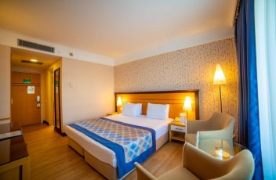
Porto Bello Hotel Resort &Spa (5 Star)
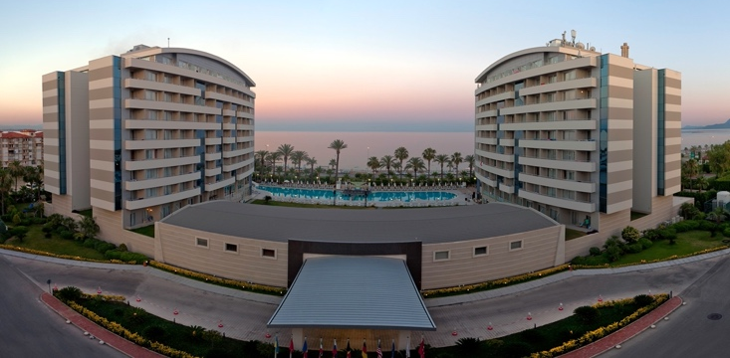

- Single Room 148,00€ (Including Breakfast, Lunch & Dinner Buffet)
- Double/Twin Room 196,00€ (Including Breakfast, Lunch & Dinner Buffet)
- 10 minutes’ drive from the competition venue
- Hotel has a pool area, Wi-Fi, continental breakfast, lunch and dinner restaurant.

ENTRY FEE

Individual : 150,00 € per athlete
Official : 75,00 € per person

Entry fees include daily local transport to/from the practice field to/from the official hotels during the qualification, elimination, and finals venue (timetable to be confirmed on site).

PAYMENT CONDITIONS

The entry fees should be paid in full upon arrival.

Payment of accommodation, should be made when booking by 27 March 2021.

NOTE:
- Please indicate in the reference/notes section the team or reservation name that corresponds to the payment
- All payment shall be made in EUR0 by BANK TRANSFER.
- All bank wire charges will be paid by the participant
- CREDIT CARDS will not be accepted as payment.

BANK INFORMATION for ACCOMMODATION, TRANSPORTATION and ENTRY FEES:

BANK ACCOUNT: | ANTALYA OKCULUK IHTISAS SPOR KULÜBÜ
BANK: | YAPI KREDI BANKASI
ACCOUNT NO: | 25086669
SWIFT CODE: | YAPITRIS
IBAN: | TR 03 0006 7010 0000 0025 0866 69

TO GUARANTEE RESERVATIONS

The whole amount of the accommodation must be paid in advance via bank transfer by 27 March 2021.

Transportation

Transport from/to Antalya Airport is 30 Euros per person. A daily shuttle service is will be available from the Porto Bello Resort Hotel & Spa, competition venue/practice venue/final venue free of charge.

Cancellations & Changes

- Cancellations received before 27 March 2021 a full refund of the payment will be made.
- Cancellations received after 26 March 2021 no refund will be given.
- Refunds will be processed after the event.
- Name changes to team officials or athletes (same category and division) will be accepted up to 72 hours before the event without any additional charge.
- Should flight arrival details change last minute, please contact the Organizing Committee using the details indicated in the Team Managers’ Booklet.
- If a participant’s arrival is later than the original scheduled arrival date, the room will be charged from the date of the original booking.

Training

A training field will be available starting on 05 April 2021 at the Konyaalti Stadium’s field located approximately 3 minutes from the official hotel. Transport to training field will be made available at no additional cost on April 05 and 06.

Weather

Temperatures in April are expected to range between 20 and 25 degrees Celsius. The average in the last few years has been 23 degrees Celsius.

Media Registration:

Media representatives can apply for registration by emailing info@archery.org

Internet

Will be available in the official hotel for free (in hotel rooms and in the lobby). There will also be Wi-Fi available at the venue.

Water

Bottled water will be available at the venue.

Visa

It is your responsibility to establish with your respective foreign office if your team requires a visa for Turkey. You can find additional information on www.evisa.gov.tr, where it is also possible to apply for the e-visa.

For participants who need a formal visa and invitation letter for entry to Turkey, will be required to complete the Visa Support sections in WAREOS by no later than 07 March 2021.

It is the applicants’ responsibility for supplying the necessary information, ensuring all details are up to date, correct and submitted by the deadlines specified.

In addition, all participants that require a visa are kindly requested to supply a copy of their latest/valid passport. Copies of each application can be uploaded on WAREOS. All passport copies and personal details entered/uploaded to WAREOS will be held securely and in the strictest of confidence and not shared with other parties.

Please ensure your passport is valid for at least six months from the date you enter Turkey, or you may not be admitted.

HEALTH REGULATIONS (COVID-19)

INFORMATION
- Everybody should follow the Government/public health authorities measures (national and sport-specific regulations) and be aware of the travel restrictions
- For your information, Medical infrastructure/Hospital with proper care will be reachable within 15 minutes from the venue, where COVID-19 test can be done

PERSONAL HYGIENE AND HEALTH ADVICES
- Anyone due to participate in the event who is feeling ill should not attend
- Participants (athlete, volunteer, official etc.) should proactively and regularly check their health status (including taking their temperature and monitoring for any symptoms)
- Stay home and self-isolate even with minor symptoms for 10 days or more depending on national protocols, when showing any symptoms (fever, tiredness, dry cough, headache, nasal congestion, runny nose, sore throat, difficulty breathing).
- Contact a healthcare provider immediately if any respiratory illness is noted
- Masks to be worn at all times everywhere (transport, common area in the hotel, venue, training etc.) except on shooting line
- Regularly and thoroughly clean your hands with an alcohol-based hand rub or wash them with soap and water
- Avoid touching eyes, nose and mouth
- Cover your mouth and nose with your bent elbow or tissue when you cough or sneeze. Then dispose of the used tissue immediately and wash your hands
- Avoid touching high-contact surfaces such as door handles, walls or windows, etc.
- Avoid going to crowded places
- Avoid steam rooms or saunas
- No spitting, as the main mode of transmission of the virus is in respiratory secretions
- No handshakes, high fives and any other personal contact
- Athletes should not share clothing, bar soap, sports equipment, water bottles or other personal items
TRANSPORT & ACCOMMODATION
- Avoid using public transport to go to the hotel and between the hotel and the venue
- All meals have to be taken in the hotel or at home, not at any other restaurant/bar
VENUE
- Access to the venue might be denied at any time in case of disease suspicion
- Limit contact/interactions
- Handwashing/alcohol- based hand gel will be available at multiple locations in the event facility and accommodation
- Regular toilet cleaning will be done (at least once per session)
- Tissues and containers will be at disposal to dispose of used tissues on transport to the venue, at the venue and any other facility
- No shows allowed. Winners will receive their medals in a simple ceremony only with the winners and their team, all wearing masks
- Medical post and designated personnel on site able to help assess cases and potential other illness will be present
- An isolation room/space to hold any symptomatic person found at the venue will be available
- Space on shooting line shall be 1.00 metre minimum per athlete
- No spectators are allowed during the event
PARTICIPANTS
- Maintain the staff/team to a minimum to minimise transmission
- Maintain social distancing, at least 1,5 metre distance between yourself and others at all time

Medical emergency contact and location

HOSPITAL
Name : Özel Akdeniz Şifa Hastanesi
Address: Kuşkavağı Mahallesi, Atatürk Bulvarı No:81, Konyaaltı, Antalya
Phone: 444 7 606

DOCTOR
Name: Mr Yusuf ADIYAMAN
Phone: +90 531 813 07 51

MEDICAL CARE
Name: Mr.Yasin ÇALHAN
Phone :+90 554 828 28 64

LOC Contact

Name: Mr. Sirer AYDIN, Registration Manager
Email: sireraydin@gmail.com
Language: English

