TO ALL World Archery Member Associations
Dear President,

As Chair of the Local Organizing Committee (LOC) of the third stage of the Hyundai Archery World Cup and the Final Qualification Tournament (FQT) to be held in Paris – France on 18-27 June 2021, I would like to invite you all to be part of one of the most important archery events to take place in Europe in 2021.

Three years before the 2024 Olympic Games in Paris, hosting the Tokyo FQT and the European World Cup Stage is the opportunity to prepare athletes, staff and volunteers.
Paris is one of the most touristic cities in the World, with beautiful and famous monuments. We hope you will be able to enjoy some good moments during your stay if the sanitary conditions allow it.

Regarding the sanitary situation, we are doing our best to secure the event by giving all guarantees to host the delegations in the safest conditions. For this reason, we chose to fully book only two hotels, to limit as much as possible the contacts with other publics.
We hope, you will be a lot to attend the two events in Paris next June!

Sincerely yours,

Jean-Michel Cleroy
World Cup Paris OC Chairman

Important Dates :

Please find enclosed information regarding the details of this event and how to complete registration. To register participation, please complete all the necessary sections in WAREOS within the deadlines listed below:

Summary of deadlines:

- Start date for online registration WAREOS 2 March 2021
- Preliminary Entries 18 March 2021
- Final Entries 28 May 2021
- Extra penalty starting date 15 June 2021
- Hotel Reservation 50% account 02 April 2021
- Transportation 02 April 2021
- Visa Support 14 May 2021
- Final Hotel Reservation & Payment 14 May 2021
- Full refund cancellation deadline 15 April 2021

Looking forward to welcoming you in Paris, France.

FQT PRELIMINARY PROGRAMME
VENUE : Charléty Stadium
Address : 99 boulevard Kellermann - 75013 PARIS (South East of Paris)

17 June 2021  Thursday | Arrival of participants  Practice field and local transport available
18 June 2021  Friday | Official Practice  Equipment Inspection  Team Managers Meeting
19 June 2021  Saturday | Men’s Team Qualification, Elimination and Finale  (Recurve)
20 June 2021  Sunday | Women’s Team Qualification, Elimination and Finale  (Recurve)
21 June 2021  Monday | Individual Elimination and Finale  (Recurve)
22 June 2021  Tuesday | Departure of teams

WORLD CUP PRELIMINARY PROGRAMME
VENUE : Charléty Stadium
Address : 99 boulevard Kellermann - 75013 PARIS (South East of Paris)

20 June 2021  Sunday | Arrival of participants  Practice field and local transport available
21 June 2021  Monday | Official Practice  Equipment Inspection  Team Managers Meeting
22 June 2021  Tuesday | Qualification Round  (Recurve and Compound)
23 June 2021  Wednesday | Individual Eliminations  Team Eliminations  (Recurve and Compound)
24 June 2021  Thursday | Individual Eliminations  Team Eliminations  (Recurve and Compound)
25 June 2021  Friday | Mixed Team Eliminations  (Recurve and Compound)
26 June 2021  Saturday | Finals – Compound
27 June 2021  Sunday | Finals – Recurve
28 June 2021  Monday | Departure of teams

NOTE: This preliminary programme is subject to change according to participation and TV requirements. All changes will be published and distributed in good time.

PRELIMINARY & FINAL REGISTRATION
All entries, accommodation reservations, transport needs, flight arrival/departure information and visa invitation letter requests are to be completed using WAREOS.

The World Archery Online Registration System (WAREOS) at https://extranet.worldarchery.sport now handles the entire registration process for this event. No entry forms, hotel reservations or transportation forms will be accepted; all information must be entered into WAREOS.

Member associations can login to WAREOS at https://extranet.worldarchery.sport with the username and password assigned by World Archery. After entering WAREOS, selecting the event from the list will allow a member association to register their athletes. Select/press the “Entries” button to see the list of categories in the event. Select/press the “category” to enter the athlete and official numbers/details participating for that event. A WAREOS User Manual can be downloaded in PDF format (English) upon login.

Contact Ms Cécile Tosetti (ctosetti@archery.sport) in the World Archery Office with any questions regarding technical problems on WAREOS. For any question regarding the organization of the event (transport, accommodation, meals etc.) please contact directly the LOC.

A maximum number of 4 athletes per country can be registered into each category of the event. Preliminary entries should be completed using WAREOS.

Start date for online registration using WAREOS 2 March 2021
End of Preliminary registration using WAREOS: 18 March 2021
End of Final registration using WAREOS: 28 May 2021

Please respect the stated deadlines.

Member Associations can only use WAREOS to make any changes or amendments to entries and will be able to do so at any time. An email will automatically notify the Organizing Committee and Member Association of any changes made in WAREOS.

Any changes that are made after the deadlines specified or if entries differ by more than 4 athletes from the preliminary entries, the following penalty fees will automatically be applied.

Penalty fees to be paid to Organizing Committee: | Cost (EUR):
Entries made after the entry deadline dates (late entries) | 45 per entry
If final entries differ from the preliminary entries by more than 4 athletes/officials. | 140 per entry
When no preliminary entries were made before the deadline date but then submit final entries. | 140 per entry

Penalty Fee to be paid to World Archery: | Cost (CHF):
Lost accreditation. | 30 each
Changes made to the athlete and/or team official names after the final entry deadline date and within 3 days prior to the start of the event (very late entries) | 50 each change

NOTE: CHF currency exchange rates will be those on the date of the event.

Member Associations that have penalty fees outstanding from 2020 will need to have paid these penalty fees before being eligible to enter and compete.

Any entries received less than 3 days before the team managers meeting for a Hyundai Archery World Cup or World Championships will be refused if no preliminary entry and/or final entry are made prior. This decision cannot be appealed by the teams and is fully compliant with the current World Archery rules, article 3.7.1.2. Entries received after the deadlines, are subject to penalties as clearly stated in the rule book and the invitation documents of World Cups and World Championships. A Member Association that has made final entries in WAREOS and does not participate will be invoiced for the number of entries entered in the system, unless they have informed World Archery and the Organizing Committee in writing at least one week prior to the event that they are unable to attend.

ACCOMMODATION & GENERAL INFORMATION
To ensure safety and security of the event, the LOC as decided to book one hotel for exclusive use and work to make a health bubble.

Due to the sanitary restrictions, all team MUST book their accommodation through the organizing committee.

The hotel is a 3 stars hotels, recently renovated, answering to all requests of professional athletes.
You will enjoy its services, locations, & design during all your stay.
To respect all the measures, the organization reserve the right to book only one hotel for your stay.
The event is exempt by the French government of quarantine measures for delegations from any country, even outside the European Community.

Ibis Paris Porte d’Orléans***
Website
The Ibis Paris Porte d’Orléans is one of the largest hotels near the competition venue. You will enjoy comfortable rooms & homemade food in the French Capital.

- Single Room price: | EUR 193.00 per room
- Double/Twin Room price: | EUR 298.00 per room
- Board plan: | Full Board : Breakfast & Dinner – Lunch will be served at the venue (including in the price)
- Check-in from | 12:00 hrs.
- Late check-out | 12:00 hrs.
- Photo

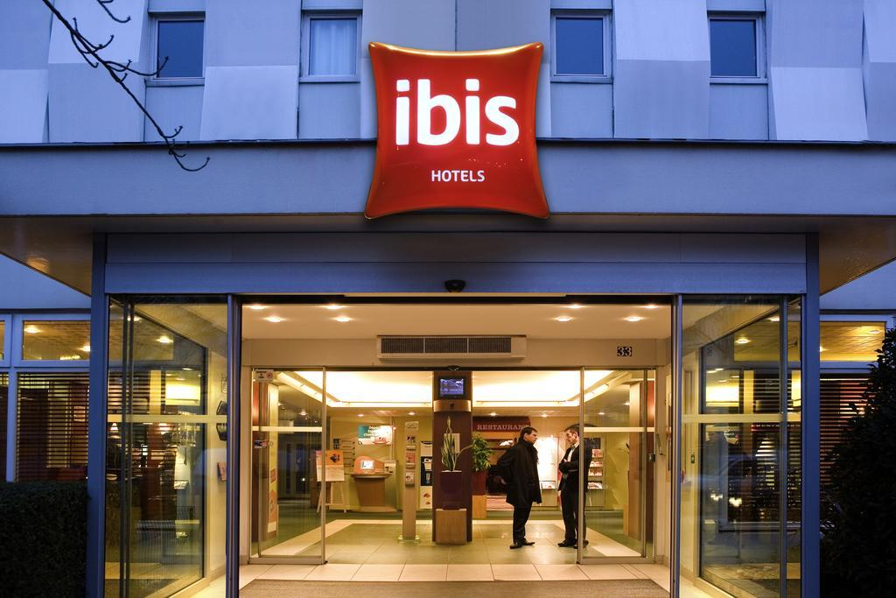
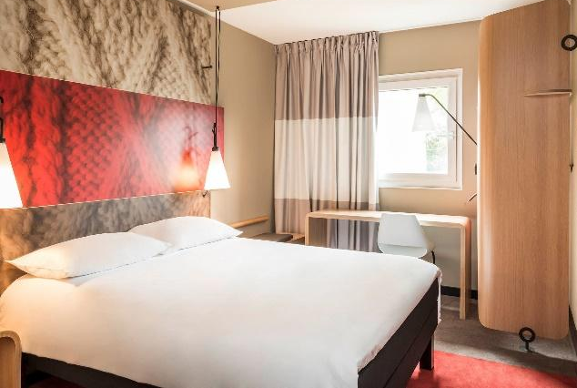

Accommodation includes breakfast and dinner at the hotel with non-alcoholic drinks. Lunch will always be served at the archery venue.

To confirm hotels reservations, a minimum of 50% deposit of the total amount is required to be bank transferred to the agency before Friday 2 April 2021.
Total amount of the reservation will have to be paid before Friday 14 May 2021.
The final outstanding balance shall be made via bank transfer before arrival. Accommodation cannot be guaranteed after 14 April.

BANK INFORMATION for ACCOMMODATION & TRANSPORTATION
Account holder :
SPARTNER AGENCY
34-36 rue de la Folie Regnault
75011 PARIS

Account :
CR CENTRE EST – SUD RHONE ENTREPRISES
313 Rue de Gerland, Bâtiment A, 69007 Lyon – France
IBAN FR76 1780 6008 6904 1322 2022 659
BIC AGRIFRPP878
PLEASE DO NOT MAKE HOTEL PAYMENTS TO THE ORGANIZING COMMITTEE

Contact to Travel Agency
Spartner Agency Phone : +33 (0)1 79 35 09 32
Mrs. Clara BUSSIGNIES Mobile : +33 (0)6 65 01 26 94
Adress : 34-36 rue de la Folie Regnault
75011 Paris, FRANCE
E-mail : archery-teamservices@spartner-agency.com
Web : http://www.spartner-agency.com/

ENTRY FEE FQT
Entry Fees:
Individual: | 70 EUR per athlete
Officials: | 50 EUR per person
Temporary Upgrade:  For athletes wishing to be a coach temporarily | 30 CHF per accreditation
Guest 70 EUR per person
The Guest accreditation is for persons (i.e. medical staff, additional coach…) included in the health bubble. No access to the training field nor to the competition field.

ENTRY FEE WC
Entry Fees:
Individual: | 230 EUR per athlete
Officials: | 115 EUR per person
Temporary Upgrade:  For athletes wishing to be a coach temporarily | 30 CHF per accreditation

Guest 160 EUR per person
The Guest accreditation is for persons (i.e. medical staff, additional coach…) included in the health bubble. No access to the training field nor to the competition field.

COVID TESTS FEE 70 EUR per athlete/official/guest
This fee includes all the COVID tests from arrival day of the delegations until the last test necessary before departure
You can book the COVID Test Fees for your delegation on WAREOS in the Extras section. The payment has to be made to the LOC.

PAYMENT CONDITIONS:
The entry fees and COVID test fees should be paid in full before arrival.
A balanced invoice will be provided via WAREOS.

BANK INFORMATION for ENTRY FEES and COVID TEST FEES:
A/C Name: Comité d’Organisation France Tir à l’Arc
Federation’s Address: 12 Place Georges Pompidou
City and Country: 93160 Noisy Le Grand, France
Telephone number: +33 (0)1 58 03 58 58
Bank: BNP Paribas
Account Number (IBAN): F76 3000 4028 3700 0111 4064 094
Swift: BNPAFRPPXXX
Bank’s address: BNP PARIBAS A
Ile de France Institutions
ACI : Z02837A
8-12, rue Sainte Cécile
75450 Paris Cedex 09
FRANCE
Email address: finance@france-tiralarc.org
City: Paris

NOTE: ALL PAYMENTS SHALL BE MADE IN EUR BY BANK TRANSFER.

All bank charges will be paid by the participants.
CREDIT CARDS are accepted for the payment of accommodation and transportation.

Cancellations & Changes
All cancellations and changes must be made through WAREOS:
- Cancellations received before 16 April 2021, a full refund of the deposit payment will be made.
- Cancellations received after 15 April 2021, no refund will be given.
- Refunds will be processed after the event.
- Name changes to team officials or athletes (same category and division) will be accepted up to 17:00hrs, two (2) days before official practice without any additional charge or penalty fees.
- Should flight arrival details change last minute, please contact the Organizing Committee using the details indicated in the team managers’ booklet.
- If a participant’s arrival is later than the original scheduled arrival date, the room will be charged from the date of the original booking in WAREOS.
- An email will automatically notify the Organizing Committee and Member Association of any changes made in WAREOS.

PERSONAL HYGIENE AND HEALTH ADVICES (COVID-19)
- Anyone due to participate in the event who is feeling ill should not attend
- Participants (athlete, volunteer, official etc.) should proactively and regularly check their health status (including taking their temperature and monitoring for any symptoms)
- Stay home and self-isolate even with minor symptoms for 10 days or more depending on national protocols, when showing any symptoms (fever, tiredness, dry cough, headache, nasal congestion, runny nose, sore throat, difficulty breathing).
- Contact a healthcare provider immediately if any respiratory illness is noted
- Masks to be worn at all times everywhere (transport, common area in the hotel, venue, training etc.) except on shooting line
- Regularly and thoroughly clean your hands with an alcohol-based hand rub or wash them with soap and water
- Avoid touching eyes, nose and mouth
- Cover your mouth and nose with your bent elbow or tissue when you cough or sneeze. Then dispose of the used tissue immediately and wash your hands
- Avoid touching high-contact surfaces such as door handles, walls or windows, etc.
- Avoid going to crowded places
- Avoid steam rooms or saunas

ADDITIONAL INFORMATION
Health bubble and spectators
Taking the sanitary situation in account the LOC works to organize the event in a health bubble. At the moment the possibility for spectators to buy tickets to attend the competitions is not guaranteed.
Medical emergency contact and location
Hospital name: Kremlin Bicêtre Hospital,
Address: 78 rue du Général Leclerc, 94270 Le Kremlin-Bicêtre,
Phone number: +33 (0)1 45 21 21 21

Hospital name: Hôpital Universitaire Pitié Salpêtrière,
Address: 47-83 Boulevard de l’Hôpital, 75651 Paris,
Phone number: +33 (0)1 42 16 00 00

Local Transportation
Local transportation will be available between official hotels and the competition venue. Transport timetables will be confirmed and provided. Buses and/or vans will set up according to Health Protocol in France.

NOTE: From 17 June transport is going to be available to take athletes to the stadium and have lunch in there & practice.

Airport transfers
Transportation will be provided from/to Paris Orly (ORY) and Paris Charles de Gaulle (CDG) airports to/from official hotels.
Airport Transport fee are detailed below:
 | PRICE per PERSON per TRANSFER
NUMBER OF PASSENGER | 1 | 2 & +
Orly Airport <> Hotel (one way) | 45 EUR | 35 EUR
CDG Airport <> Hotel (one way) | 55 EUR | 39 EUR
Train Station <> Hotel (one way) | 40 EUR | 25 EUR

Training
The training field will be available starting on 17 June 2021 at the Stade Charléty in Paris only for FQT participants and on 21 June 2021 for the Hyundai Archery World Cup participants.
The delegations will have to reserve sessions to access to the training field, to limit the number of archers shooting on the field.
The LOC will have the capacity to propose other training facilities in archery clubs located maximum 15km around the venue on request of delegations arriving before the date of the official training on the base of first askes, first served. The cost will be 15€/per day and per archer.

Weather
June (Average):
Average Temperature: 18° C
Low Temperature: 13° C
High Temperature: 23° C
Sunrise: 05.50h
Sunset: 21.58h

Media Registration
Media representatives can apply for registration by emailing info@archery.sport

Internet
Will be available in the official hotels for free (in hotel rooms and in the lobby). There will also be Wi-Fi available for access to results on venue.

Water
Water will be available at the qualification and practice venues.

Visa
All participants who need an entry visa to France, will be required to complete the Visa Support sections in WAREOS by no later than 14 May 2021.

It is the applicants’ responsibility for supplying the necessary information, ensuring all details are up to date, correct and submitted by the deadlines specified.

In addition, all participants that require a visa are kindly requested to supply a copy of their latest/valid passport. Copies of each application can be uploaded on WAREOS. All passport copies and personal details entered/uploaded to WAREOS will be held securely and in the strictest of confidence and not shared with other parties.

LOC CONTACT
Name: Patricia Renaud – Camille Perrot
Phone number : +33 (0)1 58 03 58 61 (French / Spanish)
Phone number : +33 (0)1 58 03 58 66 (English)
Email: info@france-tiralarc.org
Language: French, English and Spanish
LOC website (info and ticketing) : https://www.archeryworldcup.paris

