TO ALL World Archery Member Associations
Dear President,

As the chair of the Local Organizing Committee (LOC) of the first stage of the Archery Asia Cup to be held in Gwangju – Korea on 6–11 June 2021, I would like to invite you all to be part of one of the most important archery events which takes place in Korea in 2021.

Indeed, it is well acknowledged that Gwangju is perfectly suited for hosting this event. Since Gwangju International Archery Center was built in Gwangju in 2015, the city has been one of the best places to host such events. In addition, Gwangju has experience in hosting national archery events during the pandemic situation. Building on its experience handling the pandemic, we will do our best to successfully manage COVID-19 during the competition as well.

Gwangju, the sixth-largest city in South Korea, is a designated metropolitan city that represents the southwestern region of the country. Welcome to this marvelous city which is in the making. As we are fully aware of the risks that you are taking, we will always put priority on providing a safe environment for you to compete without worrying about your health and safety.

This is the chance for you to come and enjoy the archery competition. We cannot wait to shoot an arrow together with you to the future, and beyond.

Best Regards,

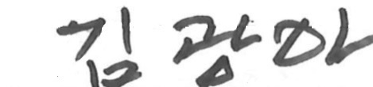

Gwang-A Kim
President of Gwangju Archery Association

Important Dates

Please find enclosed information regarding the details of this event and how to complete registration. To register participation, please complete all the necessary sections in WAREOS within the deadlines listed below:

Summary of deadlines:

- Start date for online registration WAREOS 19 April 2021
- Preliminary Entries 16 May 2021
- Final Entries 23 May 2021
- Hotel Reservation 16 May 2021
- Transportation 23 May 2021
- Visa Support 23 May 2021
- Final Hotel Reservation & Payment 23 May 2021
- Full refund cancellation deadline 30 May 2021

Looking forward to seeing you in Gwangju, Korea.

PRELIMINARY PROGRAMME

5 June 2021  Saturday | Arrival of participants  Practice field and local transport available
6 June 2021  Sunday | Official Practice  Equipment Inspection  Team Managers Meeting
7 June 2021  Monday | Qualification round  (Recurve, Compound)
8 June 2021  Tuesday | Individual Eliminations  (Recurve and Compound)
9 June 2021  Wednesday | Individual Eliminations  (Recurve and Compound)
10 June 2021  Thursday | Individual Finals  (Recurve and Compound)
11 June 2021  Friday | Team and Mixed Team Eliminations & Finals  (Recurve and Compound)
12 June 2021  Saturday | Departure of teams

NOTE: This preliminary programme is subject to change according to participation and TV requirements. All changes will be published and distributed in good time.
PRELIMINARY & FINAL REGISTRATION

All entries, accommodation reservations, transport needs, flight arrival/departure information and visa invitation letter requests are to be completed using the World Archery Online Registration System WAREOS. These systems now handle the entire registration process for this event. No entry forms, hotel reservations or transportation forms will be accepted.

Member associations can login to WAREOS at http://extranet.worldarchery.sport with the username and password assigned by World Archery. After entering WAREOS, selecting the event from the list will allow a member association to register their athletes. Select/press the “Entries” button to see the list of categories in the event. Select/press the “category” to enter the athlete and official numbers/details participating for that event. A WAREOS User Manual can be downloaded in PDF format (English) upon login.

Contact Ms CECILE TOSETTI (ctosetti@archery.sport) in the World Archery Office with any questions regarding technical problems on WAREOS. For any question regarding the organisation of the event (transport, accommodation, meals etc.) please contact directly the LOC.

Athletes from a minimum of 4 different Member Associations shall be registered and participate in the event. Entries should be completed using WAREOS.

Start date for online registration using WAREOS/Open WAREOS 19 April 2021
End of Final registration using WAREOS/Open WAREOS 23 May 2021

Please respect the stated deadlines. But considering the current situation of COVID-19, the LOC will not charge any penalty fees for late entry.

Member Associations can only use WAREOS to make any changes or amendments to entries and will be able to do so at any time. An email will automatically notify the Organising Committee and Member Association of any changes made in WAREOS.

ACCOMMODATION & GENERAL INFORMATION

UTOP Hotel – 4 star
- Single Room price: USD 120.00 per room
- Number of rooms: 150
- Double/Twin Room price: USD 160.00 per room
- Number of rooms: 90
- Board plan: full board
- Hotel website: http://www.utopboutique.com/

Hotels are allocated on a first come, first serve basis. Full-board option is included.
Due to sanitary restrictions, all teams MUST book their accommodation through the organizing committee.

- Reservations should be made before 16 May 2021
- Final Hotel Reservation & Transportation before 23 May 2021

Important Note: Please refer to the accommodation pages below for detailed hotel information. Complete all necessary sections in WAREOS and make full payment for entries and accommodation by the specified deadlines. Bank transfers only, no credit cards will be accepted.

In addition, the LOC will be responsible to provide any event information at this hotel and provide transportation to the venues. Private vehicles can be used too.

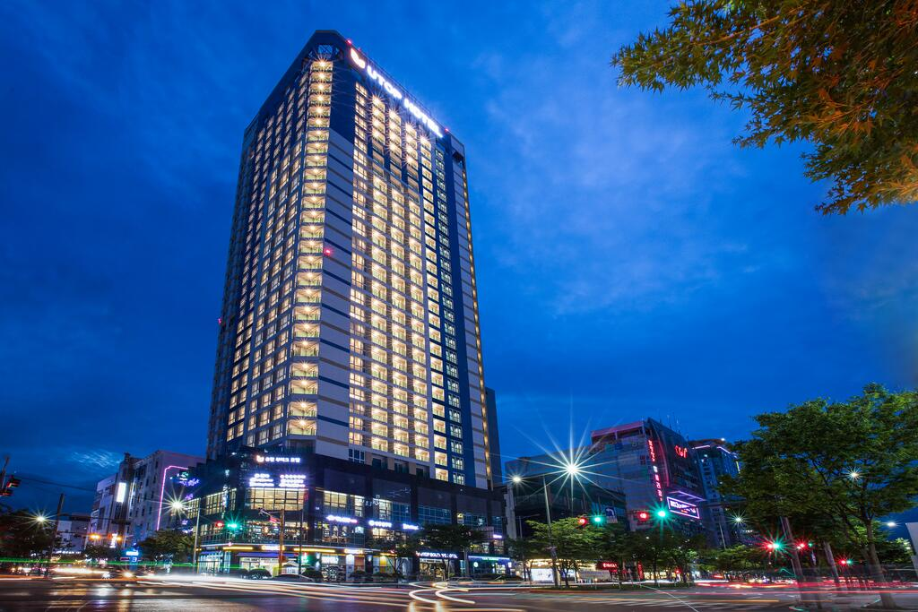

ENTRY FEE
Individual: | 250 USD per athlete
Officials: | 125 USD per person
Entry fees include airport transfer to hotels, daily local transport to and from the practice field to/from official hotels during the qualification, elimination and finals venues (timetable to be confirmed on site).

PAYMENT CONDITIONS:
The entry fees should be paid in FULL before 23 May 2021.

Reservations after this date will be considered only according to availability. The final outstanding balance shall be made via bank transfer before arrival. Accommodation cannot be guaranteed after this deadline. A balanced invoice will be provided via WAREOS.

BANK INFORMATION for ACCOMMODATION and ENTRY FEES:

A/C Name: Gwangju International Archery Center
Federation’s Address: 1187 hoejae-ro Nam-gu
Telephone number: +8262 655 1440
City and Country: Gwangju, Korea
Bank: Gwanju Bank
Account Number: 1307-020-127656
Swift: KWABKRSE
Bank’s address: 77 Yongbong-ro Buk-gu
Bank’s Phone: +8262 530 0700
City: Gwangju

NOTE: ALL PAYMENTS SHALL BE MADE IN USD BY BANK TRANSFER.

All bank charges will be paid by the participants. CREDIT CARDS are not accepted.

Cancellations & Changes
All cancellations and changes must be made through WAREOS:
- Cancellations received before 30 May 2021 a full refund of the deposit payment will be made.
- Cancellations received after 30 May 2021, no refund will be given.
- Refunds will be processed after the event.
- Name changes to team officials or athletes (same category and division) will be accepted up to 17:00hrs, two (2) days before official practice without any additional charge or penalty fees.
- Should flight arrival details change last minute, please contact the Organizing Committee using the details indicated in the team managers’ booklet.
- If a participant’s arrival is later than the original scheduled arrival date, the room will be charged from the date of the original booking in WAREOS.
- An email will automatically notify the Organizing Committee and Member Association of any changes made in WAREOS.

HEALTH REGULATIONS (COVID-19)
INFORMATION
- Everybody should follow the Government/public health authorities measures (national and sport-specific regulations) and be aware of the travel restrictions
- For your information, Medical infrastructure/Hospital with proper care will be reachable within 15 minutes from the venue, where COVID-19 test can be done

PERSONAL HYGIENE AND HEALTH ADVICES
- Anyone due to participate in the event who is feeling ill should not attend
- Participants (athlete, volunteer, official etc.) should proactively and regularly check their health status (including taking their temperature and monitoring for any symptoms)
- Stay home and self-isolate even with minor symptoms for 10 days or more depending on national protocols, when showing any symptoms (fever, tiredness, dry cough, headache, nasal congestion, runny nose, sore throat, difficulty breathing).
- Contact a healthcare provider immediately if any respiratory illness is noted
- Masks to be worn at all times everywhere (transport, common area in the hotel, venue, training etc.) except on shooting line
- Regularly and thoroughly clean your hands with an alcohol-based hand rub or wash them with soap and water
- Avoid touching eyes, nose and mouth
- Cover your mouth and nose with your bent elbow or tissue when you cough or sneeze. Then dispose of the used tissue immediately and wash your hands
- Avoid touching high-contact surfaces such as door handles, walls or windows, etc.
- Avoid going to crowded places
- Avoid steam rooms or saunas
- No spitting, as the main mode of transmission of the virus is in respiratory secretions
- No handshakes, high fives and any other personal contact
- Athletes should not share clothing, bar soap, sports equipment, water bottles or other personal items
TRANSPORT & ACCOMMODATION
- Avoid using public transport to go to the hotel and between the hotel and the venue
VENUE
- Access to the venue might be denied at any time in case of disease suspicion
- Limit contact/interactions
- Handwashing/alcohol- based hand gel will be available at multiple locations in the event facility and accommodation
- Regular toilet cleaning will be done (at least once per session)
- Tissues and containers will be at disposal to dispose of used tissues on transport to the venue, at the venue and any other facility
- No shows allowed. Winners will receive their medals in a simple ceremony only with the winners and their team, all wearing masks
- Medical post and designated personnel on site able to help assess cases and potential other illness will be present
- An isolation room/space to hold any symptomatic person found at the venue will be available
- Space on shooting line shall be 1.00 metre minimum per athlete
- No spectators are allowed during the event
PARTICIPANTS
- Maintain the staff/team to a minimum to minimise transmission
- Maintain social distancing, at least 1,5 metre distance between yourself and others at all time

ADDITIONAL INFORMATION

Medical emergency contact and location
Gwangju Nam-gu Health Center-
1 Bongseon-ro , Nam-gu, Gwangju, Korea/ tel. +82 062 607 4450
Ambulance, call the 911

Doctor details will be provided in the team manager booklet.

All athletes and officials must travel to Gwangju with a copy of their medical insurance.

Transportation

The LOC will offer shuttle bus service free of charge, from two days before the official practice day to one day after the closing day. Pick up service is only provided from Incheon Airport(ICN) and Muan Airport(MWX).
Local transport will be available between the official hotel, practice and competition venues. Transport timetables will be confirmed.
Airport | Distance from the airport to the venue | Time
Incheon Airport(ICN) | 345km | 3 hours and 40 minutes
Muan Airport(MWX) | 60km | 45 minutes

Training
A training field, which is located near the Gwangju International Archery Center, will be available from 5 June 2021 to 12 June 2021. Transport between the practice venue and hotels would be free.

Weather
Temperatures in June are expected to range between 27 and 29 degrees Celsius. The average in the last few years has been 27 degrees Celsius.

Media Registration
Media representatives can apply for registration by emailing info@archery.org

Internet
Will be available in the official hotels for free (in hotel rooms and in the lobby). There will also be Wi-Fi available for access to results on venue.

Water
Bottled water will be available at the qualification and practice venues.

Visa
All participants who need an entry visa to Korea, will be required to complete the Visa Support sections in WAREOS by no later than 23 May 2021.

It is the applicants’ responsibility for supplying the necessary information, ensuring all details are up to date, correct and submitted by the deadlines specified.

In addition, all participants that require a visa are kindly requested to supply a copy of their latest/valid passport. Copies of each application can be uploaded on WAREOS. All passport copies and personal details entered/uploaded to WAREOS will be held securely and in the strictest of confidence and not shared with other parties.

LOC CONTACT
Name: Sumin Park
Email: psm8811@gmail.com
Language: English
Phone number with international extension: +8210 5025 8811

