TO ALL World Archery Member Associations

Dear President,

As Chair of the Local Organising Committee (LOC) of the 2021 VERONICA’S CUP to be held in Kamnik, Slovenia on 07-09 May 2021, I would like to invite you all to be part of one of the most important archery events to take place in Slovenia in 2021.

Kamnik, a town embraced by the Kamnik-Savinja Alps, is considered one of the most beautiful medieval towns in Slovenia.

The first written sources about Kamnik go back to 1229. The two castles of Kamnik, Mali grad and Stari grad, were mentioned even earlier. The town boasts a rich Franciscan Library, where about 10,000 volumes of books printed before the end of the 18th century are kept. Šutna is the most beautiful street in the town, featuring typical signboards and other signs of the lively craft activities in the past.

Veronica’s Cup and Kamnik are also known as the traditional very well organized competition with one of the most beautiful scenery behind the targets.

Sincerely yours,

Gregor Končan
Organising Committee Manager
Important Dates:
Please find enclosed information regarding the details of this event and how to complete registration. To register participation, please complete all the necessary sections in WAREOS/OPEN WAREOS within the deadlines listed below:

Summary of deadlines:

- Start date for online registration WAREOS 17 March 2021
- Preliminary Entries 10 April 2021
- Final Entries 15 April 2021
- Late entries fee 29 April 2021
- Hotel Reservation 15 April 2021
- Transportation 20 April 2021
- Visa Support 20 April 2021
- Final Hotel Reservation & Payment 15 April 2021
- Full refund cancellation deadline 20 April 2021

Looking forward to welcoming you in Kamnik, Slovenia.

PRELIMINARY PROGRAMME

05 MAY 2021  Wednesday | Arrival of participants
06 MAY 2021  Thursday | Arrival of participants  Tournament Check-in  Official Practice + Equipment Inspection
07 MAY 2021  Friday | Official Practice + Equipment Inspection  Qualification Round (Recurve, Compound)
08 MAY 2021  Saturday | Individual Eliminations (Recurve, Compound)
09 MAY 2021  Sunday | Final Rounds + Medal Matches (Live TV)  Award ceremonies
10 MAY 2021  Monday | Departure of teams

NOTE: This preliminary programme is subject to change according to participation and TV requirements. All changes will be published and distributed in good time.

CATEGORIES

 | RECURVE |  |  | COMPOUND
 | MEN / WOMEN  (RM/RW) | JUNIOR MEN / JUNIOR WOMEN  (RJM/RJW) | CADET MEN / CADET WOMEN  (RCM/RCW) | MEN / WOMEN  (CM/CW) | JUNIOR MEN / JUNIOR WOMEN  (CJM/CJW) | CADET MEN / CADET WOMEN  (CCM/CCW)
INDIVIDUAL | YES | YES | YES | YES | YES | YES
TEAM | YES | NO | NO | YES | NO | NO
MIXED TEAM | YES | NO | NO | YES | NO | NO

PRELIMINARY & FINAL REGISTRATION
All entries, accommodation reservations, transport needs, flight arrival/departure information and visa invitation letter requests are to be completed using the World Archery Online Registration System WAREOS and OPEN WAREOS. These systems now handle the entire registration process for this event. No entry forms, hotel reservations or transportation forms will be accepted.

Member associations can login to WAREOS at http://extranet.worldarchery.sport with the username and password assigned by World Archery. After entering WAREOS, selecting the event from the list will allow a member association to register their athletes. Select/press the “Entries” button to see the list of categories in the event. Select/press the “category” to enter the athlete and official numbers/details participating for that event. A WAREOS User Manual can be downloaded in PDF format (English) upon login.

Other athletes (not competing as country but only as club) can register on Open WAREOS at http://extranet.worldarchery.sport with their username and password if already registered in the past or register to get the log in details if it’s the first time. After the creation of the profile, follow the instructions to register to the event.

Contact Ms CECILE TOSETTI (ctosetti@archery.sport) in the World Archery Office with any questions regarding technical problems on WAREOS. For any question regarding the organisation of the event (transport, accommodation, meals etc.) please contact directly the LOC.

Athletes from a minimum of 4 different Member Associations shall be registered and participate in the event. Entries should be completed using WAREOS / Open WAREOS.

Start date for online registration using WAREOS/Open WAREOS 17 MARCH 2021
End of Final registration using WAREOS/Open WAREOS 15 APRIL 2021

Please respect the stated deadlines.

Member Associations can only use WAREOS to make any changes or amendments to entries and will be able to do so at any time. An email will automatically notify the Organising Committee and Member Association of any changes made in WAREOS.

ACCOMMODATION & GENERAL INFORMATION
AMBIENT Hotel – 3 Star Hotel
- Single Room price: 80.00 EUR per room per day
- Double/Twin Room price: 120.00 EUR per room per day
- Board plan: half board (kosher, halal and other special meal
requests are available for additional 12 EUR per person per day)
- Check-in from 14:00
- Check-out 11:00
- Hotel website: www.ambienthotel.si
- Photo
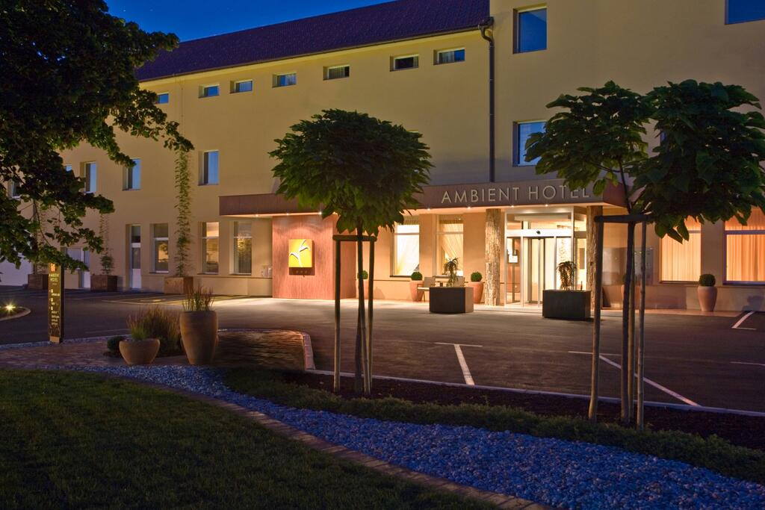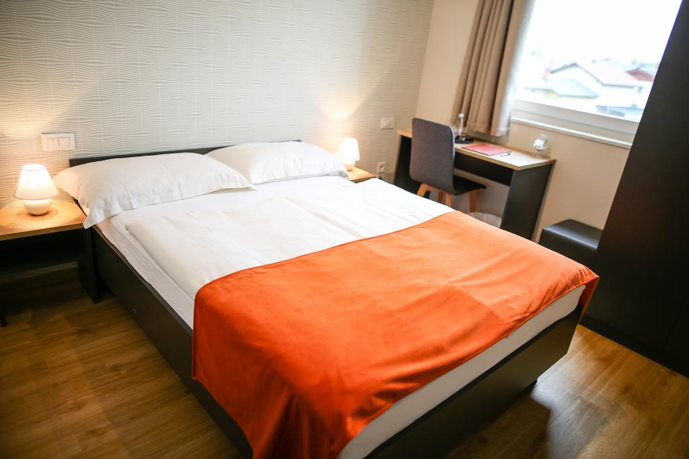
All athletes, officials and staff shall stay in the same hotel. Going home with personal vehicles is tolerated. Rooms are allocated on a first come, first serve basis. Accommodation includes breakfast and dinner. Lunch will always be served at the archery venue. All meals have to be taken in the hotel or at home, not at any other restaurant/fast-food/bar.
- Final Hotel Reservation & Transportation before 15 APRIL 2021

Important Note: Please refer to the accommodation pages below for detailed hotel information. Complete all necessary sections in WAREOS and make full payment for entries and accommodation by the specified deadlines. Bank transfers only, no credit cards will be accepted.

In addition, the LOC will be responsible to provide any event information at this hotel and provide transportation to the venues. Private vehicles can be used too.

ENTRY FEE
Entry Fees:
Individual: | 60 EUR per athlete (man, woman, juniors, cadets)
Teams: | 30 EUR per team
Officials: | FREE
Airport Transportation | 30 EUR per person
Lunch | 24 EUR per person for 3 days

PAYMENT CONDITIONS:
Entry fees should be paid before arrival or in cash on-site at the same time as the tournament check-in on Thursday, 06 MAY 2021 and Friday, 07 MAY 2021.

To confirm hotels reservations, a minimum 50% deposit of the total amount is required to be bank transferred to the OC before 20 APRIL 2021. Reservations after this date will be considered only according to availability. The final outstanding balance shall be made via bank transfer before arrival or in cash on-site at the same time as the tournament check-in. Accommodation cannot be guaranteed after this deadline. A balanced invoice will be provided via WAREOS.

BANK INFORMATION for ACCOMMODATION, TRANSPORTATION and
ENTRY FEES:
A/C Name: LOKOSTRELSKI KLUB KAMNIK
Address: CANKARJEVA CESTA 26
Telephone number: +386 40 507 893
City and Country: Kamnik, Slovenia
Bank: NOVA LJUBLJANSKA BANKA
Account Number: SI56 0231 2001 3771 875
Swift: LJBASI2X
Bank’s address: TRG REPUBLIKE 2
City: Ljubljana, Slovenia

NOTE: ALL PAYMENTS SHALL BE MADE IN EUR BY BANK TRANSFER. All bank charges will be paid by the participants. CREDIT CARDS are not accepted.

Cancellations & Changes
All cancellations and changes must be made through WAREOS / Open WAREOS:
- Cancellations received before 20 APRIL 2021 a full refund of the deposit payment will be made.
- Cancellations received after 20 APRIL 2021, no refund will be given.
- Refunds will be processed after the event.
- Name changes to team officials or athletes (same category and division) will be accepted up to two (2) days before official practice without any additional charge or penalty fees.
- Should flight arrival details change last minute, please contact the Organising Committee using the details indicated in the team managers’ booklet.
- If a participant’s arrival is later than the original scheduled arrival date, the room will be charged from the date of the original booking in WAREOS.
- An email will automatically notify the Organising Committee and Member Association of any changes made in WAREOS.

HEALTH REGULATIONS (COVID-19)
INFORMATION
- Everybody should follow the Government/public health authorities measures (national and sport-specific regulations) and be aware of the travel restrictions
- For your information, Medical infrastructure/Hospital with proper care will be reachable within 15 minutes from the venue, where COVID-19 test can be done

PERSONAL HYGIENE AND HEALTH ADVICES
- Anyone due to participate in the event who is feeling ill should not attend
- Participants (athlete, volunteer, official etc.) should proactively and regularly check their health status (including taking their temperature and monitoring for any symptoms)
- Stay home and self-isolate even with minor symptoms for 10 days or more depending on national protocols, when showing any symptoms (fever, tiredness, dry cough, headache, nasal congestion, runny nose, sore throat, difficulty breathing).
- Contact a healthcare provider immediately if any respiratory illness is noted
- Masks to be worn at all times everywhere (transport, common area in the hotel, venue, training etc.) except on shooting line
- Regularly and thoroughly clean your hands with an alcohol-based hand rub or wash them with soap and water
- Avoid touching eyes, nose and mouth
- Cover your mouth and nose with your bent elbow or tissue when you cough or sneeze. Then dispose of the used tissue immediately and wash your hands
- Avoid touching high-contact surfaces such as door handles, walls or windows, etc.
- Avoid going to crowded places
- Avoid steam rooms or saunas
- No spitting, as the main mode of transmission of the virus is in respiratory secretions
- No handshakes, high fives and any other personal contact
- Athletes should not share clothing, bar soap, sports equipment, water bottles or other personal items
TRANSPORT & ACCOMMODATION
- Avoid using public transport to go to the hotel and between the hotel and the venue
- All meals have to be taken in the hotel or at home, not at any other restaurant/bar
VENUE
- Access to the venue might be denied at any time in case of disease suspicion
- Limit contact/interactions
- Handwashing/alcohol- based hand gel will be available at multiple locations in the event facility and accommodation
- Regular toilet cleaning will be done (at least once per session)
- Tissues and containers will be at disposal to dispose of used tissues on transport to the venue, at the venue and any other facility
- No shows allowed. Winners will receive their medals in a simple ceremony only with the winners and their team, all wearing masks
- Medical post and designated personnel on site able to help assess cases and potential other illness will be present
- An isolation room/space to hold any symptomatic person found at the venue will be available
- Space on shooting line shall be 1.00 meter minimum per athlete
- No spectators are allowed during the event
PARTICIPANTS
- Maintain the staff/team to a minimum to minimise transmission
- Maintain social distancing, at least 1,5 metre distance between yourself and others at all time

ADDITIONAL INFORMATION
Medical emergency contact and location
Hospital: Zdravstveni dom dr. Julija Polca
Address: Novi trg 26, 1241 Kamnik
Phone: +386 1 831 86 00

Transportation
Transportation will be provided from LJUBLJANA airport to the official hotel, from two days before the official practice day and until two days after the closing day. Local transport will be available between the official hotel, practice and competition venues. Transport timetables will be confirmed.

Training
A training field will be available starting on 03 MAY 2021 approximately 20 minutes from the official hotels. There will be an additional payment of 15 EUR per person, per day for transport between the practice venue and hotels from 03 MAY 2021 to 06 MAY 2021.

Weather
Temperatures in May are expected between 12 and 24 degrees Celsius.

Media Registration
Media representatives can apply for registration by emailing info@archery.sport

Internet
Will be available in the official hotels for free (in hotel rooms and in the lobby). There will also be Wi-Fi available for access to results on venue.

Water
Each participant with receive clean bottles of water.

Visa
All participants who need an entry visa to Slovenia, will be required to complete the Visa Support sections in WAREOS by no later than 20 APRIL 2021.

It is the applicants’ responsibility for supplying the necessary information, ensuring all details are up to date, correct and submitted by the deadlines specified.

In addition, all participants that require a visa are kindly requested to supply a copy of their latest/valid passport. Copies of each application can be uploaded on WAREOS. All passport copies and personal details entered/uploaded to WAREOS will be held securely and in the strictest of confidence and not shared with other parties.

LOC CONTACT
Name: Gregor Koncan
Email: organization@veronicas-cup.org
Language: English
Phone number with international extension: +386 40 507 893
web page: www.veronica-cup.org
facebook www.facebook.com/veronicacup

