TO ALL World Archery Asia (WAA) Member Associations,
Dear President / Secretary General,

As Chair of the Local Organising Committee (LOC) of the 2022 Asia Cup – Stage II to be held in Sulaymaniyah, Iraq during 06 - 11 MAY 2022, I would like to invite you all to be part of one of the most important archery events to take place in the Asia/Iraq in 2022.

Sulaymaniyah also called Slemani, is a city in the east of the Kurdistan Region of Iraq, not far from the Iran–Iraq border. It is surrounded by the Azmar, Goyzha and Qaywan Mountains in the northeast, Baranan Mountain in the south and the Tasluja Hills in the west. The city has a semi-arid climate with very hot dry summers and cool wet winters.

Sulaymaniyah is the only city in Kurdistan that regularly celebrates World Music Day. In one trip to the city, a journalist working for the BBC wrote about Sulaymaniyah's distinct culture: "Culture is hugely important to the Kurdish people, especially in Sulaymaniyah, but there is a strong pull to the west—modernization and consumerism—driven perhaps by the satellite televisions they have had access to since they started running their own affairs.

The city was visited by more than 60,000 tourists in 2009. Sulaymaniyah attracted more than 15,000 Iranian tourists in the first quarter of 2010, many drawn by the fact it is not subject to strict laws faced at home. Newroz 2010 drew an exodus of Iranian tourists choosing to celebrate the event in the region.

Welcome to this amazing warm city. Our targets look forward to embracing your arrows, just as our hearts are ready to make your visit unforgettably enjoyable.

“Come and discover hundreds of reasons to visit and endless excuses to come back”.

Sincerely yours,

SAAD ALMASHHADANY
LOC President
Contact (Phone): +964 770 897 4945 (WhatsApp)
Email: 2022asiacup2.irq@gmail.com
2022 Asia Cup, Stage II
Sulaymaniyah, Iraq
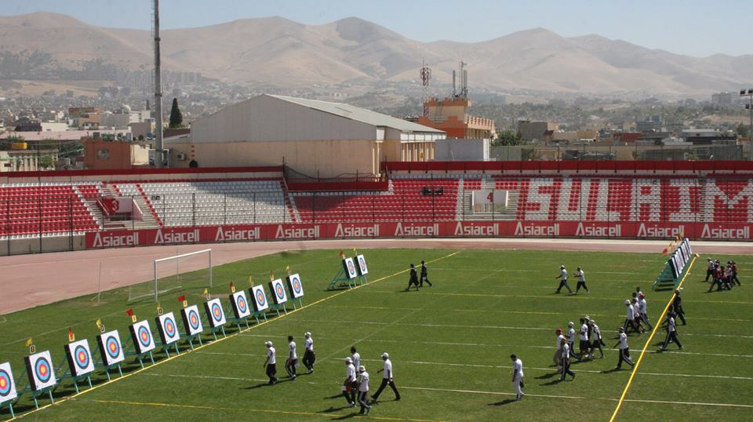
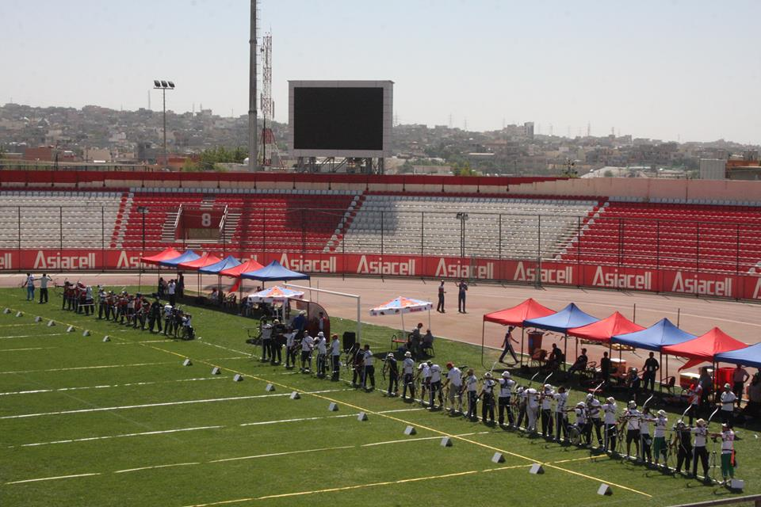
COMPETITION VENUE

The competition venue is the stadium of Sulaymaniyah Sport club which is located only 8-10 minutes from the Official Hotels.

IMPORTANT DATES

Please find enclosed detailed information regarding this event. To register participation, please complete all the necessary sections in WAREOS (https://extranet.worldarchery.sport) within the deadlines listed below.

Summary of deadlines:

- Registration Opening date on WAREOS | 24 January 2022
- Preliminary Entries | 06 February 2022
- Final Entries | 15 April 2022
- Hotel reservation confirmation | 20 March 2022
- Visa support | 10 March 2022

* Please respect the stated deadlines.

PRELIMINARY PROGRAM
05 May 2022  Thursday | Arrival of participants  Practice field will be available from 05 May 2022
06 May 2022  Friday | Official Practice (Equipment Inspection)  Opening Ceremony (TBC)  Team Managers Meeting
07 May 2022  Saturday | Qualification Round for Recurve and Compound  (Recurve and Compound)
08 May 2022  Sunday | Team / Mixed Team Eliminations & Finals (Till Semi-Finals 1/2)  (Recurve and Compound)  Individual Eliminations  (Recurve and Compound)
09 May 2022  Monday | Individual Eliminations & Finals (Till Semi-Finals 1/2)  (Compound, Recurve)
10 May 2022  Tuesday | Finals Compound – Individual and Team  - Compound (Women and Men)  - Award Ceremonies
11 May 2022  Wednesday | Finals Recurve – Individual and Team  - Recurve (Women and Men)  - Award Ceremonies  Closing Party (TBC)
12 May 2022  Thursday | Departure of participants

NOTE: This preliminary program is subject to change according to participation and T.V. requirements. All changes will be published and distributed in good time.

PRELIMINARY & FINAL REGISTRATION
All entries, accommodation reservations, transport needs, flight arrival/departure information and visa invitation letter requests are to be completed using the World Archery Online Registration System WAREOS https://extranet.worldarchery.sport. This system handles the entire registration process for this event. No entry forms, hotel reservations or transportation forms will be accepted; all information must be entered into WAREOS.

Member associations can login to WAREOS at http://extranet.worldarchery.sport with the username and password assigned by World Archery. After entering WAREOS, selecting the event from the list will allow a member association to register their athletes. Select/press the “Entries” button to see the list of categories in the event. Select/press the “category” to enter the athlete and official numbers/details participating for that event. A WAREOS User Manual can be downloaded in PDF format (English) upon login.

Contact wareos@archery.sport with any questions regarding technical problems on WAREOS. For any question regarding the organisation of the event (transport, accommodation, meals, invoices, visa etc.) please contact directly the LOC ( 2022asiacup2.irq@gmail.com ).

Athletes from a minimum of (4) different Member Associations shall be registered and participate in the event.

A maximum number of Four (4) athletes per country can be registered into each category and divisions of the event.

Start date for online registration using WAREOS 24 January 2022
End of Final registration using WAREOS 15 April 2022

* Please respect the stated deadlines.

Member Associations can only use WAREOS to make any changes or amendments to entries and will be able to do so at any time. An email will automatically notify the Organising Committee and Member Association of any changes made in WAREOS.

ENTRY FEES
Individual 150 USD per athlete
Official 100 USD per person
Guest 100 USD per person
- No Entry Fees for Teams and/or Mixed Teams
Entry fees for individual/Official include airport transfer to hotels, daily local transport to and from the practice and competition field to/from official hotels during the qualification, elimination and finals venues (timetable to be confirmed on site).
Entry fee for guest includes daily local transport to and from the practice and competition field to/from official hotels during the qualification, elimination and finals venues. They have no field of play access.

ACCOMMODATION
All participants are requested to stay only at the official hotels for logistic, management, and COVID control purpose.
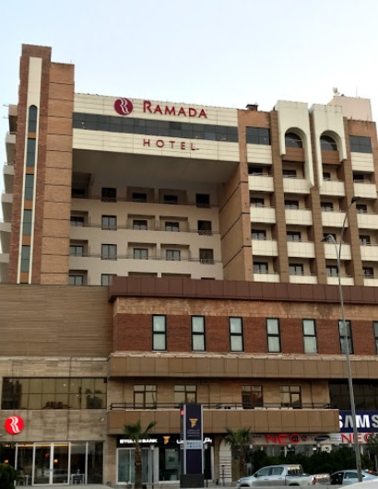
Ramada Hotel – Five Star Hotel
- Single Room price: USD 140.00 per room
- Number of rooms: 16
- Double/Twin Room price: USD 240.00 per room
- Number of rooms: 30
- Triple Room price: USD 300.00 per room
- Number of rooms: 13
- Board plan: Full board
- Check-in from 04 & 05 May 2022 – 14:00
- Hotel website:
https://www.wyndhamhotels.com/ramada/sulaymaniyah-iraq/ramada-hotel-sulaymaniyah-salim-street/overview
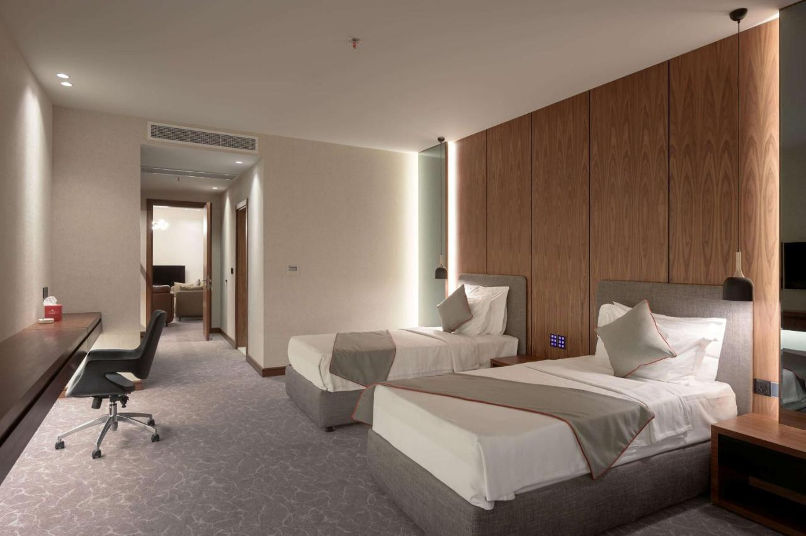
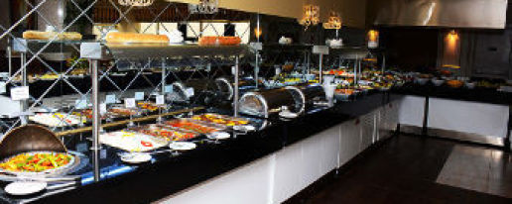

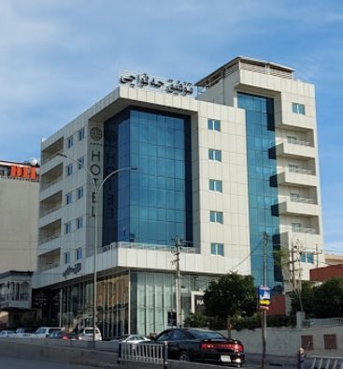
Halwachy Hotel – Four Star Hotel
- Single Room price: USD 140.00 per room
- Number of rooms: 10
- Double/Twin Room price: USD 240.00 per room
- Number of rooms: 20
- Triple Room price: USD 300.00 per room
- Number of rooms: 10
- Board plan: Full board
- Check-in from 04 & 05 May 2022 – 14:00
- Hotel Facebook Page:
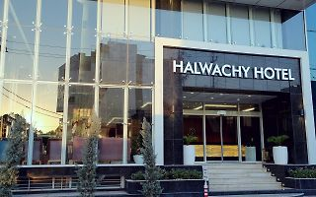
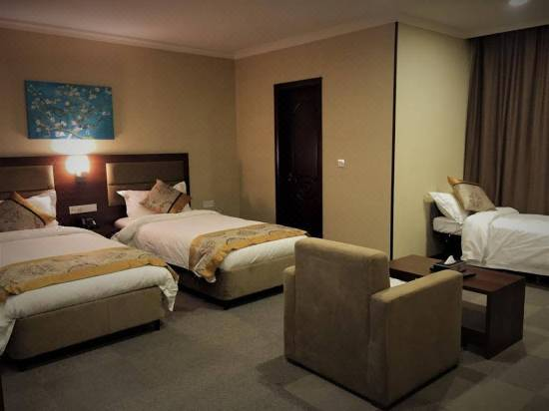
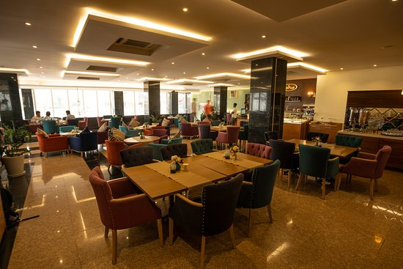
https://www.facebook.com/Halwachyhotel/
Both hotels are located in Salem Street in the down town of Sulaymaniyah. Their unique location is only 10 minutes walking away from the most popular local market (Souq Mawlawi), and they are only 20 minutes driving away from the Sulaymaniyah International Airport (ISU), and only 8-10 minutes driving away from the practice and competition venues.
Rooms are allocated on a first come, first serve basis starting by Ramada Hotel first then Halwachy Hotel. Accommodation includes breakfast, lunch and dinner with non-alcoholic drinks. Lunch will always be served at the archery venue; dinner will be served at the hotel (except for opening and closing days). Each participant will receive one FREE clean bottle of water (1.5 L) / day at hotel, and will also have FREE Laundry for (6) items (pcs) at official hotels during the stay.
In addition, the LOC will be responsible to provide any event information at these two official hotels and provide transportation to the venue.

TRANSPORTATION
FREE Transportation will be provided from Sulaymaniyah International Airport (ISU) to the official hotels on 5 May 2022 and 11, 12 May 2022 (Only 20 minutes between airport and official hotels). This airport has daily flights with many different airlines. Local transportation will be available between the official hotels, practice and competition venues for FREE. Transport timetables will be confirmed.

VISA
All participants who need an entry visa to Iraq, will be required to complete the Visa Support sections in WAREOS by no later than 10 March 2022

It is the applicants’ responsibility for supplying the necessary information, ensuring all details are up to date, correct and submitted by the deadlines specified.

In addition, all participants that require a visa are kindly requested to supply a copy of their latest/valid passport. Copies of each application can be uploaded on WAREOS. All passport copies and personal details entered/uploaded to WAREOS will be held securely and in the strictest of confidence and not shared with other parties.

PAYMENT CONDITIONS
Complete all necessary sections in WAREOS and a balanced invoice will be provided via WAREOS.

All Fees MUST be paid upon arrival in FULL CASH (in USD) before receiving accreditation cards (At registration office – Ramada Hotel).

CANCELLATIONS & CHANGES
All cancellations and changes must be made through WAREOS:

- Should flight arrival details change last minute, please contact the Organising Committee using the details indicated in the team managers’ booklet.
- If a participant’s arrival is later than the original scheduled arrival date, the room will be charged from the date of the original booking in WAREOS.
- An email will automatically notify the Organising Committee and Member Association of any changes made in WAREOS.

HEALTH REGULATIONS (COVID-19)
INFORMATION
- Everybody should follow the Government/public health authorities measures (national and sport-specific regulations) and be aware of the travel restrictions
- For your information, Medical infrastructure/Hospital with proper care will be reachable within 15 minutes from the venue, where COVID-19 test can be done.
COVID-19 TESTS
All archers, officials, delegates traveling to Sulaymaniyah, Iraq for the 2022 Asia Cup - Stage II are required to have a Negative PCR based COVID-19 test certificate obtained within 48 hours of the flight time and show it on arrival at the airport of Sulaymaniyah (ISU).

LOC will provide FREE COVID-19 tests to all participants on 11 May 2022 before departure day of the delegations (at the competition venue). This is mandatory for all participants to get on the plane by the local health authorities (Regardless the requirements of participants’ countries or vaccination status).
MEDICAL EMERGENCY CONTACT AND LOCATION
Hospital Name: D.O.H Sulaimaniyah Alinaji Clinic for Covid-19. Doctor Name: Ali Naji, MD, PhD.
Address: Wafayee 21 Street off Salim Street, Sulaimaniyah, Iraq. Phone number: +964 533191284

ADDITIONAL INFORMATION
Training
A training field will be available starting from 05 May 2022 at the Sulaymaniyah Club located approximately 8-10 minutes from the official hotels.

Weather
The last month of the spring, May, is a warm month in Sulaymaniyah, Iraq, with average temperature ranging between maximum 28.4°C (83.1°F) and minimum 14.5°C (58.1°F).
May is the last month it rains in Sulaymaniyah). Throughout May, Sulaymaniyah collects 41mm (1.61") of precipitation. Throughout the year, 745mm (29.33") of rain is accumulated.

Media Registration
Media representatives can apply for registration by emailing at 2022asiacup2.irq@gmail.com

Internet
Will be available in the official hotels for free (in hotel rooms and in the lobby). There will also be Wi-Fi available for access to results on venue.
Water
Each participant with receive one clean bottles of water (1.5 L) / day at hotel.
Bottled water will be available at the practice and competition venues.

About the city
Sulaymaniyah city is one of the most SAFE and CLEAN cities in Iraq, it is a touristic city and its people are very friendly and helpful to all foreigners. Sulaymaniyah is famous with the local products such as: Honey, Nuts, Dates, Dried Fruits and traditional sweets. Prices are very cheap especially for Mobile phones and clothes. US Dollar is accepted in most of the shops and exchange offices are everywhere in the local market. Exchange rate is 1USD = 1450 Iraqi Dinars.

LOC CONTACT

Name: Mr. Saad AL MASHHADANY
Address: Baghdad, Iraq
Email: 2022asiacup2.irq@gmail.com
Language: English / Arabic
Phone number with international extension: +964 770 897 4945 (WhatsApp)

Looking forward to welcoming you in Sulaymaniyah, Iraq.
