



December 28, 2021

To : President/Secretary General

All World Archery Members

**Subject : 2022 Asia Cup-World Ranking Tournament, Stage I Phuket on March 14 – 19, 2022**

Dear Sir / Madam,

We received the honor from World Archery Asia to organize the 2022 Asia Cup Stage I (World Ranking Tournament) for the year 2022 and it is our great pleasure to invite your archery teams to participate in this tournament. This event will be organized following the World Archery rules for 2022, in both divisions, Recurve and Compound.

Please find enclosed the necessary documents of registration, organization and participation for this event. Please complete all the necessary sections in WAREOS (<https://extranet.worldarchery.sport>) before the deadlines:

Summary of deadlines:

* Preliminary Entries 31 January 2022
* Final Entries 20 February 2022
* Final Hotel Reservation 14 February 2022
* Visa Support 31 January 2022

We earnestly look forward to the active support of our member associations to participate in this Asia Cup and awaiting your confirmation soon.

Yours in archery,



Sanguan Kosavinta

President of NAAT.

Chairman of the Organizing Committee

Address : 21, Seree Village 1, Seree Road 2, Huamark, Bangkok 10250, Thailand.

Tel. (66-2) 719 – 2777 Fax : (66-2) 719 – 2777, (66-2) 314-2332, (66-2) 319 - 6341

E-mail : [sany_bkk@yahoo.com](mailto:sany_bkk@yahoo.com) / [kosavinta@gmail.com](mailto:kosavinta@gmail.com).

IMPORTANT DATES

Please find enclosed detailed information regarding this event. To register participation, please complete all the necessary sections in WAREOS (<https://extranet.worldarchery.sport>) within the deadlines listed below.

Summary of deadlines:

|  |  |
| --- | --- |
| Registration Opening date on WAREOS | 28 December 2021 |
| Preliminary Entries | 31 January 2022 |
| Final Entries | 20 February 2022 |
| Hotel reservation | 14 February 2022 |
| Transportation | 3 March 2022 |
| Visa support | 31 January 2022 |
| Full refund cancellation deadline | 28 February 2022 |
| *After this deadline, the LOC is allowed to retain all amounts due by the Member Association. |  |

Please respect the stated deadlines.

PRELIMINARY PROGRAMME

|  |  |
| --- | --- |
| 12-13 March 2022 | Arrival of participants |
| 14 March 2022  Monday  15 March 2022  Tuesday | **Official Practice**  **Team Manager's Meeting**  **Equipment Inspection**  **Qualification Round** (Recurve, Compound) |
| 16 March 2022  Wednesday | **Qualification Round** (Recurve, Compound) |
| 17 March 2022  Thursday  18 March 2022  Friday  19 March 2022  Saturday | **Team Eliminations & Finals**  **Mixed Team Elimination**  **Recurve & Compound Individual Eliminations**  **Mixed Team Elimination**  **Recurve & Compound Individual Eliminations** |
| 20 March 2022  Sunday | Departure of teams |

**NOTE:** This preliminary programme is subject to change according to participation and TV requirements. All changes will be published and distributed in good time.

PRELIMINARY & FINAL REGISTRATION

All entries, accommodation reservations, transport needs, flight arrival/departure information and visa invitation letter requests are to be completed using the World Archery Online Registration System WAREOS <https://extranet.worldarchery.sport>. This system handles the entire registration process for this event. No entry forms, hotel reservations or transportation forms will be accepted; all information must be entered into WAREOS.

Member associations can login to WAREOS at <http://extranet.worldarchery.sport> with the username and password assigned by World Archery. After entering WAREOS, selecting the event from the list will allow a member association to register their athletes. Select/press the “Entries” button to see the list of categories in the event. Select/press the “category” to enter the athlete and official numbers/details participating for that event. A WAREOS User Manual can be downloaded in PDF format (English) upon login.

Contact [wareos@archery.sport](mailto:wareos@archery.sport) with any questions regarding **technical problems on WAREOS**. For any question regarding the organisation of the event (transport, accommodation, meals, invoices, visa etc.) please contact **directly the LOC**.

Athletes from a minimum of 4 different Member Associations shall be registered and participate in the event.

A maximum number of Four (4) athletes per country can be registered into each category and divisions of the event.

Member Associations can only use WAREOS to make any changes or amendments to entries and will be able to do so at any time. An email will automatically notify the Organising Committee and Member Association of any changes made in WAREOS.

ENTRY FEES

Individual 120 USD per athlete

Official 100 USD per person

Entry fees for individual/Official include airport transfer to hotels, daily local transport to and from the practice field to/from official hotels during the qualification, elimination, and finals venues (timetable to be confirmed on site).

PENALTY FEES TO BE PAID TO WORLD ARCHERY (CHF)

|  |  |
| --- | --- |
| Lost accreditation | **30.-** each |
| Lost classification card | **30 .-**each |
| Any change to the final country entry list, such as (but not limited to):   * Athlete or official name change * Date of birth change * Official position change * Absence or incomplete on-site contact person | **50.-** each change |

**NOTE:** CHF currency exchange rates will be those on the date of the event.

Member Associations that have penalty fees outstanding from 2021 will need to have paid these penalty fees before being eligible to enter and compete.

Any entries received less than 3 days before the team managers meeting for a Hyundai Archery World Cup or World Championships will be refused if no preliminary entry and/or final entry are made prior. This decision cannot be appealed by the teams and is fully compliant with the current World Archery rules, article 3.7.1.2. Entries received after the deadlines, are subject to penalties as clearly stated in the rule book and the invitation documents of World Cups and World Championships. A Member Association that has made final entries in WAREOS and does not participate will be invoiced for the number of entries entered in the system, unless they have informed World Archery and the Organizing Committee in writing at least one week prior to the event that they are unable to attend.

ACCOMMODATION

Each association should arrive in Phuket on March 12 or 13, 2022 the prepared facilities will be of the Royal Phuket City Hotel – Five Star Hotel, 154 Phangnga Rd, Tambon Talat Yai, Mueang Phuket District, Phuket 83000 (Official Hotel).

* Single Room price: USD 150.00 per room
* Number of rooms: 40
* Double/Twin Room price: USD 240.00 per room
* Number of rooms: 100
* Board plan: full board
* Check-in from 12 – 13 March 2022 - 14:00
* Late check-out 20 March 2022 - 12:00
* Hotel website: https://www.royalphuketcity.com/

*All participants are requested to **stay at the official hotel (Royal Phuket City Hotel)** for logistic, management, and COVID control purpose.

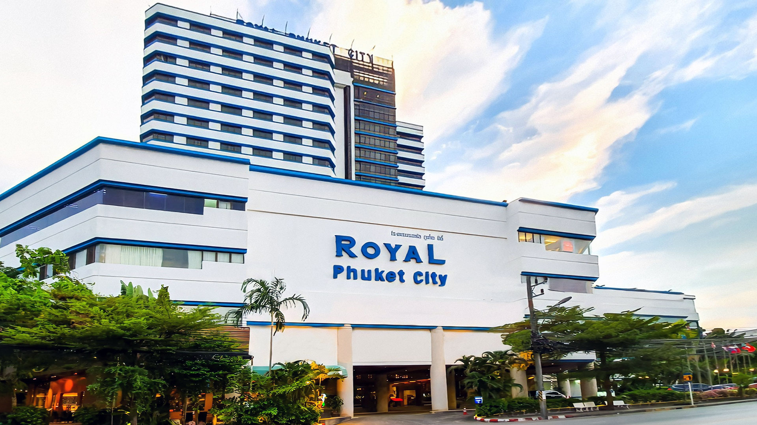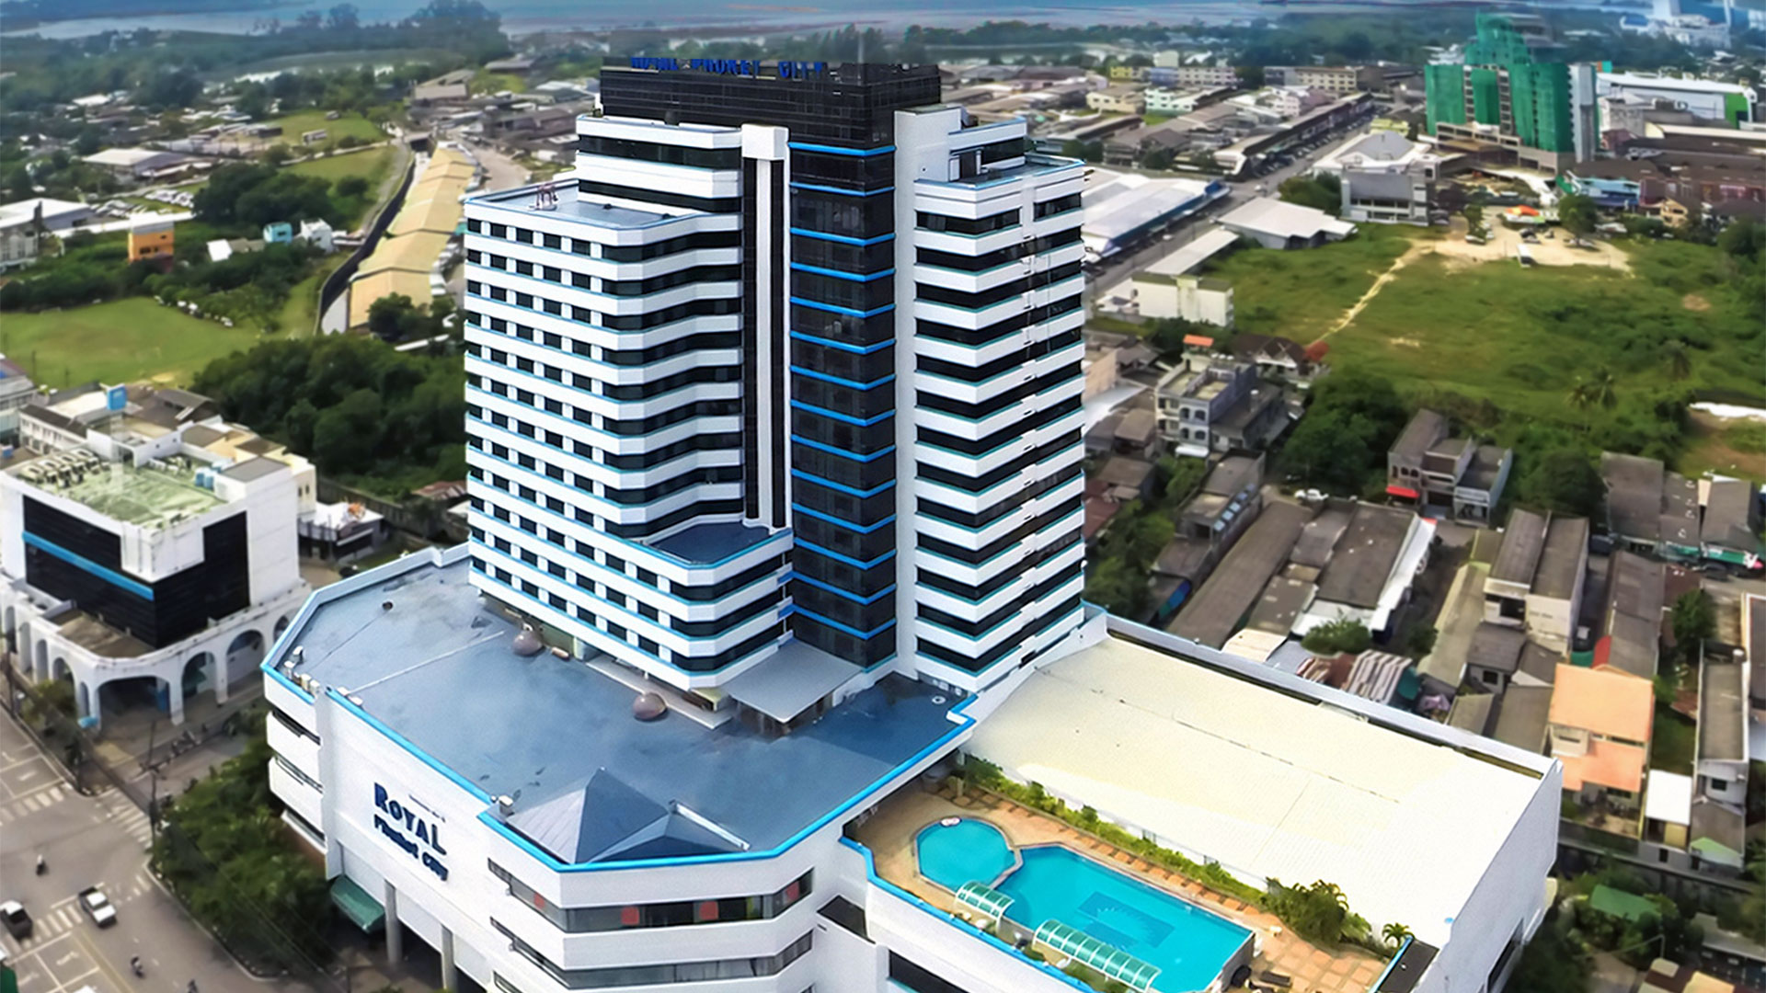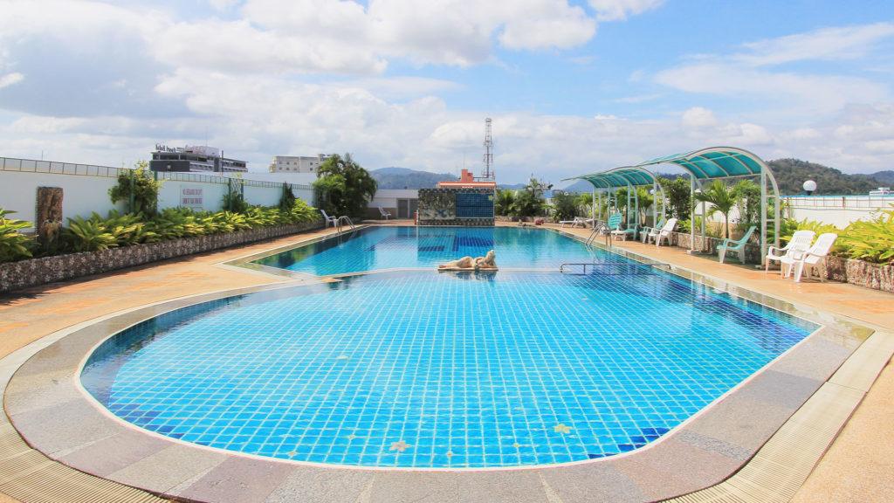 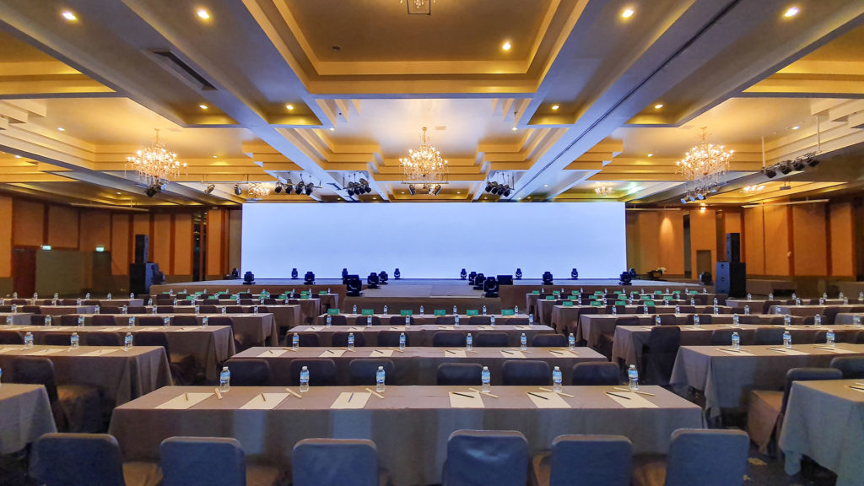

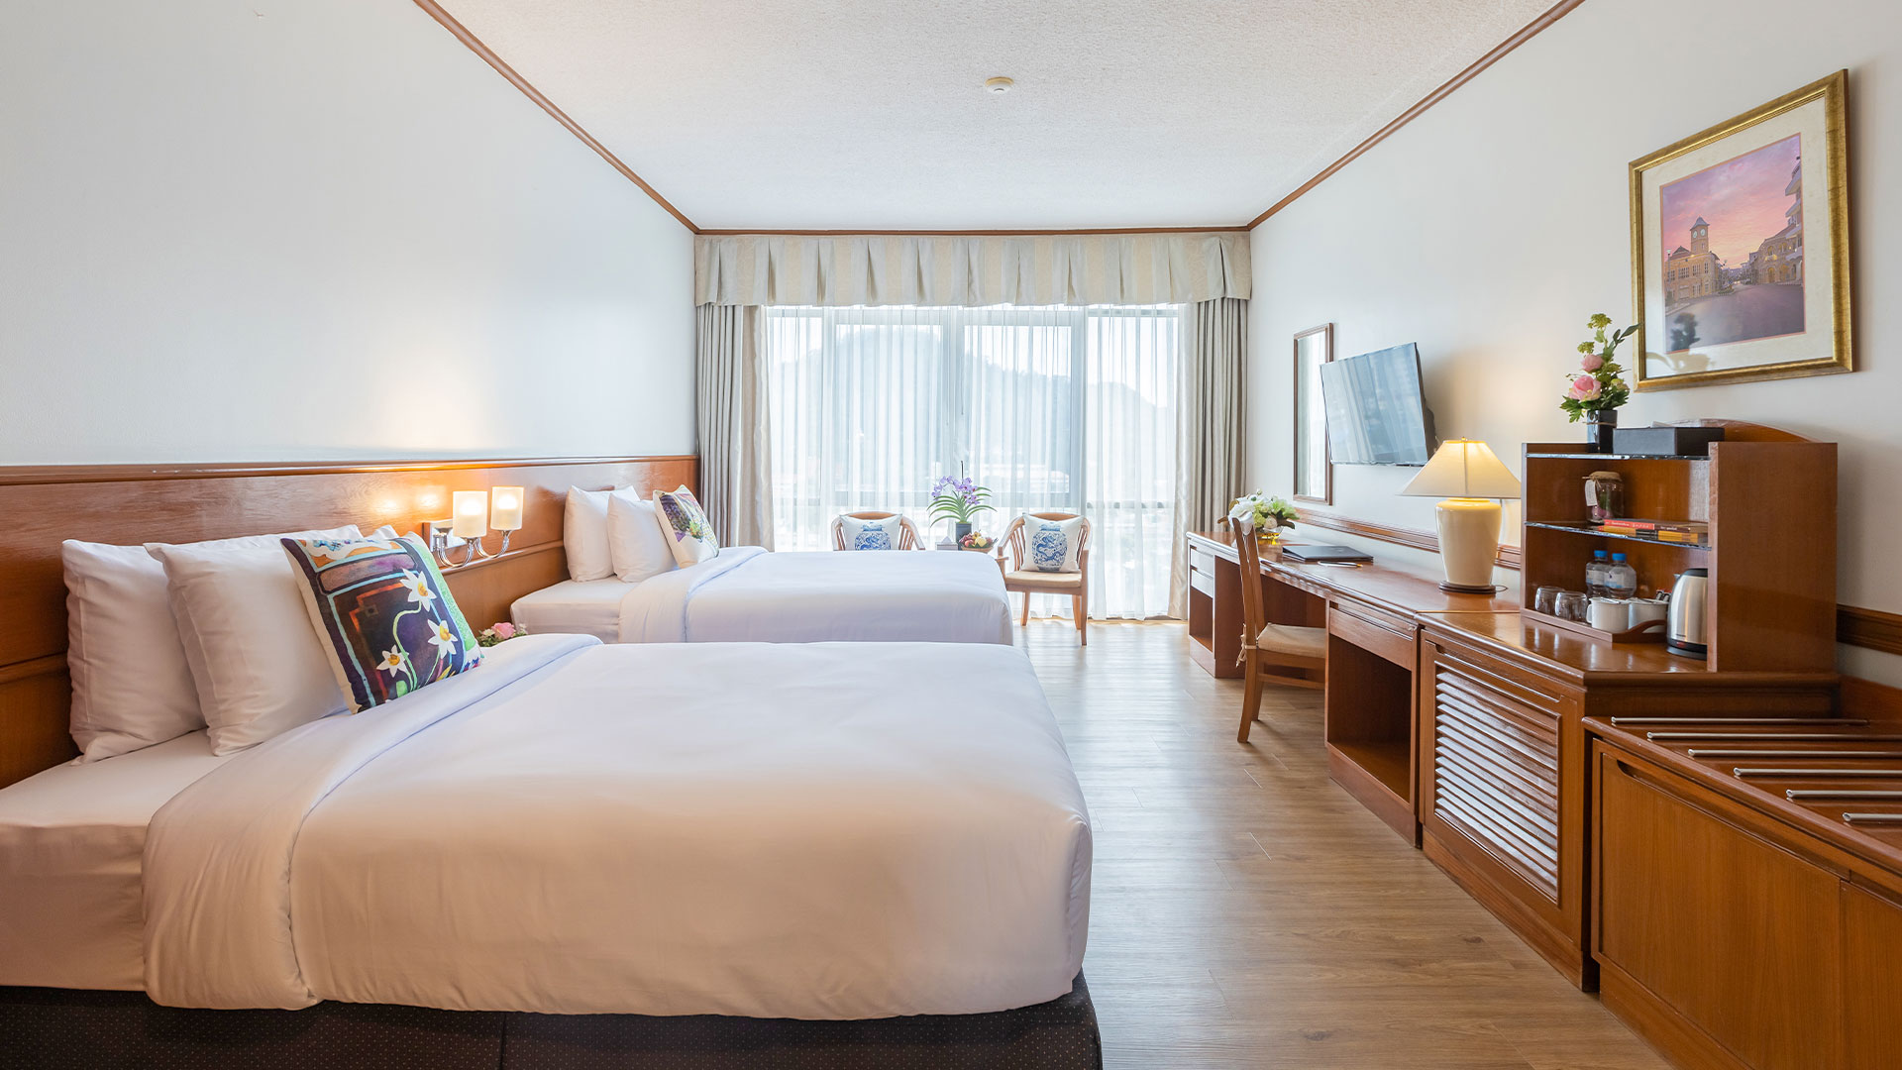 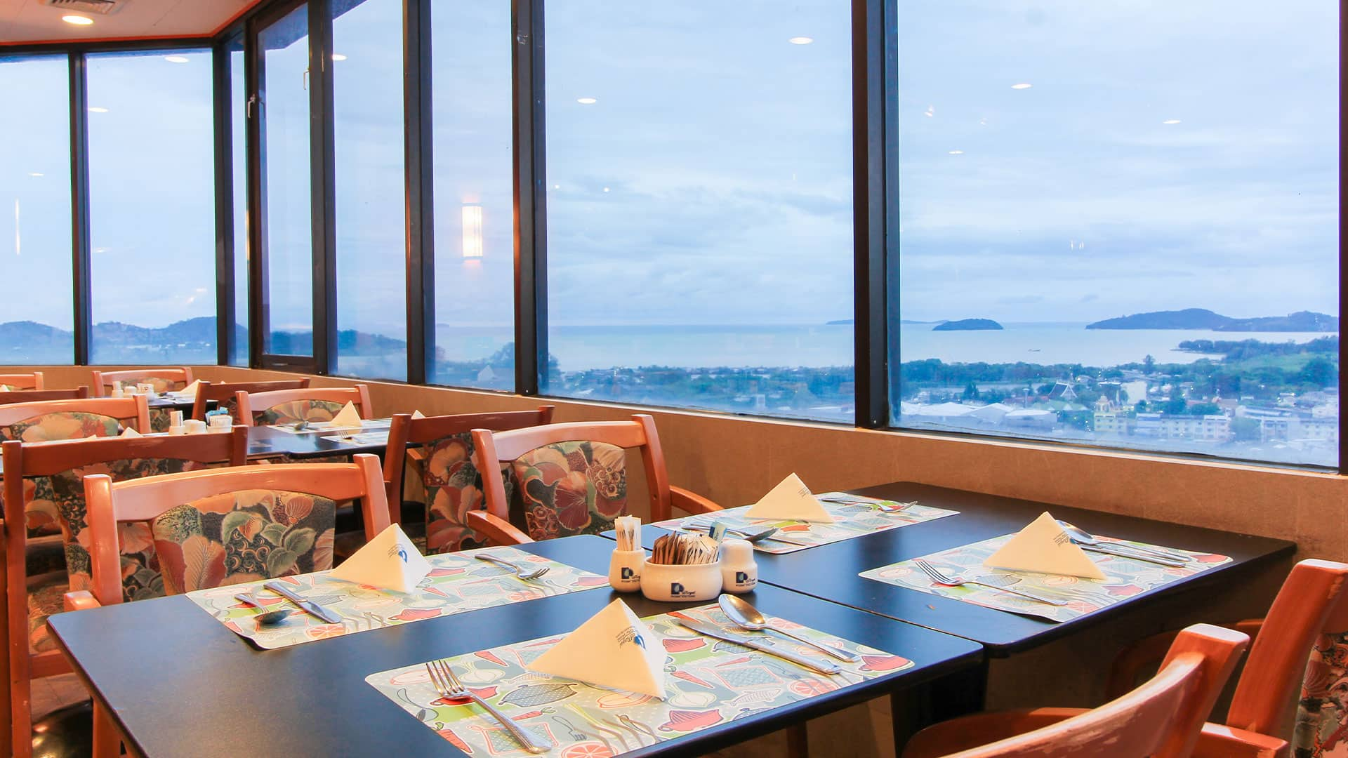

Rooms are allocated on a first come, first serve basis. Accommodation includes breakfast, lunch, and dinner with non-alcoholic drinks. Lunch will always be served at the archery venue (lunch box); dinner will be served at the hotel (buffet).

In addition, the LOC will be responsible to provide any event information at this hotel and provide transportation to the venues.

COVID TESTS FEE

**150 USD** per athlete/official/guest

This fee includes Three COVID tests from arrival day of the delegations until the last test necessary before departure.

You can book the COVID Test Fees for your delegation on WAREOS in the Extras section. The payment has to be made to the LOC.

The entry fees and COVID test fees should be paid in full before or on arrival. A balanced invoice will be provided via WAREOS.

**Measurements arriving in Thailand**

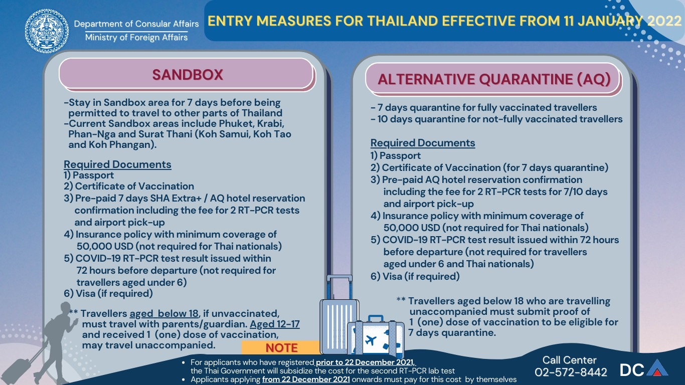

Travelers may purchase their health insurance which meets Thailand’s entry criteria here: <https://covid19.tgia.org/home/guidelinecovid>

TRANSPORTATION

We will be glad to meet you at Phuket International Airport and provide transportation to the official hotel. (Hotel - Venue - Hotel - Airport)

VISA

All participants who need an entry visa to Thailand, will be required to complete the **Visa Support sections** in WAREOS by no later than **31 January 2022**.

It is the applicants’ responsibility for supplying the necessary information, ensuring all details are up to date, correct and submitted by the deadlines specified.

In addition, all participants that require a visa are kindly requested to supply a copy of their latest/valid passport. Copies of each application can be uploaded on WAREOS. All passport copies and personal details entered/uploaded to WAREOS will be held securely and in the strictest of confidence and not shared with other parties.

PAYMENT CONDITIONS

Complete all necessary sections in WAREOS. Two available options are provided:

* Bank Transfer to Mr. Sanguan KOSAVINTA (Chairman of the Organizing Committee), no credit cards will be accepted. All bank charges will be paid by the participants.
* Cash in US Dollar only at the Organizing Committee’s Office on arrival.

Remark: All payment must be made in US dollar only. Credit card and Traveler’s Cheque are not accepted.

The entry fees should be paid in full before or on arrival.

BANK INFORMATION FOR ACCOMMODATION, TRANSPORTATION AND ENTRY FEES

A/C Name: Mr. Sanguan KOSAVINTA

Address: 21, 1st Seri Village, 2nd Seri Road, Huamark, Bangkapi, Bangkok 10250, Thailand

Telephone number: +6681 822 8260

City and Country: Bangkok, Thailand

Bank: SIAM COMMERCIAL BANK (Thanon Srinakarin (Krungthepkrita) Branch)

Account Number: 099-2-11044-0

Swift: SICOTHBK (Saving account)

Bank’s address: 256 Srinakarin Road, Huamark, Bangkapi, Bangkok 10240 Thailand

Bank’s Phone: +662 731 7400

City: Bangkok, Thailand

**NOTE**: ALL PAYMENTS SHALL BE MADE IN USD.

CANCELLATIONS & CHANGES

All cancellations and changes must be made through WAREOS / Open WAREOS:

* Cancellations received **before 28 February 2022** a full refund of the deposit payment will be made.
* Cancellations received **after 28 February 2022;** no refund will be given.
* Refunds will be processed after the event.
* Should flight arrival details change last minute, please contact the Organising Committee using the details indicated in the team managers’ booklet.
* If a participant’s arrival is later than the original scheduled arrival date, the room will be charged from the date of the original booking in WAREOS.
* An email will automatically notify the Organising Committee and Member Association of any changes made in WAREOS.

HEALTH REGULATIONS (COVID-19)

INFORMATION

* Everybody should follow the Government/public health authorities measures (national and sport-specific regulations) and be aware of the travel restrictions
* For your information, Medical infrastructure/Hospital with proper care will be reachable within 15 minutes from the venue, where COVID-19 test can be done.

Medical emergency contact and location

Patong Hospital, 57 Sainamyen Road, Patong, Kathu, Phuket 83150 Thailand,

Tel : +66 76 342 633

ADDITIONAL INFORMATION

Training

A training field will be available starting on 14 March 2022 at the Surakhun Stadium located approximately 3 minutes from the official hotels.

Weather

Phuket is a tropical island where it is never cold and very seldom hot. Temperatures in March are expected to range between 25 and 35 degrees Celsius. The average in the last few years has been 28.5 degrees Celsius.

Media Registration

Media representatives can apply for registration by emailing: kosavinta@gmail.com

Internet

Will be available in the official hotels for free (in hotel rooms and in the lobby). There will also be WiFi available for access to results on venue.

Water

Each participant with receive clean bottles of water.

Bottled water will be available at the qualification and practice venues.

LOC CONTACT

Name: Mr. Sanguan Kosavinta

Address: 21, Seree Village 1, Seree Road 2, Huamark, Bangkok 10250, Thailand

Email: kosavinta@gmail.com

Language: Chinese and English

Phone number with international extension: +6681 822 8260

Looking forward to welcoming you in Phuket, Thailand