TO ALL World Archery Asia (WAA) Members Association
Dear President / Secretary General

We are very pleased to inform you that 2022 Asia Cup (World Ranking Tournament) Stage III will be held in Sharjah, United Arab Emirates (UAE) from 20 – 25 December 2022.

On behalf of the Local Organizing Committee (LOC), we are honor to invite you to participate to one of the most important archery event to take place in Asia in 2022. Our priority is for you to be able to compete in a safe environment with all the necessary safety measures. These might change between now and the event and we request your cooperation and understanding. As we are fully aware of the risks that you are taking, we will always put priority on providing a safe environment for you to compete without worrying about your health and safety.

Sharjah is the third-most populous city in the United Arab Emirates, after Abu Dhabi and Dubai. The Emirate of Sharjah is one of the major economic centers in the country. Despite its proximity to Dubai, Sharjah has its distinctive culture and heritage. In 1998, Sharjah was awarded the "Cultural Capital of the Arab World" title by UNESCO representing the United Arab Emirates.

Local Organizing Committee (LOC) sincerely welcomes you and will do our best to host you with warm hospitality for providing beautiful memories and sharing friendship between participants from all over Asia during your stay in Sharjah, UAE.

We are looking forward to seeing you in Sharjah.

Sincerely yours,

Saeed Alkaabi Humaid Almusharrekh
Chairman Organizing Committee and Secretary, Organizing Committee and
President, UAE Archery Federation Secretary General, UAE Archery
Contact: +97165096113 Federation
Email: info@uaearchery.ae

Note 1: All archers, officials, delegates traveling to Sharjah for the 2022 Asia Cup (World Ranking Tournament) Stage III are required to have a Negative PCR based COVID 19 test certificate obtained within 48 hours of the flight time and show it on arrival at the airport.

IMPORTANT DATES:

Please find enclosed information regarding the details of this event and how to complete registration. To register participation, please complete all the necessary sections in WAREOS within the deadlines listed below:

Summary of Deadlines:

- Start date for online registration WAREOS 31 August 2022
- Preliminary Entries 20 September 2022
- Final Entries 29 November 2022
- Hotel Reservation 29 November 2022
- Transportation 29 November 2022
- Visa Support 24 October 2022
- Final Hotel Reservation & Payment 29 November 2022
- Full refund cancellation deadline 10 November 2022

*After this deadline, the LOC is allowed to retain all amounts due by the Member Association.

PRELIMINARY PROGRAMME
19 Dec 2022  Monday | Arrival of participants  Practice field will be available from 19 Dec 2022
20 Dec 2022  Tuesday | Official Practice (Equipment Inspection)  Opening Ceremony (TBC)  Team Managers Meeting
21 Dec 2022  Wednesday | Qualification Round for Recurve and Compound  (Recurve and Compound)
22 Dec 2022  Thursday | Team / Mixed Team Eliminations & Finals (Till Semi-Finals 1/2) (Recurve and Compound)  Individual Eliminations (Recurve and Compound)
23 Dec 2022  Friday | Individual Eliminations & Finals (Till Semi-Finals 1/2) (Compound, Recurve)
24 Dec 2022  Saturday | Finals Compound – Individual and Team  - Compound (Women and Men)  - Award Ceremonies
25 Dec 2022  Sunday | Finals Recurve – Individual and Team  - Recurve (Women and Men)  - Award Ceremonies
26 Dec 2022  Monday | Departure of participants

NOTE 2: This preliminary programme is subject to change according to participation and TV requirements. All changes will be published and distributed in good time.

PRELIMINARY & FINAL REGISTRATION

All entries, accommodation reservations, transport needs, flight arrival/departure information and visa invitation letter requests are to be completed using the World Archery Online Registration System WAREOS. These systems now handle the entire registration process for this event. No entry forms, hotel reservations or transportation forms will be accepted.

Member associations can login to WAREOS at http://extranet.worldarchery.sport with the username and password assigned by World Archery. After entering WAREOS, selecting the event from the list will allow a member association to register their athletes. Select/press the “Entries” button to see the list of categories in the event. Select/press the “category” to enter the athlete and official numbers/details participating for that event. A WAREOS User Manual can be downloaded in PDF format (English) upon login.

Contact Ms. CECILE TOSETTI (ctosetti@archery.sport) in the World Archery Office with any questions regarding technical problems on WAREOS. For any question regarding the organization of the event (transport, accommodation, meals etc.) please contact directly the LOC.

Athletes from a minimum of 4 different Member Associations shall be registered and participate in the event. Entries should be completed using WAREOS.

Start date for online registration using WAREOS 31 August 2022
End of Final registration using WAREOS 29 November 2022

Please respect the stated deadlines.

Member Associations can only use WAREOS to make any changes or amendments to entries and will be able to do so at any time. An email will automatically notify the Local Organizing Committee (LOC) and Member Association of any changes made in WAREOS.

*If any Athlete/official of a Member Association (MA) or any Member Association withdraw their name form the tournament after 10 November 2022, the respective Member Association (MA) are entitled to pay ACCOMMODATION FEES to the LOC as penalty.

ACCOMMODATION & GENERAL INFORMATION
Centro Sharjah
(Four Star)
Single Room price | $189
Number of rooms | 45
Twin Room price | $229
Number of rooms | 76
Board plan | Full Board
Check-In Date and time* | 19 December at 1400 hrs
Check-Out Date and time* | 26 December at 1200 hrs
*Early CHECK-IN from 9:00 am onwards can be provided, but is subject to availability.
*CHECK-OUT time: After 1200 hrs 50% charge up to 1800 hrs. Beyond 1800 hrs would be 100% of the room charge

Hotel Facilities
- Three (03) pieces of laundry per person per night
- Water bottle is unlimited in the rooms, participant’s area and events during the stay.
- Use of Workout, and Swimming Pool.
- Complimentary Tea/ Coffee making facilities in the room
- Wired & Wi-Fi broadband internet access.

Accommodation includes breakfast, lunch and dinner with non-alcoholic drinks. Lunch will be served at the archery tournament venue from 20 December 2022 (19 December Lunch will be provide in the hotel considering the presence at the hotel during Lunch hour and 26 December Lunch will also be provided under certain condition).
- Final Hotel Reservation before 29 November 2022
- Transportation before 29 November 2022

Note 3: Complete all necessary sections in WAREOS and make the payment for accommodation by the specified deadlines. Bank transfers only, no credit cards will be accepted. In addition, the LOC will be responsible to provide any event information at this hotel and provide transportation to the venues. Private vehicles cannot be used.

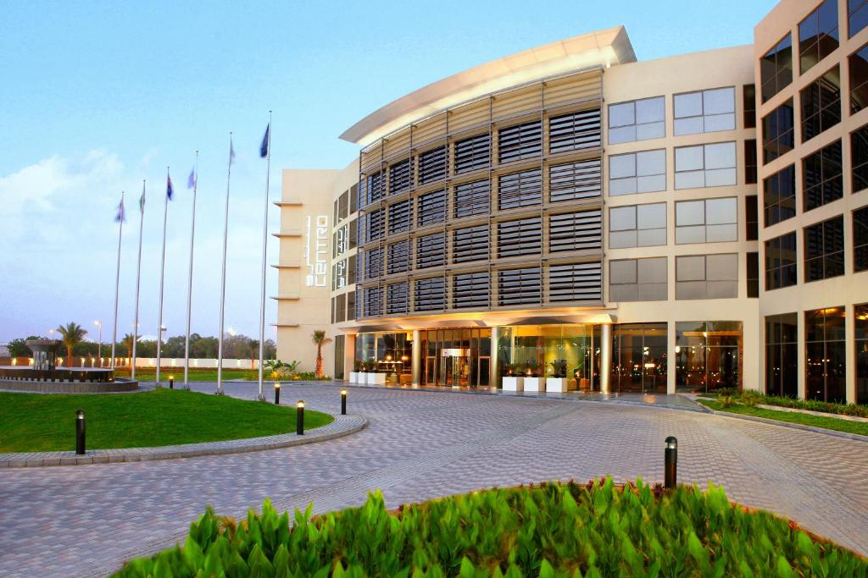
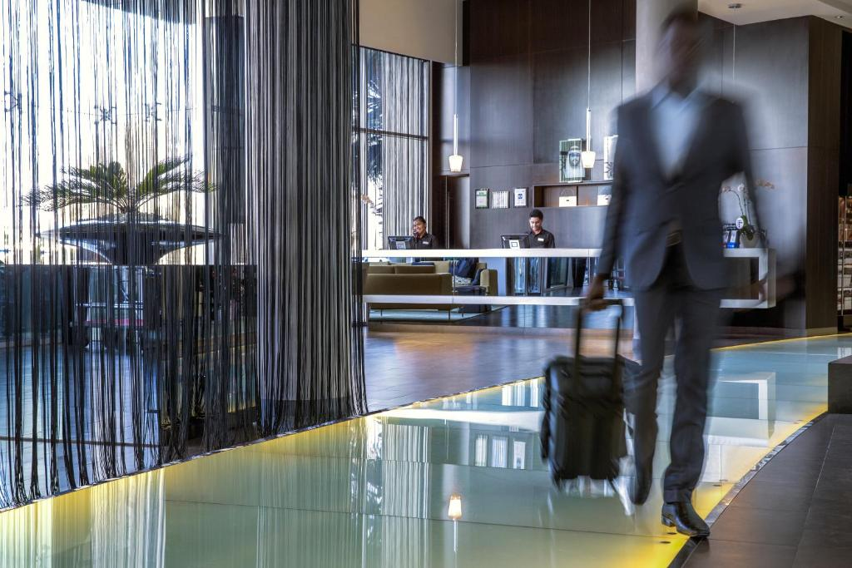
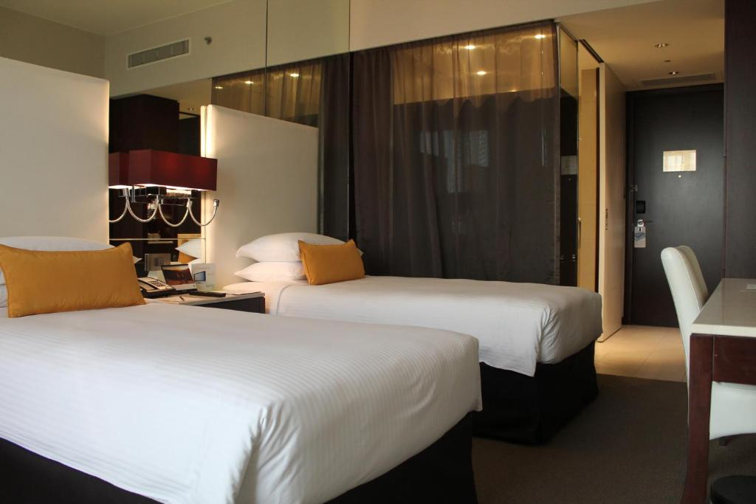
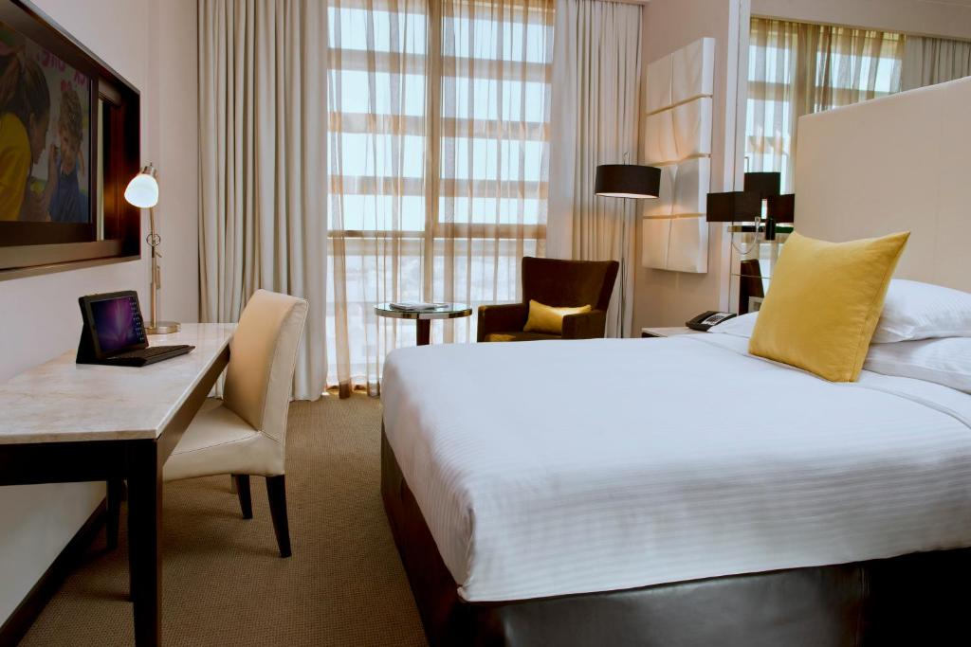
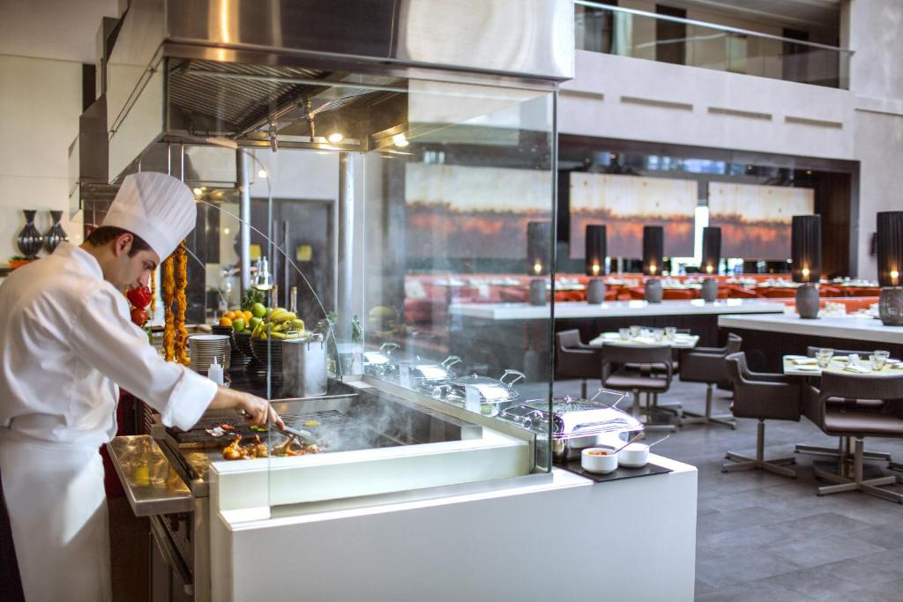
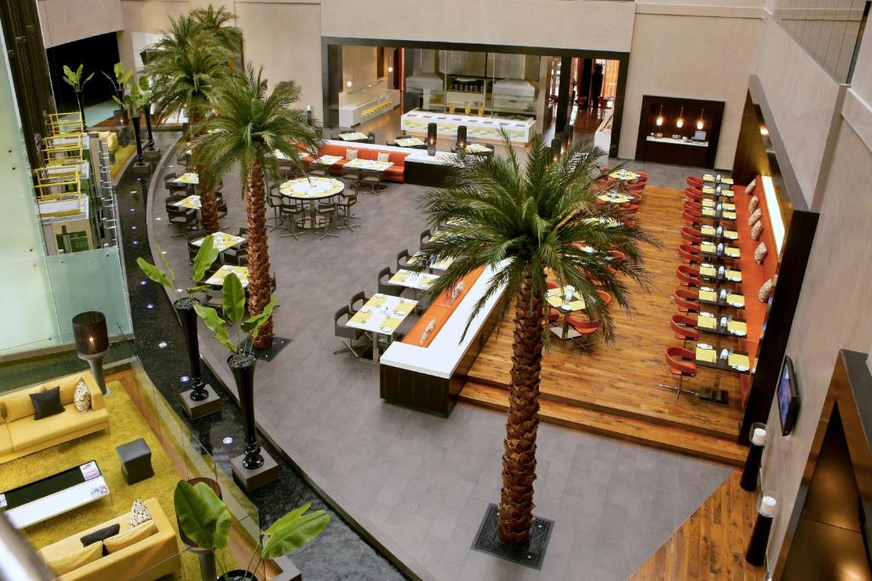
Centro Sharjah

Important Information
- Minimum of 40% of the total hotel reservation payment should be paid before 29 November 2022 by bank Transfer.
- The rest of 60% of the total amount to be paid in US$ (US dollar) to the Local Organizing Committee (LOC) office at the hotel upon arrival (before CHECK-IN).
- Countries who are willing to pay FULL amount of the hotel reservation before 29 November 2022 can also pay by bank transfer.
- Bank Transfer fees - Both sides are responsible by the sender.
- Hotel reservation cancellation should be made before 10 November 2022. Full refund will be made after the tournament.
ENTRY FEE
Individual: | $150 per athlete
Officials: | $100 per person

Entry fees include daily local transport to and from the practice field to/from official hotels during the qualification, elimination and finals venues (timetable to be confirmed on site).

COVID TESTS FEE

30 USD per athlete/official/guest
This fee includes 01 (ONE) COVID tests before departure (If required).
You can book the COVID Test Fees for your delegation on WAREOS in the Extras section. The payment has to be made to the LOC.

Covide 19 Pcr Test Payment Conditions:
The entry fees and COVID test fees should be paid in full before arrival.
A balanced invoice will be provided via WAREOS.

PAYMENT CONDITIONS:

The entry fees should be paid in FULL before 29 November 2022.
Reservations after this date will be considered only according to availability. The final outstanding balance of the accommodation along with other due payment shall be made via bank transfer before arrival or at the hotel upon arrival (before CHECK-IN). Accommodation cannot be guaranteed after this deadline. A balanced invoice will be provided via WAREOS. ALL PAYMENT SHALL BE MADE IN USD (US DOLLAR)

Bank Information for Accommodation, and Entry Fees:

BANK DETAILS (PAYMENT IN USD ONLY)
Account Name: UAE Archery Federation
NOTE 4: Please send the scanned copy of the Bank Transfer information after remittance by E-mail at Asiacup2022@uaearchery.ae

NOTE 5: CREDIT CARDS are not accepted.
Account Number: 1015715978201
Bank Name: Emirates NBD
Account IBAN AE740260001015715978201
Swift Code: EBILAEAD

CANCELLATIONS & CHANGES
All cancellations and changes must be made through WAREOS / Open WAREOS:
- Cancellations received before 10 November 2022 a full refund of the deposit payment will be made.
- Cancellations received after 10 November 2022, no refund will be given.
- Refunds will be processed after the event.
- Name changes to team officials or athletes (same category and division) will be accepted up to 1700 hrs two (2) days before official practice without any additional charge or penalty fees.
- Should flight arrival details change last minute, please contact the LOC.
- If a participant’s arrival is later than the original scheduled arrival date, the room will be charged from the date of the original booking in WAREOS.
- An email will automatically notify the LOC and Member Association of any changes made in WAREOS.

HEALTH REGULATIONS (COVID-19)

Information
- Everybody should follow the Government/public health authority’s measures (national and sport-specific regulations) and be aware of the travel restrictions.
- For your information, Medical infrastructure/Hospital with proper care will be reachable within 15 minutes from the venue.

Personal Hygiene and Health Advices
- Anyone due to participate in the event who is feeling ill should not attend
- Participants (athlete, volunteer, official etc.) should proactively and regularly check their health status (including taking their temperature and monitoring for any symptoms)
- Stay home and self-isolate even with minor symptoms for 10 days or more depending on national protocols, when showing any symptoms (fever, tiredness,
dry cough, headache, nasal congestion, runny nose, sore throat, difficulty
breathing).
- Contact a healthcare provider immediately if any respiratory illness is noted
- Masks to be worn at all times everywhere (transport, common area in the hotel, venue, training etc.) except on shooting line
- Regularly and thoroughly clean your hands with an alcohol-based hand rub or
wash them with soap and water
- Avoid touching eyes, nose and mouth
- Cover your mouth and nose with your bent elbow or tissue when you cough or
sneeze. Then dispose of the used tissue immediately and wash your hands
- Avoid touching high-contact surfaces such as door handles, walls or windows, etc.
- Avoid going to crowded places
- Avoid steam rooms or saunas
- No spitting, as the main mode of transmission of the virus is in respiratory secretions
- No handshakes, high fives and any other personal contact
- Athletes should not share clothing, bar soap, sports equipment, water bottles or other personal items

Transport
    - Transportation service from the Sharjah Airport to Hotel to Sharjah Airport (arrival and departure): USD 10 per person (one ways).
    - Transportation service from the Dubai Airport to Hotel to Dubai Airport (arrival and departure): USD 25 per person (one ways).
    - Transportation from Hotel to tournament venue and vice-versa during the practice and competition days’ are organized by the Organizing Committee at NO CHARGE.

Venue
- Access to the venue might be denied at any time in case of disease suspicion
- Limit contact/interactions
- Hand washing/alcohol- based hand gel will be available at multiple locations in the event facility and accommodation
- Regular toilet cleaning will be done (at least once per session)
- Tissues and containers will be at disposal to dispose of used tissues on transport to the venue, at the venue and any other facility
- No shows allowed. Winners will receive their medals in a simple ceremony only with the winners and their team, all wearing masks
- Medical post and designated personnel on site able to help assess cases and potential other illness will be present
- An isolation room/space to hold any symptomatic person found at the venue will be available
- Space on shooting line shall be 1.00 meter minimum per athlete
- No spectators are allowed during the event

Participants
- Maintain the staff/team to a minimum to minimize transmission
- Maintain social distancing, at least 1.5 meter distance between yourself and others at all time

ADDITIONAL INFORMATION

Medical emergency contact and location
A full time Medical team will be available at the hotel, tournament and practice venue (from 20 – 25 December 2022)
Contact: Sharjah Kuwait Hospital
www.ehs.gov.ae
Tel : +97165242111
Dir: +97165031062

Tournament Venue Transportation
Transportation from Hotel to venue and vice-versa (from 20 December – 25 December 2022) is organized by Local Organizing Committee (LOC).

Tournament and Practice Venue
The tournament venue will Al Thiqah in Sharjah for Asia Cup, World Ranking Tournament, Stage III
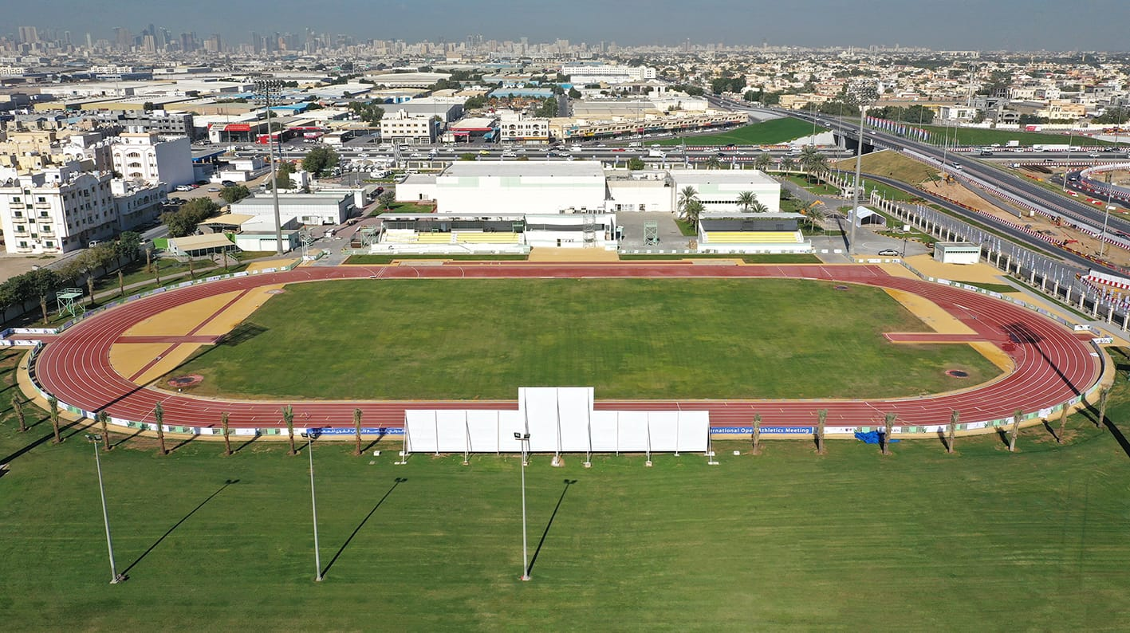

Weather
The climate in Sharjah during December can be summarized as warm and dry.
December is in the winter in Sharjah and is typically the 3rd coldest month of the year. Daytime maximum temperatures average around a comfortable 26°C (79°F), whilst at night 15°C (59°F) is normal.

On average December is the 3rd wettest month of the year in Sharjah with around 16mm of rain making it a dry time to visit. This rainfall is typically spread over 2 days, although this may vary considerably. On the flip side this corresponds to an average of 8.7 hours of sunshine per day.

Media Registration
Media representatives can apply for registration by emailing to: info@archery.sport

Team Accreditation
Please also send your team’s passport size photo for your accreditation card along with their name and designation through E-mail, before 29 November 2022. The maximum size of the document must be 1MB.

Water
Each participant with receive clean bottles of water. Unlimited bottled water will be available at the hotel, qualification and practice venues.

National Flag and Anthem
All participating teams are requested to bring two national flags (Height 3 Feet X Width As per ratio) and a CD of the National Anthem along with them, for the Awarding Ceremony.

Visa
All participants who need an entry visa to Sharjah, will be required to complete the Visa Support sections in WAREOS by no later than 24 October 2022.

Please note that each passport (participant/sports delegates/anyone traveling for the championships) must be valid AT LEAST 06 (SIX) MONTHS from the time of your entry in Sharjah (UAE). In the countries where there is UAE Embassy/Visa Consulate, the member associations are requested to obtain their visa accordingly. We will provide a visa support letter to avail visas from UAE Embassy / High Commission / Visa Consulate.

LOC CONTACT

Name: Rasha Yahya Ahmed
Email: Asiacup2022@uaearchery.ae
Number: 00971505361142 (WhatsApp - 24/7)
Language: English

Looking forward to welcoming you in Sharjah, UAE.

