TO ALL World Archery Asia Member Associations,
Dear President,

As Chair of the Local Organising Committee (LOC) of the 2022 Asian Para Archery Championship to be held in Almaty, Kazakhstan on 30th of May 2022, I would like to invite you all to be part of one of the most important archery events to take place in the Central Asia in 2022.

Today’s Almaty is the Kazakhstan's largest metropolis, scientific and educational, cultural, and historical, economic and financial, banking and industrial center of the country.

Almaty is located in the south-east of Kazakhstan, at the foot of the northern of Tien Shan ridge - Zaili Alatau. The urban territory of Almaty, the home-town of the famous variety of apples “Almaty aport“. City has more than eight thousand hectares occupied by gardens and parks, squares and boulevards. Ile-Alatau National Park, whose territory includes nature reserve and wildlife sanctuary, begins right in the Almaty vicinity.

Modern Almaty is a world-renowned sports center. Almaty won the international recognition thanks to such prestigious events as “Asian Games 2011”, World Boxing Championships, stages of World Cup in judo and ski jumping, a stage of world “Grand Prix-2013” in volleyball and professional cycling race “Tour of Almaty”

Almaty hosted the World Winter Universiade of 2017. By the opening of the Universiade the city had had a sports village, new ice palace and many other modern facilities built in its territory Almaty is the country’s largest city, former capital. Almaty is one of the major cultural, scientific, economic and transport centers of the independent state of the Kazakh Republic.

Welcome to this amazing city that reinvents itself every day. Our targets look forward to embracing your arrows, just as our hearts are ready to make your visit unforgettably enjoyable.

“Come and discover hundreds of reasons to visit and endless excuses to come back”.

Sincerely yours,

Almaz Murzabekov
4th Para Asian Championship OC Chairman

IMPORTANT DATES

Please find enclosed detailed information regarding this event. To register participation, please complete all the necessary sections in WAREOS (https://extranet.worldarchery.sport) within the deadlines listed below.

Summary of deadlines:

Registration Opening date on WAREOS | 20 February 2022
Preliminary Entries | 28 February 2022
Final Entries | 9 May 2022
Late entries fee | 23 May 2022
Hotel reservation down-payment (30%) | 22 April 2022
Hotel reservation and payment | 9 May 2022
Transportation | 9 May 2022
Visa support | 7 April 2022
Full refund cancellation deadline  *After this deadline, the LOC is allowed to retain all amounts due by the Member Association. | 9 May 2022

Please respect the stated deadlines.

PRELIMINARY PROGRAMME
30 May 2022  Monday | Arrival of participants
31 May 2022  Tuesday | Official Practice (Equipment Inspection)  Classification
01 June 2022  Wednesday | Qualification Round (Recurve Open, Compound Open, W1 Open)
02 June 2022  Thursday | Individual Eliminations  (Recurve Open)
03 June 2022  Friday | Individual Eliminations  (Compound open, W1 Open)
04 June 2022  Saturday | Team Eliminations  (Recurve Open, Compound open, W1 Open)
05 June 2022  Sunday | Finals  Individual (Compound open, W1 Open)  Team (Compound open, W1 Open)  Award ceremonies
06 June 2022  Monday | Finals  Individual (Recurve Open)  Team (Recurve Open)  Award ceremonies (Recurve Open)
07 June 2022 | Departure of teams

NOTE: This preliminary programme is subject to change according to participation and TV requirements. All changes will be published and distributed in good time.

PRELIMINARY & FINAL REGISTRATION
All entries, accommodation reservations, transport needs, flight arrival/departure information and visa invitation letter requests are to be completed using the World Archery Online Registration System WAREOS https://extranet.worldarchery.sport. This system handles the entire registration process for this event. No entry forms, hotel reservations or transportation forms will be accepted; all information must be entered into WAREOS.

Member associations can login to WAREOS at http://extranet.worldarchery.sport with the username and password assigned by World Archery. After entering WAREOS, selecting the event from the list will allow a member association to register their athletes. Select/press the “Entries” button to see the list of categories in the event. Select/press the “category” to enter the athlete and official numbers/details participating for that event. A WAREOS User Manual can be downloaded in PDF format (English) upon login.

Contact wareos@archery.sport with any questions regarding technical problems on WAREOS. For any question regarding the organisation of the event (transport, accommodation, meals, invoices, visa etc.) please contact directly the LOC.

Athletes from a minimum of 4 different Member Associations shall be registered and participate in the event.

A maximum number of four (4) athletes per country can be registered into each category and divisions of the event.

Member Associations can only use WAREOS to make any changes or amendments to entries and will be able to do so at any time. An email will automatically notify the Organising Committee and Member Association of any changes made in WAREOS.

ENTRY FEES

Individual 150 USD per athlete
Official 100 USD per person
Teams No entry fees for teams

Any changes made after the deadlines specified the following penalty fees to will automatically be applied:
COVID TESTS FEE
30 USD per athlete/official
This fee includes 02 (two) COVID tests from arrival day of the delegations until the last test necessary before departure.
You can book the COVID Test Fees for your delegation on WAREOS in the Extras section. The payment has to be made to the LOC.

PAYMENT CONDITIONS:
The entry fees and COVID test fees should be paid in full before official practice.
A balanced invoice will be provided via WAREOS.

PAYMENT CONDITIONS:
The entry fees should be paid in FULL before official practice.

Reservations after this date will be considered only according to availability. The final outstanding balance shall be made via bank transfer before arrival. Accommodation cannot be guaranteed after this deadline. A balanced invoice will be provided via WAREOS.

PENALTY FEES TO BE PAID TO ORGANISING COMMITTEE

Penalty fees for Late Entries (after final deadline): | 50 per entry
Penalty fees for not filling Preliminary entries | No fees
Penalty fee for differences between preliminary and final entries: | No Fees

PENALTY FEES TO BE PAID TO WORLD ARCHERY (CHF)
Lost accreditation | 30.- each
Lost classification card | 30 .-each
Any change to the final country entry list, such as (but not limited to):  - Athlete or official name change  - Date of birth change  - Official position change  - Absence or incomplete on-site contact person | 50.- each change

NOTE: CHF currency exchange rates will be those on the date of the event.

Member Associations that have penalty fees outstanding from 2021 will need to have paid these penalty fees before being eligible to enter and compete.

Any entries received less than 3 days before the team managers meeting for a Hyundai Archery World Cup or World Championships will be refused if no preliminary entry and/or final entry are made prior. This decision cannot be appealed by the teams and is fully compliant with the current World Archery rules, article 3.7.1.2. Entries received after the deadlines, are subject to penalties as clearly stated in the rule book and the invitation documents of World Cups and World Championships. A Member Association that has made final entries in WAREOS and does not participate will be invoiced for the number of entries entered in the system, unless they have informed World Archery and the Organizing Committee in writing at least one week prior to the event that they are unable to attend.

ACCOMMODATION

Accommodation A - athlete dormitories at the venue
- Single Room price: USD 90 per room
- Number of rooms: 12
- Double/Twin Room price: USD 160 per room
- Number of rooms: 49
- Triple Room price: USD 210 per room
- Number of rooms: 23
- Board plan: full board
- Check-in from (30 May 2022, 12:00)
- Check-out (12:00)
- Hotel website: https://akbulak-olympic.kz/
- Early check-in Chargeable (06:00-12:00 half day charge, before 06:00 full day charge)
- Late check-in Chargeable (12:00 – 18:00 half day charge, after 18:00 full day charge)
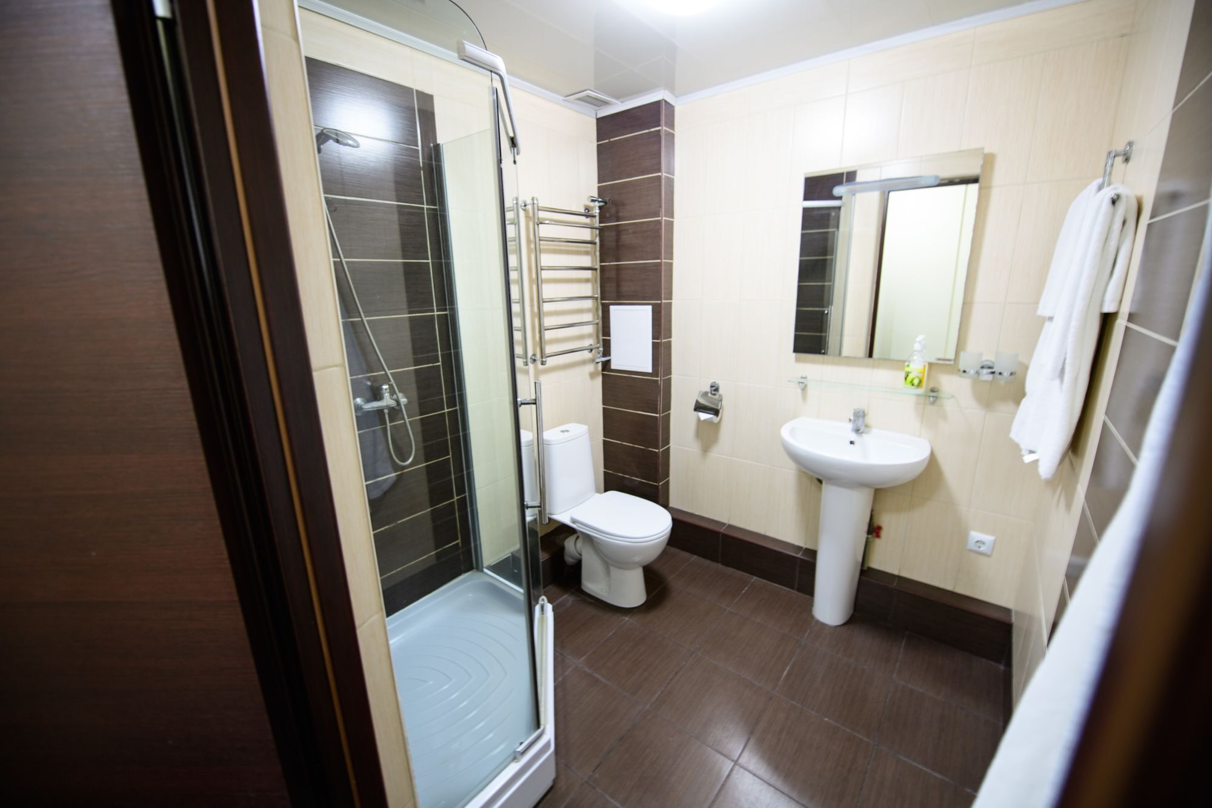
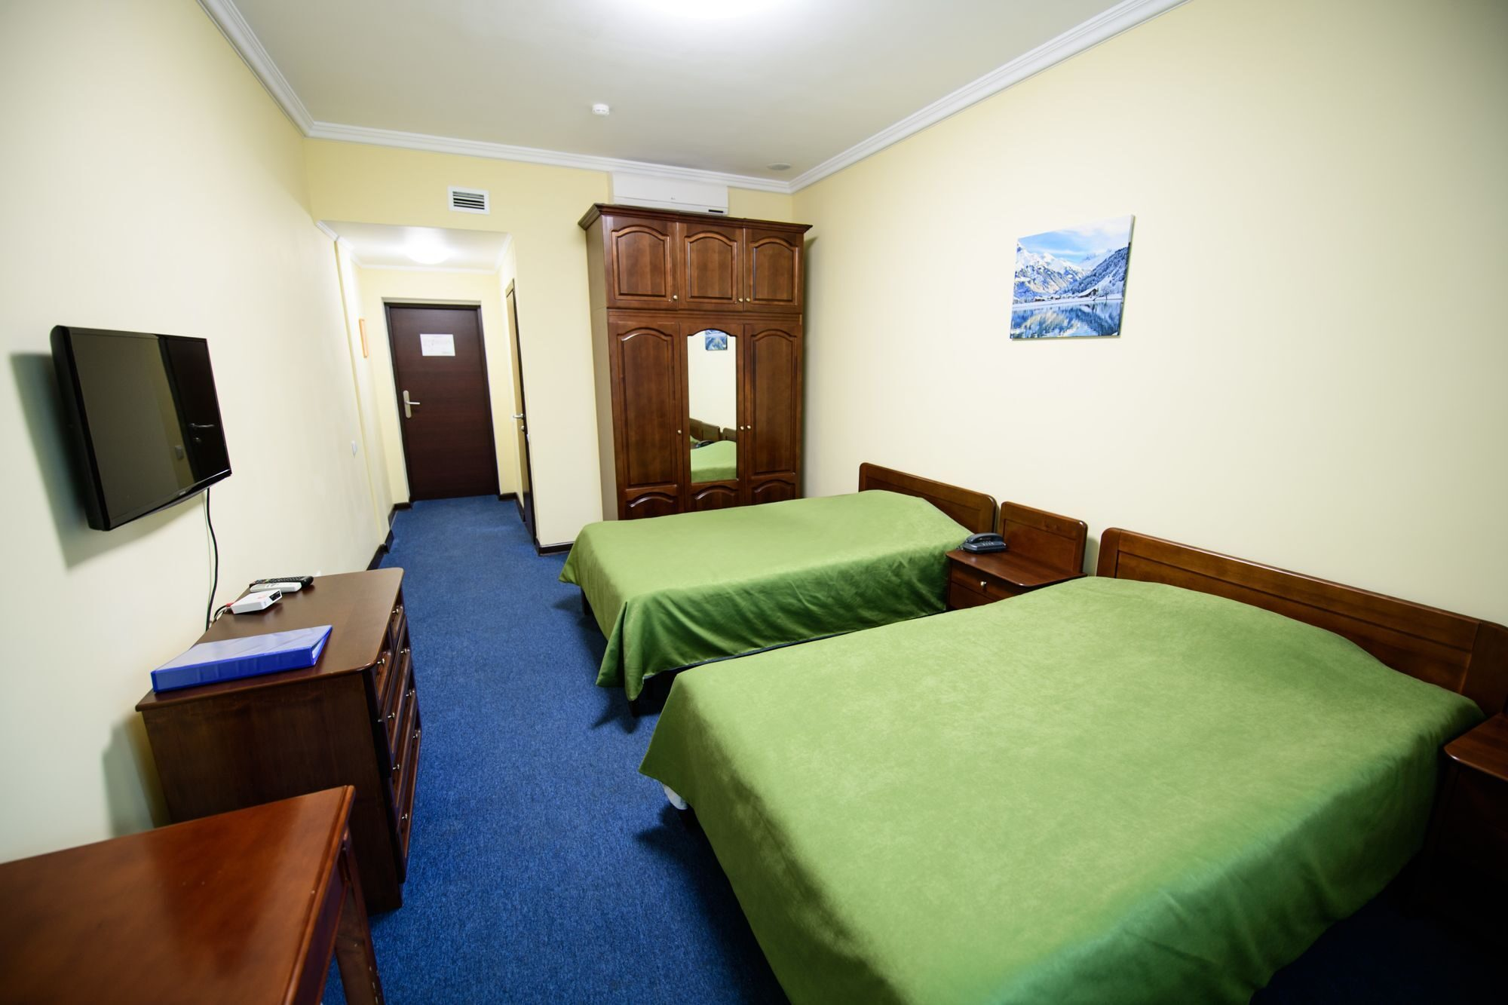

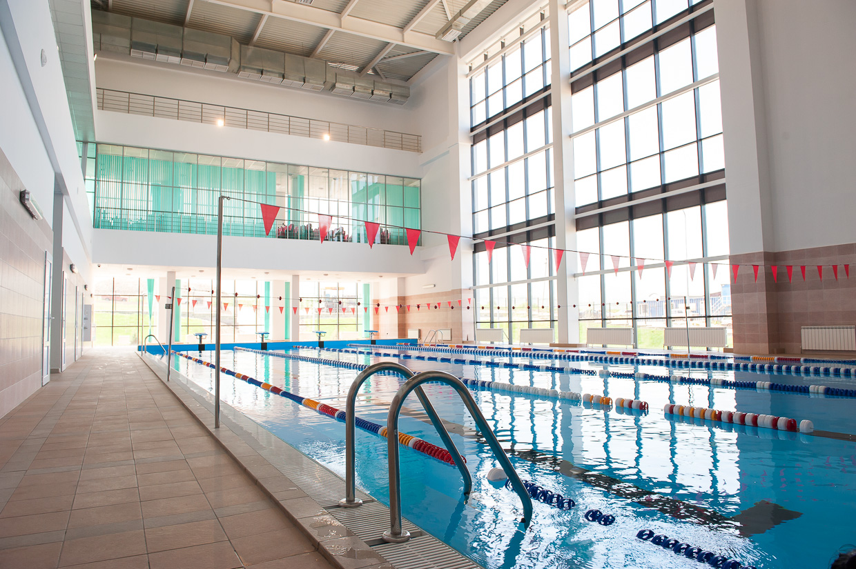
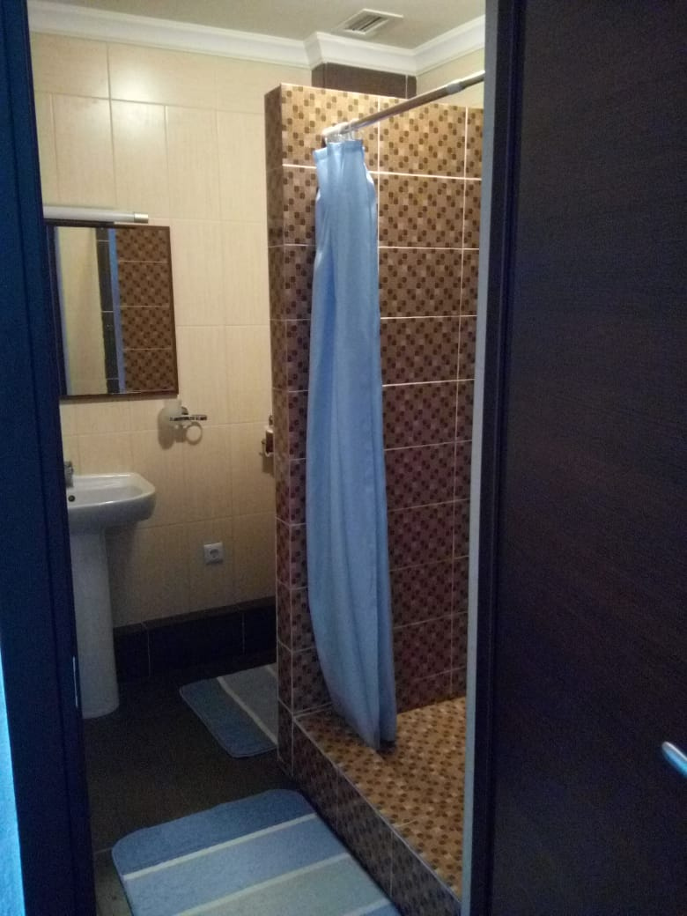

Since the venue is part of the Olympic center, there is a dormitory for athletes. The rooms are standard only. The doorways of the bathrooms are large enough for the wheelchair. However, there are no special facilities for para-athletes in the bathrooms. The rooms are minimalistic and simply furnished with only necessary facilities. Moreover, as seen in the photos, the showers are not equipped for the athletes on wheelchair. If these conditions are acceptable for your team wheelchair athletes, we can proceed with booking arrangements. The Complex is equipped with swimming pool and gym, with free access for the residents.
Accommodation includes breakfast, lunch and dinner with non-alcoholic drinks. Lunch will always be served at the archery venue, dinner will be served at the canteen.

Accommodation B - Grand Aiser Almaty hotel****
Only for the wheelchair athletes with their accompany persons.
- Double/Twin Room price: USD 200 per room
- Number of rooms: 20
- Board plan: full board
- Check-in from (30 May 2022, 12:00)
- check-out (12:00)
- Hotel website: http://www.aiserhotel.kz/
- Early check-in Chargeable (06:00-12:00 half day charge, before 06:00 full day charge)
- Late check-in Chargeable (12:00 – 18:00 half day charge, after 18:00 full day charge)

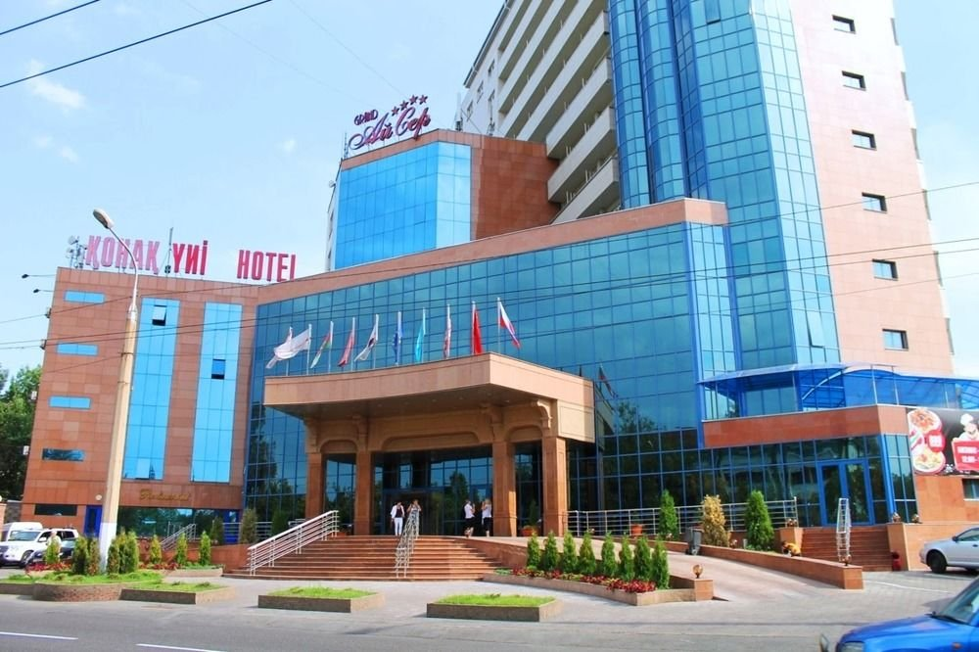
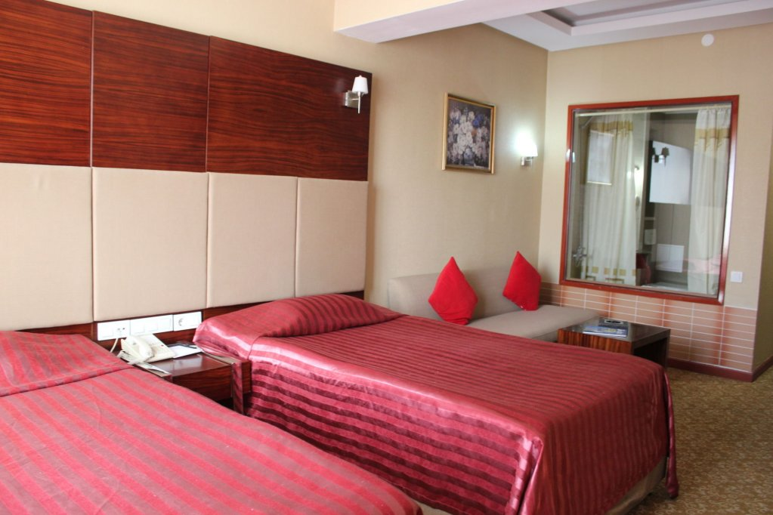
Grand Aiser is located 2 km from the city сentre. It was the official hotel for several Para events. So, the rooms are perfect for wheelchair athletes. As the event takes place outside the city, due to logistic reasons we cannot accommodate all the athletes there. The rooms are available only for the wheelchair athletes and their accompany person. Please be aware that the residents will be separated from the rest of the team. All information will be provided on time. Transfer from/to venue will be organized free of charge.
Rooms are allocated on a first come, first serve basis. Accommodation includes breakfast, lunch and dinner with non-alcoholic drinks. Lunch will always be served at the archery venue; dinner will be served at the Hotel.
TRANSPORTATION
Transportation will be provided from Almaty international airport to the official hotel, from two days before the official practice day and until two days after the closing day at 25 USD in one direction per person. Local transport will be available between the official hotel, practice and competition venues for free. Transport timetables will be confirmed.

VISA
All participants who need an entry visa to Kazakhstan, will be required to complete the Visa Support sections in WAREOS by no later than 07 April 2022.

It is the applicants’ responsibility for supplying the necessary information, ensuring all details are up to date, correct and submitted by the deadlines specified.

In addition, all participants that require a visa are kindly requested to supply a copy of their latest/valid passport. Copies of each application can be uploaded on WAREOS. All passport copies and personal details entered/uploaded to WAREOS will be held securely and in the strictest of confidence and not shared with other parties.

PAYMENT CONDITIONS
Complete all necessary sections in WAREOS and make full payment by the specified deadlines. Bank transfers or cash only, no credit cards will be accepted. All bank charges will be paid by the participants.

The entry fees should be paid in full before official practice.

To confirm hotels reservations, a minimum 30% deposit of the total amount is required to be bank transferred to the OC before 22 April 2022. Reservations after this date will be considered only according to availability. The final outstanding balance shall be made via bank transfer before arrival or by cash before official practice. Accommodation cannot be guaranteed after this deadline. A balanced invoice will be provided via WAREOS.

BANK INFORMATION FOR ACCOMMODATION, TRANSPORTATION AND ENTRY FEES
A/C Name: Federation of Archery, Crossbow and Darts of the Republic of Kazakhstan
Federation’s Address: Favorskogo 3, 050000
City and Country: Almaty, Kazakhstan
Bank: JSC Halyk Bank,
Account Number: KZ776017131000053500
Swift: HSBKKZKX
Bank’s address: 40 Al-Farabi ave., А26M3K5, Almaty, Kazakhstan,
Bank’s Phone: +7 (727) 259-07-77
City: Almaty, Kazakhstan

NOTE: ALL PAYMENTS SHALL BE MADE IN USD.

CANCELLATIONS & CHANGES
All cancellations and changes must be made through WAREOS

- Should flight arrival details change last minute, please contact the Organising Committee using the details indicated in the team managers’ booklet.
- If a participant’s arrival is later than the original scheduled arrival date, the room will be charged from the date of the original booking in WAREOS.
- An email will automatically notify the Organising Committee and Member Association of any changes made in WAREOS.

HEALTH REGULATIONS (COVID-19)
INFORMATION
- Everybody should follow the Government/public health authorities measures (national and sport-specific regulations) and be aware of the travel restrictions
- For your information, ambulance will be on duty at the field of play everyday. Medical infrastructure with proper care will be reachable within 15 minutes from the venue, where COVID-19 test can be done.
- Hosptial Almaty region, Talgar 041600, street Pavlova 5a, tel. +77 277 430 603

ADDITIONAL INFORMATION
Training
A training field will be available starting on 30 May 2022. The venue “Altyn Jebe” is located near Almaty in the picturesque foothills of the Trans-Ili Alatau in an ecologically clean area on the territory of the Olympic center “Ak-Bulak” ). The complex is located at an altitude of 1350 m above sea level (midlands). Field of play is located approximately 5 minutes walking distance from the athletes’ dorms.
For those athletes who wish to stay in the Accommodation B, transfer will be organized to the venue upon request (30th May 2022)
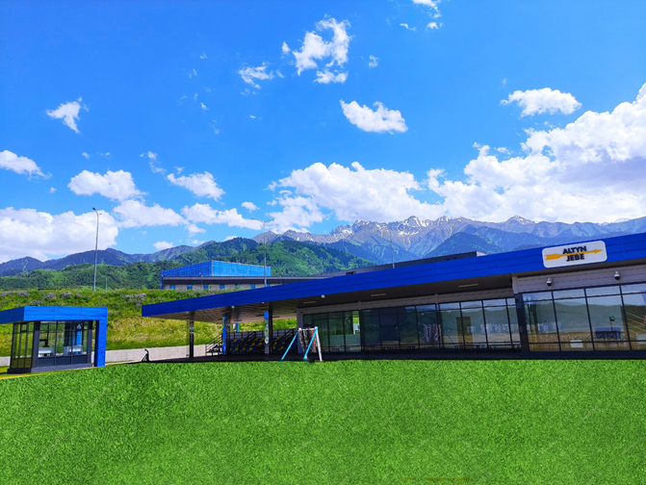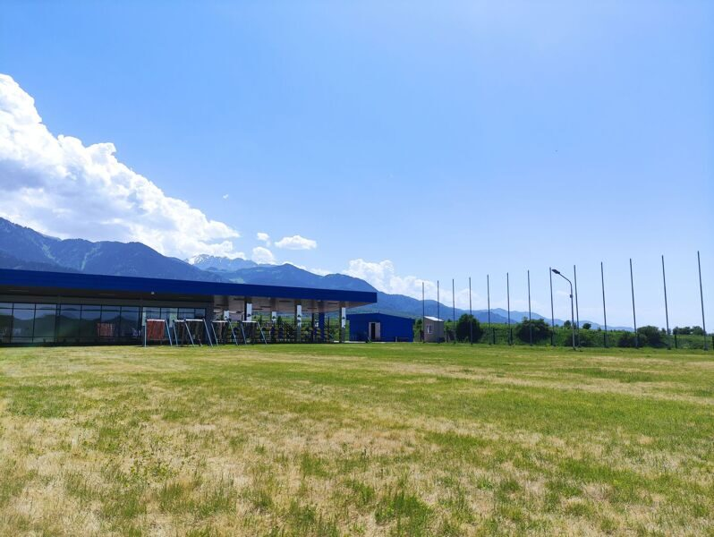
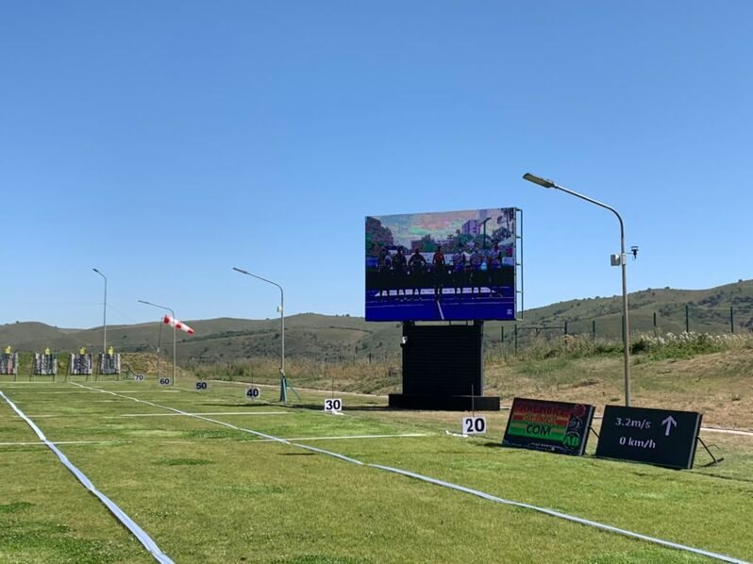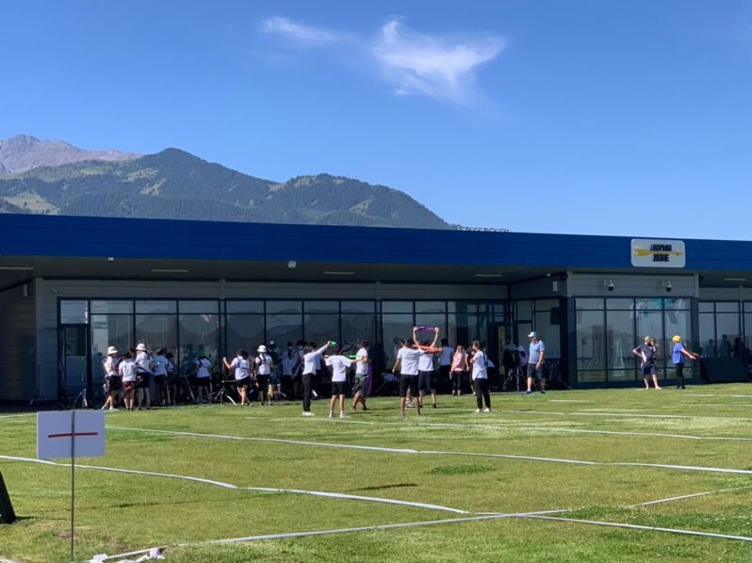

Weather
Medellin is a city where it is never cold and very seldom hot. Temperatures in May are expected to range between 25 and 28 degrees Celsius. The average in the last few years has been 24 degrees Celsius. There are chances of rain. At nights temperature in mountains are lower, so do not forget warm close.

Media Registration
Media representatives can apply for registration on the LOC website: www. or by emailing archery.kaz@gmail.com or at info@archery.sport.

Internet
Will be available in the official hotels for free (in hotel rooms and in the lobby). There will also be Wi-Fi available for access to results on venue.

Water
Each participant will receive clean bottles of water.
Bottled water will be available at the qualification and practice venues.

LOC CONTACT

Name: Ainur Tyrtykayeva
Address: pr. Turan 18, Nur-Sultan, Kazakhstan
Email: archery.kaz@gmail.com
Language: Russian and English
Phone number with international extension: +7 701 7712661

Looking forward to welcoming you in Almaty, Kazakhstan.

