To all World Archery Member Associations,
Dear President,

As Chair of the Local Organising Committee (LOC) of the PHUKET PARA ARCHERY WORLD RANKING EVENT 2022 to be held in PHUKET, THAILAND on 20 – 29 MARCH 2022, I would like to invite you all to be part of one of the most important archery events to take place in the ASIA/THAILAND in 2022.

PHUKET is one of the southern provinces of Thailand. It consists of the island of Phuket, the country’s largest island, and another 32 smaller islands off its coast. It lies of the west coast of Thailand in the Andaman Sea.

Being a big island, Phuket is surrounded by many magnificent Beaches such as Rawai, Patong, Karon, Kamala, Kata Yai, Kata Noi, and Mai Khao. Laem Phromthep viewpoint is said to feature the most beautiful sunsets in Thailand. It isn’t all just beaches though, there is also fantastic classical architecture such as the Goom Restaurant. That and the very welcome atmosphere and the famous Phuket NIGHTLIFE, you can see why the island is a hotspot for tourists in Thailand.

Welcome to this amazing city that reinvents itself every day. Our targets look forward to embracing your arrows, just as our hearts are ready to make your visit unforgettably enjoyable.

“Come and discover hundreds of reasons to visit and endless excuses to come back”.

Sincerely yours,

Mr. Chutinant Bhirombhakdi
Chairman of Local Organizing Committee

IMPORTANT DATES

Please find enclosed detailed information regarding this event. To register participation, please complete all the necessary sections in WAREOS (https://extranet.worldarchery.sport) within the deadlines listed below.

Summary of deadlines:

Registration Opening date on WAREOS | 20 January 2022
Preliminary Entries | 31 January 2022
Final Entries | 27 February 2022
Late entries fee | 7 March 2022
Hotel reservation down-payment (50%) | 8 February 2022
Hotel reservation and payment | 1 March 2022
Transportation | 15 February 2022
Visa support | 15 February 2022
Full refund cancellation deadline  *After this deadline, the LOC is allowed to retain all amounts due by the Member Association. | 1 March 2022

Please respect the stated deadlines.

PRELIMINARY PROGRAMME
Date | Description
20 March 2022  Sunday | Arrival of Participants
21 March 2022  Monday | Classification  Practice
22 March 2022  Tuesday | Classification  Practice
23 March 2022  Wednesday | Official Practice  Team Manager’s Meeting  Equipment Inspection Morning Recurve  Afternoon Compound
24 March 2022  Thursday | Qualification Round for Recurve
25 March 2022  Friday | Qualification Round for Compound
26 March 2022  Saturday | Team Eliminations & Finals  Award Ceremony
27 March 2022  Sunday | Individual Eliminations Morning Recurve  Afternoon Compound
28 March 2022  Monday | Individual Finals Morning Recurve  Afternoon Compound  Award Ceremony
29 March 2022  Tuesday | Departure of Teams

Note: This preliminary program could be changed slightly according to number of participants. All changes will be published and distributed to all participants in good time.

PRELIMINARY & FINAL REGISTRATION
All entries, accommodation reservations, transport needs, flight arrival/departure information and visa invitation letter requests are to be completed using the World Archery Online Registration System WAREOS https://extranet.worldarchery.sport. This system handles the entire registration process for this event. No entry forms, hotel reservations or transportation forms will be accepted; all information must be entered into WAREOS.

Member associations can login to WAREOS at http://extranet.worldarchery.sport with the username and password assigned by World Archery. After entering WAREOS, selecting the event from the list will allow a member association to register their athletes. Select/press the “Entries” button to see the list of categories in the event. Select/press the “category” to enter the athlete and official numbers/details participating for that event. A WAREOS User Manual can be downloaded in PDF format (English) upon login.

Contact wareos@archery.sport with any questions regarding technical problems on WAREOS. For any question regarding the organisation of the event (transport, accommodation, meals, invoices, visa etc.) please contact directly the LOC, spadtevents@gmail.com

Athletes from a minimum of 4 different Member Associations shall be registered and participate in the event.

A maximum number of four (4) athletes per country can be registered into each category and divisions of the event.

Member Associations can only use WAREOS to make any changes or amendments to entries and will be able to do so at any time. An email will automatically notify the Organising Committee and Member Association of any changes made in WAREOS.

ENTRY FEES
Individual 220 EUR per athlete
Official 120 EUR per person

Entry fees for individual/Official include airport transfer to hotels, daily local transport to and from the practice field to/from official hotels during the qualification, elimination and finals venues (timetable to be confirmed on site).

Any changes made after the deadlines specified or if entries differ by more than 4 athletes from the preliminary entries, the following penalty fees to will automatically be applied:
PENALTY FEES TO BE PAID TO ORGANISING COMMITTEE
Penalty fees for Late Entries (after final deadline): | 50 per entry

PENALTY FEES TO BE PAID TO WORLD ARCHERY (EUR)
Lost accreditation | 30.- each
Lost classification card | 30 .-each
Any change to the final country entry list, such as (but not limited to):  - Athlete or official name change  - Date of birth change  - Official position change  - Absence or incomplete on-site contact person | 50.- each change

NOTE: EUR currency exchange rates will be those on the date of the event.

Member Associations that have penalty fees outstanding from 2021 will need to have paid these penalty fees before being eligible to enter and compete.
Any entries received less than 3 days before the team managers meeting for a Hyundai Archery World Cup or World Championships will be refused if no preliminary entry and/or final entry are made prior. This decision cannot be appealed by the teams and is fully compliant with the current World Archery rules, article 3.7.1.2. Entries received after the deadlines, are subject to penalties as clearly stated in the rule book and the invitation documents of World Cups and World Championships. A Member Association that has made final entries in WAREOS and does not participate will be invoiced for the number of entries entered in the system, unless they Have informed World Archery and the Organising Committee in writing at least one week prior to the event that they are unable to attend.

ACCOMMODATION

Phuket Merlin Hotel, 158/1 Jawaraj Road, Muang, Phuket 83000 Thailand (Official Hotel)
- Single Room price: 180.00 EUR per room per night
- Number of rooms: 20
- Double/Twin Room price: 280.00 EUR per room per night
- Number of rooms: 70
- Board plan: full board (Breakfast, Lunch, Dinner)
- Check-in from 20 March 2022
- Late check-out 100.00 EUR per room (On 29 March 2022, after 12.00 pm)
- Hotel website: https://www.merlinphukettown.com/
- Covid-19 Test Fee 180.00 EUR per person
(1st Test at Phuket International Airport
2nd Test on Day 5 of competition
3rd Test 48 – 72 hrs before departure)
- Photo

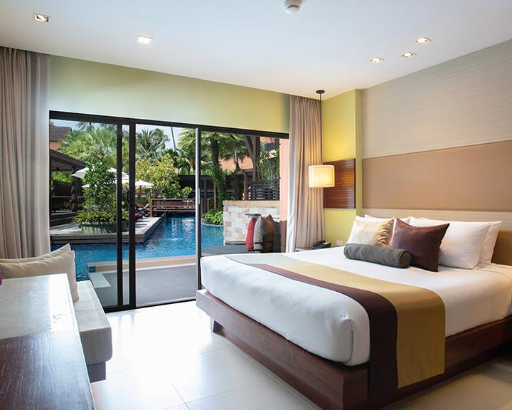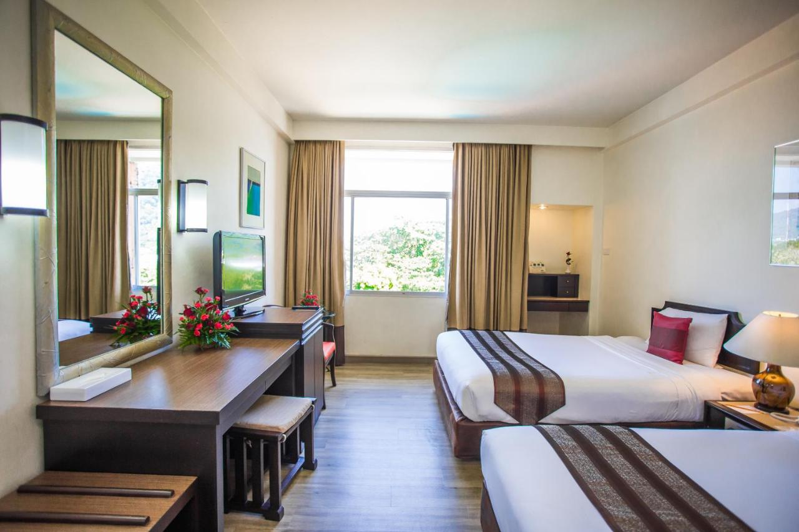
Rooms are allocated on a first come, first serve basis. Accommodation includes breakfast and lunch with non-alcoholic drinks. Lunch will always be served at the archery venue; dinner will be served at the hotel.
Teams who do not reserve their accommodation through the organising committee will be charged a double entry fee.

In addition, the LOC will be responsible to provide any event information at this hotel and provide transportation to the venues.

TRANSPORTATION
Transportation will be provided from Phuket International Airport to the Dara Hotel Phuket and until departure day. Local transport will be available between the official hotel, practice, and competition venues. Transport timetables will be confirmed.

VISA
All participants who need an entry visa to Country, will be required to complete the Visa Support sections in WAREOS by no later than 15 February 2022.

It is the applicants’ responsibility for supplying the necessary information, ensuring all details are up to date, correct and submitted by the deadlines specified.

In addition, all participants that require a visa are kindly requested to supply a copy of their latest/valid passport. Copies of each application can be uploaded on WAREOS. All passport copies and personal details entered/uploaded to WAREOS will be held securely and in the strictest of confidence and not shared with other parties.

PAYMENT CONDITIONS
Complete all necessary sections in WAREOS and make full payment by the specified deadlines. Bank transfers only, no credit cards will be accepted. All bank charges will be paid by the participants.

The entry fees should be paid in full before arrival.

To confirm hotels reservations, a minimum 50% deposit of the total amount is required to be bank transferred to the OC by 8 February 2022. Reservations after this date will be considered only according to availability. The final outstanding balance shall be made via bank transfer before arrival. Accommodation cannot be guaranteed after this deadline. A balanced invoice will be provided via WAREOS.

BANK INFORMATION FOR ACCOMMODATION, TRANSPORTATION AND ENTRY FEES
A/C Name: SPORTS ASSOCIATION FOR THE DISABLED OF THAILAND
Federation’s Address: 286 SPORTS ATHORITY OF THAILAND 14 FLOOR, HUA MARK, BANGKAPI, BANGKOK 10240, THAILAND
Telephone number: +66 21300263
City and Country: BANGKOK, THAILAND
Bank: KRUNGTHAI BANK PUBLIC COMPANY LIMITED
Account Number: 985-5-72197-7
Swift: KRTHTHBK
Bank’s address: 286 SPORTS ATHORITY OF THAILAN, HUA MARK, BANGKAPI, BANGKOK 10240, THAILAND
City: BANGKOK, THAILAND

NOTE: ALL PAYMENTS SHALL BE MADE IN EUR.

CANCELLATIONS & CHANGES
All cancellations and changes must be made through WAREOS / Open WAREOS:

- Should flight arrival details change last minute, please contact the Organising Committee using the details indicated in the team managers’ booklet.
- If a participant’s arrival is later than the original scheduled arrival date, the room will be charged from the date of the original booking in WAREOS.
- An email will automatically notify the Organising Committee and Member Association of any changes made in WAREOS.
- No refunds will be provided for all cancellation.

HEALTH REGULATIONS (COVID-19)
INFORMATION
- Everybody should follow the Government/public health authorities measures (national and sport-specific regulations) and be aware of the travel restrictions
- For your information, Medical infrastructure/Hospital with proper care will be reachable within 15 minutes from the venue, where COVID-19 test can be done.
Medical emergency contact and location
Patong Hospital
Address: 57 Sainamyen Rd., Pa Tong, Kathu District, Phuket 83120, Thailand
Tel : +66 76 342 633

ADDITIONAL INFORMATION
Training
A training field will be available starting on 21 March 2022 at the Surakhun Stadium located approximately 3 minutes from the official hotels.

Media Registration
Media representatives can apply for registration by emailing spadtevents@gmail.com

Internet
Will be available in the official hotels for free (in hotel rooms and in the lobby). There will also be Wi-Fi available for access to results on venue.

Water
Each participant with receive clean bottles of water.
Bottled water will be available at the qualification and practice venues.

TRAVEL INSURANCE (Health & Accident)
All team are advised to arrange insurance to cover all risks over the whole period of the championship event and the travelling period.

Measurements arriving in Thailand
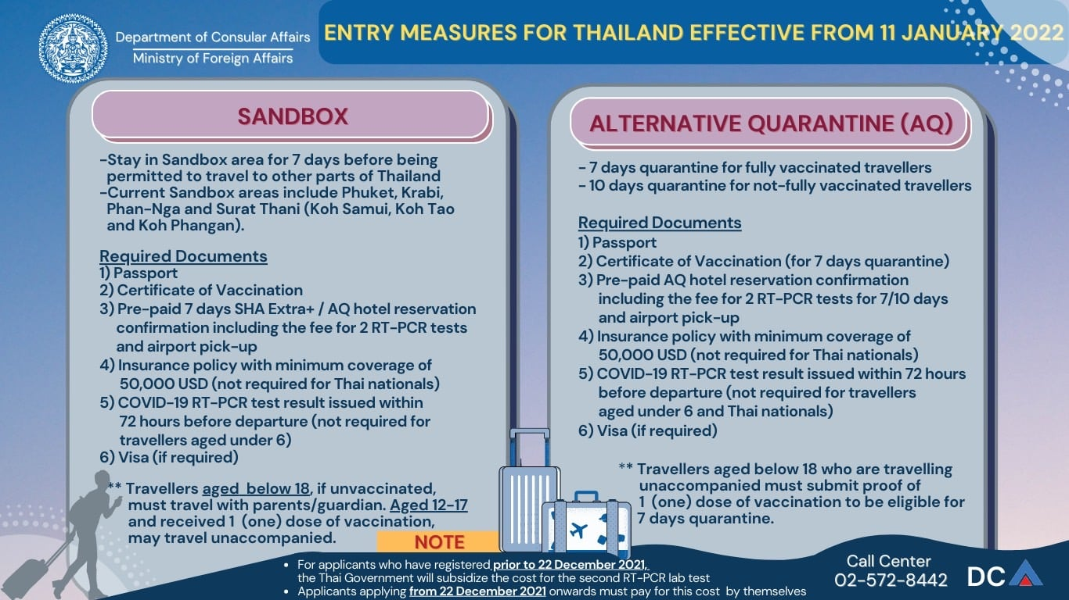

Travelers may purchase their health insurance which meets Thailand’s entry criteria here: https://covid19.tgia.org/home/guidelinecovid

LOC CONTACT

Name: Miss Ramida Ruchirattikan
Address: 286 SPORTS ATHORITY OF THAILAND 14 FLOOR, HUA MARK, BANGKAPI,
BANGKOK 10240, THAILAND
Email: spadtevents@gmail.com
Language: English
Phone number with international extension: +66 97 159 8979
Looking forward to welcoming you in Phuket, Thailand

