TO ALL World Archery Member Associations

Dear President,

As Chair of the Local Organising Committee (LOC) of the 2022 VERONICA’S CUP to be held in Kamnik, Slovenia on 06-08 May 2022, I would like to invite you all to be part of one of the most important archery events to take place in Slovenia in 2022.

Kamnik, a town embraced by the Kamnik-Savinja Alps, is considered one of the most beautiful medieval towns in Slovenia.

The first written sources about Kamnik go back to 1229. The two castles of Kamnik, Mali grad and Stari grad, were mentioned even earlier. The town boasts a rich Franciscan Library, where about 10,000 volumes of books printed before the end of the 18th century are kept. Šutna is the most beautiful street in the town, featuring typical signboards and other signs of the lively craft activities in the past.

Veronica’s Cup and Kamnik are also known as the traditional very well organized competiton with one of the most beautiful scenery behind the targets.

Sincerely yours,

Gregor Končan
Organising Committee Manager
Important Dates
Please find enclosed information regarding the details of this event and how to complete registration. To register participation, please complete all the necessary sections in WAREOS/OPEN WAREOS (https://extranet.worldarchery.sport) within the deadlines listed below:

- Start date for online registration WAREOS 18 January 2022
- Preliminary Entries 06 February 2022
- Final Entries 15 April 2022
- Late entries fee 30 April 2022
- Hotel Reservation 15 April 2022
- Transportation 15 April 2022
- Visa Support 10 April 2022
- Final Hotel Reservation & Payment 29 April 2022
- Full refund cancellation deadline 25 April 2022

Please respect the stated deadlines.

CATEGORIES

 | RECURVE |  |  | COMPOUND
 | MEN / WOMEN  (RM/RW) | JUNIOR MEN / JUNIOR WOMEN  (RJM/RJW) | CADET MEN / CADET WOMEN  (RCM/RCW) | MEN / WOMEN  (CM/CW) | JUNIOR MEN / JUNIOR WOMEN  (CJM/CJW) | CADET MEN / CADET WOMEN  (CCM/CCW)
INDIVIDUAL | YES | YES | YES | YES | YES | YES
TEAM | YES | NO | NO | YES | NO | NO
MIXED TEAM | YES | NO | NO | YES | NO | NO

PRELIMINARY PROGRAMME

03 MAY 2022  Tuesday  04 MAY 2022  Wednesday | Arrival of participants  Unofficial practice available (practice field)  Arrival of participants  Unofficial practice available (practice field)
05 MAY 2022  Thursday | Arrival of participants  Unofficial practice available (practice field)  REGISTRATION  Official Practice + Equipment Inspection
06 MAY 2022  Friday | Qualification Round (Recurve, Compound)
07 MAY 2022  Saturday | Individual Eliminations (Recurve, Compound)
08 MAY 2022  Sunday | Final Rounds + Medal Matches (Live TV)  Award ceremonies
09 MAY 2022  Monday | Departure of teams

NOTE: This preliminary programme is subject to change according to participation and TV requirements. All changes will be published and distributed in good time.

PRELIMINARY & FINAL REGISTRATION

All entries, accommodation reservations, transport needs, flight arrival/departure information and visa invitation letter requests are to be completed using the World Archery Online Registration System WAREOS and OPEN WAREOS. These systems now handle the entire registration process for this event. No entry forms, hotel reservations or transportation forms will be accepted.

Member associations can login to WAREOS at http://extranet.worldarchery.sport with the username and password assigned by World Archery. After entering WAREOS, selecting the event from the list will allow a member association to register their athletes. Select/press the “Entries” button to see the list of categories in the event. Select/press the “category” to enter the athlete and official numbers/details participating for that event. A WAREOS User Manual can be downloaded in PDF format (English) upon login.

Other athletes / Club archers (not competing as country but only as club) can register on Open WAREOS at http://extranet.worldarchery.sport with their username and password if already registered in the past or register to get the log in details if it’s the first time. After the creation of the profile, follow the instructions to register to the event.

Contact wareos@archery.sport with any questions regarding technical problems on WAREOS. For any question regarding the organisation of the event (transport, accommodation, meals, invoices, visa etc.) please contact directly the LOC.

Athletes from a minimum of 4 different Member Associations shall be registered and participate in the event. Entries should be completed using WAREOS / Open WAREOS.

Start date for online registration using WAREOS/Open WAREOS 18 JANUARY 2022
End of Final registration using WAREOS/Open WAREOS 15 APRIL 2022

Please respect the stated deadlines.

Member Associations can only use WAREOS to make any changes or amendments to entries and will be able to do so at any time. An email will automatically notify the Organising Committee and Member Association of any changes made in WAREOS.

ACCOMMODATION & GENERAL INFORMATION
AMBIENT Hotel – 3 Star Hotel
- Single Room price: 85.00 EUR per room per day
- Double/Twin Room price: 130.00 EUR per room per day
- Board plan: half board (kosher, halal and other special meal
requests are available for additional 15 EUR per person per day)
- Check-in from 14:00
- Check-out 11:00
- Hotel website: www.ambienthotel.si
- Photo
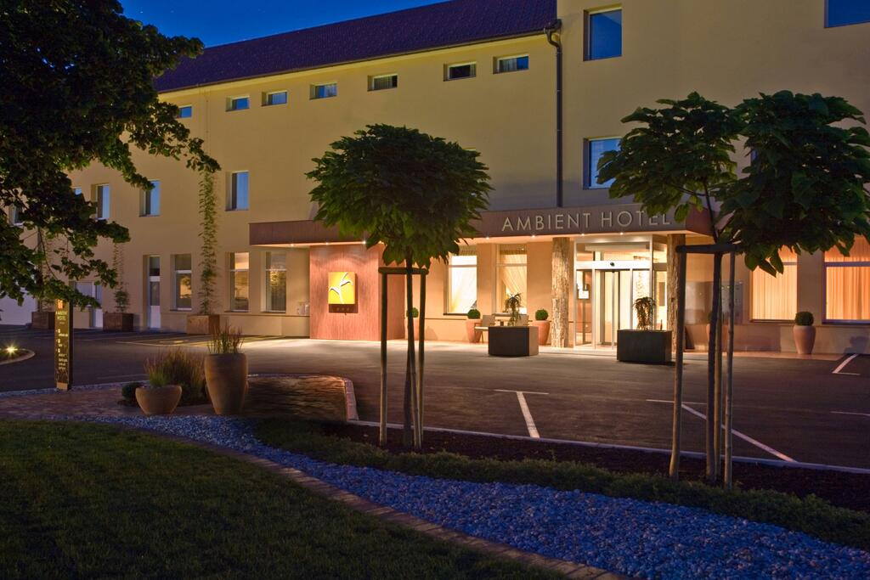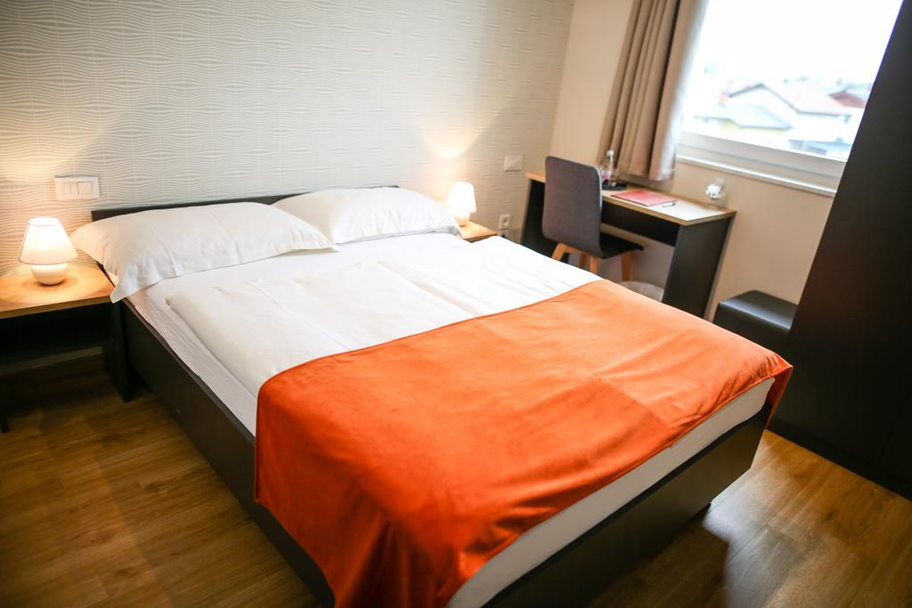

SPORN Hotel – 3 Star Hotel
- Single Room price: 95.00 EUR per room per day
- Double/Twin Room price: 140.00 EUR per room per day
- Board plan: half board (kosher, halal and other special meal
requests are available for additional 15 EUR per person per day)
- Check-in from 14:00
- Check-out 11:00
- Hotel website: www.sporn.si
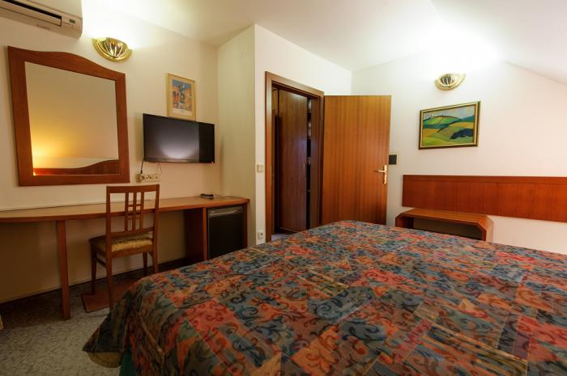
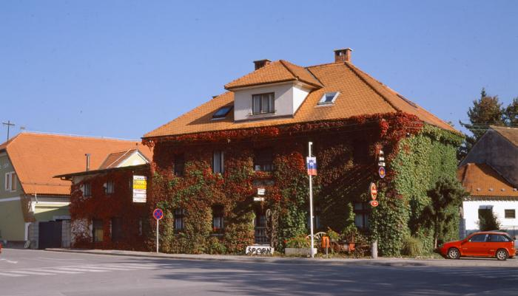
- Photo
Rooms are allocated on a first come, first serve basis. Accommodation includes breakfast and dinner. Lunch will always be served at the archery venue.
- Final Hotel Reservation & Transportation before 15 APRIL 2022

Important Note: Please refer to the accommodation pages above for detailed hotel information. Complete all necessary sections in WAREOS and make full payment for entries and accommodation by the specified deadlines. Bank transfers only, no credit cards will be accepted.

In addition, the LOC will be responsible to provide any event information at this hotel and provide transportation to the venues. Private vehicles can be used too.

LUNCHES
Lunches will be served on the shooting field from 06 MAY 2021 to 08 MAY 2021. Price for all 3 lunches together is 30 EUR.

ENTRY FEE
Individuals: 70 € / archer
Officials: 0 € / person
Team: 40 € / team
Mixed Team: 40 € / team

Entry fees include daily local transport to and from the practice field to/from official hotels during the qualification, elimination and finals venues (timetable to be confirmed on site) from 06 MAY 2022 to 08 MAY 2022.

ENTRY FEES IN NON-OFFICIAL HOTELS
Individuals: 70 € / archer
Officials: 00 € / person
Team: 40 € / team
Mixed Team: 40 € / team

Entry fees include daily local transport to and from the practice field to/from official hotels during the qualification, elimination and finals venues (timetable to be confirmed on site).
PENALTY FEES TO BE PAID TO ORGANISING COMMITTEE
Penalty fees for Late Entries (after final deadline):
20 € / archer

Penalty fees for not filling Preliminary entries
No penalty fee

Penalty fee for differences between preliminary and final entries:
*If the difference between final and preliminary entries number is more than 4 athletes/officials.
No penalty fee

PAYMENT CONDITIONS:
All fees should be paid in full before arrival!

To confirm hotels reservations, a minimum 50% deposit of the total amount is required to be bank transferred to the OC before 15 APRIL 2022. Reservations after this date will be considered only according to availability.

The final outstanding balance shall be made bank transferred to the OC before 29 APRIL 2022.

BANK DETAILS FOR ACCOMMODATION, TRANSPORTATION AND ENTRY FEES:
A/C Name: LOKOSTRELSKI KLUB KAMNIK
Address: CANKARJEVA CESTA 26
Telephone number: +386 40 507 893
City and Country: Kamnik, Slovenia
Bank: NOVA LJUBLJANSKA BANKA
Account Number: SI56 0231 2001 3771 875
Swift: LJBASI2X
Bank’s address: TRG REPUBLIKE 2
City: Ljubljana, Slovenia

NOTE: ALL PAYMENTS SHALL BE MADE IN EUR BY BANK TRANSFER. All bank charges will be paid by the participants. CREDIT CARDS are not accepted.

Cancellations & Changes
All cancellations and changes must be made through WAREOS / Open WAREOS:
- Cancellations received before 25 APRIL 2022 a full refund of the deposit payment will be made.
- Cancellations received after 25 APRIL 2022, no refund will be given.
- Refunds will be processed after the event.
- Name changes to team officials or athletes (same category and division) will be accepted up to two (2) days before official practice without any additional charge or penalty fees.
- Should flight arrival details change last minute, please contact the Organising Committee using the details indicated in the team managers’ booklet.
- If a participant’s arrival is later than the original scheduled arrival date, the room will be charged from the date of the original booking in WAREOS.
- An email will automatically notify the Organising Committee and Member Association of any changes made in WAREOS.

ADDITIONAL INFORMATION
HEALTH REGULATIONS (COVID-19)
- Everybody should follow the Government/public health authorities measures (national and sport-specific regulations) and be aware of the travel restrictions
- For your information, Medical infrastructure/Hospital with proper care will be reachable within 15 minutes from the venue, where COVID-19 test can be done.

Medical emergency contact and location
Hospital: Zdravstveni dom dr. Julija Polca
Address: Novi trg 26, 1241 Kamnik
Phone: +386 1 831 86 00

Transportation
Transportation will be provided from LJUBLJANA airport to the official hotel, from two days before the official practice day and until two days after the closing day at 40 EUR price for roundtrip. Local transport will be available between the official hotel, practice and competition venues. Transport timetables will be confirmed.

There will be an additional payment of 15 EUR per person, per day for transport between the practice venue and hotels from 03 MAY 2022 to 05 MAY 2022.

Weather
Temperatures in May are expected between 12 and 24 degrees Celsius.

Media Registration
Media representatives can apply for registration by emailing organization@veronicas-cup.org

Internet
Will be available in the official hotels for free (in hotel rooms and in the lobby). There will also be Wi-Fi available for access to results on venue.

Water
Each participant with receive clean bottles of water.

Visa
All participants who need an entry visa to Slovenia, will be required to complete the Visa Support sections in WAREOS by no later than 10 APRIL 2022.

It is the applicants’ responsibility for supplying the necessary information, ensuring all details are up to date, correct and submitted by the deadlines specified.

In addition, all participants that require a visa are kindly requested to supply a copy of their latest/valid passport. Copies of each application can be uploaded on WAREOS. All passport copies and personal details entered/uploaded to WAREOS will be held securely and in the strictest of confidence and not shared with other parties.

LOC CONTACT
Name: Gregor Koncan
Email: organization@veronicas-cup.org
Language: English
Phone number with international extension: +386 40 507 893
web page: www.veronicas-cup.org
facebook www.facebook.com/veronicacup

