TO ALL World Archery Africa Member Associations

Dear President / Secretary General,

As Chair of the Local Organising Committee (LOC) of the 13th African Archery Championships and the Continental Qualifier for Paris 2024 which will be held in Nabeul, Tunisia from 8 to 12 November 2023 I would like to invite you all to be part of this prestigious archery event to take place in the Northern part of Africa in 2023.

The Cap Bon region is a vast garden where orange and lemon trees put out their flowers at the beginning of Spring, its beaches of fine sand are among the most beautiful in Tunisia.

The principal town of Cap Bon, Nabeul is famous for its pottery, its rush mats, and its flower essences, the fishing port of Kelibia, the thermal springs of Korbous, and the falconers of El Haouaria are just a few of the curiosities found in the region.

Tunisia and the friendly people of Nabeul ate expecting to welcome you soon.
Looking forward to seeing you all in November!
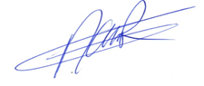
Sincerely yours,

Contact (Phone): +21620320236 (WhatsApp)
Email: ridha.manai@gmail.com
tunisia.shooting@gmail.com

Ridha MANAI
LOC President

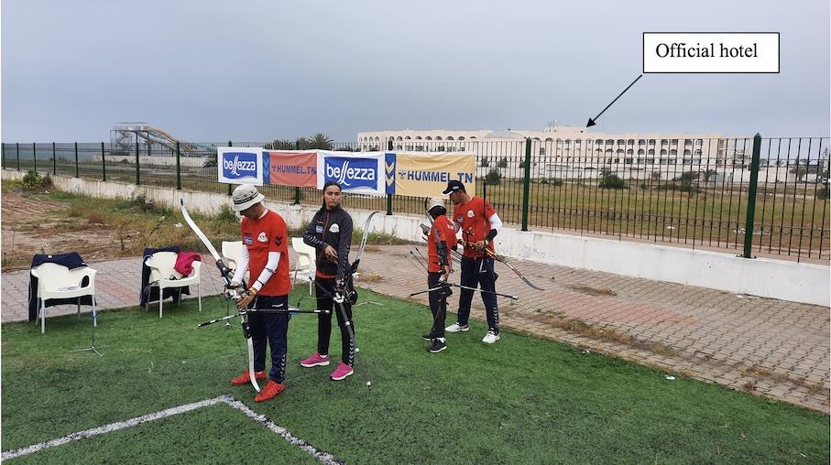
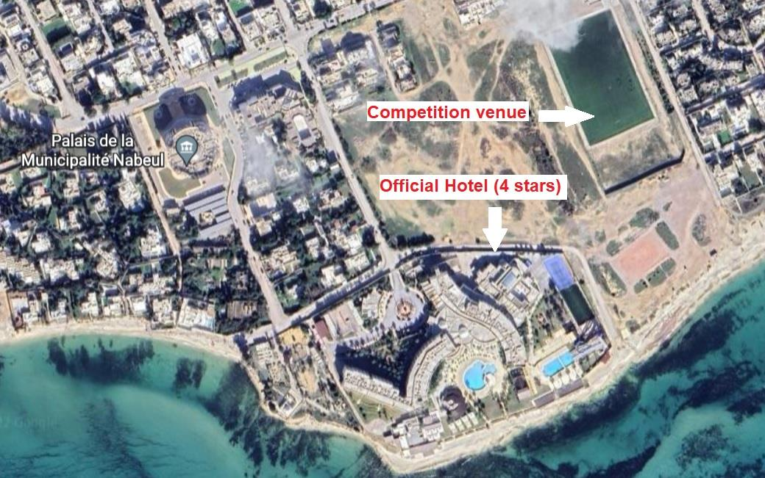
COMPETITION VENUE

The event will take place at the Nabeul Rugby Stadium in Nabeul which is located a short walking distance from the official hotel.

IMPORTANT DATES
Please find enclosed detailed information regarding this event. To register for participation, please complete all the necessary sections in WAREOS (https://extranet.worldarchery.sport) within the deadlines listed below.
Summary of deadlines:
- Registration Opening date on WAREOS | 10 August 2023
- Final Entries | 15 October 2023
- Hotel reservation down-payment (50%) | 1 October 2023
- Final payment, hotel & entry fees | 25 October 2023
- Transportation | 15 October 2023
- Visa Support Request | 5 September 2023
- Full refund cancellation deadline | 25 October 2023
*After this deadline, the LOC is allowed to retain all amounts due by the Member Association
* Please respect the stated deadlines.

PRELIMINARY PROGRAMME
6 - 7 November 2023  Monday - Tuesday | Arrival of participants  Practice field will be available from 6 November 2022
8 November 2023  Wednesday | Official Practice (Equipment Inspection)  Team Managers Meeting  Opening Ceremony (TBC)
9 November 2023  Thursday | Qualification Round  (Recurve 70m Round, Compound 50m Round and Barebow 50m Round)  + Para Archery
10 November 2023  Friday | Team / Mixed Team Eliminations & Finals (Till Semi-Finals 1/2)  (Recurve , Compound and Barebow)
11 November 2023  Saturday | Individual Eliminations & Finals (Till Semi-Finals 1/2)  (Compound, Recurve and Barebow)
12 November 2023  Sunday | Finals (Medal Matches) - Individual and Team  - Barebow (Women and Men)  - Compound (Women and Men)  - Recurve (Women and Men)
Award Ceremonies
Closing Party (TBC)

13 November 2023  Monday | Departure of teams

- This preliminary programme is subject to change according to participation and T.V. requirements. All changes will be published and distributed in good time.
- This is the second time to include Barebow division and Para Archery in the African Archery Championships, so there will be no minimum number of athletes for those categories.

FINAL REGISTRATION
All entries, accommodation reservations, transport needs, flight arrival/departure information, and visa invitation letter requests are to be completed using the World Archery Online Registration System WAREOS https://extranet.worldarchery.sport. This system handles the entire registration process for this event. No entry forms, hotel reservations, or transportation forms will be accepted; all information must be entered into WAREOS.
Member associations can login to WAREOS at http://extranet.worldarchery.sport with the username and password assigned by World Archery. After logging in to WAREOS and selecting the event from the list, member associations will be allowed to register their athletes. Select/press the “Entries” button to see the list of categories in the event. Select/press the “category” to enter the athlete and official numbers/details participating for that event. A WAREOS User Manual can be downloaded in PDF format (English) upon login.
Contact wareos@archery.sport with any questions regarding technical problems on WAREOS. For any questions regarding the organization of the event (transport, accommodation, meals, invoices, visa, etc.) please contact directly the LOC (tunisia.shooting@gmail.com ).
A maximum number of Four (4) athletes per country (Member Association) can be registered into each category and division of the event. Preliminary entries should be completed using WAREOS.
Member Associations can only use WAREOS to make any changes or amendments to entries and will be able to do so at any time. An email will automatically notify the Organising Committee and Member Association of any changes made in WAREOS.
ENTRY FEES
Individual 160 USD per athlete
Official 110 USD per person
Guest 110 USD per person
- No Entry Fees for Teams and/or Mixed Teams
The entry fees for individual/Official include the accreditation card and access to practice and competition fields, and also include airport transfer to hotels, daily local transport to and from the official hotel during the qualification, elimination, and finals (if needed).
The entry fee for guest includes the accreditation card without access to the field of play.
Any changes that are made after the deadlines specified or if entries differ by more than (4) athletes from the preliminary entries, the following penalty fees will automatically be applied.

PENALTY FEES ARE TO BE PAID TO THE ORGANISING COMMITTEE
Penalty fees for Late Entries (after the final deadline): | 50 USD per entry
Member Associations that have penalty fees outstanding to World Archery from 2022 will need to pay these penalty fees before being eligible to enter and compete.
Any entries received less than (3) days before the team managers’ meeting will be refused if no preliminary entry and/or final entry is made prior. This decision cannot be appealed by the teams and is fully compliant with the current World Archery rules, article 3.7.1.2. Entries received after the deadlines are subject to penalties as clearly stated in the rulebook and the invitation document of this Championship. A Member Association that has made final entries in WAREOS and does not participate will be invoiced for the number of entries entered in the system unless they have informed World Archery Africa and the Organising Committee in writing at least one week prior to the event that they are unable to attend.

ACCOMMODATION
All participants are requested to stay only at the official hotel for logistics, management, and security.
Khayam Garden Beach Resort & Spa (4 stars) – The Official Hotel
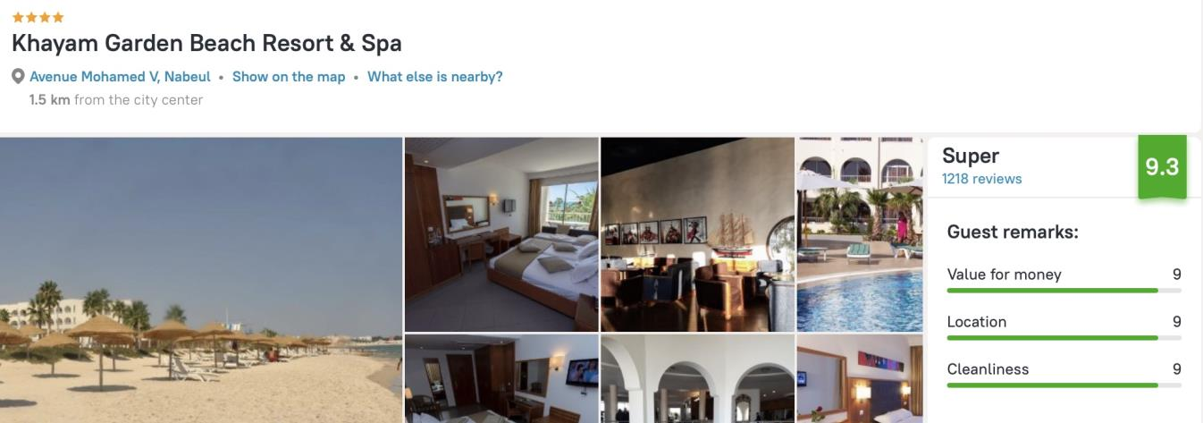

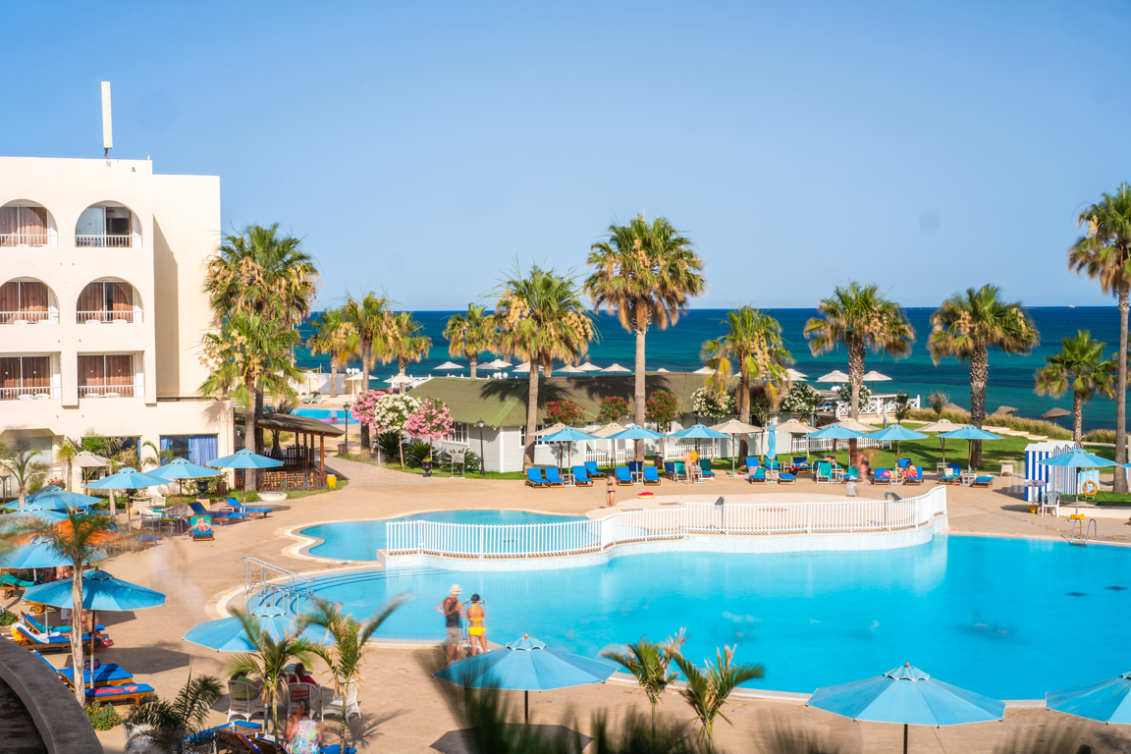
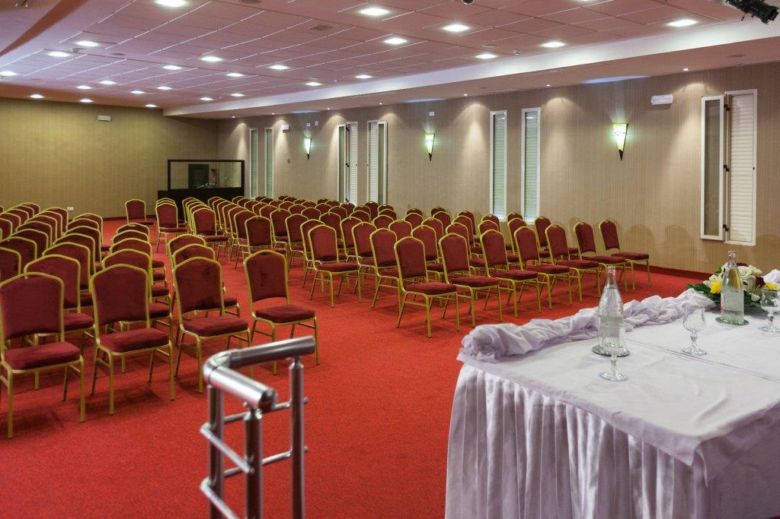
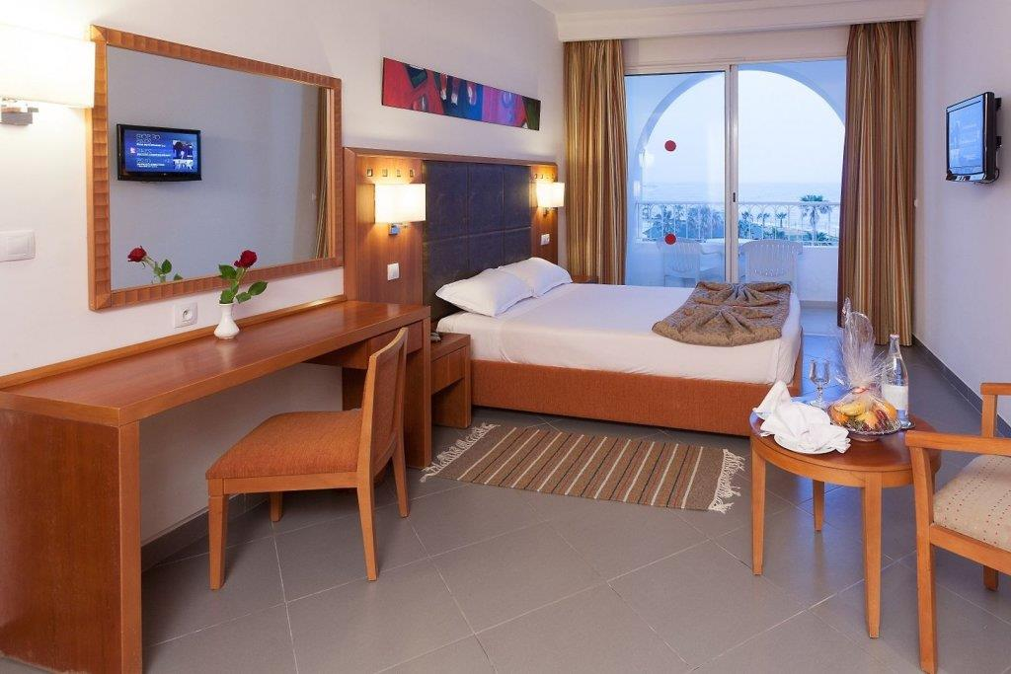  Single Room |  | Double/Twin Room  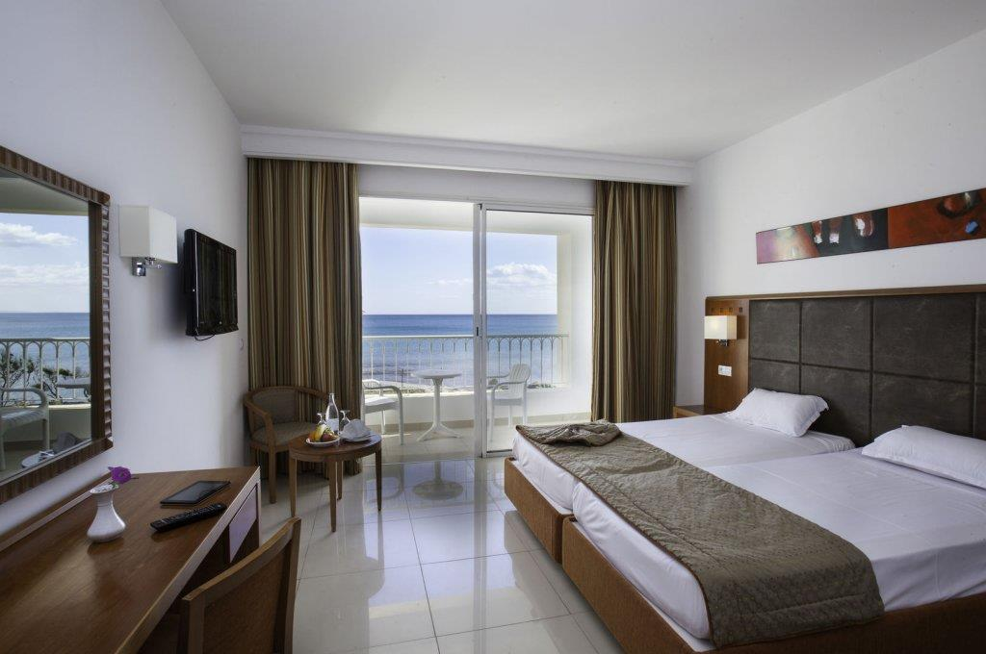
- Single Room price | 150 USD per room/night |  | Number of rooms : 60
- Double / Twin Room | 220 USD per room/night |  | Number of rooms : 90
- Board plan: Full Board: Breakfast, Lunch and Dinner in the official hotel.
- Check-in from: 14:00
- Check-out: 12:00
Rooms will be allocated on a first-come, first-serve basis. Accommodation rates include breakfast, lunch, and dinner. Laundry service will be available for extra charges (with 50% discount)
Early arrivals and late departures of the teams will need to be arranged with LOC case by case.
FREE closing party and dinner will be offered to ALL participants.
FREE Tour will be organized for ALL participants

TRANSPORTATION
FREE Local transportation will be provided from the Tunis Carthage International Airport (TUN) to the official hotel (around 40 minutes between the airport and the official hotel). This airport has daily flights with many different airlines. Also from the hotel to the airport (departure). Transport timetables will be confirmed.

VISA
All participants who need an entry visa to Tunisia will be required to complete the Visa Support sections in WAREOS by no later than 05 September 2023.

It is the applicant’s responsibility to supply the necessary information, ensuring all details are up to date, correct, and submitted by the deadlines specified.

In addition, all participants that require a visa are kindly requested to supply a copy of their latest/valid passport. Copies of each application can be uploaded on WAREOS. All passport copies and personal details entered/uploaded to WAREOS will be held securely and in the strictest of confidence and not shared with other parties.

PAYMENT CONDITIONS
Complete all necessary sections in WAREOS and make full payment by the specified deadlines. Bank transfers only, no credit cards will be accepted. All bank charges will be paid by the participants.

ALL the fees should be paid in full before arrival.
To confirm hotel reservations, a minimum 50% deposit of the total amount is required to be bank transferred to the LOC before 1 October 2023. Reservations after this date will be considered only according to availability. The final outstanding balance shall be made via bank transfer before 25 October 2023. Accommodation cannot be guaranteed after this deadline. A balanced invoice will be provided via WAREOS and LOC.

Important:
- All payment is to be made to The Tunisian Shooting Federation, after receiving the corresponding proforma invoice.
- Please email LOC to make sure you receive the proforma invoice in the correct mailbox
- After 01 October 2023 reservations will be considered only according to availability.
BANK INFORMATION FOR ACCOMMODATION AND ENTRY FEES
Account Holder name | Fédération Tunisienne de Tir
Federation address | Maison des Fédérations Sportives,6ème étage
City, Post code & Country | Cite Olympique, 1004 , Tunisie
Telephone number | +21671766471
Bank | Banque Internationale Arabe De Tunisie(BIAT)
Account number | TN5908002000642009961289
Swift Code | BIATTNTT
Bank address | 10 Rue 8600 Cherguia 2035 Tunis.Cartage
Email address | tunisia.shooting@gmail.com
NOTE: ALL PAYMENTS SHALL BE MADE IN USD BY BANK TRANSFER

CANCELLATIONS & CHANGES
All cancellations and changes must be made through WAREOS:
- Should flight arrival details change at the last minute, please contact the Organising Committee using the details indicated in the team managers’ booklet.
- If a participant’s arrival is later than the original scheduled arrival date, the room will be charged from the date of the original booking in WAREOS.
- An email will automatically notify the Organising Committee and Member Association of any changes made in WAREOS.
MEDICAL EMERGENCY
For Emergencies, there are (2) Hospitals close to the official hotel (Accommodation / Venue):
- HOPITAL REGIONAL AHMED TLETELI NABEUL, Address: Avenue Habib THAMEUR – NABEUL (2.2 km from the Hotel) Phone: (216) 72 285 673.
- HOPITAL REGIONAL MOHAMED TAHAR ELMAAMOURI, Address: EL Mrezka – NABEUL
- (6.6 km from the Hotel) Phone: (216) 72285 673

ADDITIONAL INFORMATION
Training
The training field will be available starting on 6-7 November 2023 from 14:00 at Nabeul Rugby Stadium located approximately 10 minutes walking from the official hotel.
The delegations will have to reserve sessions to access the training field, to limit the number of archers shooting on the field.
Weather – November (Average)
- The maximum day temperature in Nabeul is 18° degrees Celsius
- The minimum day temperature in Nabeul is 13° degrees Celsius
- 10 hours and 15mn of daylight per day
- 6 hours of sunshine per day
- Low heat and humidity
- 08 days of rain
- 3+ UV index
Media Registration
Media representatives can apply for registration by emailing LOC: tunisia.shooting@gmail.com
Internet
Will be available in the official hotel for free (in hotel rooms and in the lobby). There will also be Wi-Fi available for the results team at the venue.
Every participants will receive a FREE Mobile SIM card with some internet data (can be recharged).
Water
Drinking water in Tunisia is safe to drink and cook with when taken from taps in urban areas like Nabeul. Bottles of water will be distributed at the venue.
CURRENCY
- Currency brought into or taken from Tunisia is therefore monitored by law.
- At present, the customs law in Tunisia states that you can bring any amount you wish in cash in dollars, or in other currencies, but you must declare this upon arrival at any customs points when arriving by air, land, or sea.
- Exchange rates fluctuate – so there would be a need to charge a levy for cash being deposited.
- Average exchange rate in the bank is:
1 United States Dollar (USD) = 3.11 Tunisian Dinar (TND) + exchange commission.

Electricity
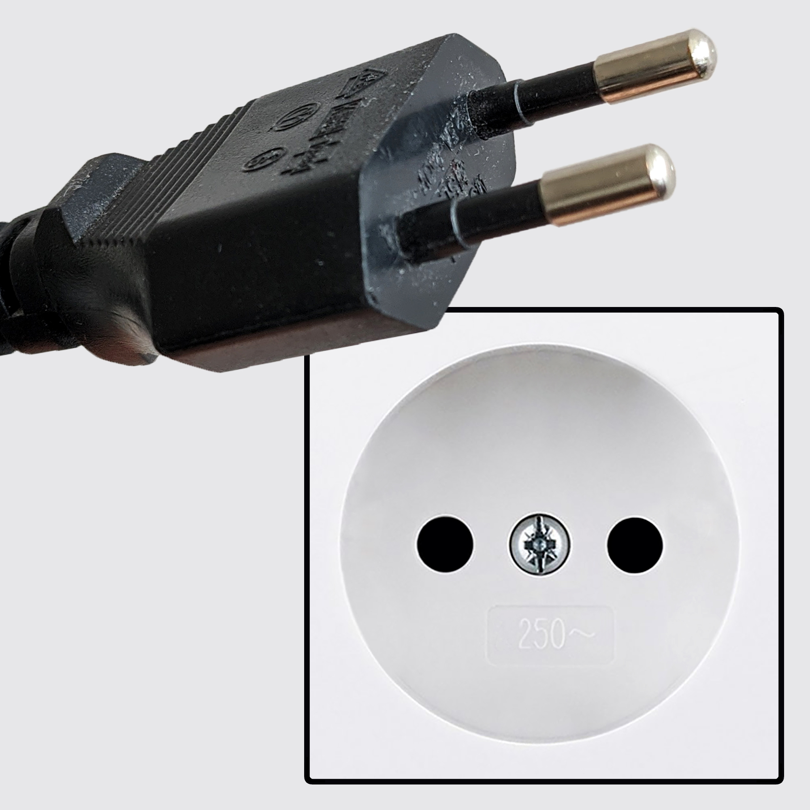
power plug used in Tunisia: Type C
ABOUT Tunisia
There are many good places to visit in Nabeul and around it such as the following:
Friguia Park (53 minutes by car)
Visit Friguia Park, one of the largest zoos in North Africa. On an area of about 36 hectares, there live more than 56 species of animals, including giraffes, monkeys, ostriches, leopards, lions, servos, and pink flamingos. The attraction is also seal shows and the possibility of feeding animals. Friguia Park is an ideal place to spend free time among animals and beautiful nature. | 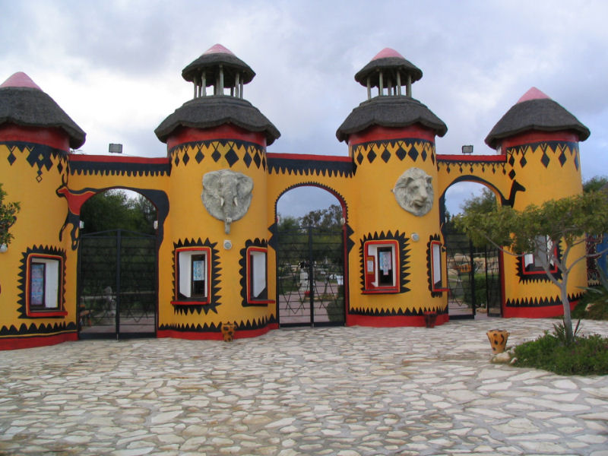

AZURE CITY SHOPPING CENTRE (30 minutes by car)
Azur City, a shopping center with innovative architecture, is the number 1 shopping and leisure destination in Tunisia. It will have an exceptional location to the south of Tunis (governorate of Ben Arous) with direct access from the A1 motorway and will offer the most complete range of shops and leisure activities. Important catchment area and strategic location: more than 8 million visitors are expected/per year, including more than 1.5 million inhabitants within

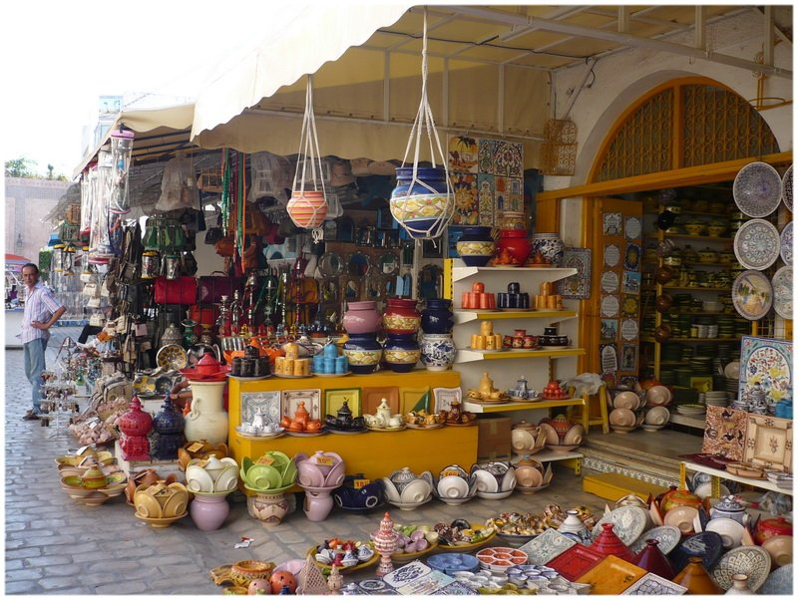
SOUKS AND PANORAMAS (Nabeul)
In Nabeul, stroll through the souk surrounded by arcades and boutiques.
In the Artisanal Village, experienced artisans will astound you with their ingenuity, ironwork, rush mats, embroidered clothing, and engraved copper.
In the pottery stores, choose a beautiful vase in multicolored ceramic, the local specialty.
The covered market will make your mouth water with its collection of spices, fruits, vegetables, and fish.

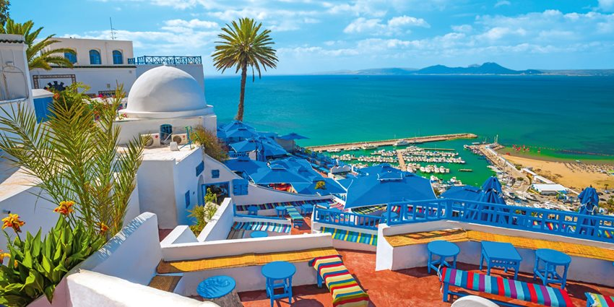
Tunis - Carthage - Sidi Bou Said (60 mins. by car)
Sightseeing of Tunis city center: walk along narrow medina streets with characteristic architecture of the old town and local shops. Drive to Carthage - today's Tunisian district, where you'll find a presidential residence and villas of Tunisian elites, and in antiquity, the center of the Phoenician Empire. Lunch break. Visit the remains of a huge complex of Antoninus thermal baths, located by the sea, the Amphitheatre, and the Punic tombs. Drive to Sidi Bou Said, a hilltop town of artists, captivating with white-blue houses along cobbled streets.

The amphitheater of El Jem(60 mins. by car)
One of the best preserved and largest in the entire Roman empire, the amphitheater of El Jem is a major symbol of the height of Roman Africa, which added its own particular touch to Roman culture. It is also a prime example of the best of Roman architecture and sheds valuable light on those moments of collective madness that constituted the Roman games. | 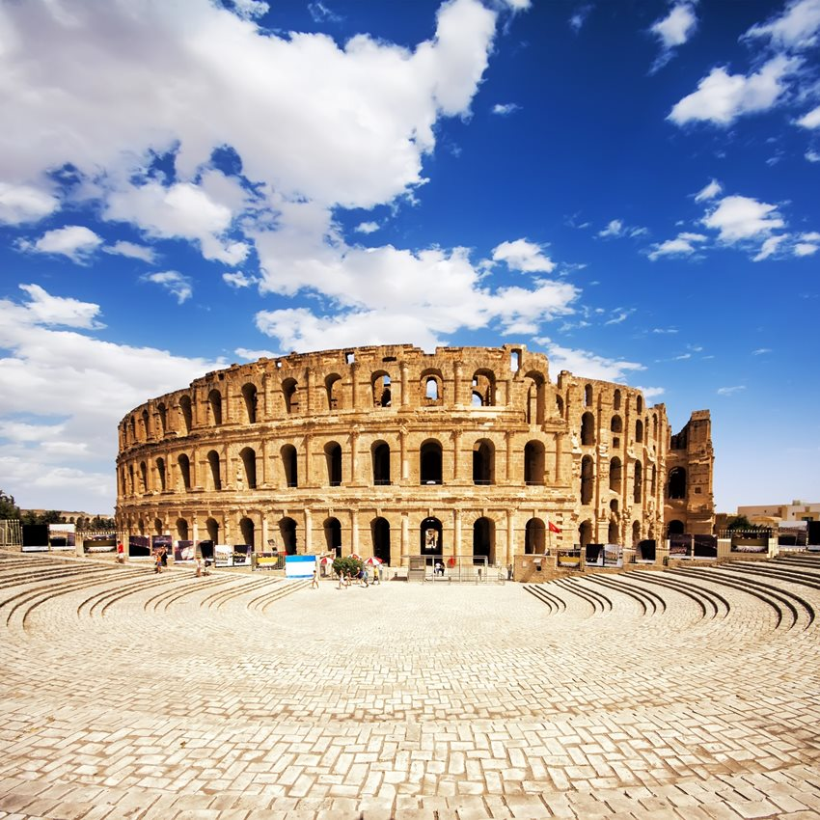

LOC CONTACT
Name: Ridha MANAI
Address: Maison des Fédérations Sportives, Cité Olympique, 1004 Tunisia
Email: tunisia.shooting@gmail.com
Language: English / French
Phone number (WhatsApp) – French / English (Nejib): +216 52536980

Looking forward to welcoming you in Nabeul, Tunisia

