National Archery Association of Thailand
286 Sports Authority of Thailand, Ramkhamhaeng Road, Huamark, Bangkapi
Bangkok 10240, Thailand, Tel: +66 2 719 2777
Email: sany_bkk@yahoo.com, kosavinta@gmail.com

INVITATION
TO : All Archery Member Associations,
Dear President / Secretary General,

As Chairman of the Local Organizing Committee (LOC) of the Asian Continental Qualifier Tournament to be held in Bangkok, Thailand on 09 – 12 November 2023, I would like to invite you all to be part of one of the most important archery events to take place in Bangkok, Thailand.

Bangkok, officially known in Thai as Krung Thep Maha Nakhon and colloquially as Krung Thep, is the capital of Thailand and situated in the Chao Phraya River. Bangkok is the seat of all branches of the national government. The Government House, parliament House and Courts are all in the city. Bangkok of the site of the Grand Palace and Dusit Palace. Most government ministries also have headquarters and offices in the capital.

Bangkok, Thailand has hosted many world class sporting events, and we continue to see athletes from many countries compete in our country at this time in many high-profile events.

We welcome you all to Thailand ‘The Land of Smile’ and we hope you can join us here.

Sincerely Yours,
Sanguan Kosavinta
President
National Archery Association of Thailand

IMPORTANT DATES

Please find enclosed detailed information regarding this event. To register participation, please complete all the necessary sections in WAREOS (https://extranet.worldarchery.sport) within the deadlines listed below.

Summary of deadlines:

Registration Opening date on WAREOS | 01 June 2023
Preliminary Entries | 09 August 2023
Final Entries | 19 October 2023
Late entries fee | 26 October 2023
Hotel reservation down-payment (50%) | 08 October 2023
Hotel reservation and payment | 19 October 2023
Transportation | 19 September 2023
Visa support | 20 August 2023
Full refund cancellation deadline  *After this deadline, the LOC is allowed to retain all amounts due by the Member Association. | 15 October 2023

Please respect the stated deadlines.

Asian Continental Qualifier tournament for The Paris 2024 Olympic Games
09 Nov 2023  Thursday | Arrival of participants
10 Nov 2023  Friday | Continental Qualifier Tournament  Morning : Qualification Rounds  Qualification Round Recurve Women, Elimination  Lunch Break  Afternoon : Qualification Rounds Recurve Men, Elimination
11 Nov 2023  Saturday | Continental Qualifier Tournament  Morning : Recurve Women Quarter Final , Final  Lunch Break  Afternoon : Recurve Men Quarter Final, Final  Award ceremonies (Compound, Recurve)
12 Nov 2023  Sunday | Departure of teams

NOTE: This preliminary programme is subject to change according to participation and
TV requirements. All changes will be published and distributed in good time.

PRELIMINARY & FINAL REGISTRATION
All entries, accommodation reservations, transport needs, flight arrival/departure information and visa invitation letter requests are to be completed using the World Archery Online Registration System WAREOS https://extranet.worldarchery.sport. This system handles the entire registration process for this event. No entry forms, hotel reservations or transportation forms will be accepted; all information must be entered into WAREOS.

Member associations can login to WAREOS at http://extranet.worldarchery.sport with the username and password assigned by World Archery. After entering WAREOS, selecting the event from the list will allow a member association to register their athletes. Select/press the “Entries” button to see the list of categories in the event. Select/press the “category” to enter the athlete and official numbers/details participating for that event. A WAREOS User Manual can be downloaded in PDF format (English) upon login.

Contact wareos@archery.sport with any questions regarding technical problems on WAREOS. For any question regarding the organization of the event (transport, accommodation, meals, invoices, visa etc.) please contact directly the LOC.

Athletes from a minimum of 4 different Member Associations shall be registered and participate in the event.

A maximum number of 3 athletes per country can be registered into each category and divisions of the event.

Member Associations can only use WAREOS to make any changes or amendments to entries and will be able to do so at any time. An email will automatically notify the Organising Committee and Member Association of any changes made in WAREOS.

ENTRY FEES
Individual USD 170.- per athlete
Official USD 120.- per person
*There is no Entry Fee for Team
Guest USD 350.- per person

International License CHF 100.- per participant per calendar year to be paid to World Archery

Entry fees for individual/Official/Teams include daily local transport between official hotel to the practice field / and venue during the qualification, elimination and finals venues (timetable to be confirmed on site).

Entry fee for guest includes daily local transport between field to/from official hotels during the qualification, elimination and finals venues. They have no field of play access.

Any changes made after the deadlines specified or if entries differ by more than 4 athletes from the preliminary entries, the following penalty fees to will automatically be applied:
PENALTY FEES TO BE PAID TO ORGANISING COMMITTEE (USD)

Penalty fees for Late Entries (after final deadline): | 50.- per entry
Penalty fees for not filling Preliminary entries | 150.- per entry
Penalty fee for differences between preliminary and final entries:  *If the difference between final and preliminary entries number is more than 4 athletes/officials | 150.- per entry

PENALTY FEES TO BE PAID TO WORLD ARCHERY (CHF)
Lost accreditation | 30.- each
Lost classification card | 30 .-each
Any change to the final country entry list, such as (but not limited to):  - Athlete or official name change  - Date of birth change  - Official position change  - Absence or incomplete on-site contact person | 50.- each change

NOTE: CHF currency exchange rates will be those on the date of the event.

Member Associations that have penalty fees outstanding from 2023 will need to have paid these penalty fees before being eligible to enter and compete.

Any entries received less than 3 days before the team managers meeting for a Hyundai Archery World Cup or World Championships will be refused if no preliminary entry and/or final entry are made prior. This decision cannot be appealed by the teams and is fully compliant with the current World Archery rules, article 3.7.1.2. Entries received after the deadlines, are subject to penalties as clearly stated in the rule book and the invitation documents of World Cups and World Championships. A Member Association that has made final entries in WAREOS and does not participate will be invoiced for the number of entries entered in the system, unless they have informed World Archery and the Organizing Committee in writing at least one week prior to the event that they are unable to attend.

ACCOMMODATION

Alexander Hotel – Three Star Hotel
- Single Room price: USD 190.- per room / night
- Number of rooms: 50
- Double/Twin Room price: USD 270.- per room / night
- Number of rooms: 190
- Triple room price : USD 400.- per room / night
- Number of rooms: 30
- Board plan: full board
- Check-in from 09 November 2023
- Late check-out 13.00 pm.
- Hotel website: http://alexanderhotel.co.th
- Photo (hotel & rooms)

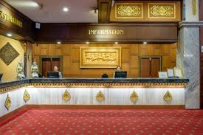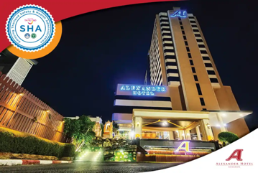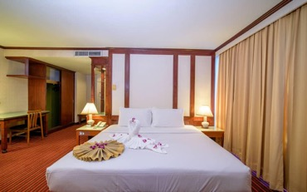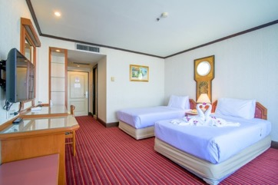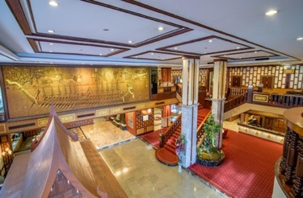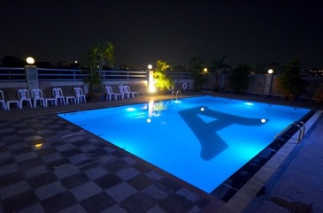

Grand Four Wings Convention Bangkok – Five Star Hotel

- Single Room price: USD 290.- per room / night
- Number of rooms: 20
- Double/Twin Room price: USD 390.- per room / night
- Number of rooms: 50
- Board plan: full board
- Check-in from 09 November 2023
- Late check-out 13.00 pm.
- Hotel website: https://www.grandfourwings.com/
- Photo (hotel & rooms)

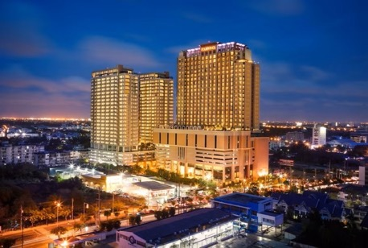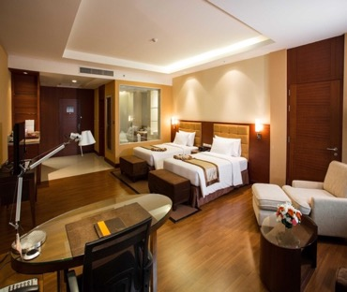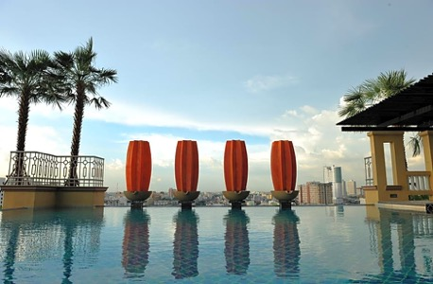

Rooms are allocated on a first come, first serve basis. Accommodation includes breakfast and lunch with non-alcoholic drinks. Lunch will always be served at the archery venue; dinner will be served at the hotel.
LOC will do not allow for non - official hotel.

TRANSPORTATION
Transportation will be provided from Suvarnabhumi airport to the official hotel, from two days before the official practice day and until one days after the closing day round trip at USD 60.- per person. Local transport will be available between the official hotel, practice and competition venues for free. Transport timetables will be confirmed.

VISA
All participants who need an entry visa to Country, will be required to complete the Visa Support sections in WAREOS by no later than 14 August 2023.

It is the applicants’ responsibility for supplying the necessary information, ensuring all details are up to date, correct and submitted by the deadlines specified.

In addition, all participants that require a visa are kindly requested to supply a copy of their latest/valid passport. Copies of each application can be uploaded on WAREOS. All passport copies and personal details entered/uploaded to WAREOS will be held securely and in the strictest of confidence and not shared with other parties.

PAYMENT CONDITIONS
Complete all necessary sections in WAREOS and make full payment by the specified deadlines. Bank transfers only, no credit cards will be accepted.

To confirm hotels reservations, a minimum 50% deposit of the total amount is required to be bank transferred to the OC before 02 October 2023. Reservations after this date will be considered only according to availability. The final outstanding balance shall be made via bank transfer before arrival. Accommodation cannot be guaranteed after this deadline. A balanced invoice will be provided via WAREOS.

BANK INFORMATION FOR ACCOMMODATION, TRANSPORTATION AND ENTRY FEES
A/C Name : National Archery Association of Thailand
Address : 286 Sport Authority of Thailand, Ramkhamhaeng, Huamark, Bangkapi, Bangkok 10240 Thailand
Telephone number : +6681 822 8260
Bank : Krungthai Bank
Branch Sports Authority of Thailand
Account Number : 662 5 87044 7
Swift : KRTHTHBK
Bank’s Address : 286 Sport Authority of Thailand, Ramkhamhaeng, Huamark, Bangkapi, Bangkok 10240 Thailand

NOTE: All payment will be made in USD by Bank Transfer or cash on arrival. All bank charges will be paid by the participants.
CANCELLATIONS & CHANGES
All cancellations and changes must be made through WAREOS / Open WAREOS:

- Should flight arrival details change last minute, please contact the Organising Committee using the details indicated in the team managers’ booklet.
- If a participant’s arrival is later than the original scheduled arrival date, the room will be charged from the date of the original booking in WAREOS.
- An email will automatically notify the Organising Committee and Member Association of any changes made in WAREOS.

HEALTH REGULATIONS (COVID-19)
INFORMATION
- Everybody should follow the Government/public health authorities measures (national and sport-specific regulations) and be aware of the travel restrictions
- For your information, Medical infrastructure/Hospital with proper care will be reachable within 15 minutes from the venue, where COVID-19 test can be done.
- All participants must have your own insurance which cover health and accident.
Medical emergency contact and location
Ramkhamhaeng Hospital, 436 Ramkhamhaeng 36/1, Huamak, Bangkapi, Bangkok 10240
Contact Number +662 7439999

ADDITIONAL INFORMATION
Training
A training field will be available starting on 04 November 2023 at the Huamark Archery Field located approximately 15 minutes from the official hotels.

Weather
Bangkok is a city where it is never cold but quite hot. Temperatures in November are expected to range between 28 and 33 degrees Celsius. There are chances of rain, mainly on November.

Media Registration
Media representatives can apply for registration by emailing: kosavinta@gmail.com

Internet
Will be available in the official hotels for free (in hotel rooms and in the lobby). There will also be Wi-Fi available for access to results on venue.

Water
Each participant with receive clean bottles of water.
Bottled water will be available at the qualification and practice venues.

LOC CONTACT

Name: Mr. Sanguan Kosavinta
Address: 21, Seree Village 1, Seree Road 2, Huamark, Bangkok 10250, Thailand
Email: kosavinta@gmail.com
Language: Chinese and English
Phone number with international extension: +6681 822 8260

Looking forward to welcoming you in Bangkok, Thailand.

