TO
ALL World Archery Member Associations,

Dear President/Secretary General
As Chair of the Local Organizing Committee (LOC) of the ASIA CUP, STAGEII to be held in TASHKENT, UZBEKISTAN on 29 April 2023, I would like to invite you all to be part of one of the most important archery events to take place in the UZBEKISTAN in 2023.

Tashkent is the capital and largest city of Uzbekistan. It is the most populous city in Central Asia, with a population of 2,909,500 (2022).Tashkent comes from the Turkic tash and kent, literally translated as "Stone City" or "City of Stones".
Tashkent is a city which is famous for its exceptionally valuable architectural heritage. There are many interesting monuments which have been preserved from the Middle Ages; buildings of 19th c. erected by the architects such as A. Benoua, V. Gueintselman and A. Makarov according to European traditions; imposing Soviet era administrative and apartment structures; and modern buildings which combine the latest architectural achievements with national style, local picturesque decor, and Asian architectural traditions. The most important monuments date back to the 16th c., the "golden age" of the city's history.

The city has a deeply ingrained culture of service based on the friendliness, respect, and warmth of its people. Its local government and institutions are fully committed to the city’s development. Its modern infrastructure offers absolute comfort when hosting world class events.

Welcome to this amazing city that reinvents itself every day. Our targets look forward to embracing your arrows, just as our hearts are ready to make your visit unforgettably enjoyable.

“Come and discover hundreds of reasons to visit and endless excuses to come back”.

Sincerely yours,

Imamov Otabek

Asia Cup, Stage II (LOC)
Vice President
Uzbekistan Archery Federation

IMPORTANT DATES

Please find enclosed detailed information regarding this event. To register participation, please complete all the necessary sections in WAREOS (https://extranet.worldarchery.sport) within the deadlines listed below.

Summary of deadlines:

Registration Opening date on WAREOS | 10 February 2023
Preliminary Entries | 08 March 2023
Final Entries | 09 April 2023
Late entries fee | 20 April 2023
Hotel reservation down-payment (50%) | 20 March 2023
Hotel reservation and payment | 08 April 2023
Transportation | 08 April 2023
Visa support | 01 April 2023
Full refund cancellation deadline  *After this deadline, the LOC is allowed to retain all amounts due by the Member Association. | 25 March 2023

Please respect the stated deadlines.

PRELIMINARY PROGRAMME
29 April 2023  Saturday | Arrival of participants  Practice field will be available from 29 April 2023
30 April 2023  Sunday | Official Practice (Equipment Inspection)  Team Managers Meeting
01 May 2023  Monday | Opening Ceremony (TBC)  Qualification Round for Recurve and Compound  (Recurve and Compound)
02 May 2023  Tuesday | Team / Mixed Team Eliminations & Finals (Till Semi-Finals 1/2) (Recurve and Compound)  Individual Eliminations (Recurve and Compound)
03 May 2023  Wednesday | Individual Eliminations & Finals (Till Semi-Finals 1/2) (Compound, Recurve)
04 May 2023  Thursday | Finals Compound – Individual and Team  - Compound (Women and Men)  - Award Ceremonies
05 May 2023  Friday | Finals Recurve – Individual and Team  - Recurve (Women and Men)  - Award Ceremonies
06 May 2023  Saturday | Departure of participants

NOTE: This preliminary programme is subject to change according to participation and TV requirements. All changes will be published and distributed in good time.

PRELIMINARY & FINAL REGISTRATION
All entries, accommodation reservations, transport needs, flight arrival/departure information and visa invitation letter requests are to be completed using the World Archery Online Registration System WAREOS https://extranet.worldarchery.sport. This system handles the entire registration process for this event. No entry forms, hotel reservations or transportation forms will be accepted; all information must be entered into WAREOS.

Member associations can login to WAREOS at http://extranet.worldarchery.sport with the username and password assigned by World Archery. After entering WAREOS, selecting the event from the list will allow a member association to register their athletes. Select/press the “Entries” button to see the list of categories in the event. Select/press the “category” to enter the athlete and official numbers/details participating for that event. A WAREOS User Manual can be downloaded in PDF format (English) upon login.

Contact wareos@archery.sport with any questions regarding technical problems on WAREOS. For any question regarding the organization of the event (transport, accommodation, meals, invoices, visa etc.) please contact directly the LOC.

Athletes from minimum of 4 different Member Associations shall be registered and participate in the event.

Member Associations can only use WAREOS to make any changes or amendments to entries and will be able to do so at any time. An email will automatically notify the Local Organizing Committee and Member Association of any changes made in WAREOS.

ENTRY FEES
Individual 150USD per athlete
Official 100 USD per person
Guest 100 USD per person
VIP guest 100 USD per person
International License 100 CHF per participant per calendar year to be paid to World
Archery

Entry fees for individual/Official/Teams include daily local transport to and from the practice field to/from official hotels during the qualification, elimination and finals venues (timetable to be confirmed on site).

Entry fee for guest includes daily local transport to and from the practice field to/from official hotels during the qualification, elimination and finals venues. They have no field of play access.

Entry fee for VIP guest includes daily local transport to and from the practice field to/from official hotels during the qualification, elimination and finals venues. They have no field of play access.

Any changes made after the deadlines specified or if entries differ by more than 4 athletes from the preliminary entries, the following penalty fees to will automatically be applied:

PENALTY FEES TO BE PAID TO ORGANISING COMMITTEE

Penalty fees for Late Entries (after final deadline): | 50 USD per entry
Penalty fees for not filling Preliminary entries | 150USD per entry
Penalty fee for differences between preliminary and final entries:  *If the difference between final and preliminary entries number is more than 04athletes/officials | 150 USD per entry

PENALTY FEES TO BE PAID TO WORLD ARCHERY (CHF)
Any change to the final country entry list, such as (but not limited to):  - Athlete or official name change  - Date of birth change  - Official position change  - Absence or incomplete on-site contact person | 50 CHF each change
NOTE:CHF currency exchange rates will be those on the date of the event.
ACCOMMODATION
Central Palace – 3 Star Hotel
- Single Room price: USD 180.00 per room
- Number of rooms: 9
- Double/Twin Room price: USD 300 per room
- Number of rooms: 30
- Board plan: Full board
- Check-in from 29 April 2023 - 14:00 (early check-in: one night charge is applicable)
- Late check-out 6 May 2023 - Up to 18:00 hrs50% of the accommodation rate
After 18:00 hrs one night charge is applicable
- Hotel website: https://central-palace-hotel-tashkent.booked.net
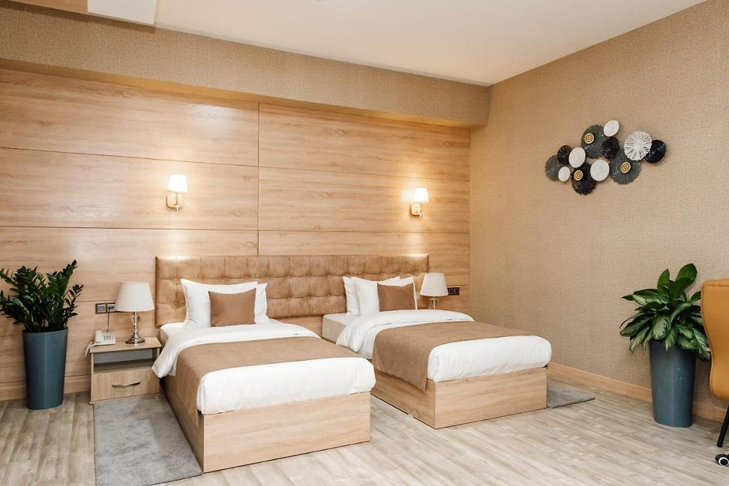

Le Grande Plaza– 4 Star Hotel
- Single Room price: USD 200.00 per room
- Number of rooms: 20
- Double/Twin Room price: USD 320.00 per room
- Number of rooms: 50
- Board plan: Full board
- Check-in from 29 April- 14:00(early check - in : one night charge is applicable)
- Late check-out 6 May 2023 - Up to 18:00 hrs50% of the accommodation rate
After 18:00 hrs one night charge is applicable
- Hotel website: https://le-grande-plaza-hotel-tashkent.nochi.com
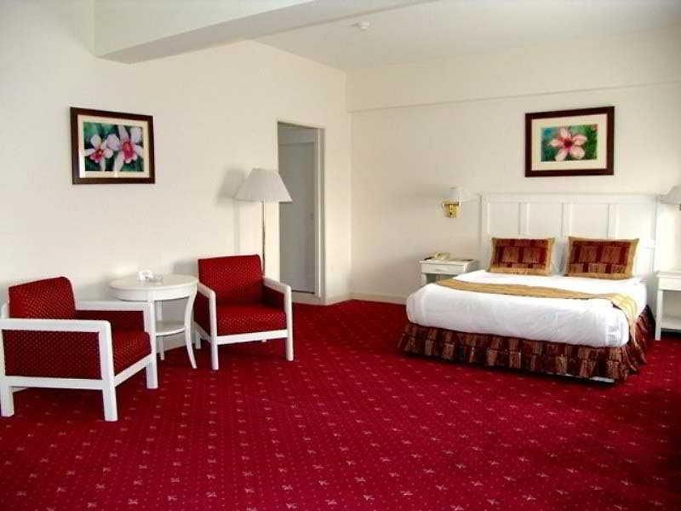
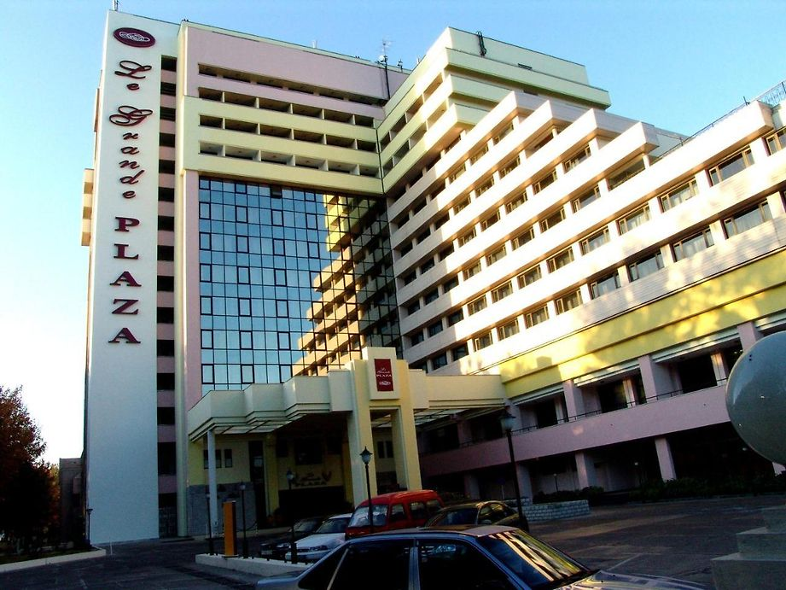

Hotels are allocated on a first come, first serve basis. Accommodation includes breakfast, lunch and dinner with non-alcoholic drinks. Lunch will always be served at the archery venue from 30 April 2023; dinner will be served at the hotel.

***Due to SECURITY RESTRICTION, all MAs MUST reserve their accommodation through the organizing committee at the official hotel. No MA’s can reserve Non-Official hotels. If any MA’s do reserve a Non-Official hotel, LOC will not allow them to participate in the Asia Cup, Stage II.

TRANSPORTATION
Transportation will be provided from Islam Karimov Tashkent International Airport to the official hotel on arrival day and on departure day.

Transfer cost from/to airport to/from hotel: USD 15per person one way

Local transport will be available between the official hotel, practice and competition venues at NO charge.Transport timetables will be confirmed.

VISA
All participants who need an entry visa to Country, will be required to complete the Visa Support sections in WAREOS by no later than 01 APRIL 2023.

It is the applicants’ responsibility for supplying the necessary information, ensuring all details are up to date, correct and submitted by the deadlines specified.

In addition, all participants that require a visa are kindly requested to supply a copy of their latest/valid passport. Copies of each application can be uploaded on WAREOS. All passport copies and personal details entered/uploaded to WAREOS will be held securely and in the strictest of confidence and not shared with other parties.

PAYMENT CONDITIONS
Complete all necessary sections in WAREOS and make full payment by the specified deadlines. Bank transfers only, no credit cards will be accepted. All bank charges will be paid by the participants.

The entry fees should be paid in full before arrival or upon arrival (before Check-In at the hotel)

To confirm hotels reservations, a minimum 50% deposit of the total amount is required to be bank transferred to the LOC before 20 MARCH 2023. Reservations after this date will be considered only according to availability. The final outstanding balance shall be made via bank transfer before arrival OR after arrival at the hotel lobby.Accommodation cannot be guaranteed after this deadline. A balanced invoice will be provided via WAREOS.

BANK INFORMATION FOR ACCOMMODATION, TRANSPORTATION ANDENTRY FEES
A/C Name: Info Day Service ( represent Archery Federation of Uzbekistan)
Federation’s Address: Uzbekistan, c.TashkentChilonzor region, st.Foziltepa, 38
Organizing company address: Uzbekistan Tashkent, SH. RUSTAVELI STREET 41 - UY
Telephone number: +998909121891(Uzbekistan federation) + 998 909699998 (Info Day Service)
City and Country: Uzbekistan Tashkent city
Bank: "Kapital Bank " Tashkent city branch
AccountNumber: 202088 404007 0303700 1 (USD)
Swift: KACHUZ22
Bank’s address: Uzbekistan Tashkent, Mirabad region Nukus street 86 A
Bank’s Phone: 78-140 93 70 fax 78-140 93 54
City: Tashkent City

NOTE: ALL PAYMENTS SHALL BE MADE IN USD to Info Day Service on behalf of Uzbekistan Federation

CANCELLATIONS& CHANGES
All cancellations and changes must be made through WAREOS:
- Should flight arrival details change last minute, please contact the Local Organizing Committee using the details indicated in the team managers’ booklet.
- If a participant’s arrival is later than the original scheduled arrival date, the room will be charged from the date of the original booking in WAREOS.
- An email will automatically notify the Local Organizing Committee and Member Association of any changes made in WAREOS.

HEALTH REGULATIONS (COVID-19)
INFORMATION
- Everybody should follow the Government/public health authorities measures (national and sport-specific regulations) and be aware of the travel restrictions
- For your information, Medical infrastructure/Hospital with proper care will be reachable within 15 minutes from the venue, where COVID-19 test can be done.

Medical emergency contact and location
DarmonService
Address: Tashkent, Uzbekistan, 100059, Chilonzor region, St.Chuponota 18/19/
Tel:+998 71 200 00 17
VENUE - College of the Olympic Reserve
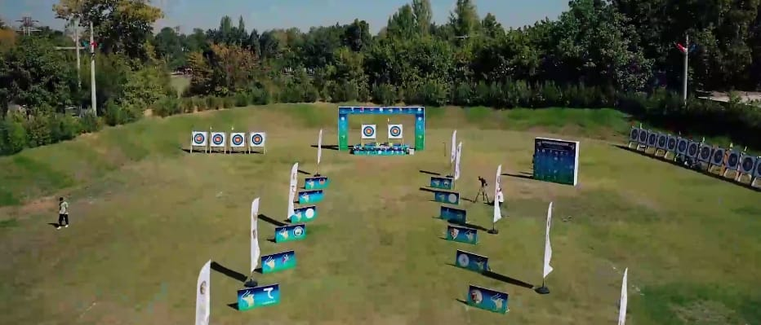
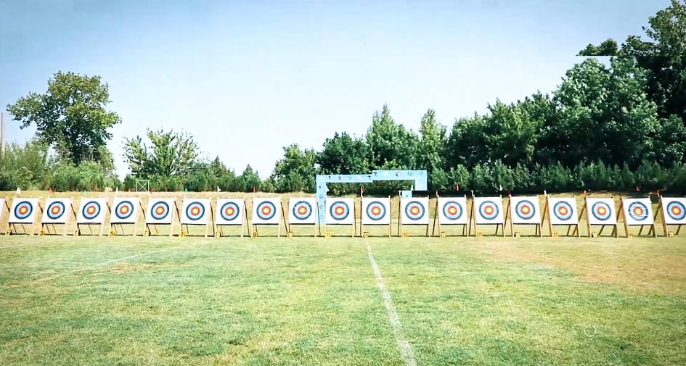
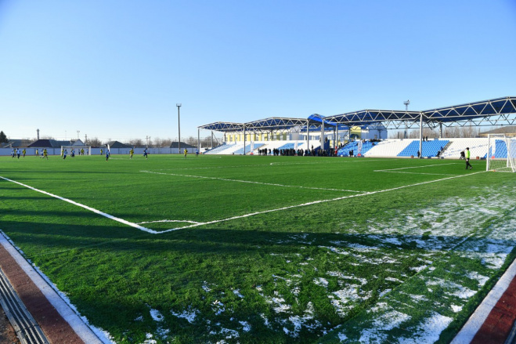
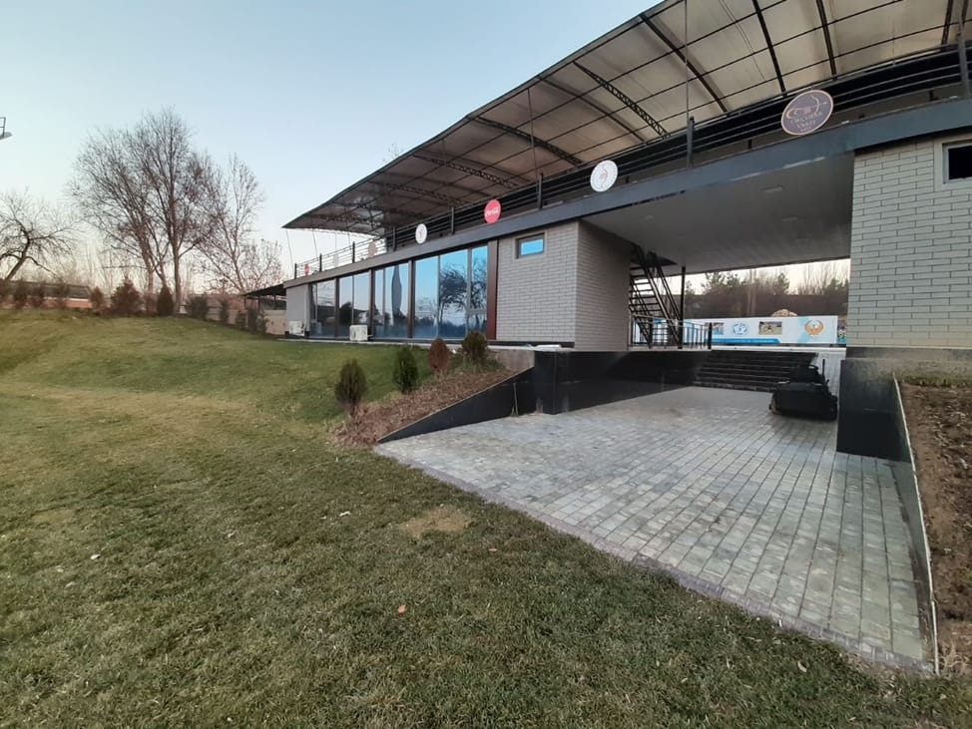

ADDITIONAL INFORMATION

Training
A training field will be available starting on 29 April 2023at the College of the Olympic Reserve located in 38 Katartal Street, Tashkent 100173 College of Olympic reserve approximately 20 minutes from the official hotels. There will be NO additional payment for transport between the practice venue and hotels.

Weather
Tashkent - city, with lots of sunny days. The weather in spring in Tashkent during the daytime is +21 +25°C, while at night it drops to +16°C. There are chances of rain, mainly in the afternoons.

Media Registration
Media representatives can apply for registration on the LOC email:uaf.office@gmail.com

Internet
It will be available in the official hotels for free (in hotel rooms and in the lobby). There will also be Wi-Fi available for access to results on venue.

Water
Each participant with receive clean bottles of water.
Bottled water will be available at the qualification and practice venues.

LOC CONTACT

Name: ORKHAN KOPADZE
Address: Uzbekistan, c.TashkentChilonzor region, st.Foziltepa, 38
Email: uaf.office@gmail.com
Language: English
Phone number with international extension: +998909121891 (WhatsApp)

Looking forward to welcoming you in TASHKENT, UZBEKISTAN.

