TO ALL World Archery Member Associations,

Dear President,

I am the President of the Archery Association of Singapore (AAS) and also the Chair of the Local Organising Committee (LOC) of the 2023 Asia Cup Stage 3 which will be held in Singapore on 5-10 June 2023. I would like to invite you all to be part of what promises to be an exciting archery event taking place in a vibrant locale that never fails to surprise visitors to our shores.

Singapore is coming back from the pandemic! In 2022, the city state remains within the top 5 most popular cities in the world by international tourist arrivals based on statistics and rankings from the World Tourism Organization.

You and your association members might like to know that from 29 August 2022, all travellers can enjoy quarantine-free travel in Singapore regardless of their vaccination status. Covid caseloads remain very low; most of the resident population are fully vaccinated. This will immeasurably make it much easier for your athletes and officials to travel to Singapore for competition.

Singapore has hosted many world class sporting events, and we continue to see athletes from many countries compete in our country at this time in many high-profile events.

We welcome you all to this unique city state which on each and every day lives up to a tagline often given to it – “Uniquely Singapore”. We hope you can join us here!

Sincerely yours,
Asia Cup Stage 3 Singapore 2023 OC Chairperson

IMPORTANT DATES

Please find enclosed detailed information regarding this event. To register for participation, please complete all the necessary sections in WAREOS (https://extranet.worldarchery.sport) within the deadlines listed below.

Summary of deadlines:

Registration Opening date on WAREOS | 20th February 2023
Preliminary Entries | 5th March 2023
Final Entries | 15th May 2023
Late Entries Fee | 20th May 2023

Hotel Reservation Deposit – 50% | 15th May 2023
Hotel Reservation and Payment | 15th May 2023
Transportation | 15th May 2023
Visa Support | 15th April 2023
Cancellation Deadline – FULL Refund | 20th May 2023

- After the deadlines, the LOC will be allowed to retain the full amount of fees due from the Member Association
- Please respect the stated deadlines

PRELIMINARY PROGRAMME

3rd – 4th June 2023 | Arrival of Teams
5 June 2023, Monday | Official Practice, Team Manager Meeting, Equipment Inspection and Open Ceremony
6th June 2023, Tuesday | Qualification Round – Recurve, Compound
7th June 2023, Wednesday | Qualification Round – Recurve, Compound
8th June 2023, Thursday | Individual / Team and Mixed Team Elimination
9th June 2023, Friday | Mixed Team, Recurve and Compound Individual Elimination Final, Award Ceremony
10th June 2023, Saturday | Mixed Team, Recurve and Compound Individual Elimination Final, Award Ceremony
11th June 2023, Sunday | Departure of Teams

- NOTE: This preliminary Programme is subject to change according to participation and TV requirements. All changes will be published and distributed in good time

PRELIMINARY & FINAL REGISTRATION

- All entries, accommodation reservations, transport needs, flight arrival/departure information and visa invitation letter requests are to be completed using the World Archery Online Registration System WAREOS https://extranet.worldarchery.sport. This system handles the entire registration process for this event. No entry forms, hotel reservations or transportation forms will be accepted; all information must be entered into WAREOS.

- Member associations can login to WAREOS at http://extranet.worldarchery.sport with the username and password assigned by World Archery. After entering WAREOS, selecting the event from the list will allow a member association to register their athletes. Select/press the “Entries” button to see the list of categories in the event. Select/press “Category” to enter the athlete and official numbers/details participating for that event. A WAREOS User Manual can be downloaded in PDF format (English) upon login.

- Contact wareos@archery.sport with any questions regarding technical problems on WAREOS. For any question regarding the organization of the event (transport, accommodation, meals, invoices, visa etc.) please contact the LOC directly.

- Athletes from a minimum of 4 different Member Associations shall be registered to participate in the event.

- A maximum number of four (4) athletes per country can be registered in each category and division of the event.

- Member Associations can only use WAREOS to make any changes or amendments to entries and will be able to do so at any time. An email will automatically notify the Organising Committee and Member Association of any changes made in WAREOS.

ENTRY FEE

Individual | USD180 Per Athlete
Official | USD130 Per individual
International License | 100 CHF per participant per calendar year to be paid to World Archery

ENTRY FEES IN NON-OFFICIAL HOTELS

Individual | USD380 Per Athlete
Official | USD280 Per individual
International License | 100 CHF per participant per calendar year to be paid to World Archery

If there are any changes made after the specified deadlines, or if entries differ by more than 4 athletes from the preliminary entries, the following penalty fees will automatically be applied:

PENALTY FEES TO BE PAID TO ORGANISING COMMITTEE
Penalty fees for Late Entries (after final deadline) | USD 50 per entry
Penalty fees for not filling Preliminary Entries | USD 50 per entry
Penalty fee for differences between Preliminary and Final entries  - If the difference between Final and Preliminary entries numbers is more than 4 athletes/officials | USD 50 per entry

PENALTY FEES TO BE PAID TO WORLD ARCHERY (CHF)
Any change to final country entry list, such as (but not limited to):  - Athlete’s or Official’s name Change  - Date of Birth change  - Official’s position change  - Absence or Incomplete on-site contact person | CHF 50 per change
NOTE: CHF currency exchange rates will be those prevailing on the date of the event

ACCOMMODATION

VILLAGE HOTEL BUGIS [4-star Hotel]

Single Room Rate | USD200 Per room/night
Numbers of Rooms | 15
Double/Twin Room Rate | USD320 Per room/night
Numbers of Rooms | 80
Board Plan | FULL Board
Checked in | 3rd June 2023, 1400hrs
Checked Out | 11th June 2023, 1200hrs
Late check-out till 1800hrs is at the applicable day-use rates and check-out after 1800hrs is at full-day charge, subject to room availability

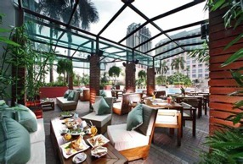
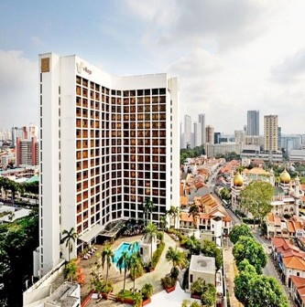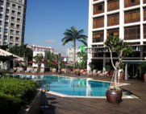

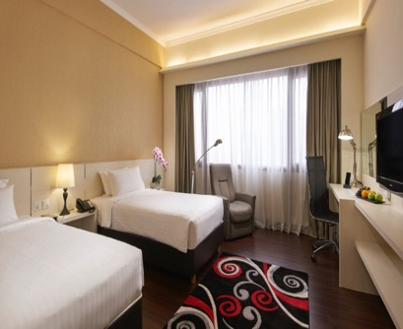

Hotels room reservations will be based on first come first serve basis. It is mandatory to choose official hotels by the Local Organizing Committee.

TRANSPORTATION

Transportation will be provided from Changi Airport to the official hotel, from two days
before the official practice day until one day after the closing day at USD25 Charge for one way
(Round trip USD50). Local transport will be available between the official hotel, practice and
competition venues free of charge. Transport timetables will be confirmed later on.

VISA APPLICATION

All participants who need an entry visa to Singapore, will be required to complete the Visa Support sections in WAREOS no later than 15th April 2023.

It is the applicants’ responsibility for supplying the necessary information, ensuring all details are up to date, correct and submitted by the deadlines specified.

All participants who require visas are kindly requested to supply a copy of their latest/valid passport. Copies of each application can be uploaded on WAREOS. All passport copies and personal details entered/uploaded to WAREOS will be held securely and in the strictest of confidence and not shared with other parties.

PAYMENT INFORMATION

Please complete all necessary sections in WAREOS and make full payment by the specified deadlines. Payment by bank transfers only. NO credit cards will be accepted. All bank charges are to be paid by the participants.

The entry fees should be paid in full before arrival in Singapore.

To confirm hotels reservations, a minimum 50% deposit of the total amount is required to be bank transferred to the LOC before 15th May 2023. Reservations after this date will be considered only according to availability. The final outstanding balance shall be made via bank transfer before arrival. Accommodation cannot be guaranteed after this deadline. A balanced invoice will be provided via WAREOS.

BANK INFORMATION FOR ACCOMMODATION, TRANSPORTATION AND ENTRY FEES

Account Name | Archery Association of Singapore
Association Address | 3 Stadium Drive, #01-33, Singapore 397630
Contact Number of Association | +65 97334239 / +65 91547390
Account Number | 519284780001
City & Country | Singapore
Bane Name | Oversea Chinese Banking Corporation Limited
Swift | OCBCSGSG
Bank Address | 65 Chulia St, OCBC Centre, Singapore 049513
Bank Contact | +65 1800 363 3333
City | Singapore
NOTE: ALL PAYMENTS SHALL BE MADE IN USD

CANCELLATIONS & CHANGES

All cancellations and changes must be made through WAREOS:

- Should flight arrival details change at the last minute, please contact the Organising Committee using the details indicated in the team managers’ booklet.

- If a participant’s arrival is later than the original scheduled arrival date, the room will be charged from the date of the original booking in WAREOS.

- An email will be sent automatically to notify the Organising Committee and Member Association of any changes made in WAREOS.

MEDICAL EMERGENCY CONTACT AND LOCATION

Ng Teng Fong General Hospital  Address:  1 Jurong East Street 21  Singapore 609606  Contact: +65 6908 2222  Website:  http://www.ntfgh.com.sg | Raffles Hospital  Address:  585 North Bridge Road  Singapore 188770  Contact: +65 6311 1111  https://www.rafflesmedicalgroup.com/services/hospital/

INFORMATION

- WEATHER
The average high-temperature in June 2023

Temperature | 27°C 81°F
High Temperature | 31°C 88°F
Low Temperature | 24°C 75°F
Day Temperature | 29° C85°F
Night Temperature | 28.7°C 84°F
Sunshine Hours | 8 hours

- MEDIA REGISTRATION
  - Media representatives can apply by emailing at event@archerysingapore.org.sg (LOC media contact)

- INTERNET
  - Internet will be available in the official hotels for free (in hotel rooms and in the lobby).

- WATER
  - Each participant will receive one clean bottle for them to refill water when necessary, as part of the national efforts to save water and reduce usage of plastics. Water dispensers will be located at the stadium.

LOC CONTACT

Name | Leong Sek Choon (Mr)
Email | secretary@archerysingapore.org.sg
Language | English
Contact | +65 83828943
Name | Edelin Wong (Ms)
Email | events@archerysingapore.org.sg
Language | English, Mandarin
Contact | +65 97334239

Looking forward to welcoming you in Singapore!

