

TO ALL World Archery Member Associations,

Dear President,

As Chair of the Local Organising Committee (LOC) of the 2023 Conquest Cup to be held in Istanbul, Turkiye on 27 – 29 May 2022, I would like to invite you all to be part of one of the most important archery events to take place in the Turkiye in 2022.

Welcome to this amazing city that reinvents itself every day. Our targets look forward to embracing your arrows, just as our hearts are ready to make your visit unforgettably enjoyable.

Sincerely yours,

**Muhammet Mustafa BAKIRCI**

**OC Chairman**

IMPORTANT DATES

Please find enclosed detailed information regarding this event. To register participation, please complete all the necessary sections in WAREOS (<https://extranet.worldarchery.sport>) within the deadlines listed below.

Summary of deadlines:

|  |  |
| --- | --- |
| Registration Opening date on WAREOS | 12 December 2022 |
| Preliminary Entries | 27 February 2023 |
| Final Entries | 06 May 2023 |
| Late entries fee | 22 May 2023 |
| Hotel reservation down-payment (50%) | 27 February 2023 |
| Hotel reservation and payment | 06 May 2023 |
| Transportation | 06 May 2023 |
| Visa support | 27 April 2023 |
| Full refund cancellation deadline  *After this deadline, the LOC is allowed to retain all amounts due by the Member Association. | 06 May 2023 |

Please respect the stated deadlines.

PRELIMINARY PROGRAMME

|  |  |  |
| --- | --- | --- |
| 25 May 2023  Thursday  26 May 2023  Friday | | Arrival of participants  **Official Practice** (Equipment Inspection) followed immediately by qualification |
| 27 May 2023  Saturday | **Qualification Round** (Recurve, Compound) | |
| 28 May 2023  Sunday | **Individual Eliminations** (1/16, 1/8, ¼, 1/2)  (Compound, Recurve) | |
| 29 May 2023  Monday | **Finals** (Compound, Recurve)  **Award ceremonies** (Compound, Recurve) | |
| 30 May 2023  Tuesday | Departure of teams | |

**NOTE:** This preliminary programme is subject to change according to participation and TV requirements. All changes will be published and distributed in good time.

PRELIMINARY & FINAL REGISTRATION

All entries, accommodation reservations, transport needs, flight arrival/departure information and visa invitation letter requests are to be completed using the World Archery Online Registration System WAREOS <https://extranet.worldarchery.sport>. This system handles the entire registration process for this event. No entry forms, hotel reservations or transportation forms will be accepted; all information must be entered into WAREOS.

Member associations can login to WAREOS at <http://extranet.worldarchery.sport> with the username and password assigned by World Archery. After entering WAREOS, selecting the event from the list will allow a member association to register their athletes. Select/press the “Entries” button to see the list of categories in the event. Select/press the “category” to enter the athlete and official numbers/details participating for that event. A WAREOS User Manual can be downloaded in PDF format (English) upon login.

Contact [wareos@archery.sport](mailto:wareos@archery.sport) with any questions regarding **technical problems on WAREOS**. For any question regarding the organisation of the event (transport, accommodation, meals, invoices, visa etc.) please contact **directly the LOC**.

Athletes from a minimum of 4 different Member Associations shall be registered and participate in the event.

A maximum number of six (6) athletes per country can be registered into each category and divisions of the event.

Member Associations can only use WAREOS to make any changes or amendments to entries and will be able to do so at any time. An email will automatically notify the Organising Committee and Member Association of any changes made in WAREOS.

This event is also open to archers who are not part of a national team (club archers) and that individual registration (not through Member Association) is through Open Wareos (not wareos)

ENTRY FEES

Individual 150 EUR per athlete

Official 75 EUR per official

Teams 100 EUR per Team

ENTRY FEES IN NON-OFFICIAL HOTELS

Individual 300 EUR per athlete

Official 150 EUR per official

Teams 200 EUR per Team

Entry fees for individual/Official/Teams include daily local transport to and from the practice field to/from official hotels during the qualification, elimination and finals venues (timetable to be confirmed on site).

Any changes made after the deadlines specified or if entries differ by more than 4 athletes from the preliminary entries, the following penalty fees to will automatically be applied:

|  |  |  |
| --- | --- | --- |
| PENALTY FEES TO BE PAID TO ORGANISING COMMITTEE | |  |
| |  |  | | --- | --- | | **Penalty fees for Late Entries (after final deadline):** | **50** per entry | | **Penalty fees for not filling Preliminary entries** | **150** per entry | | **Penalty fee for differences between preliminary and final entries:**  *If the difference between final and preliminary entries number is more than 4 athletes/officials | **150** per entry | | |  |
|  |

Member Associations that have penalty fees outstanding from 2022 will need to have paid these penalty fees before being eligible to enter and compete.

Any entries received less than 3 days before the team managers meeting for a Hyundai Archery World Cup or World Championships will be refused if no preliminary entry and/or final entry are made prior. This decision cannot be appealed by the teams and is fully compliant with the current World Archery rules, article 3.7.1.2. Entries received after the deadlines, are subject to penalties as clearly stated in the rule book and the invitation documents of World Cups and World Championships. A Member Association that has made final entries in WAREOS and does not participate will be invoiced for the number of entries entered in the system, unless they have informed World Archery and the Organising Committee in writing at least one week prior to the event that they are unable to attend.

ACCOMMODATION

**CROWN PLAZA HARBIYE (5 Star Hotel)**

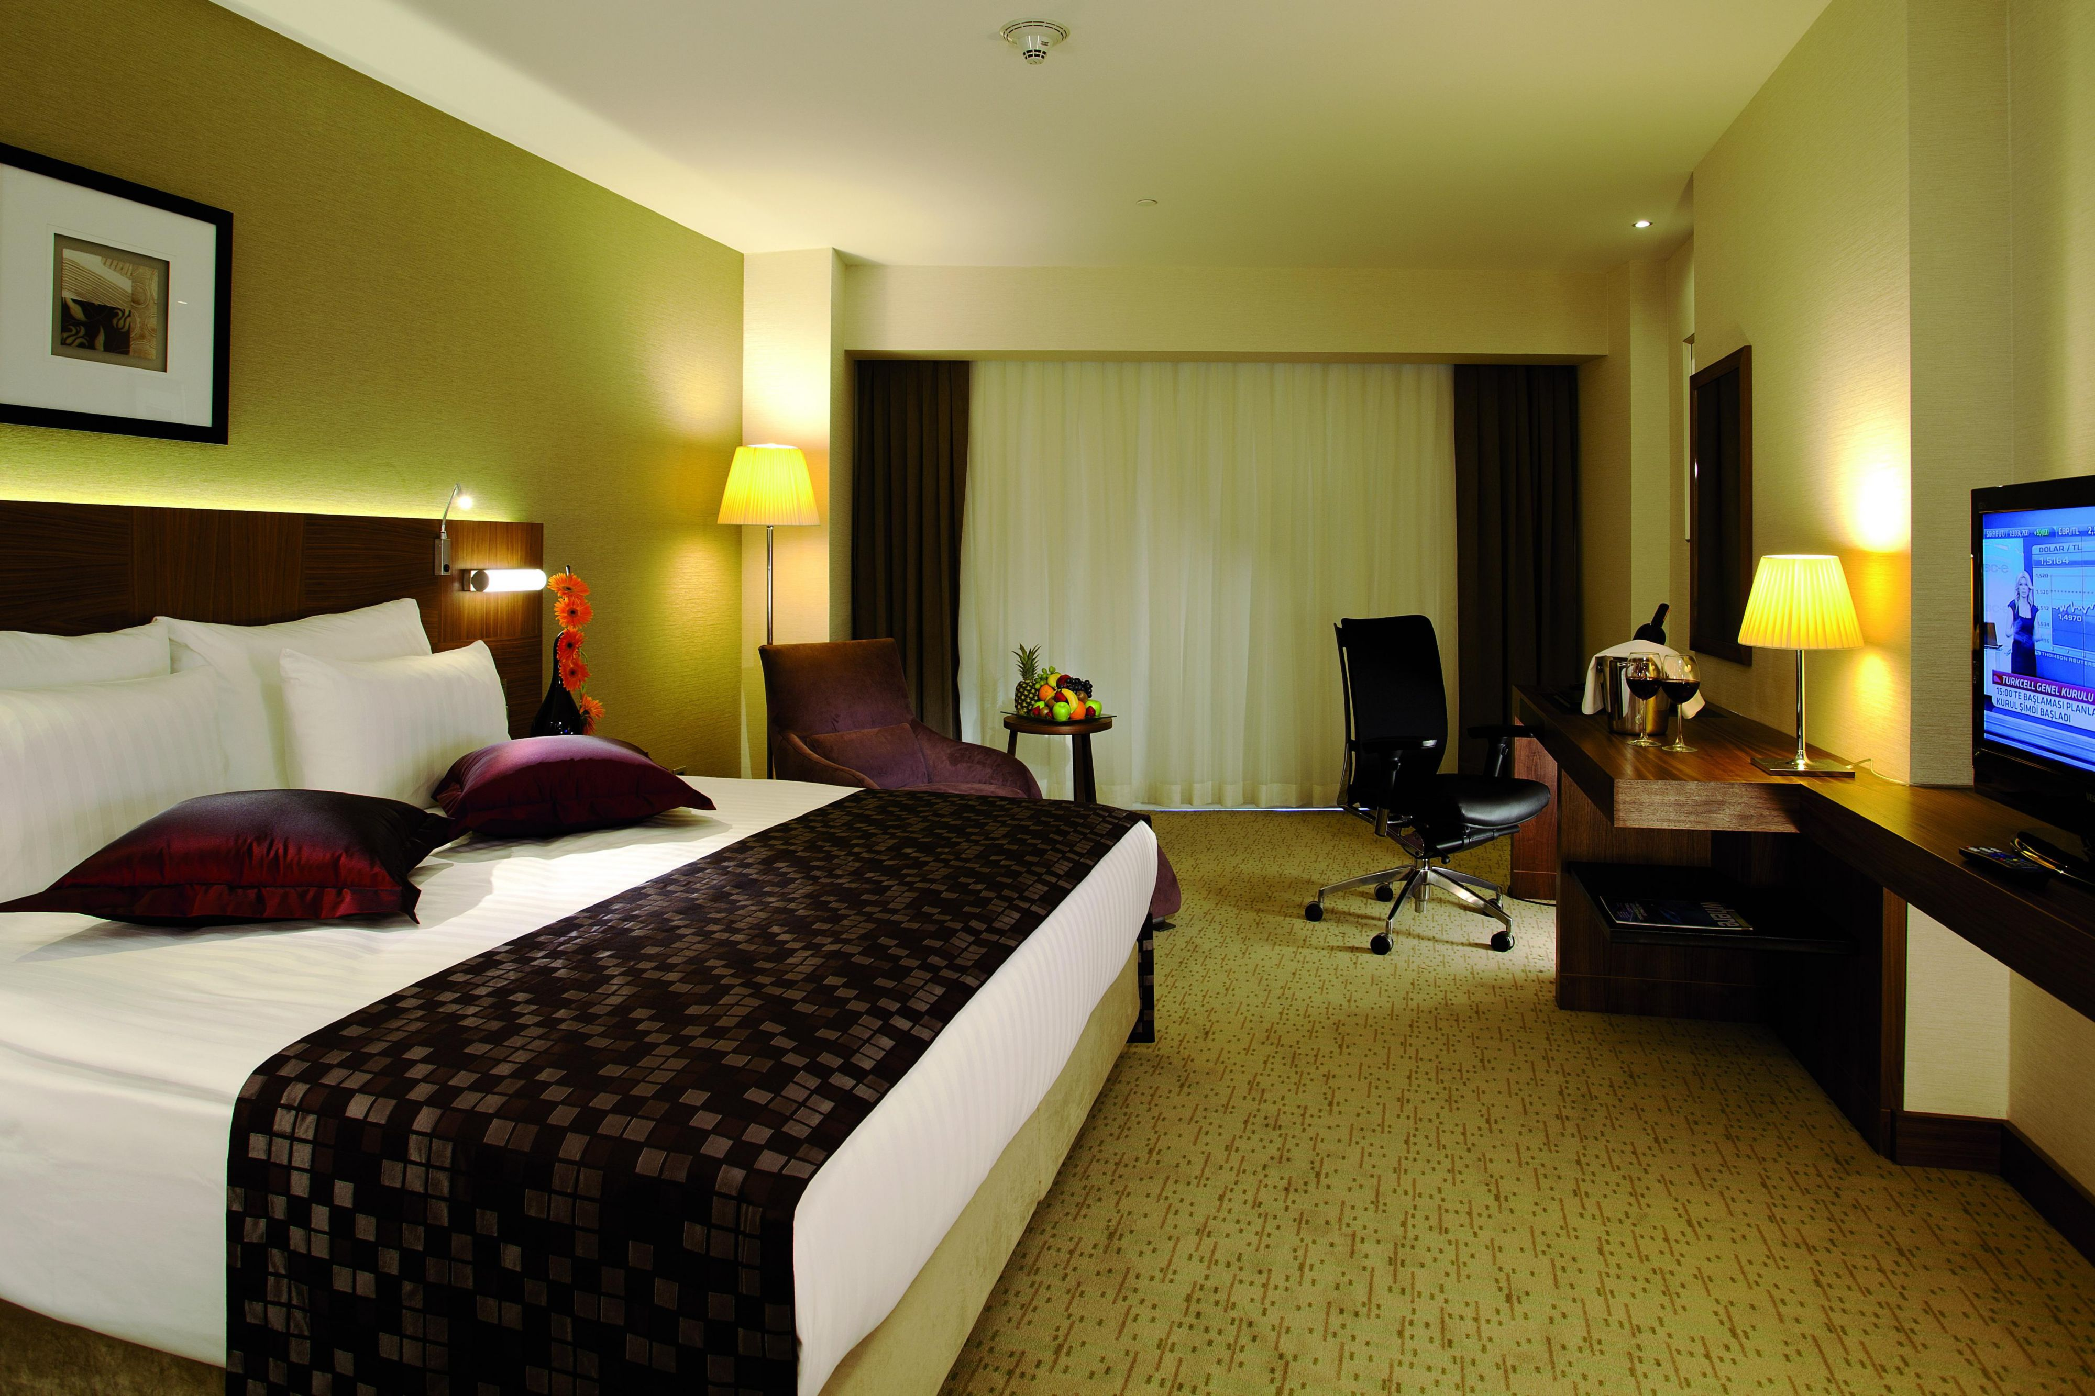**metin, iç mekan, sahne, raf içeren bir resim

Açıklama otomatik olarak oluşturuldu**

* Single Room price: EUR 190.00 per room
* Number of rooms: 50
* Double/Twin Room price: EUR 234.00 per room
* Number of rooms: 100
* Board plan: HB – Breakfast & Dinner
* Check-in from/check-out 25.05.2023 - 14:00 / 30.05.2023
* Late check-out No
* <https://www.ihg.com/crowneplaza/hotels/gb/en/istanbul/istih/hoteldetail?cm_mmc=GoogleMaps-_-CP-_-TR-_-ISTIH>

**HILTON DOUBLETREE PIYALEPASA**



* Single Room price: EUR 228.00 per room
* Number of rooms: 40
* Double/Twin Room price: EUR 286.00 per room
* Number of rooms: 60
* Board plan: HB – Breakfast & Dinner
* Check-in from 25.05.2023 - 14:00 / 30.05.2023
* Late check-out No
* <https://www.hilton.com/en/hotels/istikdi-doubletree-istanbul-piyalepasa/?SEO_id=GMB-EMEA-DI-ISTIKDI>

Rooms are allocated on a first come, first serve basis. Accommodation includes breakfast and dinner with non-alcoholic drinks. Lunch will always be served at the archery venue. The price for lunch will be 15.00 EUR per person.

In addition, the LOC will be responsible to provide any event information at this hotel and provide transportation to the venues. Private vehicles can be used too.

Teams who do not reserve their accommodation through the organising committee will be charged a double entry fee.

TRANSPORTATION

Transportation will be provided from Istanbul Airport and Istanbul Sabiha Gokcen International Airport to the official hotels, from two days before the official practice day and until two days after the closing day and the roundtrip price is 80.00 EUR per person. Local transport will be available between the official hotels, practice and competition venues for free. Transport timetables will be confirmed.

VISA

All participants who need an entry visa to Turkiye, will be required to complete the **Visa Support sections** in WAREOS by no later than **27 April 2023**.

It is the applicants’ responsibility for supplying the necessary information, ensuring all details are up to date, correct and submitted by the deadlines specified.

In addition, all participants that require a visa are kindly requested to supply a copy of their latest/valid passport. Copies of each application can be uploaded on WAREOS. All passport copies and personal details entered/uploaded to WAREOS or OPENWAREOS will be held securely and in the strictest of confidence and not shared with other parties.

PAYMENT CONDITIONS

Complete all necessary sections in WAREOS or OPENWAREOS and make full payment by the specified deadlines. Bank transfers only, no credit cards will be accepted. All bank charges will be paid by the participants.

The entry fees should be paid in full before arrival.

To confirm hotels reservations, a minimum 50% deposit of the total amount is required to be bank transferred to the OC before **27 February 2023**. Reservations after this date will be considered only according to availability. The final outstanding balance shall be made via bank transfer before arrival. Accommodation cannot be guaranteed after this deadline. A balanced invoice will be provided via WAREOS or OPENWAREOS.

BANK INFORMATION FOR ACCOMMODATION, TRANSPORTATION AND ENTRY FEES

A/C Name: OKMEYDANI SPOR VE EĞİTİM VAKFI İKTİSADİ İŞLETMESİ

Club Address Keçecipiri mahallesi, Fatih Sultan Minberi Caddesi (street) No:1 Beyoğlu, İstanbul, Türkiye

Telephone number: +90 (530) 353 14 53

City and Country: İstanbul, Türkiye

Bank: VakıfBank

Account Number: TR48 0001 5001 5804 8021 7925 70

Swift: TVBATR2A

Bank’s address: Piyalepaşa, Fatih Sultan Minberi Cd.( street) No:18A Beyoğlu/İstanbul

Bank’s Phone: +90 (212) 361 18 24

City: İstanbul, Türkiye

**NOTE**: ALL PAYMENTS SHALL BE MADE IN EUR.

CANCELLATIONS & CHANGES

All cancellations and changes must be made through WAREOS / Open WAREOS:

* Should flight arrival details change last minute, please contact the Organising Committee.
* If a participant’s arrival is later than the original scheduled arrival date, the room will be charged from the date of the original booking in WAREOS.
* An email will automatically notify the Organising Committee and Member Association of any changes made in WAREOS.

HEALTH REGULATIONS (COVID-19)

INFORMATION

* Everybody should follow the Government/public health authorities measures (national and sport-specific regulations) and be aware of the travel restrictions
* For your information, Medical infrastructure/Hospital with proper care will be reachable within 15 minutes from the venue, where COVID-19 test can be done.

**MEDICAL EMERGANCY CONTACT AND LOCATION**

Prof. Dr. Cemil TASCIOGLU City Hospital

Kaptan Paşa, SSK Okmeydanı Hst. No: 25, 34384

Sisli / Istanbul

00 90 212 314 55 55

ADDITIONAL INFORMATION

Training

A training field will be available starting 25 May 2023 at the Archery Foundation Stadium located approximately 20 minutes from the official hotels.

Weather

Istanbul is not very cold on the dates of the competition, but it is not very hot either. The air temperature in April is expected to be between 14 degrees and 18 degrees. In May, the air temperature can vary between 18 degrees and 25 degrees.

Media Registration

Media representatives can apply for registration on the LOC website: [www.okcularvakfi.org](http://www.okcularvakfi.org) or at [info@okcularvakfi.org](mailto:info@okcularvakfi.org)

Internet

Will be available in the official hotels for free (in hotel rooms and in the lobby). There will also be Wi-Fi available for access to results on venue.

Water

Each participant with receive clean bottles of water.

Bottled water will be available at the qualification and practice venues.

A water fountain system will be used.

LOC CONTACT

Name: Ömer CAN

Address: Keçecipiri mahallesi, Fatih Sultan Minberi Caddesi (street) No:1 Beyoğlu, İstanbul, Türkiye

Email: conquestcup@okcularvakfi.org

Language: English, Japanese, Chinese

Phone number with international extension: +90 (530) 353 14 53 (WP) or +90 (212) 254 66 54/125

Looking forward to welcoming you in İstanbul, Türkiye