TO ALL World Archery Member Associations,
Dear President,

As Chair of the Local Organising Committee (LOC) of the European Grand Prix to be held in Lilleshall, GBR, 3 – 8 April 2023 we would like to invite you all to be part of this event.

This event will be organised following the World Archery Rules in the classes of Recurve and Compound divisions in the Outdoor Target Archery discipline.

PARTICIPATION IS OPEN TO ALL WORLD ARCHERY MEMBER ASSOCIATIONS.

Please find enclosed the necessary documents concerning the registration, organisation and participation in this event.

We are looking forward to welcoming you and we are sure you will enjoy your stay at Lilleshall.

Yours sincerely
Jon Nott
Event Director
Archery GB
www.archerygb.org
Email:EGP23@archerygb.org

IMPORTANT DATES

Please find enclosed detailed information regarding this event. To register participation, please complete all the necessary sections in WAREOS (https://extranet.worldarchery.sport) within the deadlines listed below.

Summary of deadlines:

Registration Opening date on WAREOS | 6 December 2022
Preliminary Entries | 3 January 2023
Final Entries | 13 March 2023
Hotel reservation down-payment (50%) | 6 January 2023  If we have not received your deposit on this date, the rooms will be released and could end up costing extra
Full payment | 13 March
Transportation final deadline | 13 March 2023
Visa support | 31 December 2023
Full refund cancellation deadline*  *After this deadline, the LOC is allowed to retain all amounts due by the Member Association. | 13 January 2023

Please respect the stated deadlines.

PRELIMINARY PROGRAMME
Saturday April 1 | AM | Arrivals
 | PM | Arrivals / Practice Open from 14:00
Sunday April 2 | AM | Arrivals / Practice Open
 | PM | Arrivals / Practice open
Monday April 3 | AM | Official Practice
 | PM | Qualification Recurve
Tuesday April 4 | AM | Teams Recurve
 | PM | Qualification Compound
Wednesday April 5 | AM | Teams Compound
 | PM | Individual Eliminations Recurve
Thursday  April 6 | AM | Individual Eliminations Compound
 | PM | Teams CQT European Game Recurve
Friday  April 7 | AM | Individual Eliminations CQT European Games Recurve & Compound
 | PM | Mixed Teams
Saturday  April 8 | AM | Compound Finals (The Orangery Finals Range)
 | PM | Recurve Finals (The Orangery Finals Range)
Sunday April 9 | AM | Departures All day
 | PM

NOTE: This preliminary programme is subject to change according to participation and TV requirements. All changes will be published and distributed in good time.

PRELIMINARY & FINAL REGISTRATION
All entries, accommodation reservations, transport needs, flight arrival/departure information and visa invitation letter requests are to be completed using the World Archery Online Registration System WAREOS https://extranet.worldarchery.sport. This system handles the entire registration process for this event. No entry forms, hotel reservations or transportation forms will be accepted; all information must be entered into WAREOS.

Member associations can login to WAREOS at http://extranet.worldarchery.sport with the username and password assigned by World Archery. After entering WAREOS, selecting the event from the list will allow a member association to register their athletes. Select/press the “Entries” button to see the list of categories in the event. Select/press the “category” to enter the athlete and official numbers/details participating for that event. A WAREOS User Manual can be downloaded in PDF format (English) upon login.

Contact wareos@archery.sport with any questions regarding technical problems on WAREOS. For any question regarding the organisation of the event (transport, accommodation, meals, invoices, visa etc.) please contact directly the LOC.

A maximum number of SIX (6) athletes per country can be registered into each category and divisions of the event.

Athletes from a minimum of 4 different Member Associations shall be registered and participate in the event.

Member Associations can only use WAREOS to make any changes or amendments to entries and will be able to do so at any time. An email will automatically notify the Organising Committee and Member Association of any changes made in WAREOS.

REGULATIONS for CLUB ARCHERS participating in European GRAND PRIX
Club archers (i.e. athletes not competing as country) can register on Open WAREOS with their username and password if already registered in the past or register to get the log in details if it’s the first time. After the creation of the profile, follow the instructions to register to the event.
This does not guarantee his/her participation. The process of registration and inclusion must respect the Club Archers’ regulations and procedures in order to be able to participate to this event. Club Archers participating in WAE event must be members of a WA Member Association (therefore official members of the Archery Federation of his/her country). The athlete’s national federation will be able to veto the entry if required.
Club Archers cannot have coaches or guest accredited to access the FoP (blue area). If guest or coaches will accompany a Club Archer, he will be treated as a spectator.
DRESS REGULATIONS: Club Archers must respect WA rules (Book 1, point 3.22) in terms of uniform for the WA events. Club Archers cannot use any National Team uniform (neither of his country nor any other).
Club Archer must be present in the Official Practice day when he will pick up his/her accreditation, confirm name and data given and pass the equipment inspection. The Club Archer is not allowed to miss the official practice and arrive directly to the qualification day. Travel plan should be arranged according to the schedule.

ENTRY FEES

Individual 200 Euro Per Athlete
Official 100 Euro Per Person
Teams 100 Euro per team (no charge for mixed teams)

Entry fees for individual/Official/Teams include daily local transport to and from the practice field to/from official hotels during the qualification, elimination and finals venues.

Any changes made after the deadlines specified or if entries differ by more than 4 athletes from the preliminary entries, the following penalty fees to will automatically be applied:
PENALTY FEES TO BE PAID TO ORGANISING COMMITTEE
Penalty fees for Late Entries (after final deadline): | 80 per entry
Penalty fees for not filling Preliminary entries | 150 per entry
Penalty fee for differences between preliminary and final entries:  *If the difference between final and preliminary entries number is more than 4 athletes/officials | 80 per entry

Lost accreditation | 30 Euro

Any entries received less than 3 days before the team managers meeting will be refused if no preliminary entry and/or final entry are made prior. This decision cannot be appealed by the teams and is fully compliant with the current World Archery rules, article 3.7.1.2. Entries received after the deadlines, are subject to penalties as clearly stated in the rule book and the invitation documents of World Cups and World Championships. A Member Association that has made final entries in WAREOS and does not participate will be invoiced for the number of entries entered in the system, unless they have informed World Archery and the Organising Committee in writing at least one week prior to the event that they are unable to attend.
ACCOMMODATION

Entries will only be accepted using the LOC accommodation.
Rooms are allocated on a first come, first serve basis. Accommodation includes breakfast, lunch and dinner with non-alcoholic drinks. Lunch will always be served at the archery venue; dinner will be served at the hotel. In addition, the LOC will be responsible to provide any event information at this hotel and provide transportation to the venues.
All our hotels are about 15 – 20 transfer time to Lilleshall.
The Mercure Hotel
- Single Room price: Euro 190.00 per room
- Double/Twin Room price: Euro 300 per room
- Board plan: full board
- Hotel website: Mercure Telford Centre | Hotel in TELFORD - ALL (accor.com)
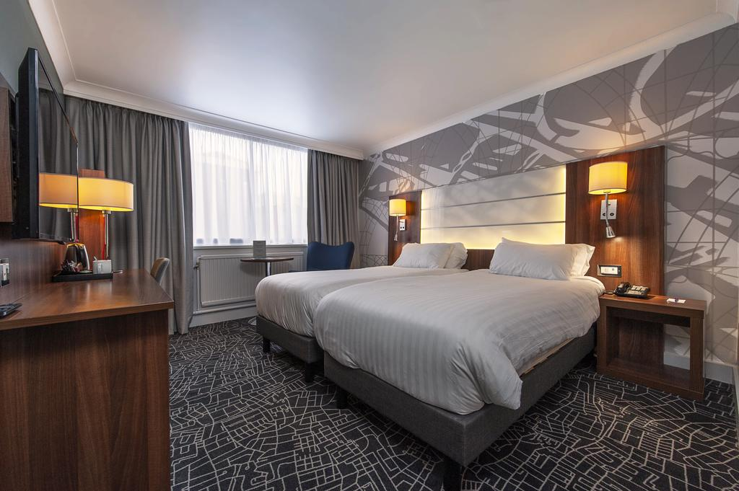
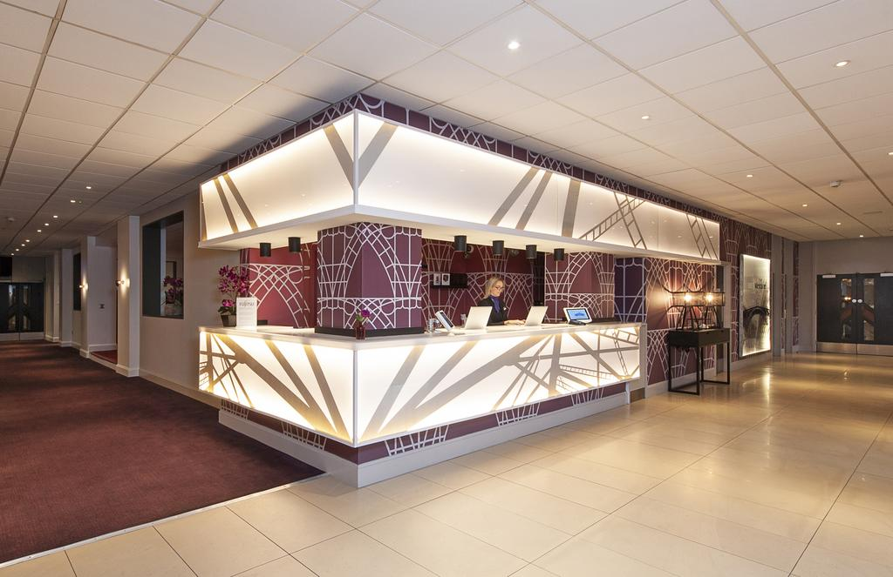

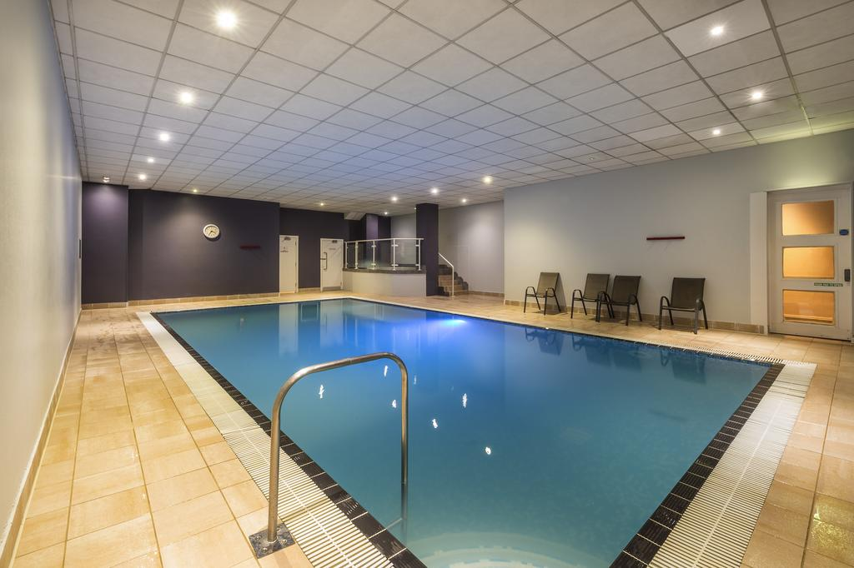
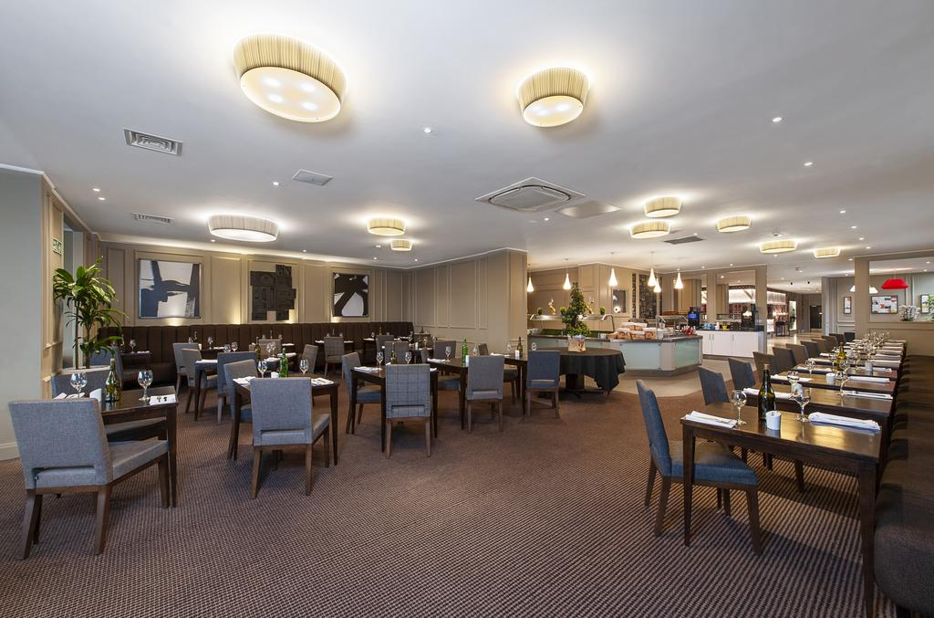

The Holiday Inn
- Single Room price: Euro 190.00 per room
- Double/Twin Room price: Euro 300 per room
- Board plan: full board
- Hotel website: Hotel in Telford, | Holiday Inn Telford - Ironbridge Hotel (ihg.com)

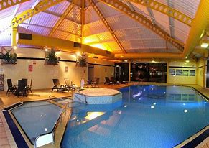
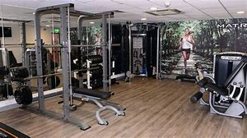

The International Hotel
- Single Room price: Euro 150.00 per room
- Double/Twin Room price: Euro 250 per room
- Board plan: full board
- Hotel website: Home | The International Hotel Telford
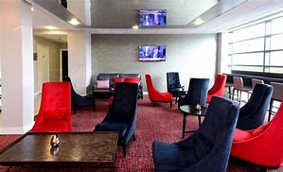
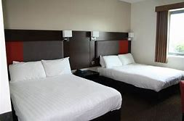

All hotels are set in close proximity to each other in Telford Town Centre and Southwater, where a cinema, bowling alley, ice rink, shopping centre, supermarket, many restaurants, and the town park are all a short walk away.

Your reservation of room choice will only be given on receipt of deposit, selection on WAREOS is not a guarantee without deposit.
We are able to also offer limited large basic dormitory accommodation for team looking for a discount option please contact the LOC for availability and details.

TRANSPORTATION
The LOC will collect the teams from 3 international airports.
Birmingham International Airport – BHX – 55 KM €65 Euro per person each way
(Transfers should take 50 minutes to 1 hour)

Manchester international Airport – (MAN) 80 KM €75 Euro per person each way
(Transfers should take 1 hour 15 to 1 hour 30)

London Heathrow International Airport – (LHR) 180 KM €90 Euro per person each way
(Transfers should take 2 hour 30 to 3 hours)

The last date for the payment of the transportation details must be with the LOC no later than 13th March All fees must be paid no later than 13th March

From the airports to the hotel / return trip, the organiser will use buses, small buses, vans, and cars, which will depend on number of persons scheduled for transportation.

Transportation from the airports will start Saturday 1st April and will end Monday 10 April. Arrivals and transport requests outside of these dates can be arranged by special arrangement with the LOC only.

VISA
All participants who need an entry visa to Country, will be required to complete the Visa Support sections in WAREOS by no later than 31st December 2022

It is the applicants’ responsibility for supplying the necessary information, ensuring all details are up to date, correct and submitted by the deadlines specified.

In addition, all participants that require a visa are kindly requested to supply a copy of their latest/valid passport. Copies of each application can be uploaded on WAREOS. All passport copies and personal details entered/uploaded to WAREOS will be held securely and in the strictest of confidence and not shared with other parties.

PAYMENT CONDITIONS
Complete all necessary sections in WAREOS and make full payment by the specified deadlines. Bank transfers only, no credit cards will be accepted. All bank charges will be paid by the participants. All fees should be paid in full before arrival.

To confirm hotels reservations, a minimum 50% deposit of the total amount is required to be bank transferred to the OC before 6th January Reservations after this date will be considered only according to availability. The final outstanding balance shall be made via bank transfer before arrival. Accommodation cannot be guaranteed after this deadline. A balanced invoice will be provided via WAREOS.

BANK INFORMATION FOR ACCOMMODATION, TRANSPORTATION AND ENTRY FEES
Account Name: The Grand National Archery Society T/A Archery GB
Account Address: Lilleshall National Sports Centre, Nr Newport, Shropshire, TF10 9AT
IBAN Number: GB47NWBK60720117529050
Account Number: 17529050
SWIFT / BIC code: NWBKGB2L
Bank Name: Natwest
Bank Address: 217 Dean Street, Telford TF3 4BB
NOTE:
- Please state country code as reference when making payment on transfer.
- ALL PAYMENTS MUST HAVE BEEN MADE IN FULL BEFORE ARRIVAL
- ALL PAYMENTS SHOULD BE IN EURO (€) by Bank Transfer
- NO TRAVELLERS CHEQUES, NO FOREIGN CURRENCIES
- BANK TRANSFER FEES ARE THE RESPONSIBILITY OF THE SENDER

CANCELLATIONS & CHANGES
All cancellations and changes must be made through WAREOS

- Should flight arrival details change last minute, please contact the Organising Committee using the details indicated in the team managers’ booklet.
- If a participant’s arrival is later than the original scheduled arrival date, the room will be charged from the date of the original booking in WAREOS.
- An email will automatically notify the Organising Committee and Member Association of any changes made in WAREOS.

ADDITIONAL INFORMATION
Venue
Training
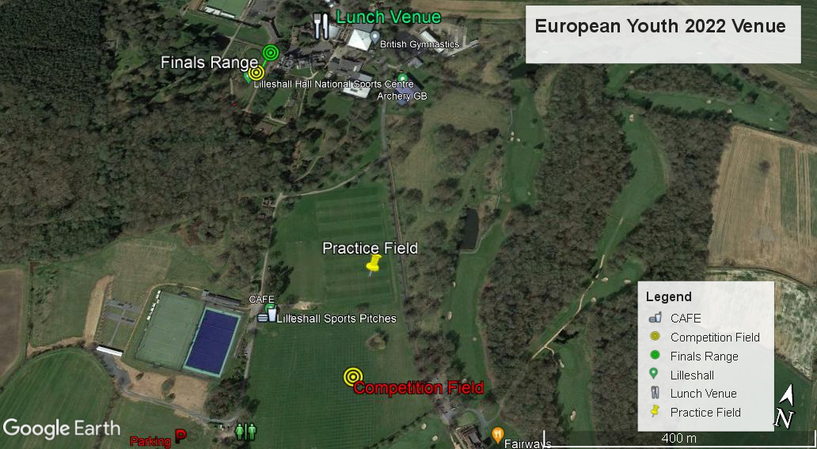
A training field will be available at venue starting on 01/04/2022 from 14:00 and will close 07/04/2022.
LILLESHALL Venue 2023

Weather

Month | Maximum temperature (°C) | Minimum temperature (°C) | Days of air frost (days) | Sunshine (hours) | Rainfall (mm) | Days of rainfall ≥1 mm (days) | Monthly mean wind speed at 10 m (knots)
April | 13.21 | 3.92 | 4.37 | 158.08 | 47.08 | 10.37 | 8.15

Media Registration
Media representatives can apply for registration, please contact the LOC directly

Internet
Will be available in the official hotels for free (in hotel rooms and in the lobby). There will also be Wi-Fi available for access to results on venue.

Water
Each participant with receive a free water bottle
A water fountain system will be used.

Prizes
WAE will give a total amount of 12.000 € for each competition (Recurve and Compound, Men and Women) to the winners.
Prize money for the winners:
1st place: 1500 €
2nd place: 1000 €
3rd place: 500 €
Unless specified otherwise in this document, WA Rules will apply.
See also the contents of the Organizer Agreement.

LOC CONTACT for accommodation

Email: EGP23@archerygb.org
Phone: +44 1952 677 888
Language: English

We are Looking forward to welcoming you in Lilleshall GBR

