EUROPEAN GRAND PRIX 2023
INVITATION PACKAGE

TO ALL WORLD ARCHERY AND WORLD ARCHERY EUROPE MEMBER ASSOCIATIONS

Dear President, Secretary General,

On behalf of the Local Organizing Committee I would like to invite your country to the European Grand Prix 2023, second leg, which will be held from 29 May - 4 June in UMAG, Croatia.

This event will be organized following the WA and WAE EGP RULES, Recurve and Compound divisions in the Outdoor Target Archery discipline.

THE PARTICIPATION IS OPEN TO ALL WORLD ARCHERY MEMBER ASSOCIATIONS AND CLUB MEMBERS.

Please, find enclosed the necessary documents concerning the registration, organization, and participation in this event. To register participation, please complete all the necessary sections in WAREOS within the deadlines.

We are looking forward to welcoming you and your teams to UMAG, Croatia.
Sincerely yours,
Mr. Darko Uidl
Organizing Committee
President
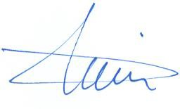

IMPORTANT DATES

Summary of deadlines:

Registration Opening Date – Online WAREOS 4 February 2023
Preliminary Entries Deadline 17 March 2023
Preliminary Hotel Reservation & Payment 17 March 2023
Final Entries Deadline 8 May 2023
Final Hotel Reservation 8 May 2023
Transportation 8 May 2023
Final Payment 8 May 2023
Visa Support 10 March 2023
Full refund cancellation deadline 14 April 2023

PRELIMINARY PROGRAMME

Day |  | Date | Description
Saturday | 27 May |  | Arrival of participants  Unofficial Practice
Sunday | 28 May |  | Arrival of Participants  Unofficial Practice
Monday | 29 May |  | Official Practice & Equipment Inspection  Team Managers' Meeting
Tuesday | 30 May |  | Qualification Round  (Practice Field open)
Wednesday | 31 May |  | Mixed Teams
Thursday | 1 June |  | Individual Eliminations up to semifinals
Friday | 2 June |  | Team Eliminations and Finals  Team and Mixed Team Award Ceremony
Saturday | 3 June |  | Individual Finals  Award Ceremony
Sunday | 4 June |  | Departure of teams

NOTE
This preliminary programme is subject to change according to participation and TV requirements. All changes will be published and distributed in good time.
Website: http://www.archeryeurope.org

PRIZE MONEY

WAE will give total amount of 12.000 € to the individual winners as follows:

1st place 1.500 €
2nd place 1.000 €
3rd place 500 €

PRELIMINARY & FINAL REGISTRATION

All entries, accommodation reservations, transport needs, flight arrival/departure information and visa invitation letter requests are to be completed using the World Archery Online Registration System WAREOS. These systems now handle the entire registration process for this event. No entry forms, hotel reservations or transportation forms will be accepted.
Member associations can login to WAREOS at http://extranet.worldarchery.sport with the username and password assigned by World Archery. After entering WAREOS, selecting the event from the list will allow a member association to register their athletes. Select/press the “Entries” button to see the list of categories in the event. Select/press the “category” to enter the athlete and official numbers/details participating for that event. A WAREOS User Manual can be downloaded in PDF format (English) upon login.
Contact Ms Cecile TOSETTI (ctosetti@archery.sport) in the World Archery Office with any questions regarding technical problems on WAREOS. For any question regarding the organisation of the event (transport, accommodation, meals etc.) please directly contact the LOC.

A maximum number of 6 men and 6 women per country can be registered into each division of the event.
The host country may enter the maximum of 8 men and 8 women per division.

Start date for online registration using WAREOS: 4 February 2023
End of Final registration using WAREOS: 8 May 2023

Please respect the stated deadlines.
Club Archers are allowed to participate due to EGP Rules (WAE official web site).

Member Associations should only use WAREOS to make any changes/amendments to their entries and will be able to do so at any time. Any changes made in WAREOS an email will instantly be automatically sent to the Local Organizing Committee and Member Association with the updated information.

NOTE
Member Associations that have penalty fees outstanding from earlier events will need to pay these penalty fees and get good standing before being eligible to enter and compete.
Also, World Archery fee must have been paid prior the participation.

Starting date of online registration with WAREOS is: | 4 February 2023
End of Preliminary registration: | 17 March 2023
End of Final registration: | 8 May 2023

Please respect the stated deadlines.

However, any changes that are made after the deadlines specified or if entries differ by more than 4 participants from the preliminary entries, the following penalty fees will automatically be applied:
Penalty fees to be paid to Organizing Committee: | Cost:
Penalty fee for late entries (after the final deadline) | 50 € per entry
Penalty fee for not filling Preliminary entries | 150 € per entry
Penalty fee for differences between preliminary and final entries: | 150 € per entry

Any entries received less than 3 days before the Team managers meeting will be refused if no preliminary entry and/or final entry are made prior.

ACCOMMODATION & GENERAL INFORMATION

Important Note
Non-official accommodation is not allowed. Any team or individual accommodated in non-official hotel will not be accredited and participation in the event will be refused.

The official hotels are divided in two categories: Standard and Comfort. Hotels are especially selected by the organization for the event. Hotel allocations will be made on a 'first come-first serve' basis. Accommodation rates will offer full board and half board meal packages.

Reservations should be made before 17 March 2023
Final Hotel Reservation & Transportation Forms 8 May 2023

To confirm your hotel reservations, 60% deposit of the total amount is to be paid by a bank transfer to the Organizing Committee before 17 March 2023. Reservations received after this date will be considered only according to availability.

o Standard Hotel **** (Apartments Amfora / Stella)

Enjoy holidays at the heart of Istrian west coast. Spacious Stella apartments are tucked away within a quiet, wooded landscape, yet close to everything the Stella Maris Resort has to offer. Designed with your perfect family holiday in mind, apartments Stella boast a swimming pool with a sundeck, open concept living rooms and spacious master bedroom. You'll love it here.

If you like your accommodation to be so close to the beach you can hear the murmur of the sea from your window; you'll love Apartments Amfora. Blessed with a shaded terrace, these family apartments located within Stella Maris Resort are minutes away from the children's pool and the waterpark with sprinklers, slides and all kinds of fun water effects.

Half board (dinner at the hotel)
Single Room price 195 €
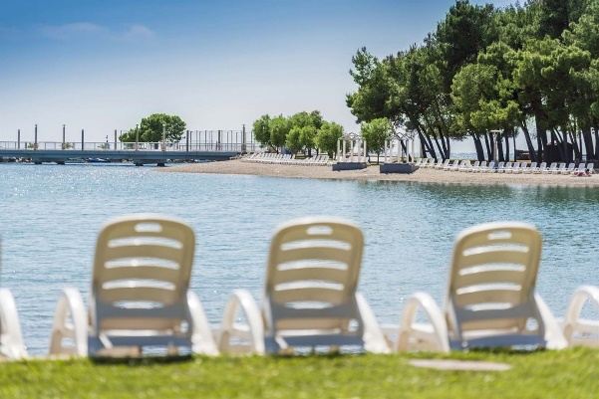
Number of rooms 1
Double/Twin 238 € per room
Number of rooms 19
Triple 429 € per room
Number of rooms 10
Quad 534 € per room
Number of rooms 10

Full board (lunch and dinner at the hotel)
Single Room 211 €
Double/Twin 270 € per room
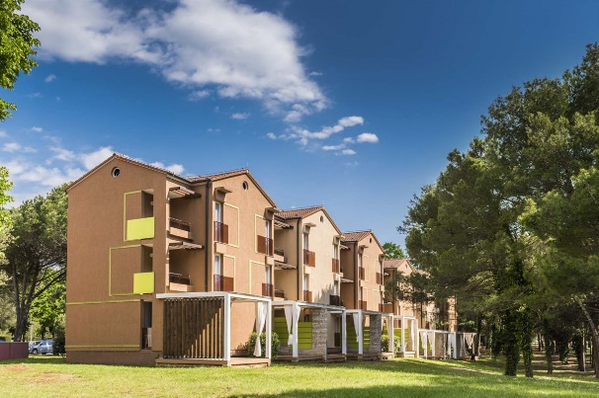
Triple 477 € per room
Quad 598 € per room

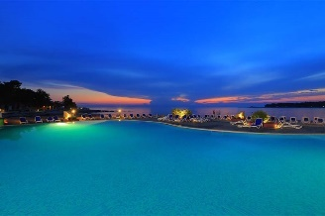
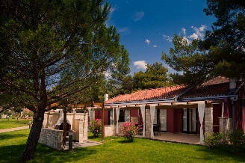

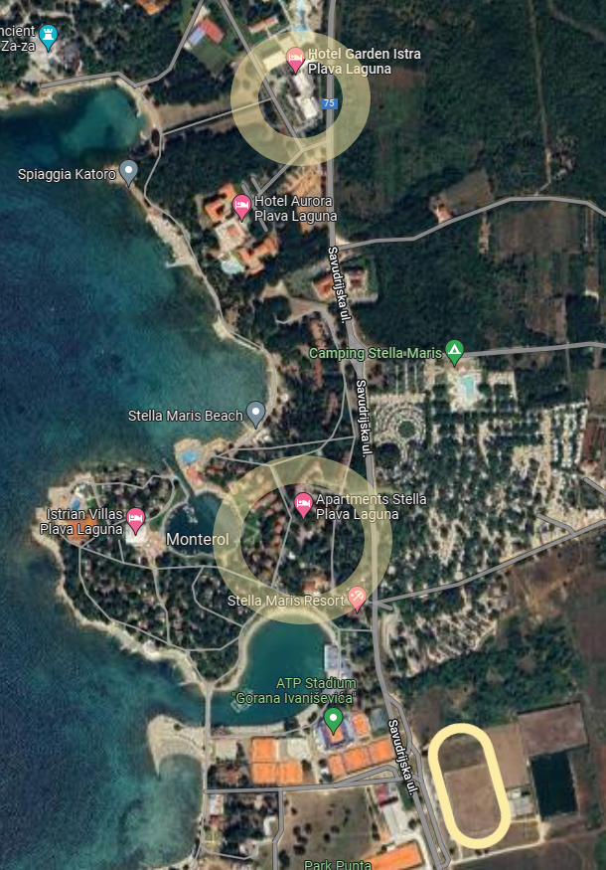

- Comfort Hotel **** (Village Sol Garden Istra)

Residence Garden Istra Plava Laguna will undergo a complete renovation and improvement, both of the accommodation capacities and the common areas in the building. In the upcoming season, guests will be greeted by rooms and suites equipped with new furniture and decorated in a modern style and bright, pleasant colours. The rooms still remain family-friendly and focus on comfort and functionality, so that each guest can enjoy and relax even more on vacation.

Half board (dinner at the hotel)
Single Room 200 €
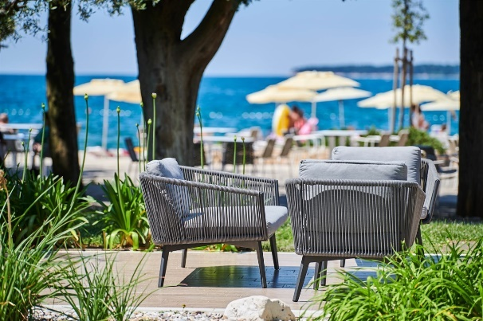
Number of rooms 50
Double/Twin 324 € per room
Number of rooms 80

Full board (lunch and dinner at the hotel)
Single Room 216 €
Double/Twin 356 € per room

Board plans half board, full board
Check-in from 25 May 2023
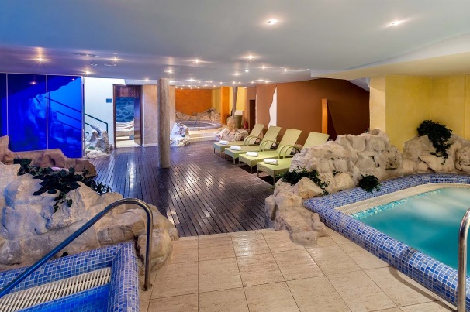
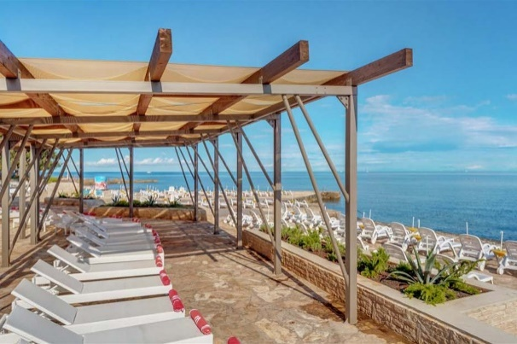

The hotel rates are per room, per night, including free internet. Additional purchases in the hotel bar, café and mini bar are at own expense.*
*All prices are including city tax.

HOTEL UPDATE ON COVID-19 MEASURES

All information will be forwarded to the WhatsApp and Viber groups for everyone signed up for this mode of communication. Information will be shared through Instagram, and Facebook.

Important Note

Refer to the accommodation pages for detailed hotel information.
Please complete all the necessary sections in WAREOS and make full payment for entries, transport, and accommodation by the specified deadlines.
Bank transfers only, no credit cards or travel checks will be accepted.

ENTRY FEE
Individuals 200 € per Athlete
Officials 100 € per Person
Teams 100 € per Team
There is no entry fee for Mix teams.

Temporary Upgrade: 30 € per accreditation (for athletes wishing to be a coach temporarily).

Entry fees include daily local transport to and from the practice field to/from official hotels during the qualification, elimination, and finals venues (timetable to be confirmed on site).

PAYMENT CONDITIONS

All fees should be paid in full before arrival.

Payment of accommodation and local transportation: a minimum deposit of 60% of the total amount owed should be made when booking by 17 March 2023.
The final outstanding balance shall be transferred before 8 May 2023. Accommodation cannot be guaranteed after this deadline. A balance invoice will be provided via WAREOS.
Entry fee should be paid by 17 March 2023 separately than Accommodation & Transportation due to Croatian Tax policy.

Bank information for ACCOMMODATION & TRANSPORTATION

BANK RAIFFEISEN BANK AUSTRIA d.d.
ACCOUNT HOLDER NAME UNILINE d.o.o.
ADRESS BOZE GUMPCA 38, 52100 PULA
ACCOUNT NO HR3124840081100646084
BIC/SWIFT CODE RZBHHR2X

Bank information for ENTRY FEES

BANK PRIVREDNA BANKA ZAGREB d.d.
ACCOUNT HOLDER NAME HRVATSKI STRELICARSKI SAVEZ
ADDRESS HRVATSKOG PROLJECA 34, 10040 ZAGREB
ACCOUNT NO HR6623400091110039202
BIC/SWIFT CODE PBZGHR2X

NOTE: All payments shall be made in EUR only by BANK TRANSFER.

Bank transfer fees are responsible on the sender.
Credit cards and Travel checks will not be accepted.

CANCELLATIONS & CHANGES
- All cancellations and changes must be made through WAREOS:
- Cancellations received before 14 April 2023 a full refund of the deposit payment will be made.
- Cancellations received after 14 April 2023 no refund will be given.
- Refunds will be processed after the event.
- Name changes to team officials or athletes (same category and division) will be accepted up to 72 hours before the event without any additional charge.
- Should flight arrival details change last minute, please contact the Organizing Committee using the details indicated in the Team Managers’ Booklet.
- If a participant’s arrival is later than the original scheduled arrival date, the room charges will start from the dates of the original booking made by the Member Association.

HEALTH REGULATIONS (COVID-19)

INFORMATION

- Everybody should follow the Government/public health authorities measures (national and sport-specific regulations) and be aware of the travel restrictions.
- For your information, medical infrastructure/Hospital with proper care will be reachable within 20 minutes from the venue.

PERSONAL HYGIENE AND HEALTH ADVICE
- Anyone due to participate in the event who is feeling ill should not attend.
- Participants (athlete, volunteer, official etc.) should proactively and regularly check their health status (including taking their temperature and monitoring for symptoms).
- Contact a healthcare provider immediately if any respiratory illness is noted.
- Regularly and thoroughly clean your hands with an alcohol-based hand rub or wash them with soap and water.
- Avoid touching eyes, nose, and mouth.
- No spitting, as the main mode of transmission of the virus is in respiratory secretions.
- Athletes should not share clothing, bar soap, sports equipment, water bottles or other personal items.

TRANSPORT & ACCOMMODATION

- Avoid using public transport to go to the hotel and between the hotel and the venue.
- All meals have to be taken in the hotel or at home, not at any other restaurant/bar.

VENUE

- Access to the venue might be denied at any time in case of disease suspicion.
- Handwashing/alcohol-based hand gel will be available at multiple locations in the event facility and accommodation.
- Regular toilet cleaning will be done (at least once per session).
- Medical post and designated personnel on site able to help assess cases and potential other illness will be present.

PARTICIPANTS

- Maintain the staff/team to a minimum to minimise transmission.
- Maintain social distancing at all times.

ADDITIONAL INFORMATION

Transport:
As the Umag is not in the close distance of a major international airport (except for the local Pula airport), you can choose one of these for your arrival airport, whichever suits you best.

CROATIA Zagreb Airport, Pula Airport
SLOVENIA Ljubljana Airport
ITALY Trieste Airport

Local transport to Umag from the above-mentioned airports is rare, so we advise you to book the private transfer options below. Price is per person one way.

Private Transfers  to/from Umag - one way | Standard car 1-3 pax | Van 4-7 pax
Pula Airport | 140 € | 45 €
Zagreb Airport | 440 € | 125 €
Ljubljana Airport | 350 € | 95 €
Trieste Airport | 240 € | 75 €

Group transfer with bus – fixed time departure - one way
If you choose this transfer, you will have to adapt to all other passengers and wait for the departure time.
Only one bus transfer available on arrival dates.
Minimum of 20 passengers to confirm the transfer departure. Organizer can cancel the transfer if there will not be 20 or more passengers booked per transfer.

One-way group transfer to/from Umag price per person:

Zagreb Airport Bus (min 20 up to 50) 80 €
Minibus (min 7 up to 15) 110 €

Training
Training venues will be available starting from 27 May 2023. For those teams wishing to arrive earlier and practice we would organize a training camp. Please announce your arrival by 10 March 2023. (archery@archery.hr)

Internet
Free WiFi will be available in the official hotel (in hotel rooms and in the lobby).

Meals
The lunch is foreseen to be served at hotels. Team managers can request a lunchbox in hotel where they are located to dine at FoP during the official days.

Water
Water will be available at the venues free of charge.

Media Registration
Media representatives can apply for registration by emailing archery@archery.hr

Weather
Monthly Averages in May/June
Min Temperature 14°C Max Temperature 25°C Sunshine Hours 276
Chance of Rain 37% Precipitation 89 mm Rainy Days 11

Dress regulations
WA & WAE dress regulations do apply. Club archers, please comply with EGP Rules.

Closing Party
Banquet or closing party will not be organized.

VISA SUPPORT

All participants who need an entry visa to Croatia, will be required to complete the Visa Support Form in WAREOS no later than 10 March 2023.

It is the applicants’ responsibility for supplying the necessary information, ensuring all details are up to date, correct and submitted by the deadlines specified.
In addition, all participants that require a visa are kindly requested to supply a copy of their latest/valid passport. Copies of each application can be uploaded on WAREOS. All passport copies and personal details entered/uploaded to WAREOS will be held securely and in the strictest of confidence and will not be shared with other parties.
Please note that the Organizing Committee can provide invitation for the period of the European Grand Prix only.

LOC CONTACT

President of Organizing Committee Darko Uidl
General Secretary - Entry Fee Kresimir Cadez
Email archery@archery.hr
+385 91 4343 463
English and Croatian
Transport, Accommodation
& Finances Hrvoje Mijic
Email egp2023@uniline.hr
+385 99 4696 283
Language English and Croatian

EGP e-mail infoegp2023@archery.hr
Official website http://waegp2023.org

CLUB ARCHERS PARTICIPATION

Club archer’s participation in EGP 2023. is allowed.

Attachment 1
CLUB ARCHER REGISTRATION FORM

Event: European Grand Prix 2023
UMAG CROATIA DATE 29 May – 4 June 2023
Country:
Family Name:
Name: |  |  |  |  |  | WA ID #  (If any)
Date of birth: |  |  |  | DIVISION |  |  | RM
Club name: |  |  |  |  |  |  | RW
 |  |  |  |  |  |  | CM
 |  |  |  |  |  |  | CW

Email address:
Address: | Street:
 | City:
 | Postal code:
 | Phone #:

All cells must be completed

To complete ONLY by THE LOC
Day | Month | Year

Date the Form was received:

Please send this form completed to the Local Organizing Committee and to your National Archery Federation/Association:

- The Local Organizing Committee (LOC) will contact you to coordinate final registration, payment and any other information needed to complete your registration to the event.
- Your Federation will need to register your data in WAREOS (WA Registration & Entry Online System) in order to include you into the results system and WAREOS.

Attachment 2

REGULATION for CLUB ARCHERS participating in European GRAND PRIX

  - The Club Archer is responsible to send the completed form to the LOC and to his/her Federation. Sending the form does not guarantee his/her participation. The process of registration and inclusion must respect the Club Archers’ regulations and procedures in order to be able to participate to this event.

  - As soon as the Club Archer will be registered in WAREOS (by his/her Federation) and the LOC has accepted his/her registration, the Club Archer will be informed by the LOC that he/she can officially take part in the event.

  - Club Archers participating in WAE event must be members of a WA Member Association (therefore official members of the Archery Federation of his/her country).

  - The LOC will work on a “first come, first serve” basis, to take into consideration the forms they will be receiving. However, in order to participate, the Club Archer must also fulfil all the requirements requested in terms of booking, payments and other information requested by the LOC.

  - Club Archers cannot have coaches or guest accredited to access the FoP (blue area). If guest or coaches will accompany a Club Archer, he will be treated as a spectator.

  - DRESS REGULATIONS: Club Archers must respect WA rules (Book 1, point 3.22) in terms of uniform for the WA events. Club Archers cannot use any National Team uniform (neither of his country nor any other).

  - Club Archer must be present in the Official Practice Day when he will pick up his/her accreditation, confirm name and data given and pass the equipment inspection. The Club Archer is not allowed to miss the official practice and arrive directly to the qualification day. Travel plan should be arranged according to the schedule.

  - Club archers could be Junior or Senior Categories. Cadet’s archers are not allowed to participate in the event as Club Archer.

CLUB ARCHER REGISTRATION PROCEDURE

- The Club Archer interested in participating in a Grand Prix competition, has to read Invitation Package and study cost and conditions to participate.

- After the end of the Preliminary Registration, the LOC (Local Organizing Committee) will calculate the available spaces for Club Arches per Division and inform WAE, which will advertise and publish the spots available for Club Archer on WAE Website.

- Max 30% of spots of the spots available (for Division) are for Club Archers from the host country, 70% are for International Club Archers.

- The Club Archer will visit the WAE Website and as soon as she/he knows the places available, completes the 'Club Archer Registration Form' and sends it to the LOC and to her/his National Archery Federation.

- The belonging Federation, receiving the Club Archer Registration Form, has to check:
  - if she/he is a member of the Federation
  - If all is OK, the Federation will register the data of the archer in WAREOS (WA Registration & Online System) in order to include her/him into the result system and WA WAREOS data base. If Club Archer is included in WAREOS, the Federation has to inform LOC that the archer is eligible for the event.

- The LOC will prepare a list of Club Archers forms ordered by date of arrival and inform the Club Archer that her/his form has been received and she/he is included in the Club Archers list. The LOC requests to start room booking and fees-cost payment as indicated in the Invitation Package.

- The Club Archer contacts LOC to arrange room booking, arranges payments and informs about travel plan.

