To All World Archery Member Associations

Dear President,

As Chairman of the Local Organizing Committee (LOC) for the 2024 Final World Quota Tournament which will be held on 14th to 17th June 2024 in Antalya-TURKIYE, I would like to invite and welcome your Association to participate in our event.

This competition will be organized following the World Archery, in Recurve divisions.

Sincerely yours,

Abdullah TOPALOGLU
Chairman of LOC
Important Dates:

Please find enclosed detailed information regarding this event. To register participation, please complete all the necessary sections in WAREOS (https://extranet.worldarchery.sport) within the deadlines listed below.

Summary of deadlines:

Registration Opening date on WAREOS | 19 January 2024
Preliminary Entries / 50% down-payment | 16 March 2024
Final Entries / Full invoice payment | 24 May 2024
Transportation | 24 May 2024
Visa support | 14 May 2024
Full refund cancellation deadline  *After this deadline, the LOC is allowed to retain all amounts due by the Member Association. | 24 May 2024

Please adhere to the provided deadlines. It is imperative for Member Associations to update WAREOS with any changes, including cancellations or modifications, even after submitting a preliminary entry. Non-compliance may result in additional penalties.

PRELIMINARY PROGRAMME

12 June 2024  Wednesday | Arrival of participants  Practice field and local transport available.
13 June 2024  Thursday | Arrival of participants  Practice field and local transport available.
14 June 2024  Friday | Qualification Round & Team Matches RW  Qualification Round RW  Team Matches & Finals RW
15 June 2024  Saturday | Qualification Round & Team Matches RM  Qualification Round RM  Team Matches & Finals RM
16 June 2024  Sunday | Individual Eliminations RW  Individual Eliminations & Finals RW
17 June 2024  Monday | Individual Eliminations RM  Individual Eliminations & Finals RM

NOTE: This preliminary programme is subject to change according to participation and TV requirements. All changes will be published and distributed in good time.
PRELIMINARY & FINAL REGISTRATION
All entries, accommodation reservations, transport needs, flight arrival/departure information and visa invitation letter requests are to be completed using the World Archery Online Registration System WAREOS https://extranet.worldarchery.sport. This system handles the entire registration process for this event. No entry forms, hotel reservations or transportation forms will be accepted; all information must be entered into WAREOS.

Member associations can login to WAREOS at https://extranet.worldarchery.sport with the username and password assigned by World Archery. After entering WAREOS, selecting the event from the list will allow a member association to register their athletes. Select/press the “Entries” button to see the list of categories in the event. Select/press the “category” to enter the athlete and official numbers/details participating for that event. A WAREOS User Manual can be downloaded in PDF format (English) upon login.

Contact wareos@archery.sport with any questions regarding technical problems on WAREOS. For any question regarding the organisation of the event (transport, accommodation, meals, invoices, visa etc.) please contact directly the LOC.

A maximum number of 3 athletes per country can be registered into each category of the event. Preliminary entries should be completed using WAREOS.

Member Associations can only use WAREOS to make any changes or amendments to entries and will be able to do so at any time. An email will automatically notify the Organising Committee and Member Association of any changes made in WAREOS.

ACCREDITATION FEES

Individual 400 EUR per athlete
Team Manager 180 EUR per person
Coach 250 EUR per person
Medical Person 180 EUR per person
Guest 500 EUR per person
VIP guest 750 EUR per person

All other fees applicable to the event can be found in the Policies and Procedures Athletes, Officials and Team Management.

Entry fees for individual/Official include daily local transport to and from the practice field to/from official hotels during the qualification, elimination, and finals venues (timetable to be confirmed on site).

Entry fee for guest includes daily local transport to and from the practice field to/from official hotels during the qualification, elimination, and finals venues. They have no field of play access.

Entry fee for VIP guest includes daily local transport to and from the practice field to/from official hotels during the qualification, elimination, and finals venues. They have no field of play access.

Member Associations that have penalty fees outstanding from 2023 will need to have paid these penalty fees before being eligible to enter and compete.

Any entries received less than 3 days before the team managers meeting will be refused if no preliminary entry and/or final entry are made prior. This decision cannot be appealed by the teams and is fully compliant with the current World Archery rules, article 3.7.1.2.

Entries received after the deadlines, are subject to penalties as clearly stated in the rule book and the invitation documents of the event. A Member Association that has made final entries in WAREOS and does not participate will be invoiced for the number of entries entered in the system, unless they have informed World Archery and the Organising Committee in writing at least one week prior to the event that they are unable to attend.
ACCOMMODATION

Porto Bello Hotel Resort & Spa – Five Star Hotel
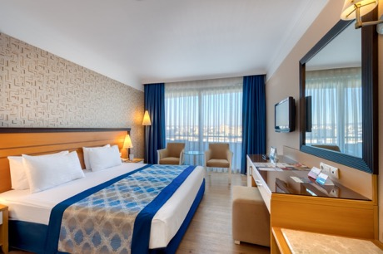
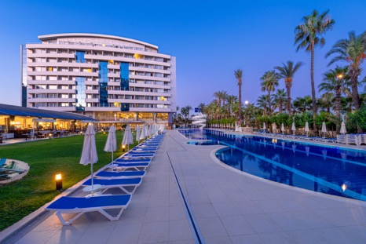
- Single Room price: EUR 260 per room
- Number of rooms: 30
- Double/Twin Room price: EUR 300 per room
- Number of rooms: 200
- Board plan: Full Board
- Check-in from 12.06.2024
- Hotel website: https://www.portobello.com.tr/tr

Sealife Family Resort Hotel – Five Star Hotel
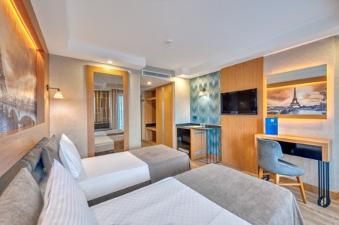
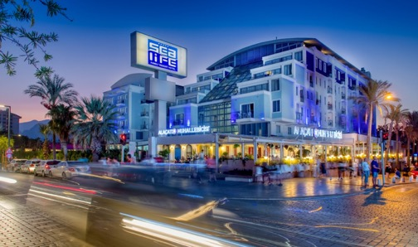

- Single Room price: EUR 250 per room
- Number of rooms: 20
- Double/Twin Room price: EUR 290 per room
- Number of rooms: 150
- Board plan: Full Board
- Check-in from 12.06.2024
- Hotel website: https://www.sealifehotel.com/tr

Nashira City Resort Hotel – Four Star Hotel
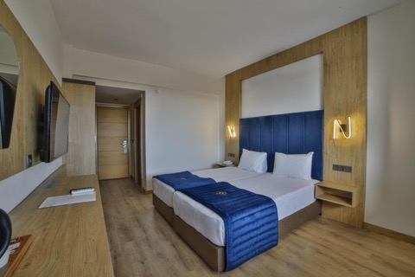
- Single Room price: EUR 190 per room
- Number of rooms: 15
- Double/Twin Room price: EUR 250 per room
- Number of rooms: 75
- Board plan: Full Board
- Check-in from 12.06.2024
- Hotel website: https://nashirahotels.com

Rooms are allocated on a first come, first serve basis. Accommodation includes breakfast, lunch, and dinner with non-alcoholic drinks.

In addition, the LOC will not be responsible to provide any event information at this hotel or provide transportation to the venues.

TRANSPORTATION
Transportation will be provided from Antalya airport to the official hotel, from two days before the official practice day and until two days after the closing day at 70 EUR price (one way). Local transport will be available between the official hotel, practice, and competition venues for free. Transport timetables will be confirmed.

VISA
All participants who need an entry visa to Türkiye will be required to complete the Visa Support sections in WAREOS by no later than 14 May 2024.

It is the applicants’ responsibility for supplying the necessary information, ensuring all details are up to date, correct and submitted by the deadlines specified.

In addition, all participants that require a visa are kindly requested to supply a copy of their latest/valid passport. Copies of each application can be uploaded on WAREOS. All passport copies and personal details entered/uploaded to WAREOS will be held securely and in the strictest of confidence and not shared with other parties.

PAYMENT CONDITIONS
Complete all necessary sections in WAREOS and make full payment by the specified deadlines. Bank transfers only, no credit cards will be accepted. All bank charges will be paid by the participants.

The entry fees should be paid in full before arrival.

To confirm hotels reservations, a minimum 50% deposit of the total amount is required to be bank transferred to the OC before 16 March 2024. Reservations after this date will be considered only according to availability. The final outstanding balance shall be made via bank transfer before 24 May 2024. Accommodation cannot be guaranteed after this deadline. A cost summary will be available through WAREOS.

BANK INFORMATION
BANK ACCOUNT: | ANTALYA OKCULUK IHTISAS SPOR KULÜBÜ
BANK: | YAPI KREDI BANKASI
ACCOUNT NO: | 25086669
SWIFT CODE: | YAPITRIS
IBAN: | TR 03 0006 7010 0000 0025 0866 69

NOTE: ALL PAYMENTS SHALL BE MADE IN EUR.

CANCELLATIONS & CHANGES
All cancellations and changes must be made through WAREOS.

- Should flight arrival details change last minute, please contact the Organising Committee using the details indicated in the team managers’ booklet.
- If a participant’s arrival is later than the original scheduled arrival date, the room will be charged from the date of the original booking in WAREOS.
- An email will automatically notify the Organising Committee and Member Association of any changes made in WAREOS.

HEALTH REGULATIONS

Medical emergency contact and location
AKDENIZ SIFA HOSPITAL
Kuskavagi Mah. Ataturk Bulvari No 81 Konyaalti / ANTALYA – TURKEY
+ 90 444 7 606

ADDITIONAL INFORMATION

Training
A training field will be available starting on 16 June 2024 at the Antalyaspor Training Facilities and Konyaalti Stadium.

Weather
Temperatures in April are expected to range between 30 and 35 degrees Celsius. The average in the last few years has been 32 degrees Celsius.

Media Registration
Media representatives can apply for registration on the LOC website: www.tof.gov.tr or by emailing media@tof.gov.tr (LOC media contact) or at info@archery.sport.

Internet
Will be available in the official hotels for free (in hotel rooms and in the lobby). There will also be Wi-Fi available for access to results and internet on venue.

Water
Each participant with receive clean bottles of water.
Bottled water will be available at the qualification and practice venues.
A water fountain system will be used.

LOC CONTACT
Name: Sirer AYDIN
Email: sireraydin@tof.gov.tr
Language: English
Phone number with international extension: + 90 533 515 25 33

Looking forward to welcoming you in Antalya, TURKIYE

Terms and Conditions
Introduction
The Member Association acknowledges to have understood and accepted in their whole and without any restrictions the sale and purchase terms and conditions of this invitation package, and of the registration platform https://extranet.worldarchery.sport/wareos/.

Consequently, the Member Association who wishes to register to an event, and book some or all associated extras proposed by the local organizing committee acknowledges that they are fully aware present terms and conditions are accepted by entering information in WAREOS.
Any Member Association declares that it is entitled to enter a contractual relationship with the Local Organising Committee of the event, in accordance with these terms and conditions.
The Local Organising Committee commits itself to communicate, within reason, to its potential clients the greatest information available on the following topics:
Description of the main characteristics of the proposed products and of their use.
Pricing
Information on the methods of payment and reimbursement conditions.

Article 1: Entirety
The platform https://extranet.worldarchery.sport/wareos/ is the propriety of, has been designed and created and is managed by World Archery Federation at Lausanne, Switzerland, and put at the disposal of the Local Organising Committee to facilitate registration to World Archery events.
The present terms and conditions include any and all rights and obligations of the parties. No single, specific, or general term or condition that may appear on documentation sent, given, or handed over to a Member Association will alter, replace, or complete parts of or the entirety of these terms and conditions
World Archery reserves the right to modify at any time and without any preliminary notification of any kind these terms and conditions.

Article 2: Object
The present terms and conditions define the rights and obligations of the parties in relation to the registration made through the platform https://extranet.worldarchery.sport/wareos/ of services offered by the Local Organising Committee in the scope of the event it has been set for.

Article 3: Contractual documents
The present terms and conditions and the registration process make up the contractual documents between the parties.

Article 4: Electronic signature:
The Member Association’s entering registration information is the electronic signature which is binding between the parties in the same sense as a handwritten signature would be.

Article 5: Registration Confirmation – Contract
The contract is validated as soon as the Member Association has entered its preliminary registration by entering information in WAREOS. A modification of the registration is possible until the deadline for registration set in the document. Modifications may be subject to penalty fees.

Article 6: Prices
The official prices are listed in the “Policies and Procedures Athletes, officials and team management”, the invitation package prices will be based on the official price list, converted to the currency elected by the LOC for invoicing (CHF, EUR or USD).
The official prices valid on the date that the registration confirmation is sent to the Member Association are binding between the parties.
Article 7: Payment methods
All payments shall be made by bank transfer to the organising committee respecting the stated deadlines, with all bank charges paid by the Member Association. For any open invoices that are not settled 21 days prior the beginning of the event, the Local Organising committee will be entitled to charge a 5% surcharge on all open amounts.
Any payments received cash by World Archery on behalf of the organising committee will incur a 10% additional service fee, to be paid to World Archery.

Article 8: Payment deadlines and refunds
After the final deadlines of registration mentioned in this document, Member Association will not be entitled to any refund, and all remaining unpaid amounts shall be paid to the Local Organising Committee.
Failure to do so, will results in an immediate suspension of the Member Association, who will be set as not in good standing on the day of the official practice of the event, and so until the full amount is paid to the LOC.

Article 9: Availability of services
The availability of services is guaranteed on a first come, first serve basis, provided that the payment of such service has been paid to the local organising committee, partially or in full as mentioned in this document.
The local organising committee is not required to hold services for a Member Association that as not paid in full such service.

Article 10: Force-majeure
None of the two parties will have failed in their respective contractual obligations if their execution is delayed or prevented by a case of force-majeure. Cases considered to be a force majeure are extraordinary events or circumstances beyond the control of the parties, such as a war, strike, riot, crime, or an event described by the legal term "act of God" (e.g., flooding, earthquake, volcano eruption, etc). However, force majeure is not intended to excuse negligence or other malfeasance of a party, as where non-performance is caused by the usual and natural consequences of external forces, or where the intervening circumstances are specifically contemplated. The party experiencing a force majeure must notify in writing with 24 hours after becoming aware of the occurrence. The parties will then, within 7 business days examine, unless the force majeure prevents it, if and how the contractual obligations will be met.

Article 11: Privacy statement
All information exchanged by the Parties will be treated with the utmost confidentiality
All information requested by World Archery and the Organising Committee from the Member Association are necessary to process the event registration and can therefore be communicated only to the contractual partners of World Archery and the Local Organsing Committee.
World Archery and the Local Organising committee are authorized to send informative and promotional e-mails to the Member Association, using the WAREOS e-mail address and the contact person provided by the Member Association during the registration.
October 2023 by World Archery Federation, Maison du Sport International, Avenue de Rhodanie 54 - 1007 Lausanne (Switzerland)

