TO ALL World Archery Asia (WAA) Member Associations,

Dear President / Secretary General,

As Chair of the Local Organising Committee (LOC) of the **2024 Asia Cup – Stage I** to be held in **Baghdad, Iraq** during **20 - 25 February 2022**, I would like to invite you all to be part of one of the most important archery events to take place in Asia/Iraq in 2024.

Baghdad is the capital of Iraq and the second-largest city in the Arab World after Cairo. It is located on the Tigris (Degla) River. In 762 CE, Baghdad was chosen as the capital of the Abbasid Caliphate, and became its most notable major development project.

Baghdad was nominated as the 2013 Arab Capital of Culture, the city is acknowledged as one of the Arab region’s principal centers of literary creation and has gained a reputation as a vehicle to foster tolerance, understanding and peace. Being a city of diversity, the literature sector in Baghdad releases several monthly newspapers in three languages, namely Arabic, English and French.

Iraq and Baghdad city in specific is thirsty to attract people from all over the World by hosting many International and Asian Events in order to regain its distinguished position.

In 2022 Iraq (Sulaymaniyah City) hosted the second stage of Asia Archery Cup and it was very successful event. We promise of present more successful event in Baghdad with an amazing Finals venue.

Welcome our historical city. Our targets look forward to embracing your arrows, just as our hearts are ready to make your visit unforgettably enjoyable.

Sincerely yours,

**Saad AL-MASHHADANI**

**LOC President**

Contact (Phone): **+964 770 897 4945 (WhatsApp)**

Email: **asiacup2024irq@gmail.com**

2024 Asia Cup, Stage I

Baghdad, Iraq

COMPETITION VENUE

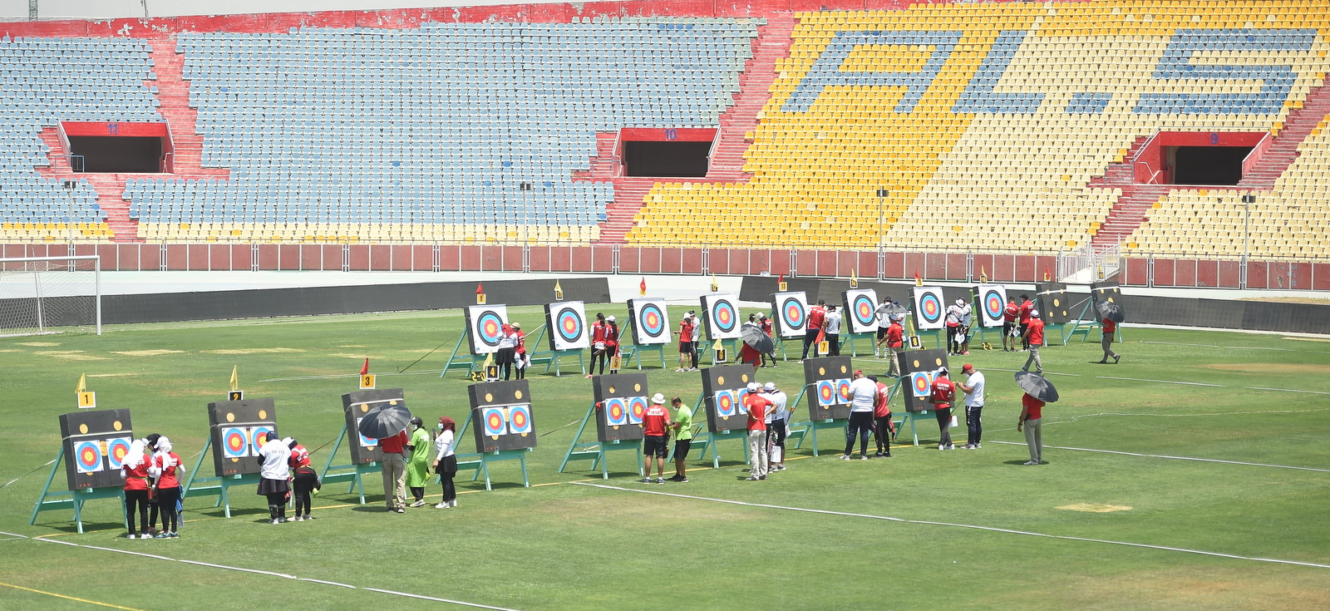

The competition venue is **Al-Shaab International Stadium** which is located only 20-25 minutes from the Official Hotel.

IMPORTANT DATES

Please find enclosed detailed information regarding this event. To register participation, please complete all the necessary sections in WAREOS (<https://extranet.worldarchery.sport>) within the deadlines listed below.

Summary of deadlines:

|  |  |
| --- | --- |
| * Registration Opening date on WAREOS | 10 October 2023 |
| * Preliminary Entries | 20 November 2023 |
| * Final Entries | 31 January 2024 |
| * Hotel reservation confirmation | 31 January 2024 |
| * Visa support | 01 January 2024 |

* Please respect the stated deadlines.

PRELIMINARY PROGRAM

|  |  |
| --- | --- |
| 19 February 2024  Monday | Arrival of participants  Practice field will be available from 19 February 2024 |
| 20 February 2024  Tuesday | **Official Practice** (Equipment Inspection)  **Opening Ceremony (TBC)**  **Team Managers Meeting** |
| 21 February 2024  Wednesday | **Qualification Round for Recurve and Compound**  (Recurve and Compound) |
| 22 February 2024  Thursday | **Team / Mixed Team Eliminations & Finals (Till Semi-Finals 1/2)**  (Recurve and Compound)  **Individual Eliminations**  (Recurve and Compound) |
| 23 February 2024  Friday | **Individual Eliminations & Finals (Till Semi-Finals 1/2)**  (Compound, Recurve) |
| 24 February 2024  Saturday | **Finals Compound – Individual and Team**   * Compound (Women and Men) * Award Ceremonies |
| 25 February 2024  Sunday | **Finals Recurve – Individual and Team**   * Recurve (Women and Men) * Award Ceremonies   **Closing Party (TBC)** |
| 26 February 2024  Monday | Departure of participants |

**NOTE:** This preliminary program is subject to change according to participation and T.V. requirements. All changes will be published and distributed in good time.

PRELIMINARY & FINAL REGISTRATION

All entries, accommodation reservations, transport needs, flight arrival/departure information and visa invitation letter requests are to be completed using the World Archery Online Registration System WAREOS <https://extranet.worldarchery.sport>. This system handles the entire registration process for this event. No entry forms, hotel reservations or transportation forms will be accepted; all information must be entered into WAREOS.

Member associations can login to WAREOS at <http://extranet.worldarchery.sport> with the username and password assigned by World Archery. After entering WAREOS, selecting the event from the list will allow a member association to register their athletes. Select/press the “Entries” button to see the list of categories in the event. Select/press the “category” to enter the athlete and official numbers/details participating for that event. A WAREOS User Manual can be downloaded in PDF format (English) upon login.

Contact [wareos@archery.sport](mailto:wareos@archery.sport) with any questions regarding **technical problems on WAREOS**. For any question regarding the organisation of the event (transport, accommodation, meals, invoices, visa etc.) please **contact directly the LOC ( [asiacup2024irq@gmail.com](mailto:asiacup2024irq@gmail.com) )**.

Athletes from a minimum of (4) different Member Associations shall be registered and participate in the event.

A maximum number of **Four (4) athletes per country** can be registered into each category and divisions of the event.

Start date for online registration using WAREOS **10 October 2024**

End of Final registration using WAREOS **31 January 2024**

* Please respect the stated **deadlines**.

Member Associations can only use WAREOS to make any changes or amendments to entries and will be able to do so at any time. An email will automatically notify the Organising Committee and Member Association of any changes made in WAREOS.

ENTRY FEES

Individual **160 USD** per athlete

Official **120 USD** per person

Guest **120 USD** per person

* **No Entry Fees for Teams and/or Mixed Teams**

Entry fees for individual/Official include airport transfer from/to official hotel and daily local transport to and from the practice field and competition venue to/from official hotel during the qualification, elimination and finals venues (timetable to be confirmed on site).

Entry fee for guest includes daily local transport to and from the practice and competition field to/from official hotel during the qualification, elimination and finals venues. They have no field of play access.

**International License**: 100 CHF **-** per participant per calendar year to be paid to World Archery

Any changes made after the deadlines specified or if entries differ by **more than 4 athletes** from the preliminary entries, the following penalty fees to will automatically be applied:

|  |  |
| --- | --- |
| PENALTY FEES TO BE PAID TO ORGANISING COMMITTEE (USD) |  |
| |  |  | | --- | --- | | **Penalty fees for Late Entries (after final deadline):** | **50 USD** per entry | | **Penalty fees for not filling Preliminary entries** | **100 USD** per entry | | **Penalty fee for differences between preliminary and final entries:**  *If the difference between final and preliminary entries number is more than 4 athletes/officials | **100 USD** per entry | |  |

ACCOMMODATION

All participants are requested to stay only at the official hotel for logistic, management, and COVID control purpose.

**Al-Mansour Hotel** – Five Star Hotel

* Single Room price: **USD 180** per room
* Number of rooms: 100
* Double/Twin Room price: **USD 270** per room
* Number of rooms: 70
* Triple Room price: **USD 360** per room
* Number of rooms: 30
* Board plan: Full board
* Check-in from 18 & 19 February 2024 – 14:00
* Hotel website: <https://www.booking.com/hotel/iq/mansor.html>



Al-Mansour Hotel is one of the first hotels in the Iraqi capital, Baghdad. It is located on the banks of the Tigris River, near Al-Sinak Bridge. It was established in the 1970s, and was opened in the beginning of 1980. It was known as Al Mansour Melia. It is located in 6153, Haifa Street , Baghdad 10004, Iraq.

Rooms are allocated on **a first come, first serve basis**. Accommodation includes breakfast, lunch and dinner with non-alcoholic drinks. Lunch will always be served at the archery venue; dinner will be served at the hotel. Each participant will receive **one FREE clean bottle of water / day** at hotel during the stay.

In addition, the LOC will be responsible to provide any event information at this official hotel.

**LOC will do not allow for non - official hotel.**

TRANSPORTATION

**FREE Transportation** will be provided from **Baghdad International Airport (BGW)** to the official hotel on 18, 19 February 2024 and 26, 27 February 2024 (Only 30 minutes between airport and official hotel). This airport has daily flights with many different airlines. Local transportation will be available between the official hotel, practice and competition venues for **FREE**. Transport timetables will be confirmed.

VISA

All participants who need an entry visa to Iraq, will be required to complete the **Visa Support sections** in WAREOS by no later than **1 January 2023**

It is the applicants’ responsibility for supplying the necessary information, ensuring all details are up to date, correct and submitted by the deadlines specified.

In addition, all participants that require a visa are kindly requested to supply a copy of their latest/valid passport. Copies of each application can be uploaded on WAREOS. All passport copies and personal details entered/uploaded to WAREOS will be held securely and in the strictest of confidence and not shared with other parties.

The following countries can obtain a visa upon arrival:

|  |  |
| --- | --- |
| * Bahrain * Kuwait * Lebanon * Oman | * Qatar * Saudi Arabia * United Arab Emirates |

PAYMENT CONDITIONS

Complete all necessary sections in WAREOS and a balanced invoice will be provided via WAREOS.

**All Fees MUST be paid upon arrival in FULL CASH (in USD – US Dollars) before receiving accreditation cards (At registration office – Al-Mansour Hotel).**

CANCELLATIONS & CHANGES

All cancellations and changes must be made through WAREOS:

* Should flight arrival details change last minute, please contact the Organising Committee using the details indicated in the team managers’ booklet.
* If a participant’s arrival is later than the original scheduled arrival date, the room will be charged from the date of the original booking in WAREOS.
* An email will automatically notify the Organising Committee and Member Association of any changes made in WAREOS.

HEALTH REGULATIONS (COVID-19)

INFORMATION

* Everybody should follow the Government/public health authorities measures (national and sport-specific regulations) and be aware of the travel restrictions
* For your information, Medical infrastructure/Hospital with proper care will be reachable within 15 minutes from the venue, where COVID-19 test can be done.

Medical emergency contact and location

**Hospital Name**: Saint Raphael (Al Rahibat) Hospital

**Address**: 8C5F+45H, Baghdad, Iraq. **Phone number**: +964 771 111 9280

ADDITIONAL INFORMATION

Training

A training field will be available starting from **19 February 2024** at Al-Shaab International Stadium which is located only 20-25 minutes from the Official Hotel.

Weather

**February Weather in Baghdad Iraq**: Daily high temperatures increase by 4°C, from 17°C to 21°C, rarely falling below 13°C or exceeding 26°C.

Daily low temperatures increase by 3°C, from 6°C to 9°C, rarely falling below 1°C or exceeding 13°C.

For reference, on July 30, the hottest day of the year, temperatures in Baghdad typically range from 28°C to 45°C, while on January 11, the coldest day of the year, they range from 5°C to 16°C.

Media Registration

Media representatives can apply for registration by emailing at [asiacup2024irq@gmail.com](mailto:asiacup2024irq@gmail.com)

Internet

Will be available in the official hotels for free (in hotel rooms and in the lobby). There will also be Wi-Fi available for access to results on venue.

Water

Each participant with receive one clean bottles of water / day at hotel.

Bottled water will be available at the practice and competition venues.

About the city

Baghdad is the capital of Iraq and the second-largest city in the Arab World after Cairo. It is located on the Tigris (Degla) River. It is very SAFE and their people are very kind and generous. Exchange rate is **1USD = 1570 Iraqi Dinars**.

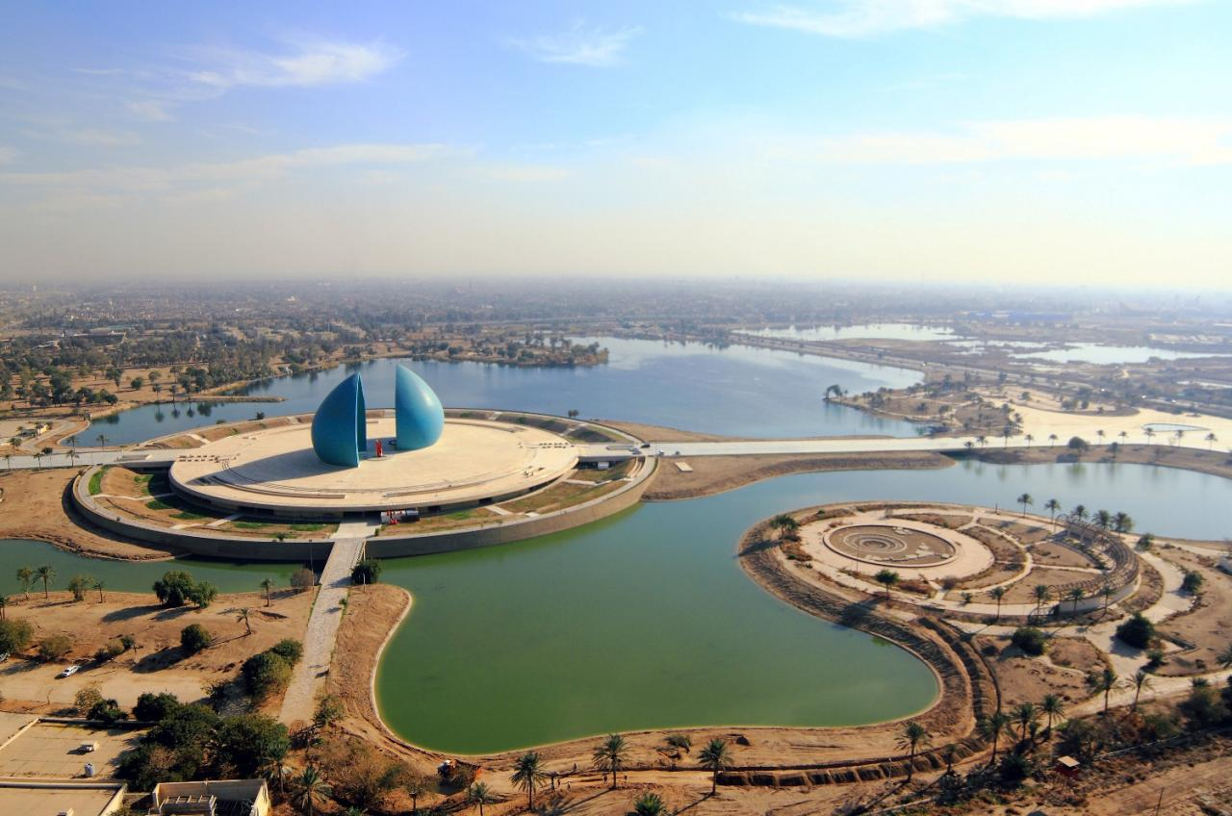

LOC CONTACT

Name: **Mr. Saad AL-MASHHADANI**

Address: Baghdad, Iraq

Email: [asiacup2024irq@gmail.com](mailto:asiacup2024irq@gmail.com)

Language: English / Arabic

Phone number with international extension: **+964 770 897 4945 (WhatsApp)**

Looking forward to welcoming you in **Baghdad, Iraq**.