Invitation to the 2024 Asia Cup – Stage III in Suwon, Korea

TO ALL World Archery Asia (WAA) Member Associations,
Dear President/Secretary General,

On behalf of the Local Organizing Committee (LOC) for the 2024 Asia Cup – Stage III, we are honored to invite you and your National Archery Association to participate in this prestigious event, taking place in Suwon, Korea, from June 3rd to 8th, 2024.

Suwon, the vibrant capital of Gyeonggi-do province, offers a welcoming backdrop for this exciting competition. Located just south of Seoul, the city boasts a rich cultural heritage and modern amenities, ensuring an unforgettable experience for both athletes and delegates.

Building upon the success of the previous Stage, we are committed to delivering an even more exceptional event. We have secured a state-of-the-art Finals venue and pledge to provide world-class facilities and exceptional organization to support your athletes in their pursuit of excellence.

We warmly invite you and your delegation to Suwon. We are eager to host your participation and extend genuine Korean hospitality, making your visit truly memorable.

For further information and registration details, please visit our official website: [https://www.asianarchery.com/event/waa_event]

We encourage you to join us for a week of thrilling competition, camaraderie, and cultural exchange in Suwon.

Sincerely,

Jongdae Baek
LOC President

2024 Asia Cup, Stage III Suwon, Korea

Contact (Phone): +82 1049975387 (WhatsApp)
Email: archerysuwon@gmail.com

COMPETITION VENUE
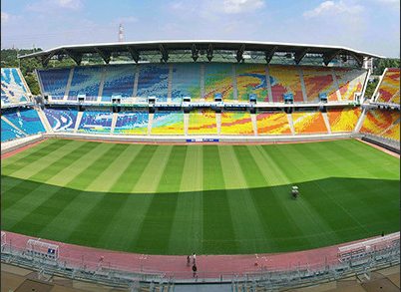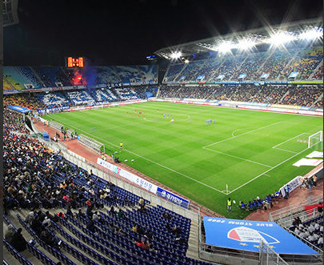
The competition venue is Suwon World Cup Stadium which is located only 15-20 minutes from the Official Hotel.

IMPORTANT DATES
Please find enclosed detailed information regarding this event. To register participation, please complete all the necessary sections in WAREOS (https://extranet.worldarchery.sport) within the deadlines listed below.
Summary of deadlines:
- Registration Opening date on WAREOS 01 February 2024
- Preliminary Entries / 50% down-payment 01 April 2024
- Final Entries / Full invoice payment 30 April 2024
- Hotel reservation confirmation 30 April 2024
- Visa support 10 April 2024
- Full refund cancellation deadline 30 April 2024
*Please respect the stated deadlines.

PRELIMINARY PROGRAM

02 June 2024 Sunday

03 June 2024
Monday

04 June 2024
Tuesday

05 June 2024
Wednesday

06 June 2024
Thursday

07 June 2024
Friday

08 June 2024
Saturday

09 June 2024
Sunday
Arrival of participants
Practice field will be available from June 3rd 2024

Official Practice (Equipment Inspection)

Opening Ceremony (TBC)

Team Managers Meeting

Qualification Round and Individual match for Recurve and Compound
(Recurve and Compound)

Team / Mixed Team Eliminations (Till Semi-Finals 1/2)
(Recurve and Compound)

Individual Eliminations & Finals (Till Semi-Finals 1/2)
(Recurve and Compound))
*Suwon city tour

Finals Recurve&Compound – Team
Bronze & Gold medal matches

Finals Recurve&Compound – Individual
- Bronze & Gold medal matches
- Award Ceremonies

Departure of participants

NOTE: This preliminary program is subject to change according to participation and T.V. requirements. All changes will be published and distributed in good time.

PRELIMINARY & FINAL REGISTRATION
All entries, accommodation reservations, transport needs, flight arrival/departure information and visa invitation letter requests are to be completed using the World Archery Online Registration System WAREOS https://extranet.worldarchery.sport. This system handles the entire registration process for this event. No entry forms, hotel reservations or transportation forms will be accepted; all information must be entered into WAREOS.

Member associations can login to WAREOS at http://extranet.worldarchery.sport with the username and password assigned by World Archery. After entering WAREOS, selecting the event from the list will allow a member association to register their athletes. Select/press the “Entries” button to see the list of categories in the event. Select/press the “category” to enter the athlete and official numbers/details participating for that event. A WAREOS User Manual can be downloaded in PDF format (English) upon login.

Contact wareos@archery.sport with any questions regarding technical problems on WAREOS. For any question regarding the organization of the event (transport, accommodation, meals, invoices, visa etc.) please contact directly the LOC ( suwonarchery@gmail.com ).

Athletes from a minimum of (4) different Member Associations shall be registered and participate in the event.

A maximum number of Four (4) athletes per country can be registered into each category and divisions of the event.

Start date for online registration using WAREOS 01 February 2024
End of Final registration using WAREOS 30 April 2024

* Please respect the stated deadlines.
Member Associations can only use WAREOS to make any changes or amendments to entries and will be able to do so at any time. An email will automatically notify the Organizing Committee and Member Association of any changes made in WAREOS.

ENTRY FEES
Individual 180 USD per athlete
Official 120 USD per person
Guest 120 USD per person

No Entry Fees for Teams and/or Mixed Teams
Entry fees for individual/Official include daily local transport to and from the practice field and competition venue to/from official hotel during the qualification, elimination and finals venues (timetable to be confirmed on site).
Entry fee for guest includes daily local transport to and from the practice and competition field to/from official hotel during the qualification, elimination and finals venues. They have no field of play access.
International License: 100 CHF - per participant per calendar year to be paid to World Archery

Any changes made after the deadlines specified or if entries differ by more than 4 athletes from the preliminary entries, the following penalty fees to will automatically be applied:

PENALTY FEES TO BE PAID TO ORGANISING COMMITTEE (USD)

Penalty fees for Late Entries (after final deadline): 50 USD per entry

Penalty fees for not filling Preliminary entries: 100 USD per entry

Penalty fee for differences between preliminary and final entries:
*If the difference between final and preliminary entries number is more than 4 athletes/officials

Airport Pick-Up Transportation:

ACCOMMODATION
100 USD per entry

50 USD per entry

All participants are requested to stay only at the official hotel for logistic, management, and COVID control purpose.

Hotel :

Ibis Ambassador Suwon hotel
- Single Room price: USD 240 per room
- Number of rooms: 40
- Double/Twin Room price: USD 340 per room
- Number of rooms: 40
- Board plan: Full board
- Check-in from 01 & 02 June 2024 – 14:00
- Hotel website: https://www.ambatel.com/ibis/suwon/ko/main.do
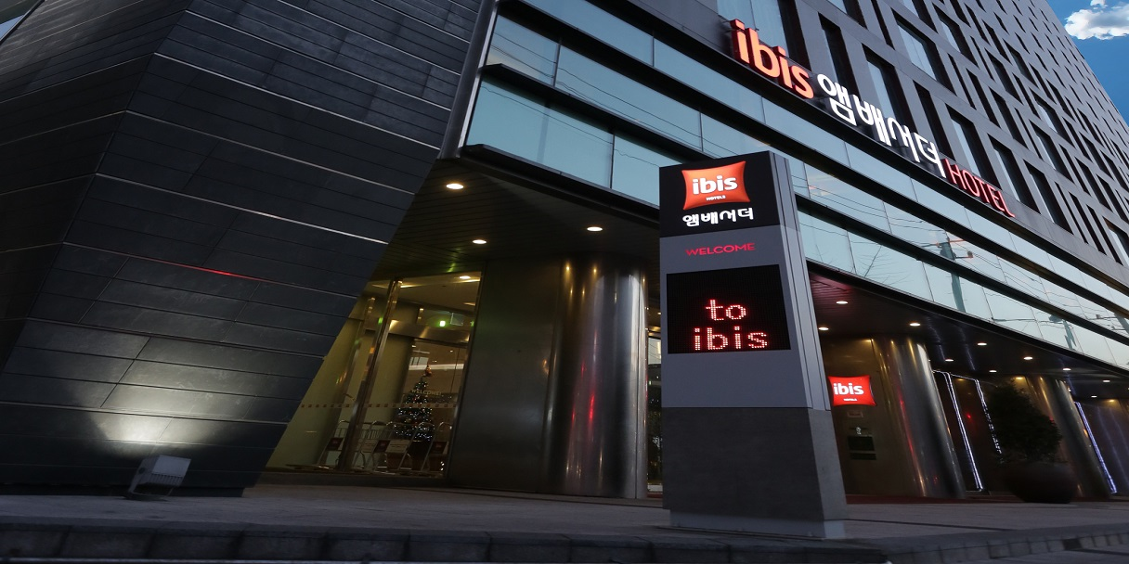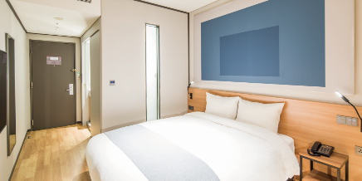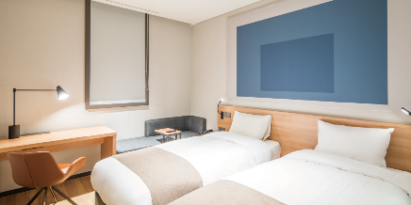
Ibis Ambassador Suwon is a leisure and business hotel located in Ingye dong, at the heart of Suwon City. (132, Gwongwang-ro, Paldal-gu, Suwon-si, Gyeonggi-do)
The hotel offers everything for an easy and comfortable stay: 215 modern rooms with free high-speed Wi-Fi, an international buffet restaurant, a gym and hot bath, banquet facilities for meetings, events and weddings and an on-site parking.

Haeden Hotel High end – Four Star Hotel

- Single Room price: USD 220 per room
- Number of rooms: 40
- Double/Twin Room price: USD 320 per room
- Number of rooms: 100
- Board plan: Full board
- Check-in from 01 & 02 June 2024 – 14:00
- Hotel website: http://www.highendhotelsuwon.com/html/main.asp
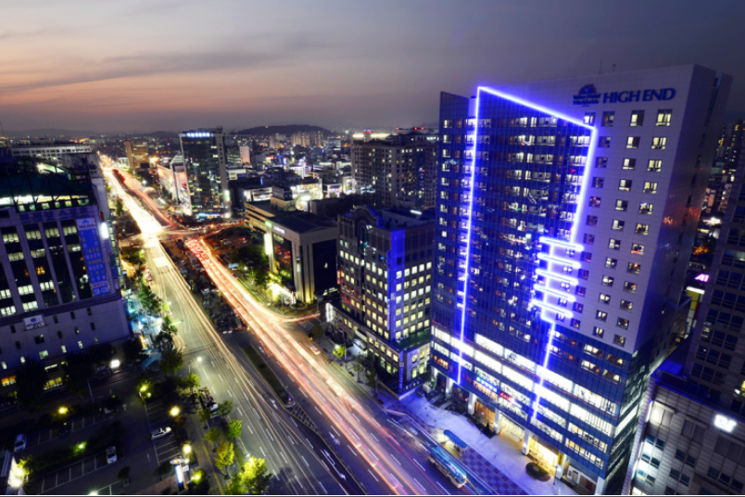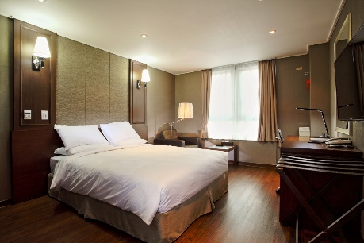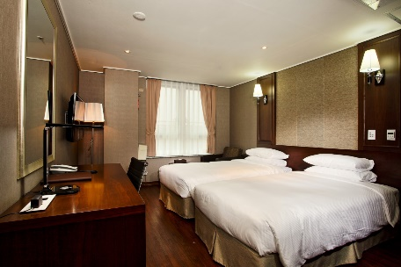
Its new hotel brand in Korea with the name of Haeden Hotel High end Suwon.
(299 Hyowon-ro, Paldal-gu, Suwon-si, Gyeonggi-do)
Opened in October, 2013, Haeden Hotel High end Suwon is the largest hotel by the number of guest rooms in Gyeonggi Province.Strategically located in Ingye-Dong which known as the Suwon City's central part of administration, financial and business district, High End offers convenience, comfort and the value for guests. 300 guest rooms consisting of Superior, Deluxe and Junior Suite are efficiently designed to suit guests' needs and The Plate, the restaurant on the 6th floor to brining you.

Rooms are allocated on a first come, first serve basis. Accommodation includes breakfast, lunch and dinner with non-alcoholic drinks. Lunch will always be served at the archery venue; dinner will be served at the hotel. Each participant will receive one FREE clean bottle of water / day at hotel during the stay.

In addition, the LOC will be responsible to provide any event information at this official hotel.

LOC will do not allow for non - official hotel

TRANSPORTATION
Airport Pick-Up Transportation
For your convenience, the 2024 Asia Cup - Stage III organizing committee will be offering private airport transfers from Incheon International Airport (ICN) to the official hotel.

Schedule:
Dates: June 1-2 and June 9-10, 2024
Cost: $50 USD per person (Two-way)
Travel Time: approximately 1 hour 30 minutes

Additional Information:
Incheon International Airport (ICN) is conveniently accessible by many major airlines with frequent daily flights.
Upon arrival at ICN, please proceed to the designated meeting point as communicated in your confirmation email.
Local transportation between the official hotel, practice venues, and competition venues will be provided free of charge according to a confirmed schedule.

VISA
All participants who need an entry visa to Iraq, will be required to complete the Visa Support sections in WAREOS by no later than 30 April 2024

It is the applicants’ responsibility for supplying the necessary information, ensuring all details are up to date, correct and submitted by the deadlines specified.

In addition, all participants that require a visa are kindly requested to supply a copy of their latest/valid passport. Copies of each application can be uploaded on WAREOS. All passport copies and personal details entered/uploaded to WAREOS will be held securely and in the strictest of confidence and not shared with other parties.

The following countries can obtain a visa upon arrival:

- Japan (90), Hong Kong (90), Macau (90),Taiwan(90), Kuwait (90), Brunei (30), Saudi Arabia (30), Oman (30), Bahrain (30)

PAYMENT CONDITIONS
Complete all necessary sections in WAREOS and a balanced invoice will be provided via WAREOS.
All Fees MUST be paid by bank transfer. The bank information is available in WAREOS.
Bank information
Bank name: INDUSTRIAL BANK OF KOREA
Bank Account Number: 287-282028-56-00017
SWIFT CODE: IBKOKRSEXXX
Bank TELL: +82 31 235 2588
Bank Address: 1037-2 Ingye-Dong, Paldal-Gu, Suwon City.
Beneficiary: Suwon archery association.

CANCELLATIONS & CHANGES
All cancellations and changes must be made through WAREOS:
  - Should flight arrival details change last minute, please contact the Organizing Committee using the details indicated in the team managers’ booklet.
  - If a participant’s arrival is later than the original scheduled arrival date, the room will be charged from the date of the original booking in WAREOS.
  - An email will automatically notify the Organizing Committee and Member Association of any changes made in WAREOS.

HEALTH REGULATIONS (COVID-19) INFORMATION
  - Everybody should follow the Government/public health authorities measures (national and sport-specific regulations) and be aware of the travel restrictions
  - For your information, Medical infrastructure/Hospital with proper care will be reachable within 15 minutes from the venue, where COVID-19 test can be done.

MEDICAL EMERGENCY CONTACT AND LOCATION
Hospital Name: Dongsuwon General Hospital
Address: 165, Jungbu-daero, Paldal-gu, Suwon-si, Gyeonggi-do, Republic of Korea.
Phone number: +82 1533-2114

ADDITIONAL INFORMATION TRAINING for Asia cup
Training Field:
A dedicated training field will be available for our use starting from June 3rd, 2024 at the Suwon World Cup Stadium.
The training field is conveniently located just 20-25 minutes from the Official Hotel.
TRAINING after Yecheon World Cup before Suwon Asia cup
Target Rent Fee - $150/per target
Stay – Suwon Cinema Motel 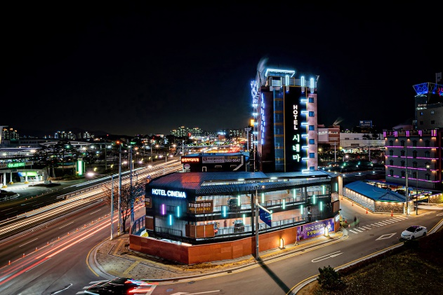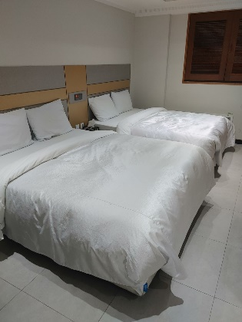
Per person/day - $40 (for twin room) / $70 (for single room or single person for twin room)
Transport – Not provided.
Meal – Not provided.

WEATHER
February Weather in Suwon, Korea : Daily high temperatures increase by 4°C, from 17°C to 21°C, rarely falling below 13°C or exceeding 26°C.
Daily low temperatures increase by 15°C, from 25°C to 27°C, rarely falling below 10°C or exceeding 30°C.

MEDIA REGISTRATION
Media representatives can apply for registration by emailing at suwonarchery@gmail.com

INTERNET
Will be available in the official hotels for free (in hotel rooms and in the lobby). There will also be Wi-Fi available for access to results on venue.

WATER
Each participant with receive one clean bottles of water / day at hotel. Bottled water will be available at the practice and competition venues.

ABOUT THE CITY
Suwon, nestled in South Korea's Gyeonggi-do province, boasts a captivating blend of ancient history and modern charm. Known as the "City of Water and Fortifications," it once served as a strategic fortress city, evident in its UNESCO-listed Hwaseong Fortress. Today, Suwon thrives as a bustling metropolis, offering vibrant markets, tranquil gardens, and cutting-edge technology at the Samsung Innovation Museum. Whether you're a history buff, a foodie, or simply seeking a vibrant cultural experience, Suwon has something to enthrall you.
Exchange rate is 1USD = 1,305 Korea wons.

LOC CONTACT
Name: Ms. Garam Lee
Address: Suwon, Korea
Email: archerysuwon@gmail.com
Language: English / Korea
Phone number with international extension: +82 1049975387 (WhatsApp)
Looking forward to welcoming you in Suwon, Korea.

