TO ALL World Archery Member Associations,
Dear President,

As Chair of the Local Organising Committee (LOC) of the South American Championship and World Ranking Event to be held in Maricá – Rio de Janeiro, Brazil on 25 March 2024, I would like to invite you all to be part of one of the most important archery events to take place in the South American/Brazil in 2024.

Maricá is surrounded by majestic beaches. It is the country’s principal city when the subject is archery, since many champions were made here. Through conviction and political will, we have taken on the challenge of transforming Maricá into a city where justice, solidarity and acceptance are paramount.

The city has a deeply ingrained culture of service based on the friendliness, respect and warmth of its people. Its local government and institutions are fully committed to the city’s development.

Athletes of the world do know that Maricá is also a city where magnificent archery events can be staged. We have already done one South American edition (2019) and a successful International Challenge with pan american countries. Participants from more than 10 countries have enjoyed the experience of shooting in our city. Those who joined us previously will certainly want to come back and be our best ambassadors to advertise our 2024 stage among the rest of the athletes of the world.

Welcome to this amazing city that reinvents itself every day. Our targets look forward to embracing your arrows, just as our hearts are ready to make your visit unforgettably enjoyable.

“Come and discover hundreds of reasons to visit and endless excuses to come back”.

Sincerely yours,

João Luiz Araujo da Cruz
South American Championship and World Ranking Event OC Chairman

IMPORTANT DATES

Please find enclosed detailed information regarding this event. To register participation, please complete all the necessary sections in WAREOS (https://extranet.worldarchery.sport) within the deadlines listed below.

Summary of deadlines:

Registration Opening date on WAREOS | 27 November 2023
Preliminary Entries / 50% down-payment | 25 December 2023
Final Entries / Full invoice payment | 04 March 2024
Transportation | 04 March 2024
Visa support | 04 February 2024
Full refund cancellation deadline  *After this deadline, the LOC is allowed to retain all amounts due by the Member Association. | 08 March 2024

Divisions and Categories
At this competition we will have Recurve, Barebow and Compound divisions for three categories, Men and Women, U21 Men and Women, U18 Men and Women, 50+ Men and Women.

PRELIMINARY PROGRAMME 70 targets (Field A and B)
25/03/2024 – Monday
Official Practice
Equipment Inspection
Teams Managers Meeting

26/03/2024 – Tuesday
Qualification Round morning and afternoon

27/03/2024 – Wednesday
Morning: mixed teams – South American + Open
Afternoon: teams – South American + Open

28/03/2024 – Thursday
Elimination Rounds – Open
All categories

29/03/2024 – Friday
Elimination Rounds – South American Championships
All categories

30/03/2024 – Saturday
Finals Individuals (South American Championship)
Awarding ceremonies
Closure ceremonies

31/03/2024 – Sunday
Finals Individuals (OPEN)
Awarding ceremonies
Closure ceremonies
Return of Delegations

01/04/2024 – Monday
Returning date.

NOTE: This preliminary programme is subject to change according to participation and TV requirements. All changes will be published and distributed in good time.

PRELIMINARY & FINAL REGISTRATION
All entries, accommodation reservations, transport needs, flight arrival/departure information and visa invitation letter requests are to be completed using the World Archery Online Registration System WAREOS https://extranet.worldarchery.sport. This system handles the entire registration process for this event. No entry forms, hotel reservations or transportation forms will be accepted; all information must be entered into WAREOS.

Member associations can login to WAREOS at http://extranet.worldarchery.sport with the username and password assigned by World Archery. After entering WAREOS, selecting the event from the list will allow a member association to register their athletes. Select/press the “Entries” button to see the list of categories in the event. Select/press the “category” to enter the athlete and official numbers/details participating for that event. A WAREOS User Manual can be downloaded in PDF format (English) upon login.

Contact wareos@archery.sport with any questions regarding technical problems on WAREOS. For any question regarding the organization of the event (transport, accommodation, meals, invoices, visa etc.) please contact directly the LOC.

There is no limit in the number of athletes a country can register in each category.

Other athletes (not competing as country but only as club) can register on Open WAREOS at https://extranet.worldarchery.sport/ with their username and password if already registered in the past or register to get the log in details if it’s the first time. After the creation of the profile, follow the instructions to register to the event. Contact (wareos@archery.sport) in the World Archery Office with any questions regarding technical problems on WAREOS. For any question regarding the organization of the event (transport, accommodation, meals etc.) please contact directly the LOC.

Archers who register using Open WAREOS may compete only in the individual events of the open competition, not in the South American Championships. They will not be able to take part in the team competition.

Member Associations can only use WAREOS to make any changes, amendments or cancellations to entries and will be able to do so at any time. An email will automatically notify the Organising Committee and Member Association of any changes made in WAREOS.

EVENTS

The South American Championship will include individual, team and mixed team events, in the categories:

• Recurve Men and Women – RM / RW
• Recurve Under 21 Men and Women – RU21M / RU21W
• Recurve Under 18 Men and Women – RU18M / RU18W
• Recurve 50+ Men and Women – R50M / R50W
• Compound Men and Women – CM / CW
• Compound Under 21 Men and Women – CU21M / CU21W
• Compound Under 18 Men and Women – CU18M / CU18W
• Compound 50+ Men and Women – C50M / C50W
• Barebow Men and Women – BM / BW
• Barebow Under 21 Men and Women – BU21M / BU21W
• Barebow Under 18 Men and Women – BU18M / BU18W
• Barebow 50+ Men and Women – B50M / B50W

Each archer may participate in one category only. Two awards will be made:

1. South American Competition: Only athletes from World Archery member associations from South America who were registered on WAREOS (not open WAREOS). Prizes will be awarded based on the results of the matches starting at 1/16.
2. Open competition: All registered athletes. Prizes will be awarded based on the results of the matches starting at 1/24.

There will be necessary a minimum of 3 teams to have a team or mixed team competition in the South American Championships and the open tournament.

ENTRY FEES

Individual 200 USD per athlete
Officials 100 USD per person
International License 100 CHF per participant per calendar year to be paid to World Archery.

Member Associations that have penalty fees outstanding from 2023 will need to have paid these penalty fees before being eligible to enter and compete.

Any entries received less than 3 days before the team managers meeting for the event will be refused if no preliminary entry and/or final entry are made prior. This decision cannot be appealed by the teams and is fully compliant with the current World Archery rules, article 3.7.1.2.

Entries received after the deadlines, are subject to penalties as clearly stated in the rule book and the invitation documents. A Member Association that has made final entries in WAREOS and does not participate will be invoiced for the number of entries entered in the system, unless they have informed World Archery and the Organising Committee in writing at least one week prior to the event that they are unable to attend.

ACCOMMODATION

Promenade Prime Hotel, Itaboraí – RJ – Three Star Hotel
- Single Room price: USD 150.00 per room
- Number of rooms: 36
- Double/Twin Room price: USD 200.00 per room
- Number of rooms: 34
- Triple Room price: USD 280.00 per room
- Number of rooms: 10
- Board plan: Full board (breakfast and dinner will be served at the hotel and lunch will be available at no extra cost in the competition venue)
- Check-in from March 23, 15:00
- Late check-out Half the room price – No later than 17:00
- Hotel website: https://promenade.com.br/hotel-prime-itaborai/
- Photo
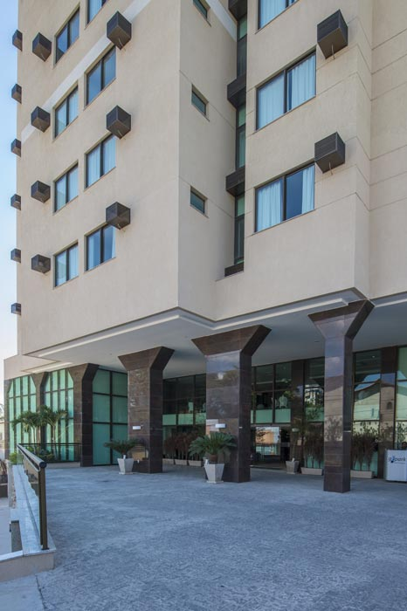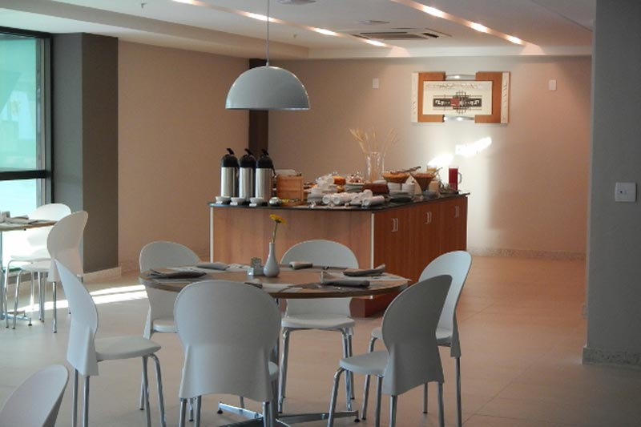
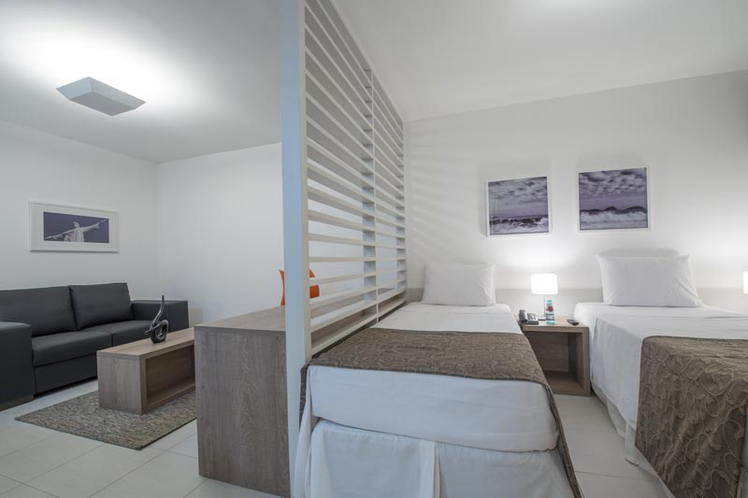
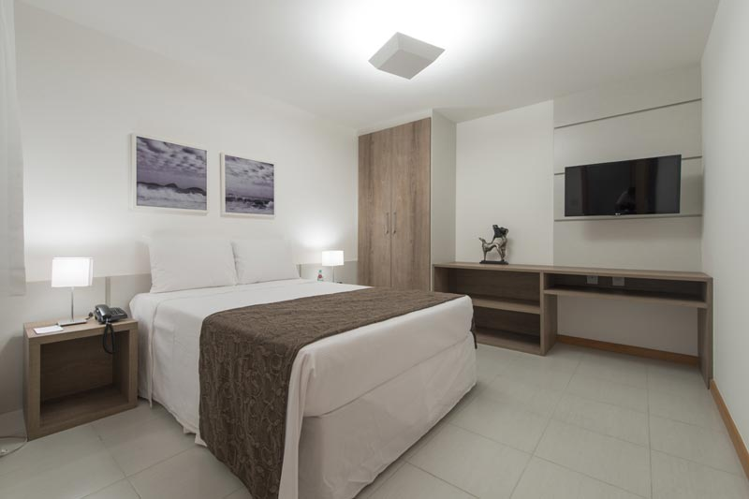
- Hotel information A/C Available, Gym, 110v Sockets, swimming pool, restaurant and other facilities presented on the website link.

Hotel Samba, Itaboraí – RJ – Three Star Hotel
- Single Room price: USD 120.00 per room
- Number of rooms: 15
- Double/Twin Room price: USD 180.00 per room
- Number of rooms: 60
- Board plan: Full board (breakfast and dinner will be served at the hotel and lunch will be available at no extra cost in the competition venue)
- Check-in from March 23, 15:00
- Late check-out Room price
- Hotel website: https://sambahoteis.com/hotel-samba-itaborai/
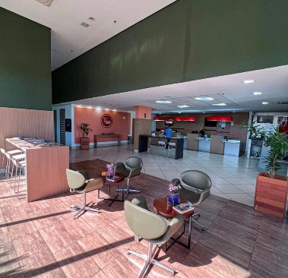
Photo
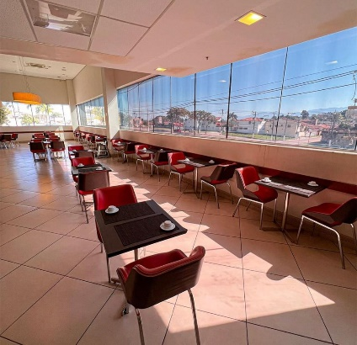
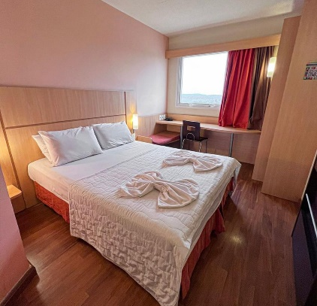

- Hotel information A/C Available, 110v Sockets, and other facilities presented on the website link.
Rooms are allocated on a first come, first serve basis. Accommodation includes breakfast and dinner with non-alcoholic drinks. Lunch will always be served at the archery venue, dinner will be served at the hotel.
Teams who do not reserve their accommodation through the organizing committee will be charged a double entry fee.
In addition, the LOC will be responsible to provide any event information at this hotel and provide transportation to the venues. Archers and officials who did not book their accommodation through the Organizing Committee but have booked rooms on their own at an official hotel will not be entitled to use the transportation provided by the organizers. Private vehicles can be used too.

TRANSPORTATION
Transportation will be provided from GIG (Aeroporto Internacional Antônio Carlos Jobim) airport to the official hotel, from two days before the official practice day and until one day after the closing day for free. Local transport will be available between the official hotel, practice and competition venues for free. Transport timetables will be confirmed.

VISA
All participants who need an entry visa to Country, will be required to complete the Visa Support sections in WAREOS by no later than 04 February 2024.

It is the applicants’ responsibility for supplying the necessary information, ensuring all details are up to date, correct and submitted by the deadlines specified.

In addition, all participants that require a visa are kindly requested to supply a copy of their latest/valid passport. Copies of each application can be uploaded on WAREOS. All passport copies and personal details entered/uploaded to WAREOS will be held securely and in the strictest of confidence and not shared with other parties.

BANK INFORMATION FOR ACCOMMODATION, TRANSPORTATION AND ENTRY FEES
Bank Operation Code: BOFAUS3N
BANK OF AMERICA - ABA 026009593
Nova York - EUA
Receiver´s Correspondent: RENDBRSP - 6550925836
INTERMEDIARY BANK - BANCO RENDIMENTO S/A - SAO PAULO BR
Reference: 17904906000133
FINAL BANK BRX CORRETORA DE CAMBIO LTDA
Confederação Brasileira de Tiro com Arco – CNPJ.: 68.760.693/0001-54
Details of charges: OUR

NOTE: ALL PAYMENTS SHALL BE MADE IN USD.

CANCELLATIONS & CHANGES
All cancellations and changes must be made through WAREOS / Open WAREOS:

- Should flight arrival details change last minute, please contact the Organising Committee using the details indicated in the team managers’ booklet.
- If a participant’s arrival is later than the original scheduled arrival date, the room will be charged from the date of the original booking in WAREOS.
- An email will automatically notify the Organising Committee and Member Association of any changes made in WAREOS.

HEALTH REGULATIONS
Medical emergency contact and location
- Hospital Municipal Dr. Ernesto Che Guevara, Rod. Amaral Peixoto, 9 - São José de Imbassai, Maricá - RJ, 24942-395, (21) 3995-9537
- Hospital Municipal Conde Modesto Leal, Rua Domicio da Gama, 433 - Centro, Maricá - RJ, 24902-035, (21) 2637-1744

ADDITIONAL INFORMATION
Training
A training field will be available starting on 23 March 2024 at Brazil Arco main training center located approximately 40 minutes from the official hotels. Transport to training will be made available at no additional cost on March 23 and 24 only from official hotel.
Please, let us know the training schedule necessities of your delegation until February 23, 2024 by e-mail (ctmarica@gmail.com).
The training transport shuttle will be arranged as the schedules previously presented.

Weather
Maricá is a city where it is never cold and very seldom hot. Temperatures in March are expected to range between 25 and 35 degrees Celsius. The average in the last few years has been 28 degrees Celsius. There are chances of rain, mainly in the afternoons.

Media Registration
Media representatives can apply for registration by emailing ctmarica@gmail.com.

Internet
Will be available in the official hotels for free (in hotel rooms and in the lobby). There will also be Wi-Fi available for access to results on venue.

Water
Each participant will receive clean bottles of water.
Bottled water will be available at the qualification and practice venues.
A water fountain system will be used.

LOC CONTACT

Name: Ricardo / Guedes, Cristina / Gil
Address: Avenue Ivone dos Santos Cardoso, 340, Itapeba, Maricá – RJ CEP.: 24913-000
Email: ctmarica@gmail.com, cristina@cbtarco.org.br
Language: Spanish, English and Portuguese
Phone number with international extension: +55 (21) 97444-2057 / +55 (21) 98227-1724
Looking forward to welcoming you in Maricá – RJ, Brazil.

Terms and Conditions
Introduction
The Member Association acknowledges to have understood and accepted in their whole and without any restrictions the sale and purchase terms and conditions of this invitation package, and of the registration platform https://extranet.worldarchery.sport/wareos/.

Consequently, the Member Association who wishes to register to an event, and book some or all associated extras proposed by the local organizing committee acknowledges that they are fully aware present terms and conditions are accepted by entering information in WAREOS.
Any Member Association declares that it is entitled to enter a contractual relationship with the Local Organising Committee of the event, in accordance with these terms and conditions.
The Local Organising Committee commits itself to communicate, within reason, to its potential clients the greatest information available on the following topics:
Description of the main characteristics of the proposed products and of their use.
Pricing
Information on the methods of payment and reimbursement conditions.

Article 1: Entirety
The platform https://extranet.worldarchery.sport/wareos/ is the propriety of, has been designed and created and is managed by World Archery Federation at Lausanne, Switzerland, and put at the disposal of the Local Organising Committee to facilitate registration to World Archery events.
The present terms and conditions include any and all rights and obligations of the parties. No single, specific, or general term or condition that may appear on documentation sent, given, or handed over to a Member Association will alter, replace, or complete parts of or the entirety of these terms and conditions
World Archery reserves the right to modify at any time and without any preliminary notification of any kind these terms and conditions.

Article 2: Object
The present terms and conditions define the rights and obligations of the parties in relation to the registration made through the platform https://extranet.worldarchery.sport/wareos/ of services offered by the Local Organising Committee in the scope of the event it has been set for.

Article 3: Contractual documents
The present terms and conditions and the registration process make up the contractual documents between the parties.

Article 4: Electronic signature:
The Member Association’s entering registration information is the electronic signature which is binding between the parties in the same sense as a handwritten signature would be.

Article 5: Registration Confirmation – Contract
The contract is validated as soon as the Member Association has entered its preliminary registration by entering information in WAREOS. A modification of the registration is possible until the deadline for registration set in the document. Modifications may be subject to penalty fees.

Article 6: Prices
The official prices are listed in the “Policies and Procedures Athletes, officials and team management”, the invitation package prices will be based on the official price list, converted to the currency elected by the LOC for invoicing (CHF, EUR, or USD).
The official prices valid on the date that the registration confirmation is sent to the Member Association are binding between the parties.
Article 7: Payment methods
All payments shall be made by bank transfer to the organising committee respecting the stated deadlines, with all bank charges paid by the Member Association. For any open invoices that are not settled 21 days prior the beginning of the event, the Local Organising committee will be entitled to charge a 5% surcharge on all open amounts.
Any payments received cash by World Archery on behalf of the organising committee will incur a 10% additional service fee, to be paid to World Archery.

Article 8: Payment deadlines and refunds
After the final deadlines of registration mentioned in this document, Member Association will not be entitled to any refund, and all remaining unpaid amounts shall be paid to the Local Organising Committee.
Failure to do so, will results in an immediate suspension of the Member Association, who will be set as not in good standing on the day of the official practice of the event, and so until the full amount is paid to the LOC.

Article 9: Availability of services
The availability of services is guaranteed on a first come, first serve basis, provided that the payment of such service has been paid to the local organising committee, partially or in full as mentioned in this document.
The local organising committee is not required to hold services for a Member Association that as not paid in full such service.
Article 10: Force-majeure
None of the two parties will have failed in their respective contractual obligations if their execution is delayed or prevented by a case of force-majeure. Cases considered to be a force majeure are extraordinary events or circumstances beyond the control of the parties, such as a war, strike, riot, crime, or an event described by the legal term "act of God" (e.g., flooding, earthquake, volcano eruption, etc). However, force majeure is not intended to excuse negligence or other malfeasance of a party, as where non-performance is caused by the usual and natural consequences of external forces, or where the intervening circumstances are specifically contemplated. The party experiencing a force majeure must notify in writing with 24 hours after becoming aware of the occurrence. The parties will then, within 7 business days examine, unless the force majeure prevents it, if and how the contractual obligations will be met.

Article 11: Privacy statement
All information exchanged by the Parties will be treated with the utmost confidentiality
All information requested by World Archery and the Organising Committee from the Member Association are necessary to process the event registration and can therefore be communicated only to the contractual partners of World Archery and the Local Organising Committee.
World Archery and the Local Organising committee are authorized to send informative and promotional e-mails to the Member Association, using the WAREOS e-mail address and the contact person provided by the Member Association during the registration.
October 2023 by World Archery Federation, Maison du Sport International, Avenue de Rhodanie 54 - 1007 Lausanne (Switzerland)

