To all World Archery Americas Member Associations
Dear President,

As Chair of the Local Organising Committee (LOC) of the 2024 Pan American Championships to be held in Medellín, Colombia, on April 9-14, 2024, I would like to invite you all to be part of the most important archery event to take place in the Americas in 2024.

Medellin is the country’s second largest city, industrial capital, business centre, and beating heart of commerce. Through conviction and political will, we have taken on the challenge of transforming Medellin into a city where justice, solidarity and acceptance are paramount.

The city has a deeply ingrained culture of service based on the friendliness, respect, and warmth of its people.

The athletes of the Americas do know that Medellin is also a city where magnificent archery events can be staged. In the past 11 years, Medellin has successfully hosted 7 stages of the Hyundai World Cup, as well as several Pan American Championships and World Ranking Events. Participants from more than 40 countries have enjoyed the experience of shooting in our city. In 2024 the Pan American Championships will return to Medellin once again. Those who have come before will certainly encourage those who haven’t to fly to our city and enjoy the competition.

Welcome to this amazing city that reinvents itself every day. Our targets look forward to embracing your arrows, just as our hearts are ready to make your visit unforgettably enjoyable.

Sincerely yours,

Maria Emma Gaviria
LOC Chairman
World Archery Americas President

IMPORTANT DATES

Please find enclosed detailed information regarding this event. To register participation, please complete all the necessary sections in WAREOS (https://extranet.worldarchery.sport) within the deadlines listed below.

Summary of deadlines:

Registration Opening date on WAREOS | 04 December 2023
Preliminary Entries / 50% down-payment | 09 January 2024 (3 months before the event)
Final Entries / Full invoice payment | 19 March 2024 (3 weeks before the event)
Transportation | 09 March 2024
Visa support | 09 February 2024
Full refund cancellation deadline  *After this deadline, the LOC is allowed to retain all amounts due by the Member Association. | 19 March 2024

Please adhere to the provided deadlines. It is imperative for Member Associations to update WAREOS with any changes, including cancellations or modifications, even after submitting a preliminary entry. Non-compliance may result in additional penalties.

PRELIMINARY PROGRAMME
07 April 2024 Arrival of participants
Sunday

08 April 2024 Arrival of participants and free practice
Monday

09 April 2024 Official practice (World Cup Format, equipment inspection and TM meeting
Tuesday

10 April 2024 Qualification Round Recurve, Compound and Barebow
Wednesday

11 April 2024 Team Eliminations Recurve, Individual Eliminations Compound and Barebow, Individual Medal Finals Barebow.
Thursday

12 April 2024 Team Eliminations Compound and Barebow, Individual Eliminations Recurve, Team Medal Finals Barebow.
Friday

13 April 2024 Mixed Team Eliminations Recurve, Compound, Barebow. Mixed Team Medal Finals Barebow, Recurve and Compound Men and Women Team Finals.
Saturday

14 April 2024 Mixed Team and Individual Finals Compound and Recurve
Sunday

15 April 2024 Departure of teams
Monday

NOTE: This preliminary programme is subject to change according to participation and TV requirements. All changes will be published and distributed in good time.

*As per World Ranking requirements it is mandatory to schedule at least gold medal matches for each individual category in a separate 1-hour session for broadcast.

PRELIMINARY & FINAL REGISTRATION
All entries, accommodation reservations, transport needs, flight arrival/departure information and visa invitation letter requests are to be completed using the World Archery Online Registration System WAREOS https://extranet.worldarchery.sport. This system handles the entire registration process for this event. No entry forms, hotel reservations or transportation forms will be accepted; all information must be entered into WAREOS.

Member associations can login to WAREOS at http://extranet.worldarchery.sport with the username and password assigned by World Archery. After entering WAREOS, selecting the event from the list will allow a member association to register their athletes. Select/press the “Entries” button to see the list of categories in the event. Select/press the “category” to enter the athlete and official numbers/details participating for that event. A WAREOS User Manual can be downloaded in PDF format (English) upon login.

Contact wareos@archery.sport with any questions regarding technical problems on WAREOS. For any question regarding the organisation of the event (transport, accommodation, meals, invoices, visa etc.) please contact the LOC directly.

A maximum number of four (4) athletes per country can be registered into each category and divisions of the event.

Member Associations can only use WAREOS to make any changes, amendments or cancellations to entries and will be able to do so at any time. An email will automatically notify the Organising Committee and Member Association of any changes made in WAREOS.

ENTRY FEES
Individual 220 USD per athlete
Team Manager 120 USD per person – Maximum 2 allowed per team.
Coach 120 USD per person
Medical 100 USD per person – Medical license shall be controlled by MA and made available to LOC or World Archery. upon request
International License 100 CHF per participant per calendar year to be paid to World Archery

All other fees applicable to the event can be found in the Policies and Procedures Athletes, Officials and Team Management.

Member Associations that have penalty fees outstanding from 2023 will need to have paid these penalty fees before being eligible to enter and compete.

Any entries received less than 3 days before the team managers meeting will be refused if no preliminary entry and/or final entry are made prior. This decision cannot be appealed by the teams and is fully compliant with the current World Archery rules, article 3.7.1.2.

Entries received after the deadlines are subject to penalties as clearly stated in the rule book. A Member Association that has made final entries in WAREOS and does not participate will be invoiced for the number of entries entered in the system, unless they have informed World Archery and the Organising Committee in writing at least one week prior to the event that they are unable to attend.

OLYMPIC GAMES QUALIFICATION

The Pan American Championships will be the Continental Team Qualification Tournament for the Paris 2024 Olympic Games. The gold medal winners in the men’s and women’s team events will be allocated three spots for the Olympics. If Mexico wins the recurve women team event in Medellin, the Olympic spots will be allocated to the team winning the silver medal.

WORLD GAMES QUALIFICATION

The Pan American Championships will also be the Continental Qualifier for the Chengdu 2025 World Games in the Compound categories. Three positions will be allocated in each gender. No country can win more than two positions at the Pan American Championships. If the three medallists come from the same country, the third positions for the World Games will be allocated to the 4th place finisher.

ACCOMMODATION

San Fernando Plaza – Five Star Hotel
- Single Room price: USD 190.00 per room
- Number of rooms: 13
- Double/Twin Room price: USD 292.00 per room
- Number of rooms: 53
- Board plan: breakfast and lunch (lunch will be served at the venue)
- Check-in from 05.04.2024 / 3.00 pm
- Late check-out Please address this with the LOC in case it is necessary.
- Hotel website: https://www.hotelsanfernandoplaza.com/
- Hotel information The hotel is surrounded by an area where there are several restaurants and shopping malls where food of all sorts (local and international cuisine) can be found.

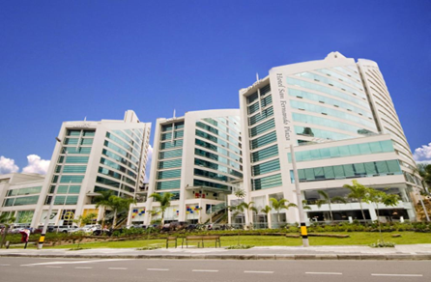
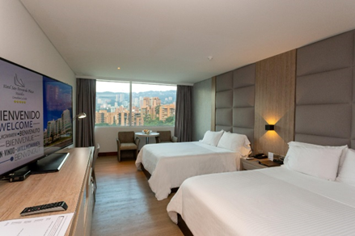
City Express Hotel – Four Star Hotel
- Single Room price: USD 165.00 per room
- Number of rooms: 70
- Double/Twin Room price: USD 270.00 per room
- Number of rooms: 45
- Board plan: breakfast and lunch (lunch will be served at the venue)
- Check-in from 05.04.2024 / 3.00 pm
- Late check-out Please address this with the LOC in case it is necessary.
- Hotel website: https://www.cityexpress.com/hoteles-colombia/antioquia/medellin
- Hotel information The hotel is surrounded by an area where there are several restaurants and shopping malls where food of all sorts (local and international cuisine) can be found.
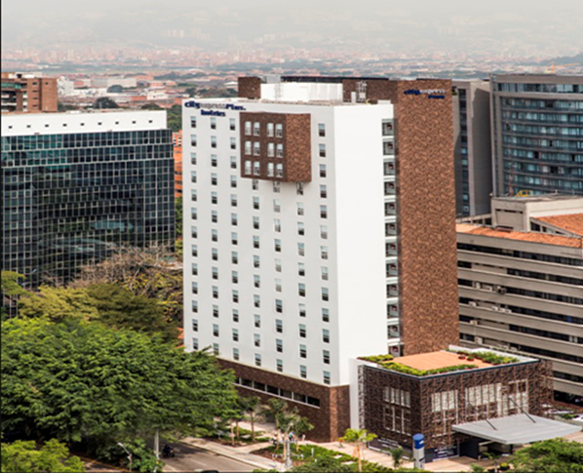

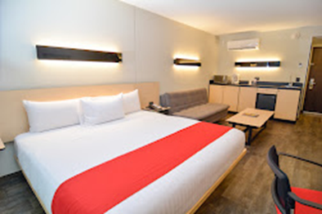
Rooms are allocated on a first come, first serve basis. Accommodation includes breakfast and lunch with non-alcoholic drinks. Lunch will always be served at the archery venue.
Hotel bookings for teams who intend to compete both at the Individual Qualifier for the Olympics and the Pan American Championships must be made using the WAREOS registration platform for the Pan American Championships. The same will apply to teams competing only at the Pan American Championships
Teams who do not reserve their accommodation through the organising committee will be charged a double entry fee.

In addition, the LOC will be responsible to provide any event information at the official hotels and provide transportation to the venues. Private vehicles can be used too. Teams who make hotel bookings on their own, even if they stay at the same hotel used by the Organizing Committee will not be entitled to use transportation arranged by the LOC.

TRANSPORTATION
Transportation will be provided from the Jose Maria Córdoba International Airport to the official hotels, from April 5 (if attending both the CQT and the Pan Am Championships), or April 7 (if competing at the Pan American Championships only). Airport drop-off transport will be provided at no additional cost on April 12-15. Local transport will be available between the official hotel, practice, and competition venues at no additional cost. Transport timetables will be confirmed.

VISA
All participants who need an entry visa to Colombia will be required to complete the Visa Support sections in WAREOS by no later than 09 February 2024.

It is the applicants’ responsibility for supplying the necessary information, ensuring all details are up to date, correct and submitted by the deadlines specified.

In addition, all participants that require a visa are kindly requested to supply a copy of their latest/valid passport. Copies of each application can be uploaded on WAREOS. All passport copies and personal details entered/uploaded to WAREOS will be held securely and in the strictest of confidence and not shared with other parties.

BANK INFORMATION FOR ACCOMMODATION, TRANSPORTATION AND ENTRY FEES
Account holder name: Federación de Arqueros de Colombia
NIT 811.030.815-6
Account holder´s address: Carrera 66B N 31 A 15, Medellin Colombia
Telephone number: +57 3168775003
Bank: Bancolombia
Account Number: 362-0000-1217 (cuenta corriente)
Swift: COLOCOBM
(if you require 11 digits for your transfer COLOCOBMXXX)
Bank’s address: Transversal 39B N 73-47 local 104
Bank’s Phone: +57 4 4449325
City: Medellin, Colombia

NOTE: ALL PAYMENTS SHALL BE MADE IN USD.

CANCELLATIONS & CHANGES
All cancellations and changes must be made through WAREOS.

- Should flight arrival details change last minute, please contact the Organising Committee using the details indicated in the team managers’ booklet.
- If a participant’s arrival is later than the original scheduled arrival date, the room will be charged from the date of the original booking in WAREOS.
- An email will automatically notify the Organising Committee and Member Association of any changes made in WAREOS.

MEDICAL EMERGENCIES

Lina Orrego
ctfedearco@gmail.com
+57 3128953839

Clínica Las Vegas (Hospital)
Calle 2 Sur No. 46-55, Medellin
+57 604 315 9000

ADDITIONAL INFORMATION
Training
For the athletes who will attend the Individual Continental Qualifier for Paris 2024, a training field will be available starting on 06 April 2024 at the Unidad Deportiva de Belen located approximately 20 minutes from the official hotels. Archers competing only in the Pan American Championships will be able to practice starting on 07 April 2024. Teams wishing to arrive earlier, please contact the LOC for information on training facilities.

Weather
Medellin is a city where it is never cold and very seldom hot. Temperatures in April are expected to range between 20 and 28 degrees Celsius. The average in the last few years has been 25 degrees Celsius. There are chances of rain, mainly in the afternoons.

Media Registration
Media representatives can apply for registration by emailing comunicacionesfedearco@gmail.com or at info@archery.sport

Internet
Will be available in the official hotels for free (in hotel rooms and in the lobby). There will also be Wi-Fi available for access to results on venue.

Water
Each participant with receive clean bottles of water. Bottled water will be available at the qualification and practice venues.

LOC CONTACT
Name: Ana Amaya
Address: Cra 66B No. 31A15, Medellin
Email: panamericano2024medellin@gmail.com
Language: Spanish and English
Phone number with international extension: +57 310 8283891
Looking forward to welcoming you in Medellin, Colombia

Terms and Conditions
Introduction
The Member Association acknowledges to have understood and accepted in their whole and without any restrictions the sale and purchase terms and conditions of this invitation package, and of the registration platform https://extranet.worldarchery.sport/wareos/.

Consequently, the Member Association who wishes to register to an event, and book some or all associated extras proposed by the local organizing committee acknowledges that they are fully aware present terms and conditions are accepted by entering information in WAREOS.
Any Member Association declares that it is entitled to enter a contractual relationship with the Local Organising Committee of the event, in accordance with these terms and conditions.
The Local Organising Committee commits itself to communicate, within reason, to its potential clients the greatest information available on the following topics:
Description of the main characteristics of the proposed products and of their use.
Pricing
Information on the methods of payment and reimbursement conditions.

Article 1: Entirety
The platform https://extranet.worldarchery.sport/wareos/ is the propriety of, has been designed and created and is managed by World Archery Federation at Lausanne, Switzerland, and put at the disposal of the Local Organising Committee to facilitate registration to World Archery events.
The present terms and conditions include any and all rights and obligations of the parties. No single, specific, or general term or condition that may appear on documentation sent, given, or handed over to a Member Association will alter, replace, or complete parts of or the entirety of these terms and conditions
World Archery reserves the right to modify at any time and without any preliminary notification of any kind these terms and conditions.

Article 2: Object
The present terms and conditions define the rights and obligations of the parties in relation to the registration made through the platform https://extranet.worldarchery.sport/wareos/ of services offered by the Local Organising Committee in the scope of the event it has been set for.

Article 3: Contractual documents
The present terms and conditions and the registration process make up the contractual documents between the parties.

Article 4: Electronic signature:
The Member Association’s entering registration information is the electronic signature which is binding between the parties in the same sense as a handwritten signature would be.

Article 5: Registration Confirmation – Contract
The contract is validated as soon as the Member Association has entered its preliminary registration by entering information in WAREOS. A modification of the registration is possible until the deadline for registration set in the document. Modifications may be subject to penalty fees.

Article 6: Prices
The official prices are listed in the “Policies and Procedures Athletes, officials and team management”, the invitation package prices will be based on the official price list, converted to the currency elected by the LOC for invoicing (CHF, EUR, or USD).
The official prices valid on the date that the registration confirmation is sent to the Member Association are binding between the parties.
Article 7: Payment methods
All payments shall be made by bank transfer to the organising committee respecting the stated deadlines, with all bank charges paid by the Member Association. For any open invoices that are not settled 21 days prior the beginning of the event, the Local Organising committee will be entitled to charge a 5% surcharge on all open amounts.
Any payments received cash by World Archery on behalf of the organising committee will incur a 10% additional service fee, to be paid to World Archery.

Article 8: Payment deadlines and refunds
After the final deadlines of registration mentioned in this document, Member Association will not be entitled to any refund, and all remaining unpaid amounts shall be paid to the Local Organising Committee.
Failure to do so, will results in an immediate suspension of the Member Association, who will be set as not in good standing on the day of the official practice of the event, and so until the full amount is paid to the LOC.

Article 9: Availability of services
The availability of services is guaranteed on a first come, first serve basis, provided that the payment of such service has been paid to the local organising committee, partially or in full as mentioned in this document.
The local organising committee is not required to hold services for a Member Association that as not paid in full such service.

Article 10: Force-majeure
None of the two parties will have failed in their respective contractual obligations if their execution is delayed or prevented by a case of force-majeure. Cases considered to be a force majeure are extraordinary events or circumstances beyond the control of the parties, such as a war, strike, riot, crime, or an event described by the legal term "act of God" (e.g., flooding, earthquake, volcano eruption, etc). However, force majeure is not intended to excuse negligence or other malfeasance of a party, as where non-performance is caused by the usual and natural consequences of external forces, or where the intervening circumstances are specifically contemplated. The party experiencing a force majeure must notify in writing with 24 hours after becoming aware of the occurrence. The parties will then, within 7 business days examine, unless the force majeure prevents it, if and how the contractual obligations will be met.

Article 11: Privacy statement
All information exchanged by the Parties will be treated with the utmost confidentiality
All information requested by World Archery and the Organising Committee from the Member Association are necessary to process the event registration and can therefore be communicated only to the contractual partners of World Archery and the Local Organising Committee.
World Archery and the Local Organising committee are authorized to send informative and promotional e-mails to the Member Association, using the WAREOS e-mail address and the contact person provided by the Member Association during the registration.
October 2023 by World Archery Federation, Maison du Sport International, Avenue de Rhodanie 54 - 1007 Lausanne (Switzerland)

