8th Fazza Para-Archery  World Ranking Event  World Qualifying Tournament for PARIS 2024  Dubai 2024  02–07 March 2024  INVITATION PACKAGE  Version 1.0 – 17 October 2023 | 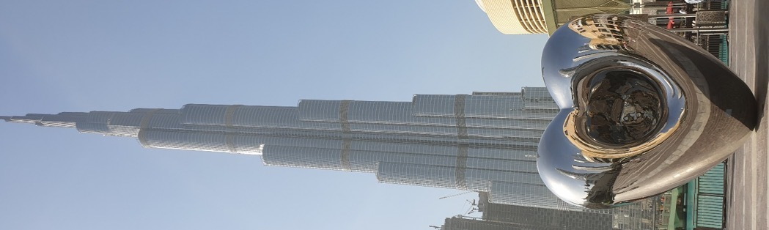
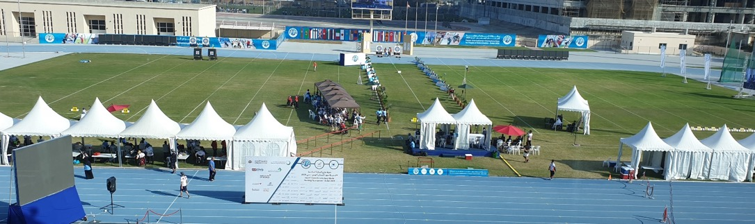

KEY DATES
Opening of the registration on WAREOS | 17/10/2023
Preliminary entries (deadline) | 03/12/2023
Final entries (deadline) | 10/02/2024
Classification request and forms submission (deadline) | 30/01/2024
Hotel reservation and payment | 05/01/2024
Transportation | 10/01/2024
Visa support | 10/01/2024
Full refund cancellation deadline | 31/12/2023
Provisional schedule
Subject to change according to participation and TV requirements.
Arrivals CO-RO-W1 | 29/02/2024
Classification – Free practice | 01/03/2024
Official Practice - Equipment inspection CO-RO-W1 | 02/03/2024
Qualification + Eliminations CO-RO-W1 | 03/03/2024
Qualification + Eliminations CO-RO-W1  Africa/Oceania Qualifying Tournament  Arrivals VI | 04/03/2024
World Final Qualifying Tournament  Official Practice - Equipment inspection VI | 05/03/2024
Qualification + Eliminations VI  WRE Eliminations CO-RO-W1 | 06/03/2024
FAZZA WRE finals (medals matches) | 07/03/2024
Departures | 08/03/2024

Dear NPCs
The Fazza International Championships unleash the return of
sporting activity for the year 2024 to be a renewed new hope
from Dubai, United Arab Emirates, for world athletes to
achieve their goals of qualifying for the World Para
Archery Championship.
The challenge is one of the characteristics of the people
of the Emirates, and people of determination are an
important and complementary part of this framework, and
by this they prove to the world that the impossible does not exist here, so no pandemic, problem or barrier can stand in front of our determination to achieve the desired future.
To all world champions, we say welcome to the homeland of challenge and in the source of happiness and in the space of the impossible. Welcome again and again to Dubai to race again and the noble competition in the fields, arenas and halls of the Dubai Club for People of Determination with new hope and renewed energy. The UAE salutes you, and Dubai welcomes you, and the Dubai Club for People of Determination opens its stadiums for your concerns, which have no limits or limits. Welcome to creativity ... to convergence ... to love.

Thani Juma Berregad
Fazza LOC - President
Dubai Club for the People of Determination

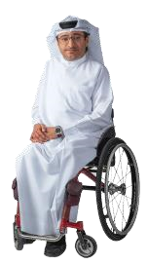
The Dubai 2024 8th Fazza International Para Archery Championships, for People of Determination carries a lot of innovation and renewal, and we know very well that there is a challenge in organizing these Championships in this exceptional years, in which the world is witnessing the pandemic.
Our country only accepts to move forward, and because our wise leadership instilled innovation and challenge in us, we quote from them their inspiring words that motivate us to develop and innovate. The directives of the sponsor of these championships, His Highness Sheikh / Hamdan bin Mohammed bin Rashid Al Maktoum, Crown Prince of Dubai and Chairman of the Dubai Executive Council. Were clear to all of us since the first version of the need for development and innovation. As it was to support His Highness Sheikh Mansour bin Mohammed bin Rashid Al Maktoum, Chairman of the Dubai Sports Council. The positive impact on continuing to organize championships, despite the challenges. The Dubai 2024 Para Archery Championships for People of Determination will be an icon of global Paralympic sports and to reach the world Paralympic game through the Dubai Gate. In Dubai, different civilizations meet to blend into one harmonious fabric that reflects the extent of harmony and rapprochement between peoples. Welcome all to your second country and among your brothers...

Majid Al- Usaimi
Fazza LOC – Manager
Dubai Club for the People of Determination

RULES TO APPLY

World Archery Rules apply for the World Ranking event. Please take time to read the updated version of rules on World Archery website:
https://www.worldarchery.sport/rulebook

During the event we will have the last qualifying tournaments for Paris 2024. Details on qualification process is available on IPC website:
https://www.paralympic.org/paris-2024/qualification-regulations

PRELIMINARY & FINAL REGISTRATION
All entries, accommodation reservations, transport needs, flight arrival/departure information and visa invitation letter requests are to be completed using the World Archery Online Registration System WAREOS.
Member associations can login to WAREOS at http://extranet.worldarchery.org

The Team Manager function MUST be declared for at least one person by country.
No accreditation will be delivered to the team:
- if nobody is declared as Team Manager.
- if the payment of registration/accommodation and other fees has not be paid in time (respect of the deadlines below)

Classification

The classification will take place on 01 March 2024.
Requests and documents (medical form and information) must be sent to classification@archery.sport no later than 30 January.
All information and forms can be found on World Archery Website:
https://www.worldarchery.sport/sport/disciplines/para-archery/classification

It is the full responsibility of teams to arrive in time. It will not be possible to postpone classification session or official practice nor equipment inspection.
It is recommended to the archers registered for classification to arrive one day before their scheduled classification.

VISA
All participants who need an entry visa to Country, will be required to complete the Visa Support sections in WAREOS by no later than 20/12/23

It is the applicants’ responsibility for supplying the necessary information, ensuring all details are up to date, correct and submitted by the deadlines specified.

In addition, all participants that require a visa are kindly requested to supply a copy of their latest/valid passport. Copies of each application can be uploaded on WAREOS. All passport copies and personal details entered/uploaded to WAREOS will be held securely and in the strictest of confidence and not shared with other parties.

FEES

ENTRY FEES (EUR)
Individual 260 USD
Official 130 USD
Guest 500 USD
International License 100 CHF per participant per calendar year to be paid
to World Archery

Entry fees for Individual/Official include daily local transport between official hotels and the qualification, elimination, and finals venues (timetable to be confirmed on site).

Entry fees for Guest include daily local transport between official hotels and the qualification, elimination, and finals venues (timetable to be confirmed on site). They have no field of play access.

Any changes that are made after the deadlines specified or if entries differ by more than 4 athletes from the preliminary entries, the following penalty fees will automatically be applied.

FEES TO BE PAID TO ORGANISING COMMITTEE (per entry)
Late Entries (after final deadline): 220 USD
Not filling Preliminary entries 165 USD
Variation preliminary / final entries*: 165 USD
*If the difference between final and preliminary entries number is more than 4 athletes/officials

PENALTY FEES TO BE PAID TO WORLD ARCHERY (each)
Lost / Damaged accreditation or lost Classification 50 CHF
Lost classification card
Any change to the final country entry list, such as (but not limited to): 50 CHF
• Athlete or official name change
• Date of birth change
- Official position change
- Absence or incomplete on-site contact person

NOTE: CHF currency exchange rates will be those on the date of the event.

Member Associations that have penalty fees outstanding from 2023 will need to have paid these penalty fees before being eligible to enter and compete.

A Member Association that has made final entries in WAREOS and does not participate will be invoiced for the number of entries entered in the system, unless they have informed World Archery and the Organizing Committee in writing at least one week prior to the event that they are unable to attend.

Accommodation
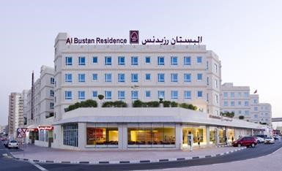
The Al Bustan Hotel is the official hotel for all athletes and officials during the FAZZA tournament. This hotel offers accommodation in single, double, and triple rooms.
Hotel name: Al Bustan Residence
Address: Al Nahda Road-Al Towar, P.O. Box 2017
Dubai, UAE

For any queries related to Accommodation registration, please contact us via msaadeldin@dcd.org.ae
feeS
The fees include VAT, three meals with non-alcoholic drinks (breakfast, Lunch, and Dinner) per person. Price if double means twin (2 beds) or 1 big bed
Fees per night (including VAT)
Please note that the room discounted price, is applicable for payment before the deadline. Which is 5th of January, from 6th of January onwards the full price will be charge as well as request for payment upon arrival.
Room Type | Price Until 5st of January | Price After 5st of January
Single room | 230 USD | 250 USD
Double room | 440 USD | 485 USD
Triple room | 640 USD | 705 USD
Quadruple room | 870 USD | 955 USD

Check-in date: 29th February 2024 at 15:00.
Check -out date: 8th February at 12:00 p.m.

Teams who arrive on 29th of February before 15:00 midday and want to have access to their rooms before the check in the hotel will charge an extra night.
- On 8th of February, teams who wants to stay in their rooms after the check-out (12.00 p.m.) will be charge for an extra night. Teams can stay in the lobby without extra cost.
- All rooms will be allocated once payment has been received in full.
- If the competition schedule will not allow teams to get lunch at the hotel, the LOC will provide lunch packets at the venue but only for lunch, this will be decided after the Competition schedule has been published officially.

Payment procedure
Full accommodation fees must be transferred to the following bank account, by no later than 05/01/2024 Please note that rooms will only be booked and allocated to teams when the accommodation payment has been received in full.
Account name | Dubai Club for People of Determination
Bank name | Dubai Islamic Bank
Branch name | Dubai Main Branch
Account number | 001520726988901
Swift-Code | DUIBAEAD
IBAN | AE95 0240 0015 2072 6988 901

CANCELLATIONS & CHANGES
All cancellations and changes must be made through WAREOS
  - full payment will be refunded if cancellations are made by 31/12/23 .
  - 50% payment will be refunded if cancellations are made by 05/01/24 .
  - No payments will be refunded to cancellations from 06/01/24 .
  - Refunds will be processed after the event within 90 Days .
  - Name changes to team officials or athletes (same category and division) will be accepted up to two (2) days before official practice without any additional charge or penalty fees, participants have to issue their visa if required.
  - Should flight arrival details change last minute, please contact the Organising Committee using the details indicated in the team managers’ booklet.
  - If a participant’s arrival is later than the original scheduled arrival date, the room will be charged from the date of the original booking in WAREOS.
  - An email will automatically notify the Organising Committee and Member Association of any changes made in WAREOS.

The value of the invoices will be issued in dollars, all bank charges will be paid by the participants

Transportation
Transportation will be provided for free to all athletes and team officials from/to Dubai International Airport to the official competition hotel takes only 5 minutes by car or bus. The distance between the competition venue and the official competition hotel is about 2.5 K.m. and takes 6 minutes by car or bus.

The LOC will have staff for meet and greet at the airport .
No. | Roll | Name | Mobile Number
1 | Airport coordinator | Ola Adnan | +971 507988484
2 | Logistics & Hotel cC | Mr.Eissa | +971 506369969
3 | Transportation | Essam Mohamed | +971 509262644

Visa
The LOC will issue the visa to the participants upon their request via registration portal to obtain your visa you must:
• upload passport copies in (pdf, JPG, JPEG) format.
• Passport should be valid at least for 6 months from the date of your departure.
• Mobile photos are not acceptable.
• Visa fees of (110) USD . and the payment should be done no later than 05th January 2024
After deadline( 05 January 2024 ) Express visa will be applied and it will cost 150 USD .
Email to: aghobash@dcd.org.ae
Note: Residents of the following countries have to submit a copy of their
National ID: Iraq, Yemen, Iran, Pakistan, Afghanistan and Tunisia.
By no later than 5th January 2024, (visa form is attached in annex 01)

Accreditation card
The Accreditation card is the official pass for the participants to the designated areas according to their category, the LOC will issue this Accreditation cards and will be giving to the head of the delegation during the delegation registration meeting (DRM) of each delegation according to a schedule based on their arrival dates, teams are requested to send the Accreditation form attached with a photo of the participant (passport size) by no later than 2nd January 2024.
MEDICAL SERVICES
Organizing committee will cover only emergency medical cases during the event.
EMERGENCY CONTACT NUMBERS
For a medical emergency outside the opening hours of the Venue Medical clinic please contact the doctor on call (telephone number to be confirmed) or the Emergency Ambulance service on 998.
Contact number | Name | Designation
+971553315531 | Yahia Kabani | Head of medical committee
+971544223038 | Mohammed Hamza  Tayar | Physiotherapy lead
Designated medical institutions:
Rashid hospital, which is located 15 minutes from competition venue Dubai club for people of determination.
Venue medical centre
Will be in Dubai club for people of determination competition stadium.
- Period: 29th February to 8th of March 2024
- Timing: 8:30 to 22:00 (emergency 24 H)
- Specialty: sports medicine – Emergency medical care (further medical investigations will be available in hospital upon doctor request)
- Facility: examination rooms ,3 beds treatment rooms
- physiotherapy room and massage (paid)
- Object: Athletes, Team Officials, Staff, Spectators
- Ambulances: 3 paramedics
Official Hotels
24H emergency on call doctor (contact help desk)
Local Emergency Numbers
Police: 999
Ambulance: 998
Fire: 997

OTHER MEDICAL MATTERS
- Team doctors are allowed to practice on their national team and all prescriptions and investigations must be arranged through the LOC medical team.
- Importation of Medicines: The head doctor accompanying a team must provide a list of the medicines the team is bringing into UAE, including dosages and quantities. The list will constitute a statement on behalf of the Member Federation which will be retained by the 8th Fazza Para Archery World Ranking
Tournament- Dubai 2024 Medical Services and will be shared with the UAE Dubai Health Authority or another government body if requested. A template form will be sent soon to the participating teams.
- Distribution of Ice
Ice will be provided at the competition and training venues.
- Players under treatment by prohibited medicine in UAE such as (marijuana) they should provide medical report with medical prescription at the airport (Dubai customs if they requested)
- Importation of medical equipment: A template form will be sent to participating teams.

Media Registration
Media representatives can apply for registration by emailing the local organising committee.

IMPORTANT CONTACT NUMBER (MOBILE PHONE):

No. | Role | Name | Mobile Number
1 | Airport | Ola Adnan | +971 507988484
2 | Coordinator Logistics | Ashraf Ghobash | +971 507746604
4 | Transportation | Essam Mohamed | +971 509262644

Contact address:
Kresh Jagarnath
Fazza LOC
Tel: 00971 4 2988205
Mobile: +971 50 5114947
P.O. Box: 20990, DUBAI - UNITED ARAB EMIRATES
Email: kjagarnath@dcd.org.ae
THE UNITED ARAB EMIRATES:
UAE is consisting of seven emirates: Abu Dhabi, Dubai, Sharjah, Ras Al Khaimah, Ajman, Umm Al Quwain and Fujairah. Four-fifths of the UAE is desert but has contrasting landscapes—from the towering red dunes of the Liwa to the rich palm-filled Oasis of Al
Ain, from the precipitous Hajjar Mountains to the more fertile stretches of its coastal PLAINS.
Though small (like the size of Scotland), the UAE has become an important player in regional and international affairs. In 1971, the late President Sheikh Zayed bin Sultan Al Nahyan unified the small, underdeveloped states into a federation—the only one in the Arab world. With his visionary leadership, oil wealth was used to develop the UAE into one of the world’s most open and successful economies.
In 2004, His Highness Sheikh Khalifa bin Zayed Al Nahyan became the President and has since continued to strive towards an ambitious vision for the UAE.
DUBAI
Dubai is located on the Eastern coast of the Arabian Peninsula, in the south west corner of the Arabian Gulf. It is extremely well known for its warm hospitality and rich cultural heritage, and the Emirati people are welcoming and generous in their approach to visitors. With year-round sunshine, intriguing deserts, beautiful beaches, luxurious hotels and shopping malls, fascinating heritage attractions and a thriving business community, Dubai receives millions of leisure and business visitors each year from around the world.
Dubai Rulers:
Since 1833 the reigning Al Maktoum family have ruled Dubai. Under their wise and progressive leadership Dubai has prospered and it is now the business and tourism hub for a region.

Dubai History:
Saruq Al-Hadid site is considered one of the most important archaeological discoveries in Dubai and the region, as it offers much of the UAE old past, especially during the Iron and Bronze Ages ،which confirms that the UAE civilization extends to 5 thousand years.
Dubai Economy:
The past few decades have witnessed incredible growth throughout all sectors of the Dubai economy. The emirate’s government is constantly working to improve its commercial transparency and introduce dynamic regulations that aid the formation of small and medium enterprises. Dubai’s economy is no longer reliant on oil, but is more diversified, relying heavily on trade, services and finance sectors. With its central geographic location between Asian and European markets, Dubai has worked hard to establish itself as an integral part of the global trade mechanism. Its central location has also allowed Dubai to become a popular and accessible tourist destination.
GENERAL INFORMATION:
Weather:
Dubai has a tropical desert climate because of its location within the Northern desert belt. Summers are extremely hot and humid, with an average high around 41 °C (106 °F) and overnight lows around 30 °C (86 °F). Most days are sunny throughout the year. Winters are warm and short with an average high of 23 °C (73 °F) and overnight lows of 14 °C (57 °F). Precipitation, however, has been increasing in the last few decades with accumulated rain reaching 150 mm (5.91 in) per year. The weather in Dubai can bring short and irregular rainfall as is typical for the Middle East. Most of the rainfall occurs in the December to March period. The weather between December and March remains warm and is the most comfortable climatic conditions of the year.
Currency:
The local currency is the dirham, which is pegged at AED 3.67 to 1 US dollar. Dubai is tolerant and cosmopolitan, and all visitors are welcome. However, Islam is a way of life in the city, and therefore tourists should adopt a certain level of cultural and religious sensitivity for the duration of their stay.
ELECTRICITY AND POWER SOCKETS IN THE UAE:
In the United Arab Emirates, the standard voltage is 240-220 V. The standard frequency is 50 Hz. The power sockets that are used are of type G. Find pictures of these power sockets and corresponding plugs.
Transportation in Dubai:
Dubai is one of the fastest growing cities in today's world, making the provision of high quality infrastructure facilities absolutely imperative, and since providing an advanced transport network for the people of Dubai has been high on the government’s agenda, which is evident from its initiatives to enhance the public transport facilities and improve roads across the emirate to make travel safer and smoother, the Roads and Transport Authority (RTA) was formed by the decree number 17 for the year 2005, The tourist can enjoy his staying in Dubai with varieties of transportation,“ Roads, Taxis, Metro, Bus, Trams, Ports and water travel, Air travel and see”.
Dubai International Airport
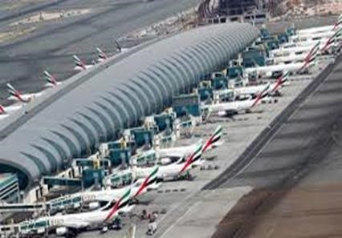
Dubai International Airport is the primary international airport serving Dubai, United Arab Emirates and is the world's busiest airport by international passenger traffic. It is also the fifth-busiest airport in the world by passenger traffic, and the sixth-busiest cargo airport in world. The airport has a total capacity of 90 million passengers annually. As of January 2016, there are over 7,700 weekly flights operated by 140 airlines to over
270 destinations across all inhabited continents

Road
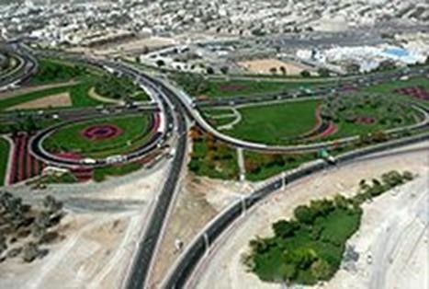
D 89 leading to Dubai Airport
The airport is connected by the road D 89. One of the longest intra-city roads, D 89 begins at the Deira Corniche and runs perpendicular to D 85 (Baniyas Road). From Deira, the road progresses south-eastward towards Dubai
International Airport, intersecting with E 311 (Emirates Road) past the airport. A road tunnel underneath one of the runways, was built in 2003.

Metro - Dubai Metro
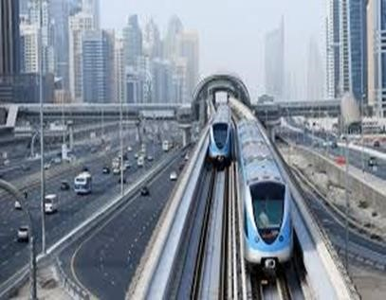
Metro Dubai is accessible for the people of Determination, there are only two metro stations between the event Hotels and the venues.
The airport is served by Dubai Metro, which operates two lines through or near the airport.
The Red Line has a station at each of Terminal
3 and Terminal 1. Services run between 6 am and 11 pm every day except Friday, when they run between 1 pm and midnight. These timings differ during the Islamic holy month of Ramadan. The stations are located in front of both terminals and can be accessed directly from the arrivals areas.
The Green Line has at a station near the Airport Free Zone, from which passengers can connect to Terminal 2.

Bus
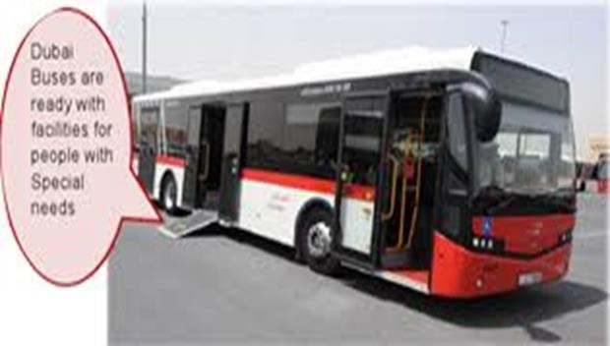
Dubai Buses operated by RTA run a number of routes to the city but mainly Deira and are available at the
Airport Ground Transportation center and the Arrivals at every terminal.
Passengers who need to
transfer between Terminals 1 and 3, and Terminal 2 can use the inter-terminal shuttle bus service which operates frequently.
Bus stations are situated opposite both Terminal 1, 2 and 3. Local buses 4, 11, 15, 33 and 44 can be used to connect with Terminal 1 and 3, while bus 2 connects with Terminal 2. Dubai International Airport Buses provide air-conditioned transport into the city centre and over 80 hotels in the city.
Emirates offers a complimentary coach service, which operates three daily services to and from Al Ain, and four daily, to and from Abu Dhabi.

Taxi
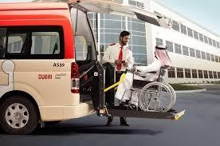
The airport is served by the Government owned Dubai Taxi Agency, which provides 24-hour service at the arrivals in every terminal.

Tourist attractions in and around Dubai
Burj AL Arab:
Is a luxury hotel located in Dubai, United Arab Emirates, at 321 m (1,053 ft), it is the fourth tallest hotel in the world. Burj Al Arab stands on an artificial island 280 m (920 ft) from Jumeirah beach and is connected to the mainland by a private curving bridge. The shape of the structure is designed to mimic the sail of a ship. Sometimes referred to as "the world's only 7-Star hotel".
Burj Khalifa:
World's tallest building, a living wonder, stunning work of art, incomparable feat of engineering, Burj Khalifa is all that, in concept and execution, Burj Khalifa has no peer, more than just the world's tallest building, Burj Khalifa is an unprecedented example of international cooperation, symbolic beacon of progress, and an emblem of the new, dynamic and prosperous Middle East.
Atlantis Dubai:
Atlantis Dubai is a huge tourist hotel complex is located in Dubai, opened in impressive and huge ceremony at a cost of U.S. $ 20 million on November 20, 2008, a project of the South African Entrepreneur Sol Cairns. The hotel is located on the Palm Jumeirah at the checkpoint north of the island; it can be reached through an underwater tunnel on the railway line. The hotel costs up to 1,200 million.
Ski Dubai:
Ski Dubai is the first INDOOR ski resort to open in the Middle East. The resort is located at the heart of Mall of the Emirates, a famous shopping center in Dubai’s Central Part of the City.
The Ski Dubai arena boasts a mountain-themed 22,500 square-meter space of skiing, snowboarding and tobogganing. If you just want to hang around and enjoy the nice temperature which is around 3 degrees Celsius. There is also the 3,000 square-meter Snow Park dedicated to people who just want to play in the snow with some nice slides.

Welcome To Dubai….
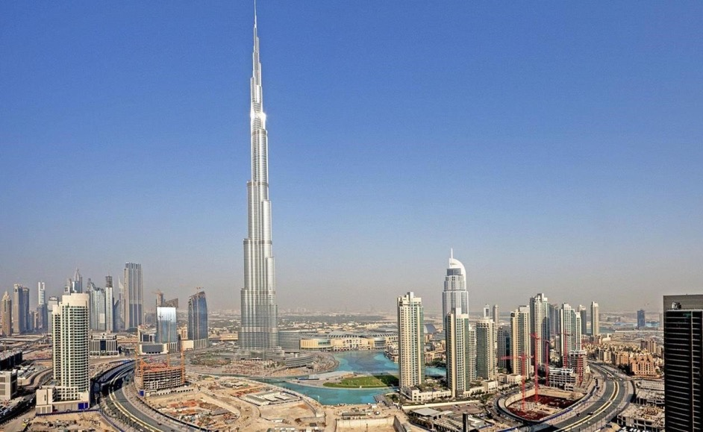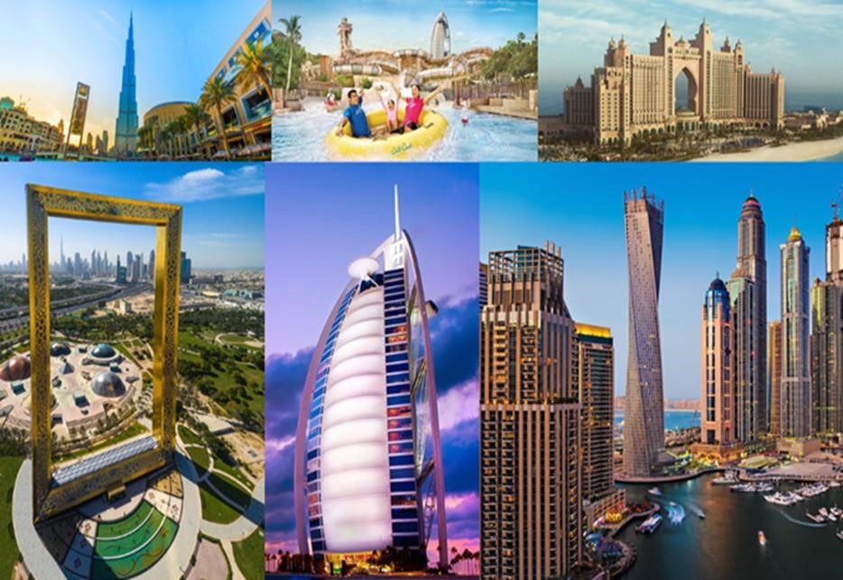

Terms and Conditions
Introduction
The Member Association acknowledges to have understood and accepted in their whole and without any restrictions the sale and purchase terms and conditions of this invitation package, and of the registration platform https://extranet.worldarchery.sport/wareos/.

Consequently, the Member Association who wishes to register to an event, and book some or all associated extras proposed by the local organizing committee acknowledges that they are fully aware present terms and conditions are accepted by entering information in WAREOS.
Any Member Association declares that it is entitled to enter a contractual relationship with the Local Organising Committee of the event, in accordance with these terms and conditions.
The Local Organising Committee commits itself to communicate, within reason, to its potential clients the greatest information available on the following topics:
Description of the main characteristics of the proposed products and of their use.
Pricing
Information on the methods of payment and reimbursement conditions.

Article 1: Entirety
The platform https://extranet.worldarchery.sport/wareos/ is the propriety of, has been designed and created and is managed by World Archery Federation at Lausanne, Switzerland, and put at the disposal of the Local Organising Committee to facilitate registration to World Archery events.
The present terms and conditions include any and all rights and obligations of the parties. No single, specific, or general term or condition that may appear on documentation sent, given, or handed over to a Member Association will alter, replace, or complete parts of or the entirety of these terms and conditions
World Archery reserves the right to modify at any time and without any preliminary notification of any kind these terms and conditions.

Article 2: Object
The present terms and conditions define the rights and obligations of the parties in relation to the registration made through the platform https://extranet.worldarchery.sport/wareos/ of services offered by the Local Organising Committee in the scope of the event it has been set for.

Article 3: Contractual documents
The present terms and conditions and the registration process make up the contractual documents between the parties.

Article 4: Electronic signature:
The Member Association’s entering registration information is the electronic signature which is binding between the parties in the same sense as a handwritten signature would be.

Article 5: Registration Confirmation – Contract
The contract is validated as soon as the Member Association has entered its preliminary registration by entering information in WAREOS. A modification of the registration is possible until the deadline for registration set in the document. Modifications may be subject to penalty fees.

Article 6: Prices
The official prices are listed in the “Policies and Procedures Athletes, officials and team management”, the invitation package prices will be based on the official price list, converted to the currency elected by the LOC for invoicing (CHF, EUR or USD).
The official prices valid on the date that the registration confirmation is sent to the Member Association are binding between the parties.

Article 7: Payment methods
All payments shall be made by bank transfer to the organising committee respecting the stated deadlines, with all bank charges paid by the Member Association. For any open invoices that are not settled 21 days prior the beginning of the event, the Local Organising committee will be entitled to charge a 5% surcharge on all open amounts.
Any payments received cash by World Archery on behalf of the organising committee will incur a 10% additional service fee, to be paid to World Archery.

Article 8: Payment deadlines and refunds
After the final deadlines of registration mentioned in this document, Member Association will not be entitled to any refund, and all remaining unpaid amounts shall be paid to the Local Organising Committee.
Failure to do so, will results in an immediate suspension of the Member Association, who will be set as not in good standing on the day of the official practice of the event, and so until the full amount is paid to the LOC.

Article 9: Availability of services
The availability of services is guaranteed on a first come, first serve basis, provided that the payment of such service has been paid to the local organising committee, partially or in full as mentioned in this document.
The local organising committee is not required to hold services for a Member Association that as not paid in full such service.

Article 10: Force-majeure
None of the two parties will have failed in their respective contractual obligations if their execution is delayed or prevented by a case of force-majeure. Cases considered to be a force majeure are extraordinary events or circumstances beyond the control of the parties, such as a war, strike, riot, crime, or an event described by the legal term "act of God" (e.g., flooding, earthquake, volcano eruption, etc). However, force majeure is not intended to excuse negligence or other malfeasance of a party, as where non-performance is caused by the usual and natural consequences of external forces, or where the intervening circumstances are specifically contemplated. The party experiencing a force majeure must notify in writing with 24 hours after becoming aware of the occurrence. The parties will then, within 7 business days examine, unless the force majeure prevents it, if and how the contractual obligations will be met.

Article 11: Privacy statement
All information exchanged by the Parties will be treated with the utmost confidentiality
All information requested by World Archery and the Organising Committee from the Member Association are necessary to process the event registration and can therefore be communicated only to the contractual partners of World Archery and the Local Organsing Committee.
World Archery and the Local Organising committee are authorized to send informative and promotional e-mails to the Member Association, using the WAREOS e-mail address and the contact person provided by the Member Association during the registration.
October 2023 by World Archery Federation, Maison du Sport International, Avenue de Rhodanie 54 - 1007 Lausanne (Switzerland)

