TO ALL World Archery Member Associations,
Dear President,

As Chair of the Local Organizing Committee (LOC) of the Parapan America Championship to be held in São Paulo– SP, Brazil on April 22-28, 2024, I would like to invite you all to be part of one of the most important archery events to take place in American/Brazil in 2024.
São Paulo, the largest city in Brazil and the Southern Hemisphere, is a vibrant metropolis that pulsates with energy and diversity. Nestled in the southeastern part of the country, this sprawling urban center serves as the economic and cultural heart of Brazil.
The cityscape of São Paulo is a captivating blend of towering skyscrapers, historic architecture, and lush green spaces. Gleaming glass structures stand side by side with colonial-era buildings, showcasing the city's rich history and its constant evolution. The iconic São Paulo skyline is a testament to the city's economic prowess and modernity.
A bustling megalopolis, São Paulo is a melting pot of cultures, home to a diverse population that includes people from all corners of the globe. This diversity is reflected in the city's gastronomy, with countless restaurants offering a culinary journey through various international cuisines. From vibrant street markets to upscale dining establishments, São Paulo caters to every palate.
Cultural enthusiasts will find a plethora of museums, theaters, and art galleries scattered throughout the city. São Paulo's cultural scene is dynamic and ever-changing, with a constant flow of exhibitions, performances, and events. The São Paulo Museum of Art (MASP) is a notable landmark, both for its impressive collection and its distinctive modernist architecture.
Despite its urban hustle, São Paulo also boasts green havens, such as Ibirapuera Park, providing a refreshing escape from the city's fast pace. The park serves as a recreational hub, offering jogging paths, lakes, and cultural spaces for locals and visitors alike.
São Paulo is a city that never sleeps, with a vibrant nightlife that caters to a wide range of tastes. From samba-filled clubs to trendy bars and electronic music festivals, the city pulses with an electric energy after dark.
In summary, São Paulo is a captivating blend of history, modernity, and cultural richness. Its dynamic atmosphere, diverse population, and cosmopolitan charm make it a truly unique destination within the global urban landscape.

Sincerely yours,

Rubens Vasconcellos Terra Neto
Parapan America Championship OC Chairman

IMPORTANT DATES

Please find enclosed detailed information regarding this event. To register participation, please complete all the necessary sections in WAREOS (https://extranet.worldarchery.sport) within the deadlines listed below.

Summary of deadlines:

Registration Opening date on WAREOS | 17 January 2024
Preliminary Entries / 50% down-payment | 05 February 2024
Final Entries / Full invoice payment | 01 April 2024
Transportation | 01 March 2024
Visa support | 05 February 2024
Full refund cancellation deadline  *After this deadline, the LOC is allowed to retain all amounts due by the Member Association. | 22 March 2024

Divisions and Categories
Visually Impaired 1
Visually Impaired 2 / 3
Recurve Men Open
Recurve Women Open
Compound Men Open
Compound Women Open
Men W1 (Rec/Comp)
Women W1 (Rec/Comp)

PRELIMINARY PROGRAMME
21 April 2024 Sunday
Arrivals

22 April 2024 Monday
Arrivals
Classification
Free practice

23 April 2024 Tuesday
Official Practice
Equipment Inspection
Team Managers Meeting

24 April 2024 Wednesday
Qualification Round in the morning and the afternoon

25 April 2024 Thursday
Elimination Rounds to semifinals

26 April 2024 Friday
Morning: mixed teams
Afternoon: doubles
Award ceremonies for mixed teams and doubles in each session

27 April 2024 Saturday
Individual Finals
Award ceremonies

28 April 2024 Sunday
Departures

NOTE: This preliminary programme is subject to change according to participation and TV requirements. All changes will be published and distributed in good time.

COMPETITION VENUE
Brazilian Paralympic Training Center
Rodovia dos Imigrantes km 11,5 | São Paulo – SP | CEP 04329-000

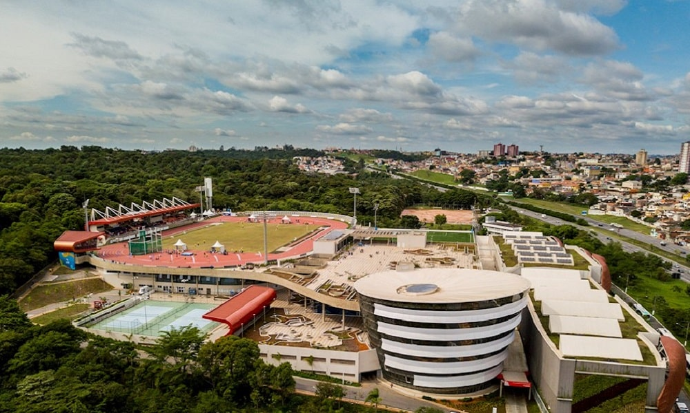
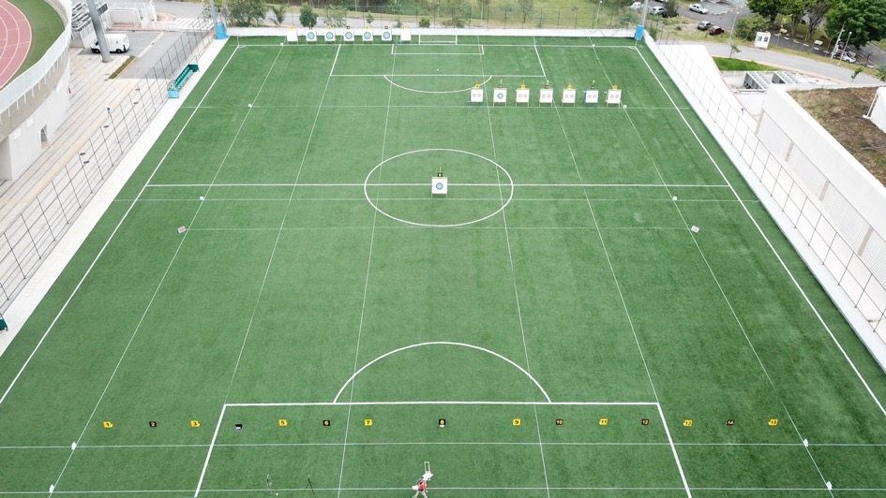

PRELIMINARY & FINAL REGISTRATION
All entries, accommodation reservations, transport needs, flight arrival/departure information and visa invitation letter requests are to be completed using the World Archery Online Registration System WAREOS https://extranet.worldarchery.sport. This system handles the entire registration process for this event. No entry forms, hotel reservations or transportation forms will be accepted; all information must be entered into WAREOS.

Member associations can login to WAREOS at http://extranet.worldarchery.sport with the username and password assigned by World Archery. After entering WAREOS, selecting the event from the list will allow a member association to register their athletes. Select/press the “Entries” button to see the list of categories in the event. Select/press the “category” to enter the athlete and official numbers/details participating for that event. A WAREOS User Manual can be downloaded in PDF format (English) upon login.

Contact wareos@archery.sport with any questions regarding technical problems on WAREOS. For any question regarding the organization of the event (transport, accommodation, meals, invoices, visa etc.) please contact directly the LOC.

Member Associations can only use WAREOS to make any changes, amendments or cancellations to entries and will be able to do so at any time. An email will automatically notify the Organising Committee and Member Association of any changes made in WAREOS.

ENTRY FEES

ATHLETES: 200 USD
OFFICIALS: 150 USD
International License 100 CHF per participant per calendar year to be paid to World Archery.

Member Associations that have penalty fees outstanding from 2023 will need to have paid these penalty fees before being eligible to enter and compete.

Any entries received less than 3 days before the team managers meeting for the event will be refused if no preliminary entry and/or final entry are made prior. This decision cannot be appealed by the teams and is fully compliant with the current World Archery rules, article 3.7.1.2.

Entries received after the deadlines, are subject to penalties as clearly stated in the rule book and the invitation documents. A Member Association that has made final entries in WAREOS and does not participate will be invoiced for the number of entries entered in the system, unless they have informed World Archery and the Organising Committee in writing at least one week prior to the event that they are unable to attend.

ACCOMMODATION
The Brazilian Paralympic Training Center Hotel
- Single Room price: 40 USD per night
- Number of Rooms 124 (please read IMPORTANT NOTICE below).
- Board plan: Full board (breakfast lunch and dinner)
- Check-in from April 21, 15:00 (lunch is not included on the day of the check-in).
- Check-out April 28, 11:00
- Hotel website: https://cpb.org.br/ct-paralimpico/hotel/
- This hotel is located 100 meters from the competition venue

The Brazilian Paralympic Training Center, located on the Imigrantes Highway in the south zone of São Paulo, also features a residential hotel with accommodations for 300 beds, exclusive catering for athletes and team officials during the competition.
Among the services available at the Paralympic Training Center hotel are a restaurant, laundry facilities, an administrative sector with meeting rooms, auditoriums, and other support spaces, including a TV room and game room.
The reception and laundry services operate 24 hours a day, while the restaurant is open from 6:30 am to 9:30 am for breakfast, 11:30 am to 3:00 pm for lunch, and 6:30 pm to 9:00 pm for dinner. On average, 13,000 meals are served monthly in the dining area of the Paralympic Training Center.
Due to the excellence in managing the facility, the Brazilian Paralympic Committee (CPB) has already received the ISO 9001 certificate. The certification attests that the CPB implements the best practices in hospitality services and event organization related to Paralympic sports, following international management standards in the third sector.
IMPORTANT NOTICE:
At the Brazilian Paralympic Training Center hotel, there are double, triple, quadruple, and sextuple rooms. To ensure that this invitation package matches the format of registration and accommodation bookings on WAREOS, we have included prices as if the athletes and officials were to stay in single rooms, which is not the case. Occupancy will be managed as follows: a certain number of rooms will be offered, where male and female athletes will be allocated to separate rooms, and the rooms are filled accordingly. For example: if a delegation consists of four male and two female individuals, the four male individuals will be accommodated in a quadruple or sextuple room. The two remaining slots in the sextuple room may be filled by two individuals from another delegation. In this example, the two female individuals may be placed in the sextuple room, and the remaining four slots will be occupied by four individuals from another delegation.
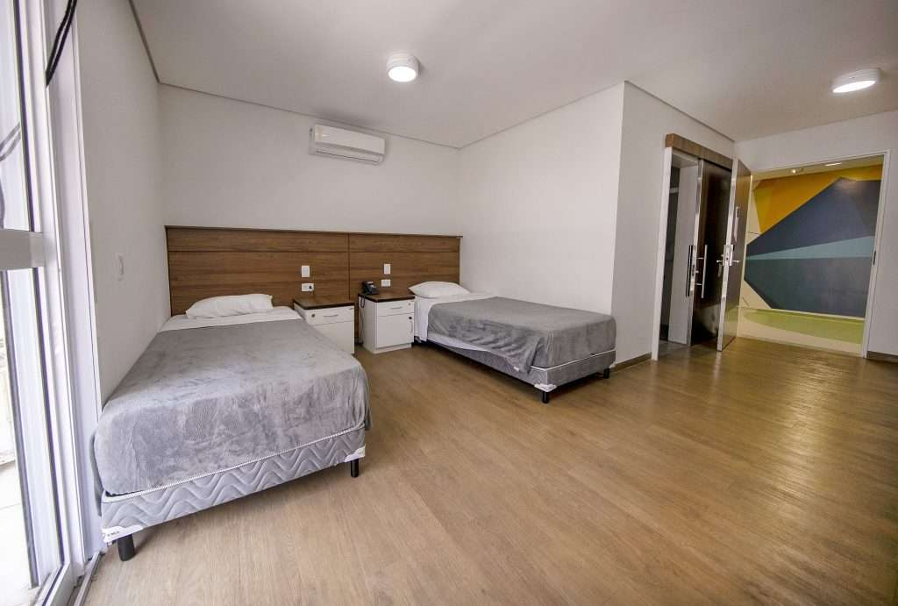
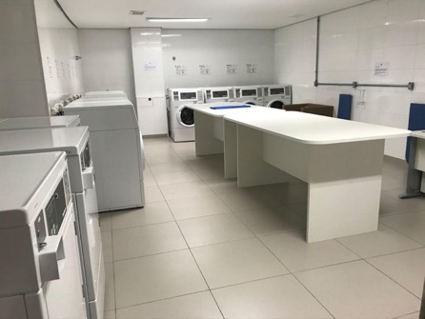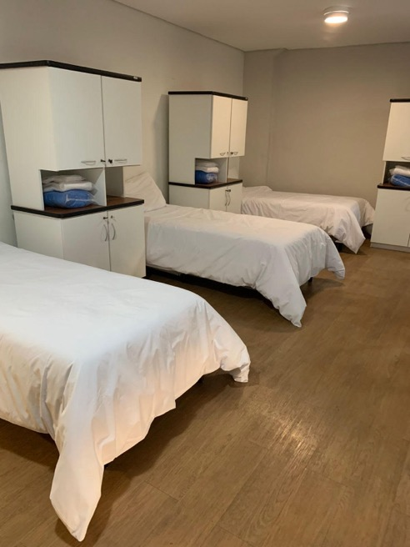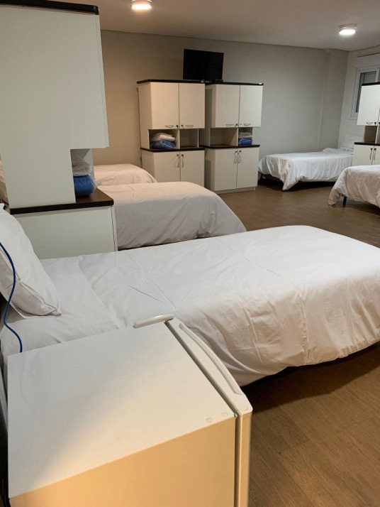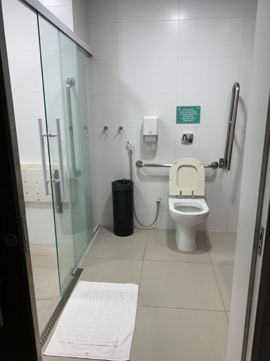

Bourbon São Paulo | Ibirapuera Convention Hotel
- Single Room price: USD 180.00 per room/Day
- Double/Twin Room price: USD 230.00 per room/Day
- Board plan: breakfast included in the price
- Check-in from April 21 or April 22, 15:00
- Check-out April 28, 11:00
- Hotel website: https://www.bourbon.com.br/hotel/bourbon-convention-ibirapuera-hotel?gad_source=1&gclid=Cj0KCQiA7OqrBhD9ARIsAK3UXh2x4n4U3jla9BRdz2nw4OCsUWM-d_8LzYBE_KsL8RtPIf1NrMtCYu8aAjh6EALw_wcB
- Hotel information A/C Available, Gym, 110v Sockets, swimming pool, restaurant and other facilities presented on the website link.
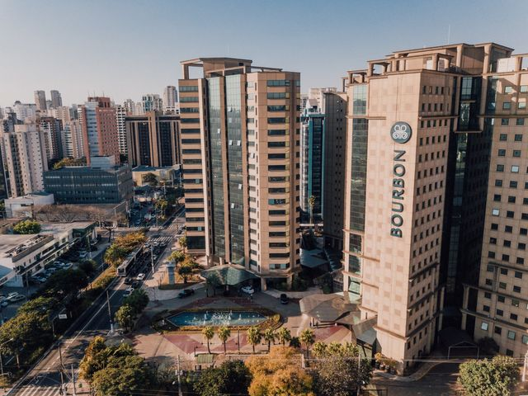
MEALS
Archers and officials staying at the Bourbon Sao Paulo who wish to have lunch or dinner at the Training Center can do so. The cost of a meal (either lunch or dinner) is approximately 10 USD. Payment to be made directly to the restaurant either in cash or by credit card.

TRANSPORTATION
The designated airport for the competition is Guarulhos International Airport-GRU. To ensure a smooth transition for all participants, we will be arranging transportation from the airport to the Brazilian Paralympic Training Center and the designated hotel on April 21 and 22. Please note that transportation services from the airport will be exclusively provided on these two days.
Similarly, for your departure, transportation from the Brazilian Paralympic Training Center and the hotel to Guarulhos International Airport will be arranged on April 28th. We kindly ask for your understanding as we optimize logistics for the convenience of all participants.
Transportation cost from the airport to the training center and/or hotel, and transportation from the training center and/or hotel to the airport is $100 USD per person.
For participants staying in hotels outside the Brazilian Paralympic Training Center, transportation must be arranged independently using services such as Uber, taxi, or rental cars. The cost associated with this transportation is the responsibility of the individual, and the organization will not be liable for either arranging or covering the expenses related to this transport.
VISA
All participants who need an entry visa to Country, will be required to complete the Visa Support sections in WAREOS by no later than 05 February 2024.
It is the applicants’ responsibility for supplying the necessary information, ensuring all details are up to date, correct and submitted by the deadlines specified.
In addition, all participants that require a visa are kindly requested to supply a copy of their latest/valid passport. Copies of each application can be uploaded on WAREOS. All passport copies and personal details entered/uploaded to WAREOS will be held securely and in the strictest of confidence and not shared with other parties.

BANK INFORMATION FOR ACCOMMODATION, TRANSPORTATION AND ENTRY FEES
BANK OF AMERICA
SWIFT: BOFAUS3N
ABA 026009593
New York – USA

Beneficiary:
Banco Rendimento S.A. - São Paulo -Brazil
Account: 6550925836

Reference: 17904906000133
BRX CORRETORA DE CAMBIO LTDA
+ *Confederação Brasileira de Tiro com Arco
Details of charges : OUR

NOTE: ALL PAYMENTS WILL BE MADE IN USD.

CANCELLATIONS & CHANGES
All cancellations and changes must be made through WAREOS / Open WAREOS:

- Should flight arrival details change last minute, please contact the Organising Committee using the details indicated in the team managers’ booklet.
- If a participant’s arrival is later than the original scheduled arrival date, the room will be charged from the date of the original booking in WAREOS.
- An email will automatically notify the Organising Committee and Member Association of any changes made in WAREOS.

HEALTH REGULATIONS
Medical emergency contact and location
In the Brazilian Paralympic Training Center, there is a medical clinic that can provide referrals to nearby hospitals in the event of a more serious issue.

ADDITIONAL INFORMATION

Weather
The temperatures in the city of São Paulo can vary between 18 and 35 degrees Celsius.

Media Registration
Media representatives can apply for registration by emailing ctmarica@gmail.com.

Water
Each participant will receive clean bottles of water.
Bottled water will be available at the qualification and practice venues.
A water fountain system will be used.

LOC CONTACT

Name: Rubens Vasconcellos Terra Neto
Address: Avenida Ivone dos Santos Cardoso, 340, Itapeba, Maricá – RJ CEP.: 24913-000
Email: rterraneto@gmail.com vicepresidencia@cbtarco.org.br ctmarica@gmail.com
Language: Spanish, English and Portuguese
Phone number with international extension: +55 (61) 98402-1916
Looking forward to welcoming you in São Paulo, Brazil.

Terms and Conditions
Introduction
The Member Association acknowledges to have understood and accepted in their whole and without any restrictions the sale and purchase terms and conditions of this invitation package, and of the registration platform https://extranet.worldarchery.sport/wareos/.

Consequently, the Member Association who wishes to register to an event, and book some or all associated extras proposed by the local organizing committee acknowledges that they are fully aware present terms and conditions are accepted by entering information in WAREOS.
Any Member Association declares that it is entitled to enter a contractual relationship with the Local Organising Committee of the event, in accordance with these terms and conditions.
The Local Organising Committee commits itself to communicate, within reason, to its potential clients the greatest information available on the following topics:
Description of the main characteristics of the proposed products and of their use.
Pricing
Information on the methods of payment and reimbursement conditions.

Article 1: Entirety
The platform https://extranet.worldarchery.sport/wareos/ is the propriety of, has been designed and created and is managed by World Archery Federation at Lausanne, Switzerland, and put at the disposal of the Local Organising Committee to facilitate registration to World Archery events.
The present terms and conditions include any and all rights and obligations of the parties. No single, specific, or general term or condition that may appear on documentation sent, given, or handed over to a Member Association will alter, replace, or complete parts of or the entirety of these terms and conditions
World Archery reserves the right to modify at any time and without any preliminary notification of any kind these terms and conditions.

Article 2: Object
The present terms and conditions define the rights and obligations of the parties in relation to the registration made through the platform https://extranet.worldarchery.sport/wareos/ of services offered by the Local Organising Committee in the scope of the event it has been set for.

Article 3: Contractual documents
The present terms and conditions and the registration process make up the contractual documents between the parties.

Article 4: Electronic signature:
The Member Association’s entering registration information is the electronic signature which is binding between the parties in the same sense as a handwritten signature would be.

Article 5: Registration Confirmation – Contract
The contract is validated as soon as the Member Association has entered its preliminary registration by entering information in WAREOS. A modification of the registration is possible until the deadline for registration set in the document. Modifications may be subject to penalty fees.

Article 6: Prices
The official prices are listed in the “Policies and Procedures Athletes, officials and team management”, the invitation package prices will be based on the official price list, converted to the currency elected by the LOC for invoicing (CHF, EUR, or USD).
The official prices valid on the date that the registration confirmation is sent to the Member Association are binding between the parties.
Article 7: Payment methods
All payments shall be made by bank transfer to the organising committee respecting the stated deadlines, with all bank charges paid by the Member Association. For any open invoices that are not settled 21 days prior the beginning of the event, the Local Organising committee will be entitled to charge a 5% surcharge on all open amounts.
Any payments received cash by World Archery on behalf of the organising committee will incur a 10% additional service fee, to be paid to World Archery.

Article 8: Payment deadlines and refunds
After the final deadlines of registration mentioned in this document, Member Association will not be entitled to any refund, and all remaining unpaid amounts shall be paid to the Local Organising Committee.
Failure to do so, will results in an immediate suspension of the Member Association, who will be set as not in good standing on the day of the official practice of the event, and so until the full amount is paid to the LOC.

Article 9: Availability of services
The availability of services is guaranteed on a first come, first serve basis, provided that the payment of such service has been paid to the local organising committee, partially or in full as mentioned in this document.
The local organising committee is not required to hold services for a Member Association that as not paid in full such service.
Article 10: Force-majeure
None of the two parties will have failed in their respective contractual obligations if their execution is delayed or prevented by a case of force-majeure. Cases considered to be a force majeure are extraordinary events or circumstances beyond the control of the parties, such as a war, strike, riot, crime, or an event described by the legal term "act of God" (e.g., flooding, earthquake, volcano eruption, etc). However, force majeure is not intended to excuse negligence or other malfeasance of a party, as where non-performance is caused by the usual and natural consequences of external forces, or where the intervening circumstances are specifically contemplated. The party experiencing a force majeure must notify in writing with 24 hours after becoming aware of the occurrence. The parties will then, within 7 business days examine, unless the force majeure prevents it, if and how the contractual obligations will be met.

Article 11: Privacy statement
All information exchanged by the Parties will be treated with the utmost confidentiality
All information requested by World Archery and the Organising Committee from the Member Association are necessary to process the event registration and can therefore be communicated only to the contractual partners of World Archery and the Local Organising Committee.
World Archery and the Local Organising committee are authorized to send informative and promotional e-mails to the Member Association, using the WAREOS e-mail address and the contact person provided by the Member Association during the registration.
October 2023 by World Archery Federation, Maison du Sport International, Avenue de Rhodanie 54 - 1007 Lausanne (Switzerland)

