Susanne Womersley

President

president@worldarcheryoceania.org
www.worldarcheryoceania.org

Dear Para-Archers from Oceania and around the World,
As President of World Archery Oceania I would like to invite you to be part of the 2024 WAO Para Grand Prix to be held in April in Sydney. This event is now in its second year, and it is the premier event for para-archers in the Oceania region.
The event will be held at Sydney Olympic Park in Homebush, returning to the venue of the 2000 Paralympic Games.
Sydney Olympic Park is located in the centre of the Sydney metropolitan area, so in easy reach of transport from the airport, major tourist attractions with a variety of accommodation options.
World Archery Oceania are grateful to Archery Australia and Sydney Olympic Park Archers for hosting this tournament, giving para-athletes an opportunity to compete at a World Archery WRE – the first of for Para archery in our region.
We are looking forward to welcoming you all to Sydney!
Best regards

IMPORTANT DATES

I attached the detailed information regarding this event. To register for participation, please complete all the necessary sections in WAREOS WorldArchery within the deadlines listed below.

Summary of deadlines:

Registration Opening date on WAREOS | 15/11/2023
Preliminary Entries  Final Entries | 7/01/2024  28/02/2024
Visa support | 14/02/2024
Full refund cancellation deadline  WA Classification Documentation  *After this deadline, the LOC is allowed to retain all amounts due by the Member Association. | 14/02/2024  8/03/2024
Please respect the stated deadlines.
Classification Documntation
All WA Classification documentation MUST be to the WA Classifiation Committee no later than 30 days prior to the classification day at the tournament. If you have any questions regarding International Classification please contact the WA Classification Committee classification@archery.sport
Important Event Information
The WAO Para Grand Prix will be run alongside the Archery Australia Para National Championships. All international archers are welcome to participate in this tournament as a visitor. Participation in the AA Para Nationals is included in your registration for the WAO Grand Prix

PRELIMINARY PROGRAM
1 April 2024  Monday | Arrival of participants
2 April 2024  Tuesday  3 April 2024  Wednesday | Unofficial Practice  Classifications  Registration  Practice  Equipment Inspection  Team Managers Meeting  Official Opening
4 April 2024  Thursday | AA National Para Championships  Morning - Ranking  Afternoon - Matchplay
5 April 2024  Friday  6 April 2024  Saturday | WAO Gand Prix  Morning - Ranking  Afternoon - Matchplay  Mixed team and Pairs Matchplay  Morning – AA National Para Championships  Afternoon – WAO Grand Prix

7April 2023  Sunday | Medal Matches and Presentations  Morning – AA National Para Championships  Afternoon – WAO Grand Prix
8 April 2024  Monday | Archers Depart

NOTE: This preliminary program is subject to change according to participation and TV requirements. All changes will be published and distributed in good time.

PRELIMINARY & FINAL REGISTRATION
All entries, transport needs, flight arrival/departure information and visa invitation letter requests are to be completed using the World Archery Online Registration System WAREOS at https://extranet.worldarchery.sport. This system handles the entire registration process for this event. No entry forms, hotel reservations or transportation forms will be accepted; all information must be entered into WAREOS.

Member associations can login to WAREOS at http://extranet.worldarchery.sport with the username and password assigned by World Archery. After entering WAREOS, selecting the event from the list will
allow a member association to register their athletes. Select/press the “Entries” button to see the list of categories in the event. Select/press the “category” to enter the athlete and official numbers/details participating for that event. A WAREOS User Manual can be downloaded in PDF format (English) upon login.

Contact wareos@archery.sport with any questions regarding technical problems on WAREOS. For any question regarding the organisation of the event (transport, accommodation, meals, invoices etc.) please directly contact the LOC.

At this stage we are not limiting the number athletes per country to be registered into each category and division of the event.

Member Associations can only use WAREOS to make any changes or amendments to entries and will be able to do so at any time. An email will automatically notify the Organising Committee and Member Association of any changes made in WAREOS.

ENTRY FEES

Individual $231 USD per athlete
Official $78 USD per person
There will be no acceptance of late entries.
Lunches

Lunches can be purchased at the venue for competition days. These will be pre-packaged and order forms will be available on the Registration day for Athletes and Team Officials to complete.
Cost of your lunch is included in your accommodation package – Half Board (Breakfast and Lunch)
Extra lunches are available but must be ordered the day prior $20 AUD

HOTEL ACCOMMODATION

Hotel accommodation is to be booked via WAREOS
Accommodation Options include with all quoted prices per room with the number with the number of persons shown e.g. 1pax or 2pax.

Prices include continental style breakfast and lunch (at the field of play), but not dinner. There are many food outlets and restaurants within 50m of the hotels.

Each hotel has a number of accessible rooms available please note your requirements in WAREOS
IBIS Hotel – Sydney Olympic Park
Single room (1pax) $182 USD
Twin room (2pax) $230 USD

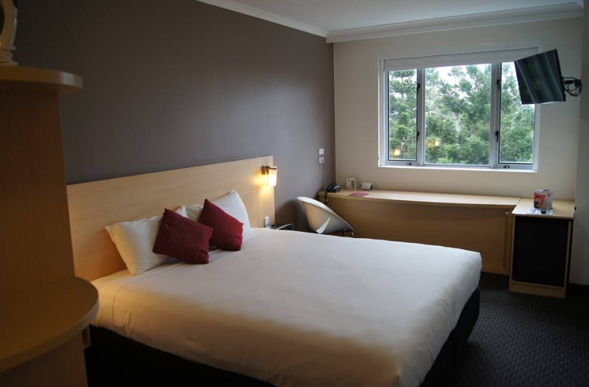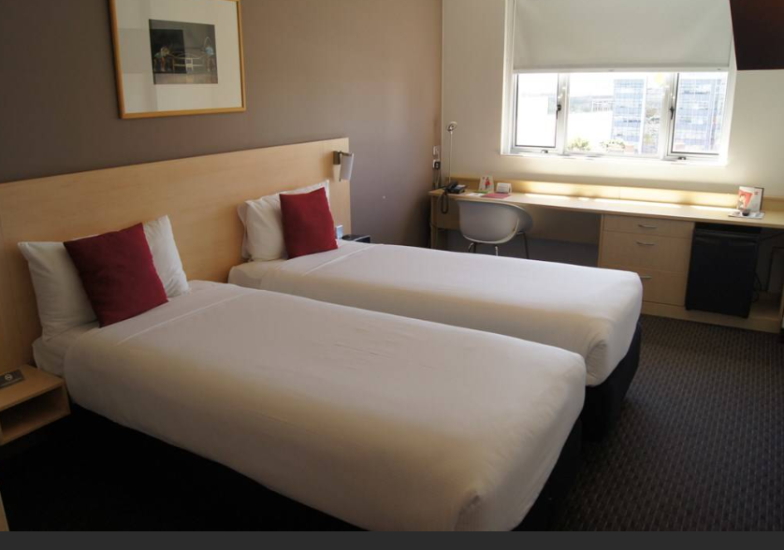

ALL - Accor Live Limitless

NOVOTEL Hotel – Sydney Olympic Park
Single room (1pax) $225 USD
Twin room (2pax) $299 USD

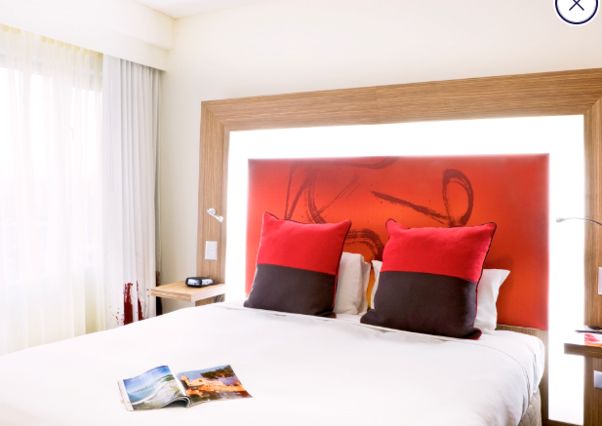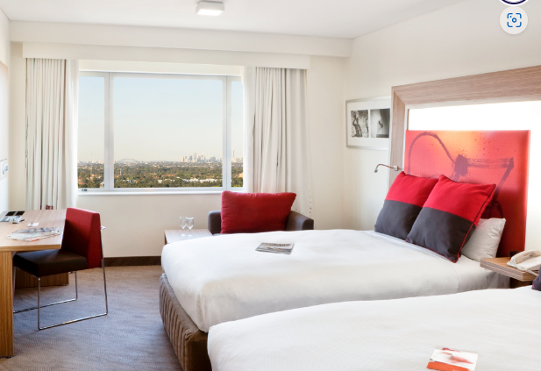

Novotel Sydney Olympic Park | Homebush Sydney | ALL - ALL (accor.com)

PULLMAN Hotel – Sydney Olympic Park
Single room (1pax) $294 USD
Twin room (2pax) $320 USD

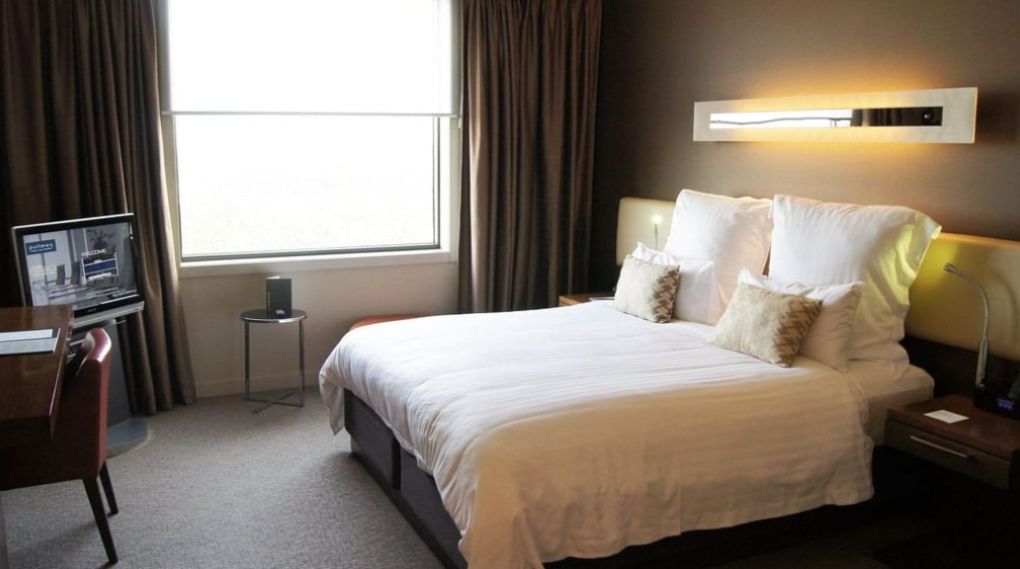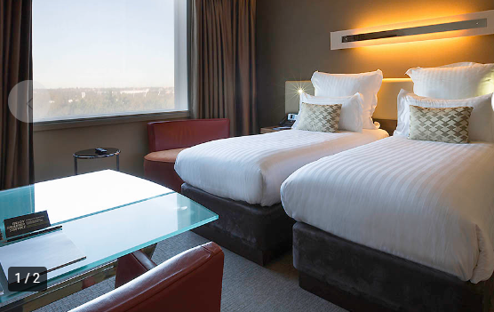
Pullman Sydney Olympic Park - AccorHotels - ALL

APARTMENT ACCOMMODATION

Apartment accommodation is to be booked via WAREOS
Accommodation Options include with all quoted prices per room with the number with the number of persons shown e.g. 1pax or 2pax.

Prices are accommodation only, with each apartment hosting a self contained kitchen. There are many food outlets and restaurants within 400m from the apartments, and lunch can be ordered for the field of play on registration day.

Quest Apartments have a number of accessible rooms available please note your requirements in WAREOS
QUEST APARTMENTS – Sydney Olympic Park
Single room (1pax) $236 USD
Twin room (2pax) $299 USD
Two room (2pax) $443 USD
Triple room (3pax) $610 USD

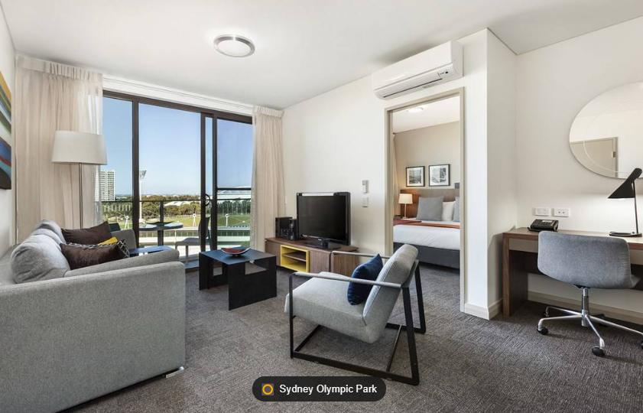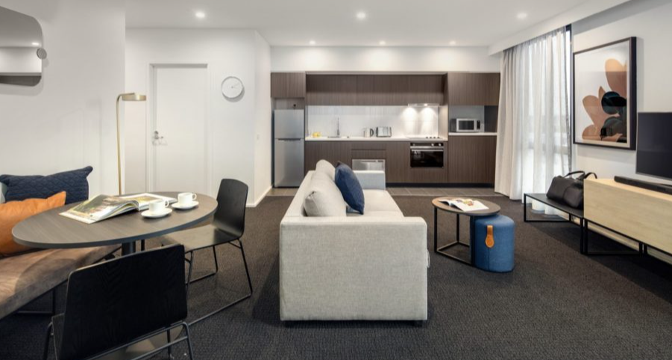

Quest at Sydney Olympic Park | Melbourne Serviced Apartment | Melbourne Accommodation (questapartments.com.au)

TRANSPORTATION
For athletes and Team Officials staying at the official accommodation, the following transport options are available at cost.
- Transport to and from the airport to the official accommodation
- Transport to and from official accommodation to the competition venue
VISA
All participants who need an entry visa to Australia, will be required to complete the Visa Support sections in WAREOS by no later than 14/2/24

It is the applicants’ responsibility for supplying the necessary information, ensuring all details are up to date, correct and submitted by the deadlines specified.

In addition, all participants that require a visa are kindly requested to supply a copy of their latest/valid passport. Copies of each application can be uploaded on WAREOS. All passport copies and personal details entered/uploaded to WAREOS will be held securely and in the strictest of confidence and not shared with other parties.

PAYMENT CONDITIONS
Complete all necessary sections in WAREOS and make full payment by the specified deadlines. Bank transfers only, no credit cards or cash will be accepted. All bank charges will be paid by the participants.

The entry fees should be paid in full before arrival.

BANK INFORMATION FOR ENTRY FEES
A/C Name: Archery Australia
Federation’s Address: PO Box 32, Sydney Markets, NSW, 2129
Telephone number: +61 2 9772 2995
Contact Anthony Maxworthy
Contact email anthony.maxworthy@archery.org.au
City and Country: SYDNEY, AUSTRALIA
Bank: Commnwealth Bank of Australia
BSB: 062 222
Account Number: 10257553
BIC/Swift: CTBAAU2S
City: Sydney

NOTE: ALL PAYMENTS SHALL BE MADE IN USD.

CANCELLATIONS & CHANGES
All cancellations and changes must be made through WAREOS:

- Should flight arrival details change last minute, please contact the Organising Committee using the details indicated below.
- An email will automatically notify the Organising Committee and Member Association of any changes made in WAREOS.

HEALTH REGULATIONS (COVID-19)
INFORMATION
- Everybody should follow the Government/public health authorities measures (national and sport-specific regulations) and be aware of the travel restrictions
- For your information, Medical infrastructure/Hospital with proper care will be reachable within 30 minutes from the venue, where COVID-19 testing can be done.
Medical emergency contact and location
Auburn Hospital: Hargrave Road Auburn NSW
+61 2 8759 3000

ADDITIONAL INFORMATION

Water
Water will be available to all compretitors free of charge.
Bottled water will be available at the competition venue for others to purchase

LOC CONTACT

Name: Tracey Hansford
Address: SOPA Archers
Email: president@sopa-archery.org.au
Language: English
Phone number with international extension: +61 416 242 281
Looking forward to welcoming you in Sydney, Australia

